**EXPERIMENT-1**

**AIM:** To design a LM35 based temperature monitoring system which will generate an alarm if the temperature rises above a threshold temperature.

**COMPONENTS REQUIRED**

* 7805 voltage regulator IC
* LM35 temperature sensor
* OP-07 IC
* Advantech USB-4704
* LabVIEW 2010
* ± 12V power supply
* Resistors of 82KΩ & 22KΩ

**THEORY**

**1. 7805 voltage regulator IC**

7805 is a three-terminal positive voltage regulator integrated circuit which operates at 12 V and gives out a constant voltage of 5 V.The output current is up to 1.5 Amp.

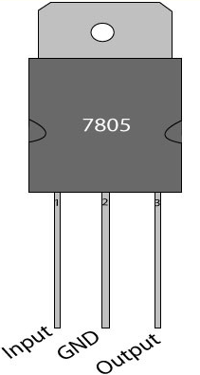

**Pin configuration of 7805**

|  |  |  |
| --- | --- | --- |
| **Pin No.** | **Function** | **Name** |
| 1 | Input voltage (5V-18V) | Input |
| 2 | Ground (0V) | Ground |
| 3 | Regulated output; 5V (4.8V-5.2V) | Output |

**2. LM35 temperature sensor**

* LM35 is a precision IC temperature sensor with its output proportional to the temperature (in oC).
* Operating temperature range is from -55°C to 150°C
* The output voltage varies by 10mV in response to every **o**C rise/fall in ambient temperature, *i.e.,*its scale factor is 0.01V/**o**C.

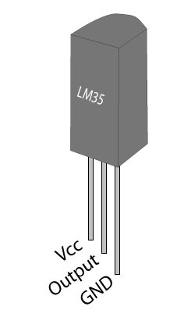

**Pin configuration of LM35**

|  |  |  |
| --- | --- | --- |
| **Pin No.** | **Function** | **Name** |
| 1 | Supply voltage; 5V (+35V to -2V) | Vcc |
| 2 | Output voltage (+6V to -1V) | Output |
| 3 | Ground (0V) | Ground |

**3. OP07-IC**

* **IC OP07** is an opamp which may be used for amplification of signals.
* GAIN (AV) in non inverting mode = 1+ (R2 / R1)

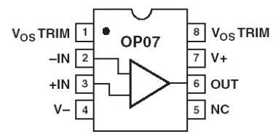

**Pin configuration of OP07**

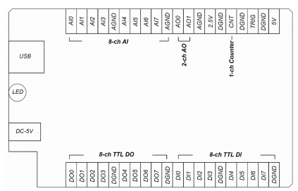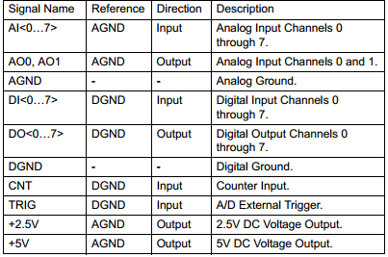**4. Advantech 4704 DAQ**

**I/O Connector Pin Assignment** **I/O Connector Signal Description**

Data is acquired using LabVIEW for online monitoring using Advantech DAQ. It acts as an interface between the hardware and the software.

**BLOCK DIAGRAM**

POWER SUPPLY

(± 12 V, DC)

7805-VOLTAGE REGULATOR

(5V)

Display & Monitoring in LABVIEW

Advantech 4704 DAQ

OP-07

NON-INVERTING AMPLFIER (Gain=5)

LM35

TEMPERATURE SENSOR

**Block diagram of temperature sensing circuit**

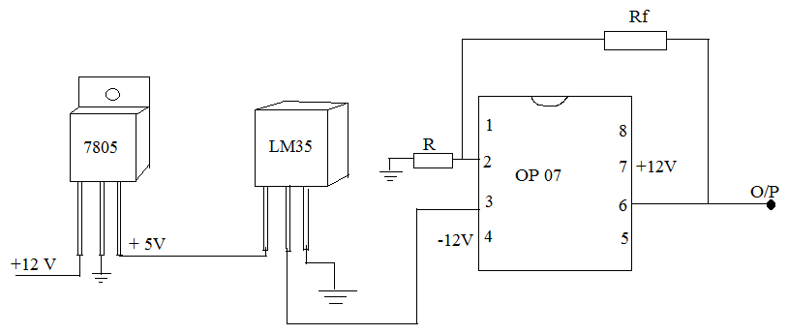**CIRCUIT DIAGRAM**

**Circuit diagram of temperature sensing circuit**

**PROCEDURE**

* The continuous temperature monitoring unit was developed using the IC LM35. LM35 needs to be operated on a regulated 5 V dc power supply.
* 12 V power supply was employed to drive 7805 IC to generate and provide a regulated 5V dc voltage to LM35.

**℃ = V * 100**

* The temp conversion is done by using formula :
* The output of the LM35 is in the range of mV. Hence, the output of LM35 was amplified by using a non-inverting amplifier having a gain of 5.
* The non-inverting amplifier was designed using op- amp (IC OP07), which was being operated by a ± 12V dc source. By selecting resistors of 82KΩ and 22 KΩ, the gain of OP-amp was set to 5.
* The output of the amplifier was then acquired in computer using NI ADVANTECH-7804 and LabVIEW-2010 softwAare. A processing program was made to initiate an alarm when the temperature rises above a threshold temperature.

**LABVIEW PROGRAMMING**

* Open LABVIEW-2010 and click on BlankVI. 2 windows opens up:

1. Front panel
2. Block diagram panel

* Draw a while loop in block diagram panel
* Right click and go to user libraries, then go to Analog i/p and ADV AI Acquire.
* Then right click go to express, then to signal and then to Amplitude level.
* Graphics, then to sound then go to output and then play waveform.
* Go to express and then to output and then to simulate signal.

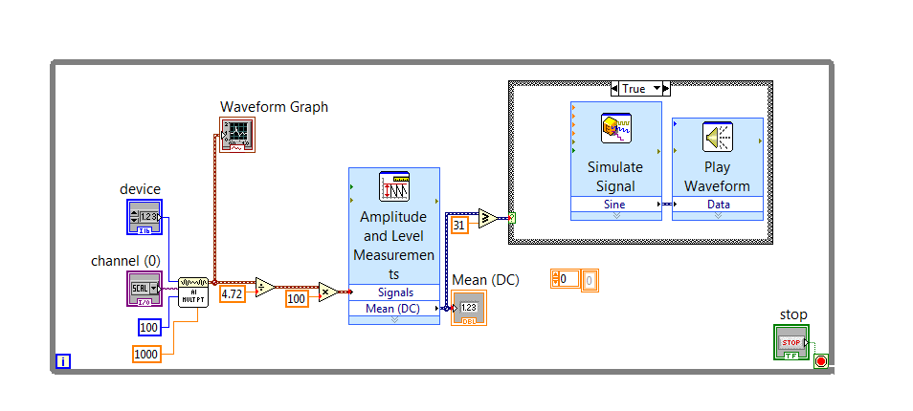

**LabVIEW: Block diagram panel**

**OBSERVATION**

* The gain can be calculated as follows: Gain(Av)= Vo/Vi= (1+Rf/Ri)=

|  |  |  |  |  |
| --- | --- | --- | --- | --- |
| **Observations** | **O/P OF 7805**  **(V)** | **O/P OF LM35**  **(V)** | **O/P OF OP-07**  **(V)** | **TEMPERATURE**  **(°C)** |
| 1 |  |  |  |  |
| 2 |  |  |  |  |
| 3 |  |  |  |  |

**CONCLUSION**

A temperature monitoring system was devised using a LM-35 temperature sensor.