效果参考图1

await DisplayAlert ("Alert", "You have been alerted", "OK");

效果参考图2

bool answer = await DisplayAlert ("Question?", "Would you like to play a game", "Yes", "No");

Debug.WriteLine ("Answer: " + answer);

效果参考图3

string action = await DisplayActionSheet ("ActionSheet: Send to?", "Cancel", null, "Email", "Twitter", "Facebook");

Debug.WriteLine ("Action: " + action);

效果参考图4

string action = await DisplayActionSheet ("ActionSheet: SavePhoto?", "Cancel", "Delete", "Photo Roll", "Email"); Debug.WriteLine ("Action: " + action);

效果参考图5

string result = await DisplayPromptAsync("Question 1", "What's your name?");

效果参考图6

string result = await DisplayPromptAsync("Question 2", "What's 5 + 5?", initialValue: "10", maxLength: 2, keyboard: Keyboard.Numeric);

图1

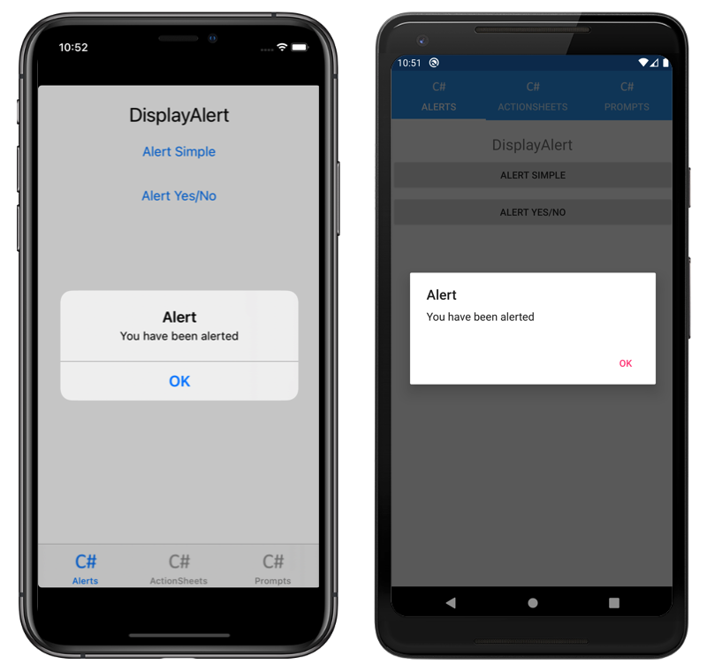

图2

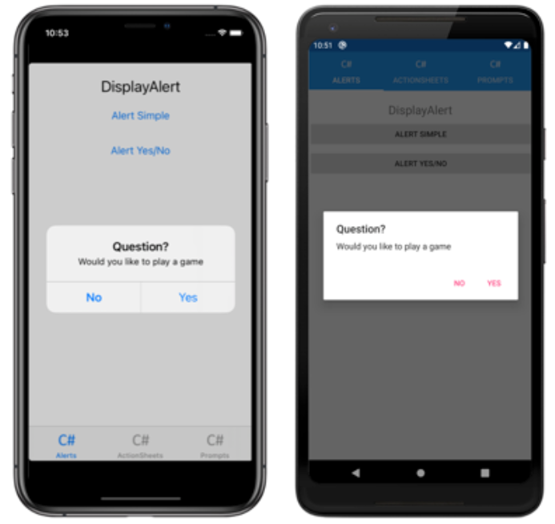

图3

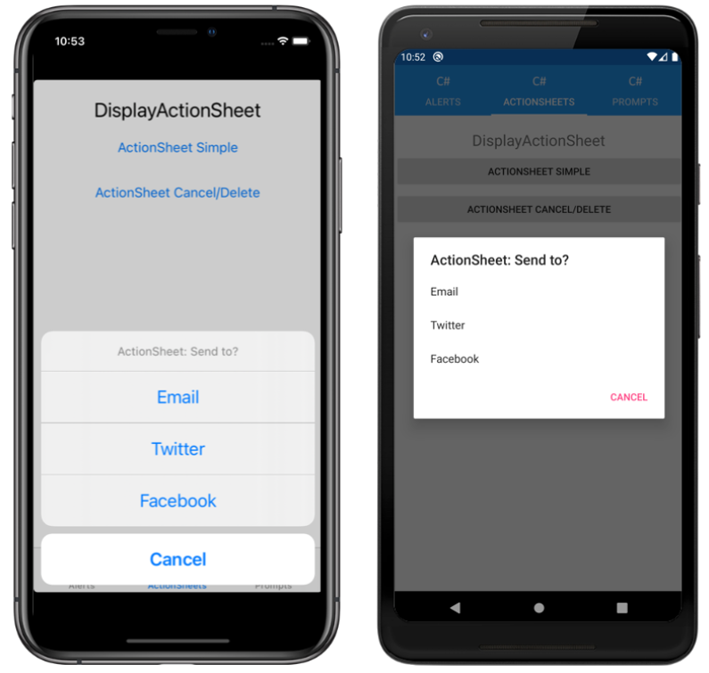

图4

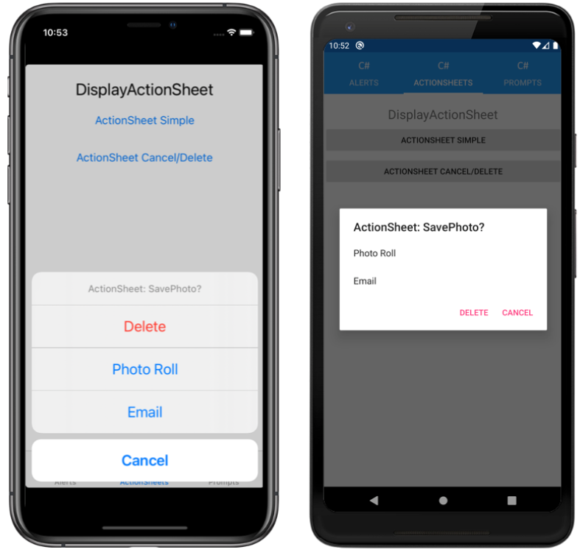

图5

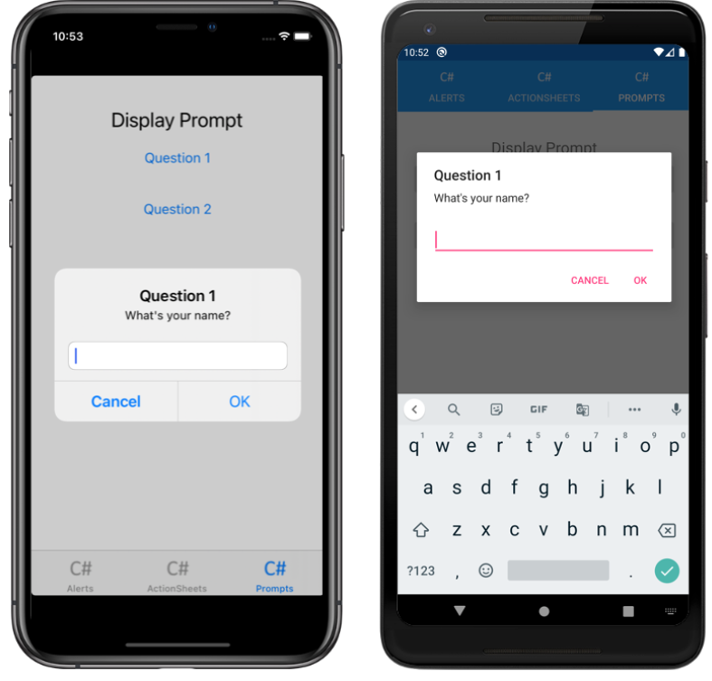

图6

