Install Docker on Amazon Linux 2 / Amazon Linux 2023 and Connect to the EC2 Instance via SSH to prepare for Docker installation.
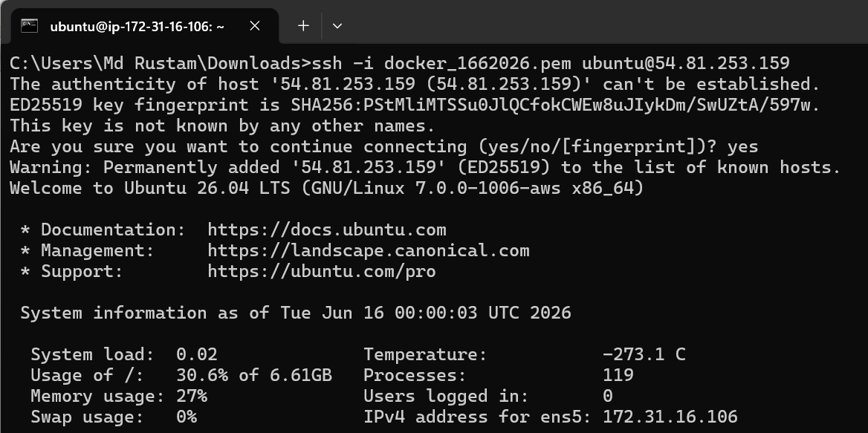
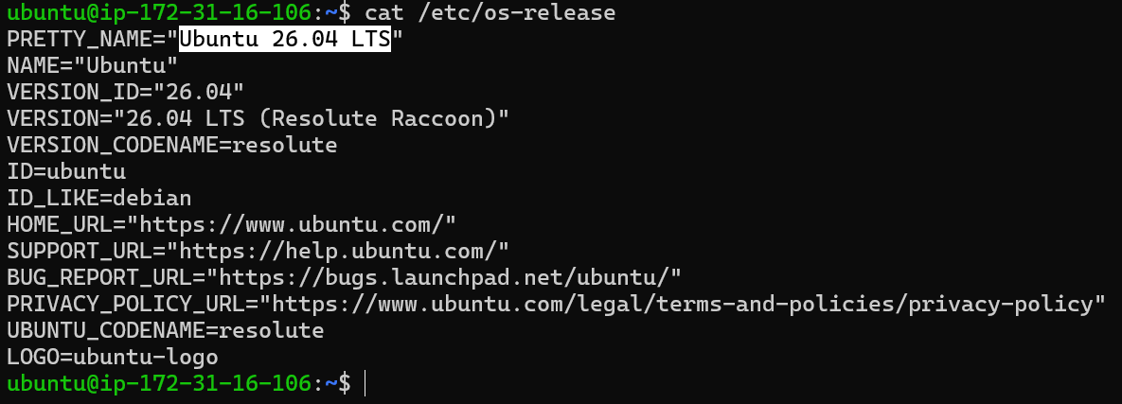
Update packages the ubuntu latest packages
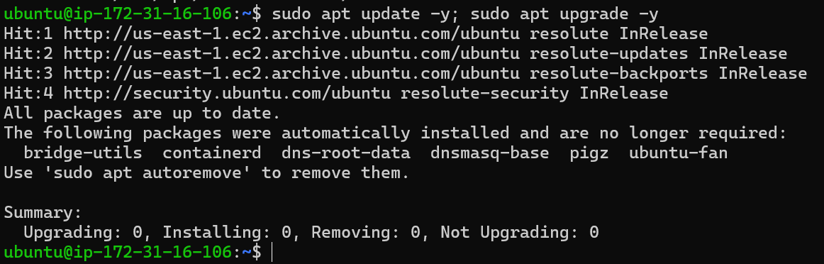
Created an script for Install prerequisites & add Docker repo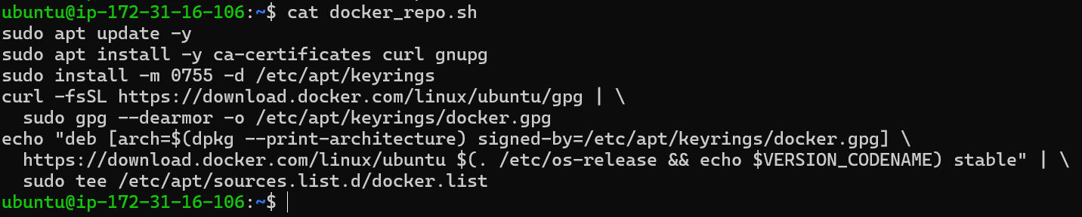

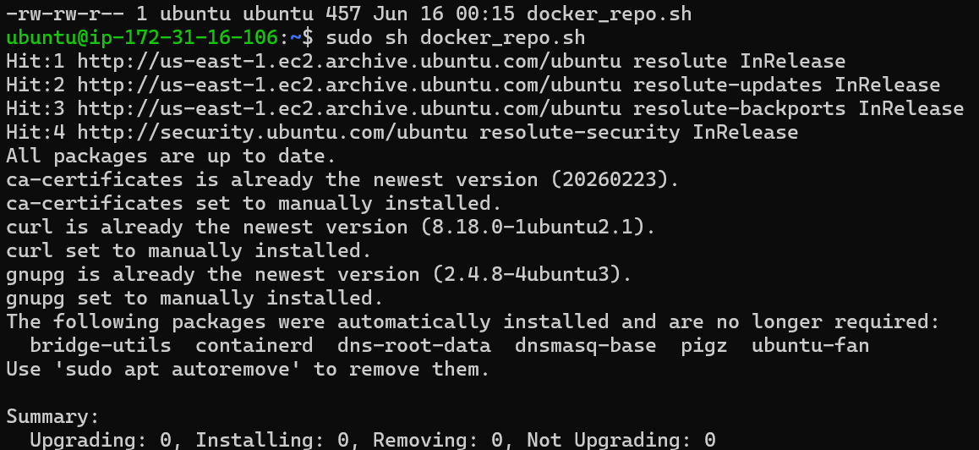
Install Docker Engine
Verify the installed docker version
Start, enable Docker service and verify the status
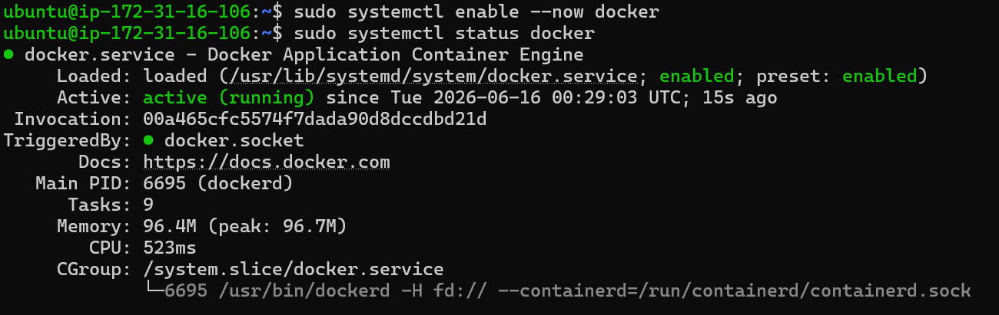
Add ec2-user to docker group (no sudo needed)
Verify Installation (Confirm Docker is installed and running).
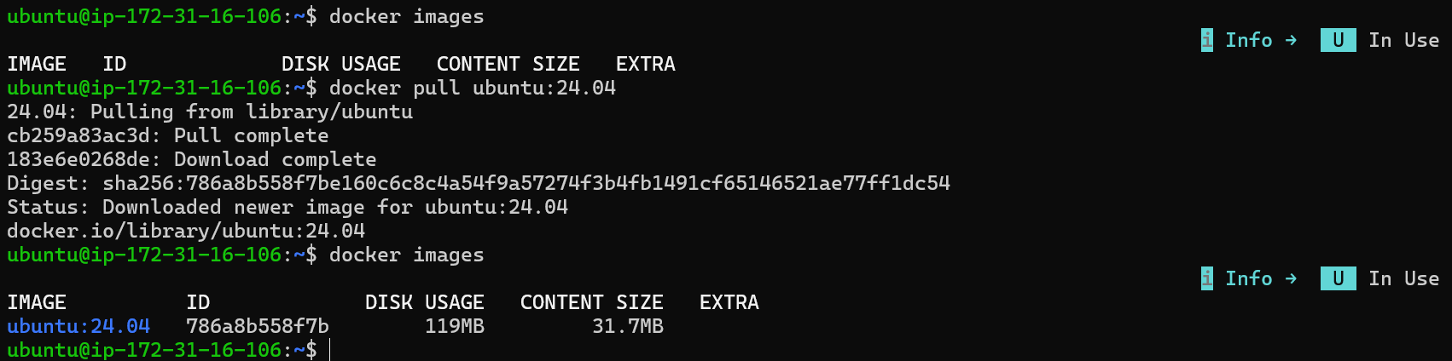
Run and control containers interactively or in background.
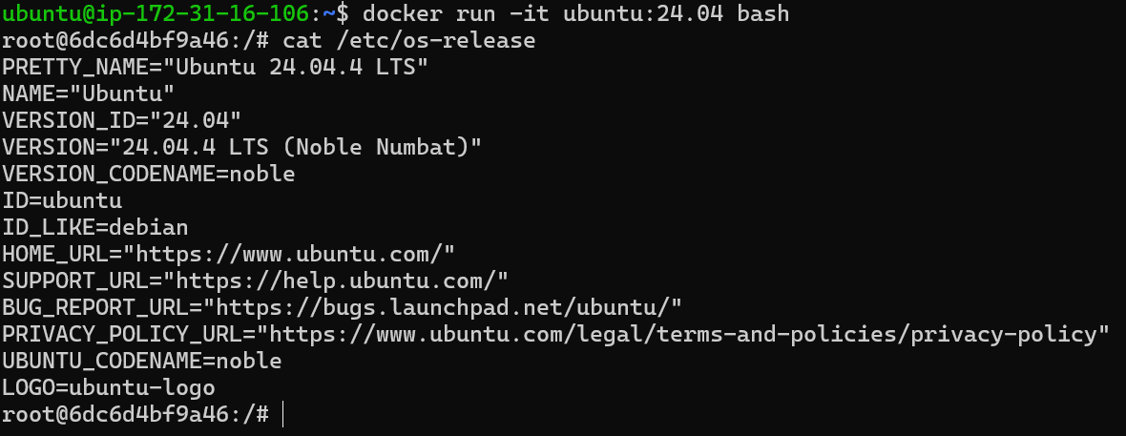
Work with Volumes (Persist data across container restarts using volumes).
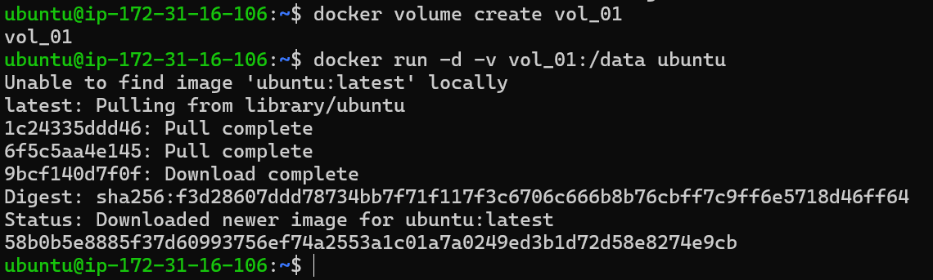
Verify the mapped Docker volume and test persistence between the host node and the container
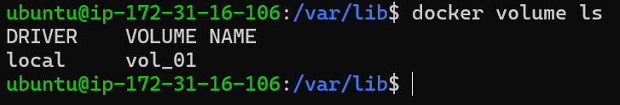
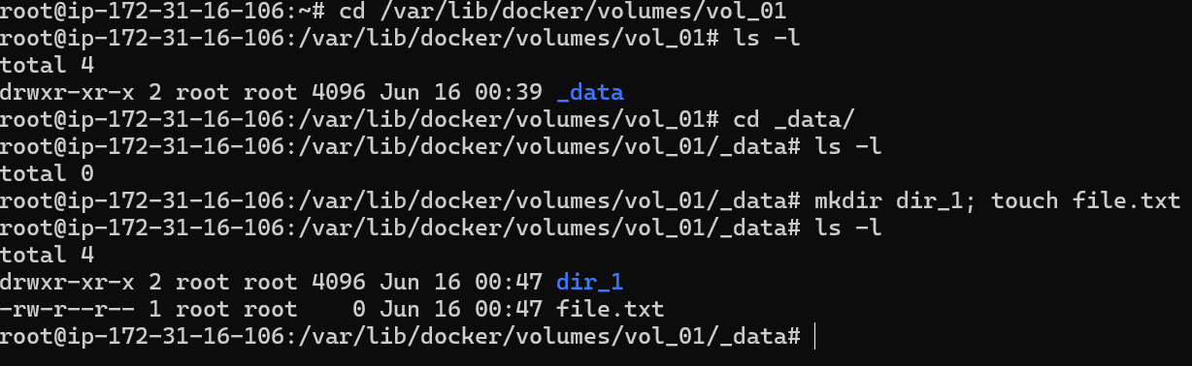
Explore Networking (Connect containers using custom networks).
