Docker Task -2

Task Description: Create a dockerfile, docker-compose file which when executed must display your basic details in the website.
This is the webpage content that displays my details
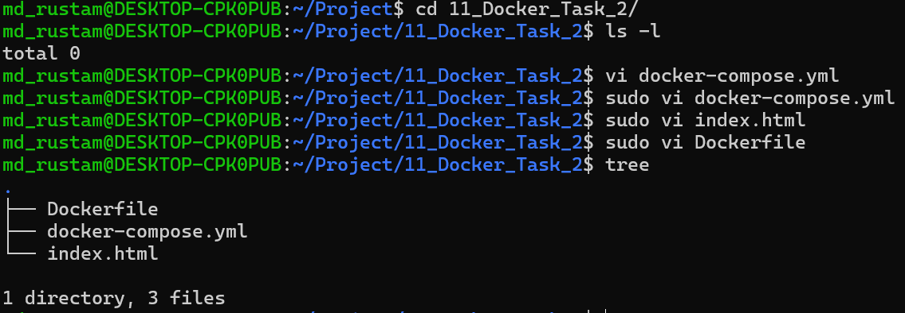
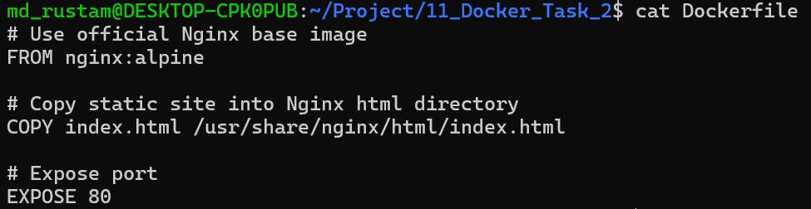
Created a lightweight Nginx image to serve a static HTML page, defines the service and maps the container port to the host port on 8080:80
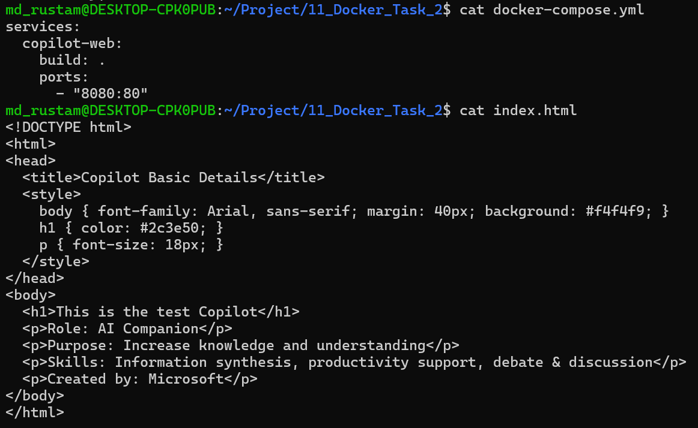
Create a project folder and put Dockerfile, docker-compose.yml, and index.html inside it. Executed the compose to build a container image and able to access the web page successfully.
