Complete step-by-step guide to set up Jenkins, create your first project, and configure user management.

Create ubuntu 24.04 server and update with latest available patch set:
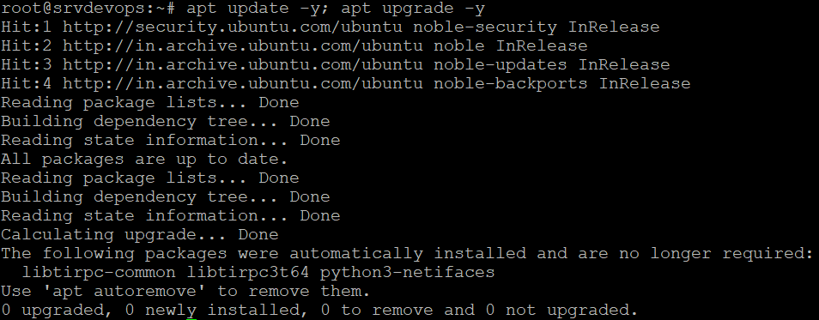
Install Java and Jenkins (Jenkins requires Java; install Java first, then Jenkins from its official repo).
sudo apt install openjdk-11-jdk -y \n wget -q -O - https://pkg.jenkins.io/debian-stable/jenkins.io.key | sudo apt-key add - \n sudo apt install jenkins -Y
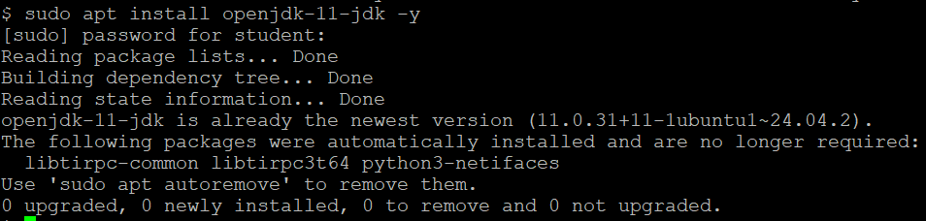
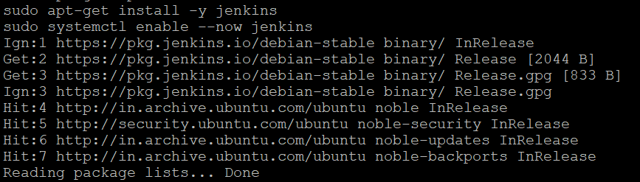
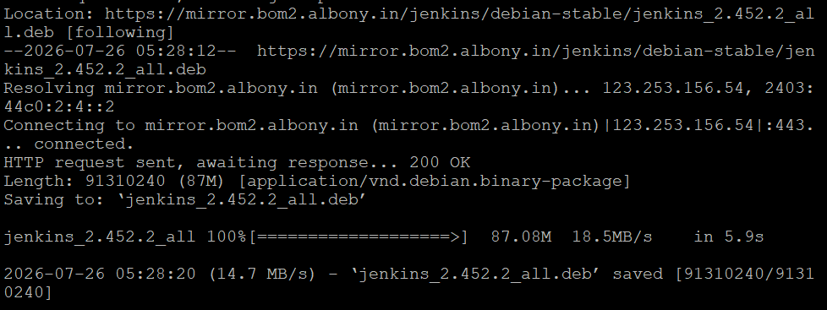
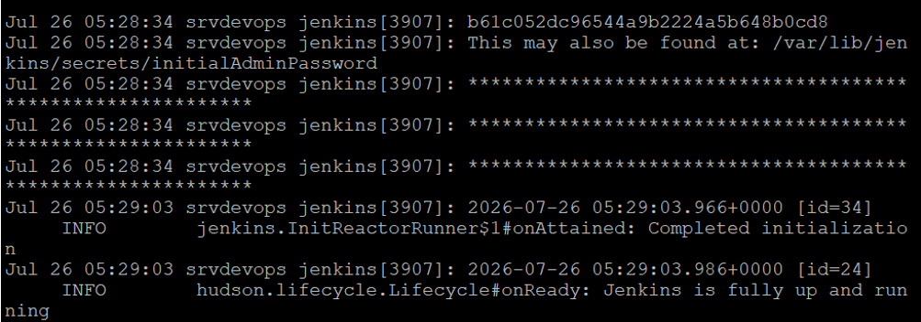
systemctl start Jenkins; systemctl status jenkins
