This is a classic CI/CD workflow setup
Step 1: Created a Simple Bash Script File that prints system info:
touch script.sh; vi script.sh
# !/bin/bash
echo "Build started..."
echo "System Info:"

uname -a
echo "Build completed successfully!"

Make the script executable:
chmod +x script.sh

Commit and push to the GitHub repo.
git add script.sh; git commit -m "Add build script"; git push origin main

Step 2: Configure Jenkins Project (Open Jenkins → New Item → select Freestyle Project):
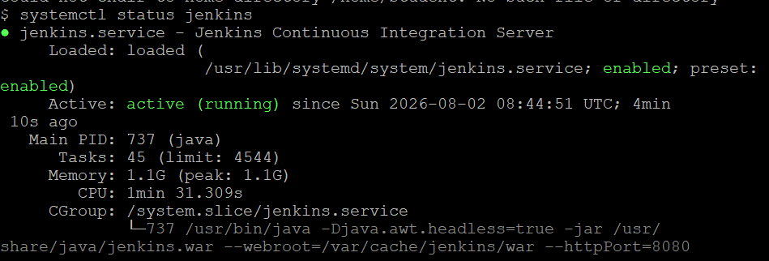

Open Jenkins → New Item → select Freestyle Project
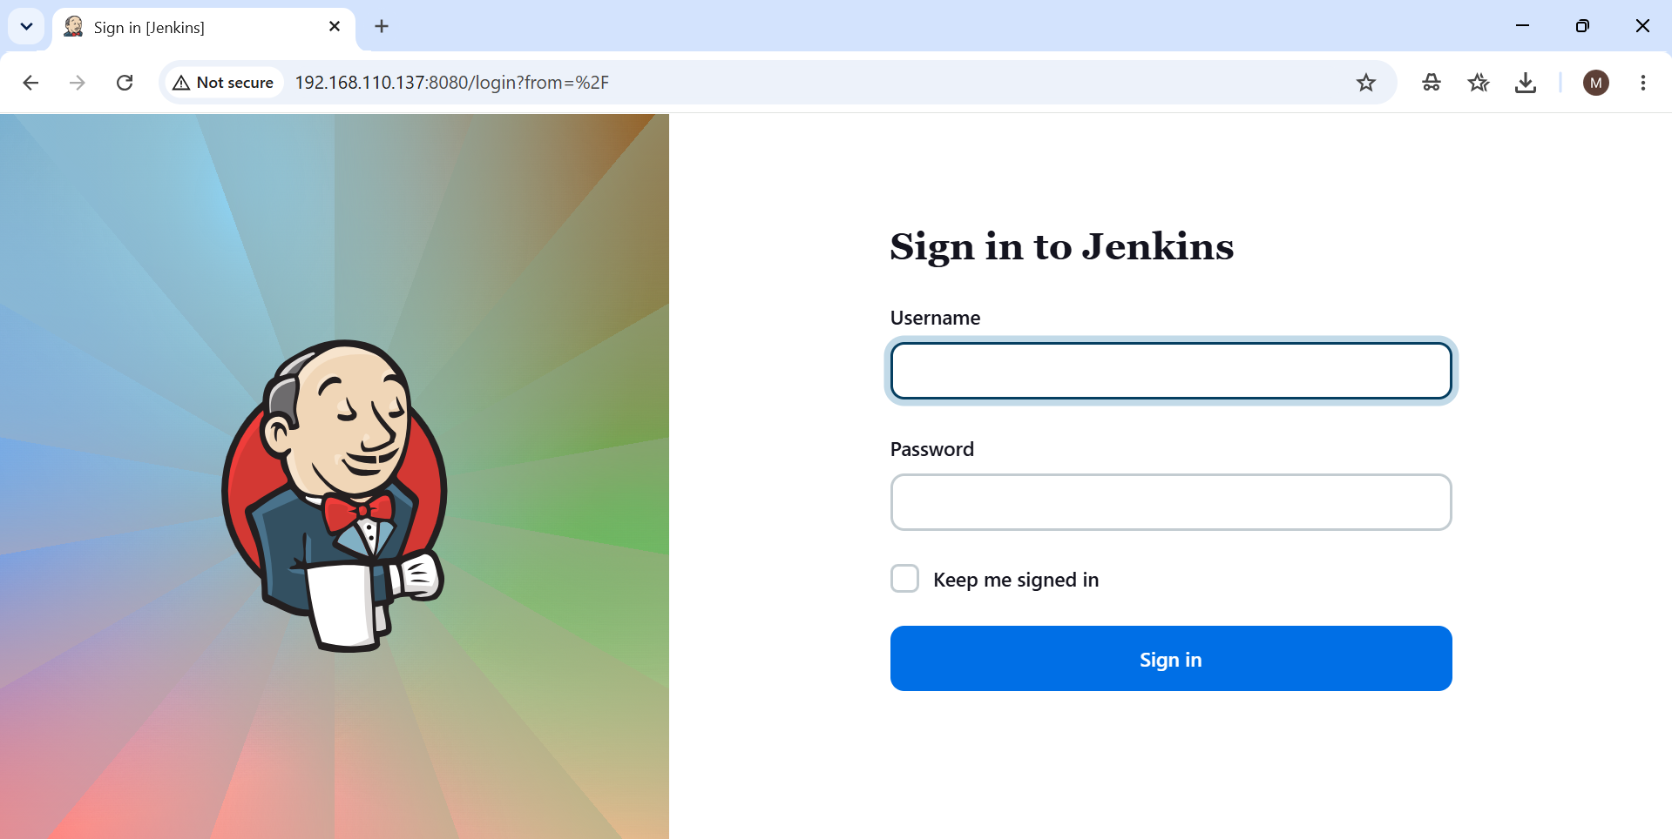
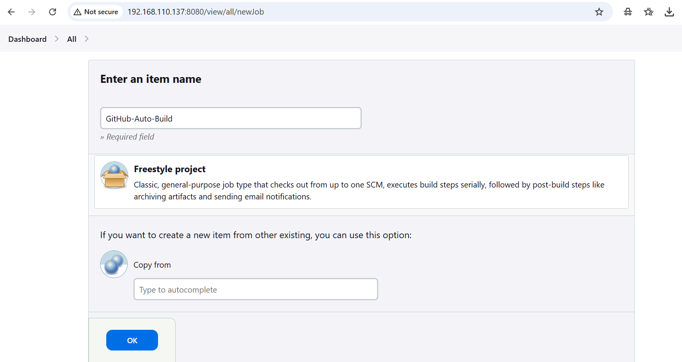

Under Source Code Management, choose Git and paste your repo URL. Under Build Triggers, GitHub hook trigger for GITScm polling
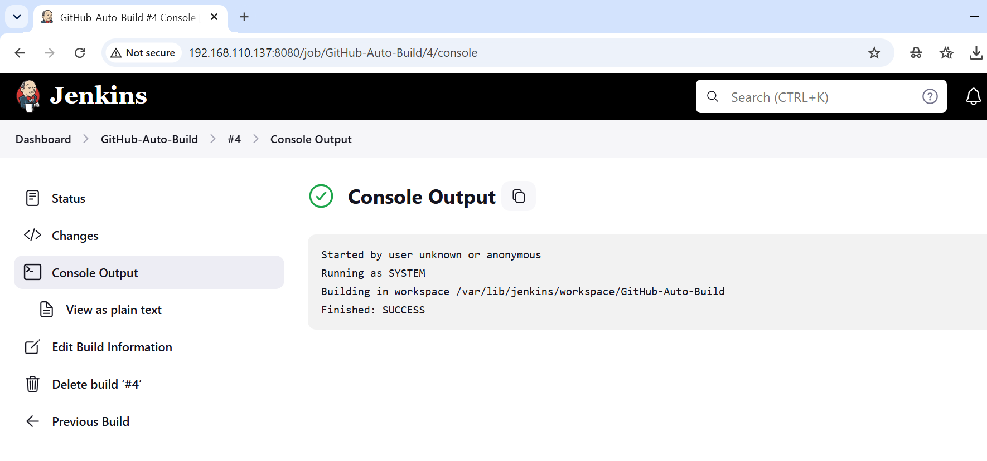

http://192.168.110.137:8080/github-webhook/
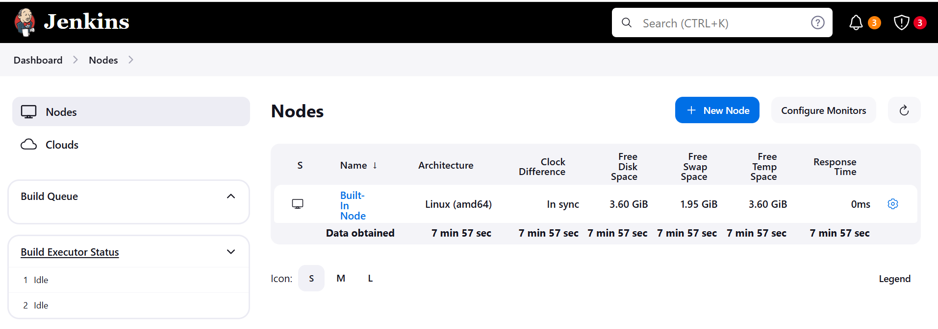
Step 3: Configure GitHub Webhook, Add Build Step, In Jenkins job → Build Steps → Execute shell:
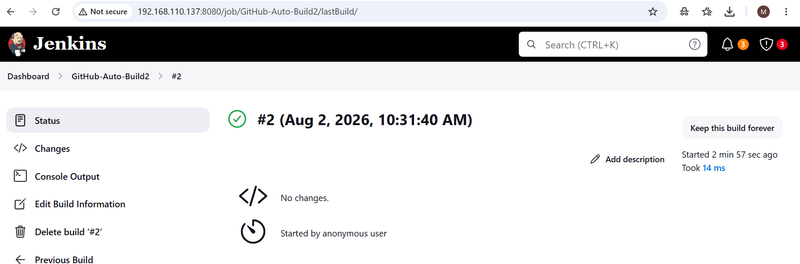

Email Notification
- Install Email Extension Plugin in Jenkins.

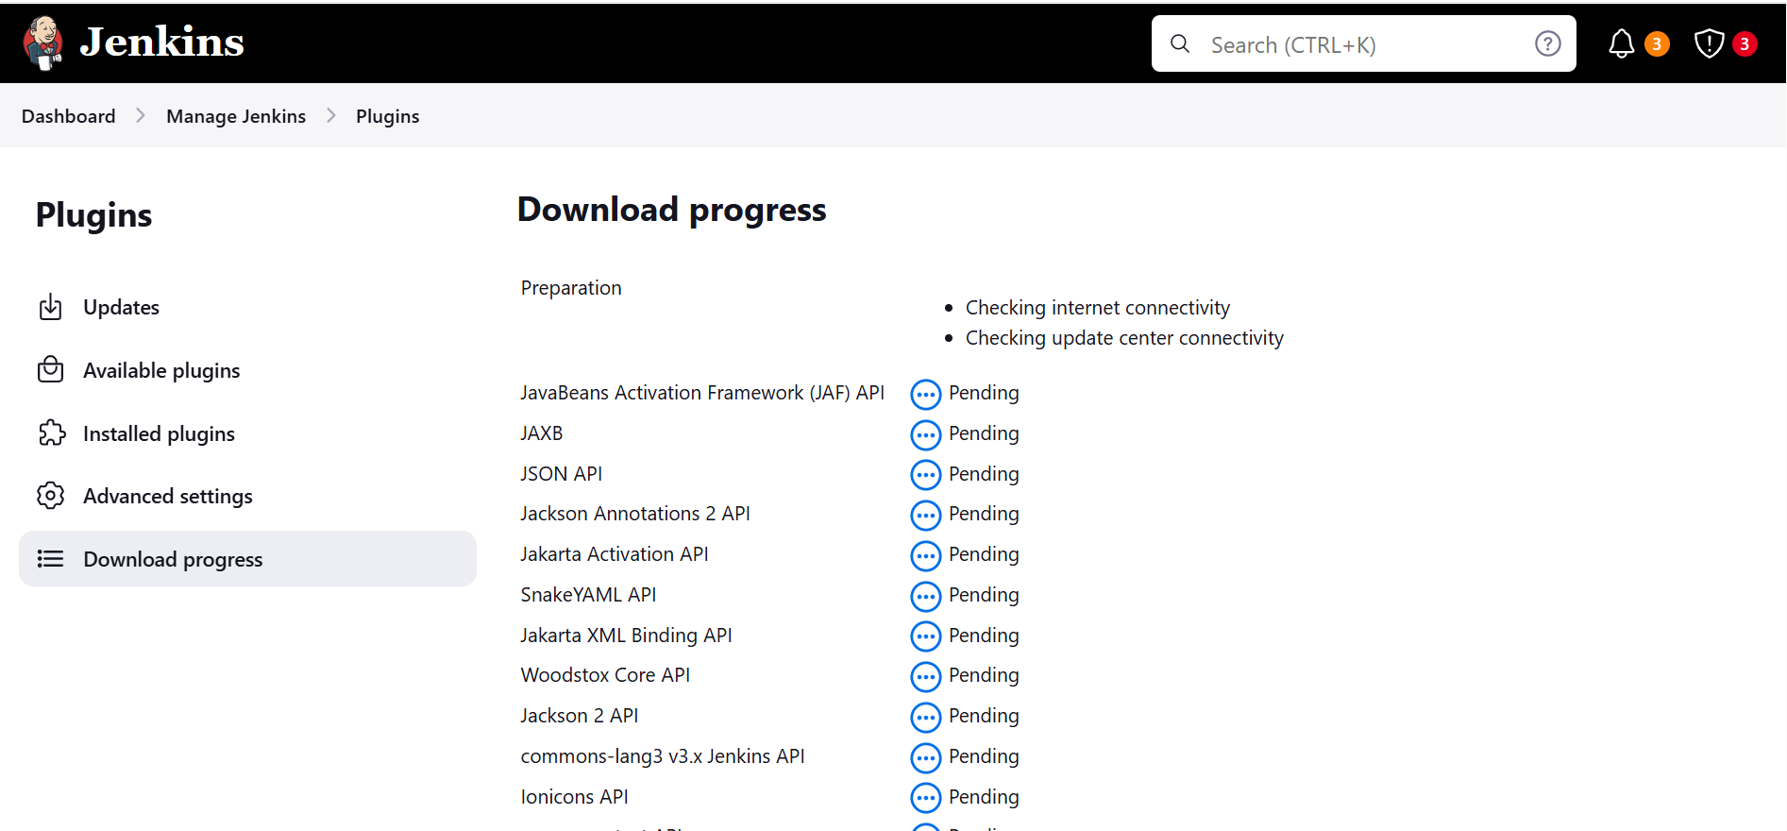

- Configure SMTP in Manage Jenkins → Configure System:
• Go to Manage Jenkins → Configure System.
• Scroll down to Extended E-mail Notification.
• Fill in the SMTP details:

- smtp.gmail.com
- Port: 587
- Use TLS

