

SmartHouse

Name:Androne Eric
Group:30435

Table of Contents
Deliverable 1 3
Project Specification 3
Functional Requirements 3
Use Case Model 3
Use Cases Identification: 3
UML Use Case Diagrams 3
Supplementary Specification 3
Non-functional Requirements 3
Design Constraints 3
Glossary 3
Deliverable 2 3
Domain Model 3
Architectural Design 3
Conceptual Architecture 3
Package Design 4
Component and Deployment Diagram 4
Deliverable 3 4
Design Model 4
Dynamic Behavior 4
Class Diagram 4
Data Model 4
System Testing 4
Future Improvements 4
Conclusion 4
Bibliography 4

Deliverable 1

Project Specification
In an era of fragmented technology, SmartHome redefines the domestic experience by prioritizing effortless control and total compatibility. This platform eliminates the frustration of juggling multiple proprietary apps, offering a single, intuitive interface designed for users of all technical levels.

Functional Requirements
- Unified Dashboard: The app shall provide a single point of control for all connected hardware, regardless of the brand.
- Cross-Brand Integration: Users must be able to group devices from different manufacturers into a single app.
- Real-Time Status Updates: The interface must reflect the current state (On/Off, Temperature, Locked/Unlocked) of all devices in real-time.
- Security: The system should ensure unauthorized users cannot access devices through the app.

Use Case Model
Actors:
- Admin
- User
- Appliance

Use Cases Identification:
- Add user
Use-Case: add a new user to the home
Level: App-wide goal
Primary Actor:Admin
Main success scenario:
- The Admin opens the app.
- The Admin opens the add user menu.
- The Admin inputs the user’s data.
- The Admin sees a message confirming the user has been added successfully.
Extensions:
3a. If the user creation failed an error message will be shown to the Admin.
- Changeing device mode
Use-Case: change the operation of a device(eg. open the lights,start the oven)
Level: User-goal
Primary Actor:User
Main success scenario:
- The User enters the app.
- The User accesses the specific device
- The User uses the device widget to change the settings
Extensions:
3a. The sensor is not working: The app will display the sensor with a message indicating the sensor is offline.
3b.The operating mode can cannot be changed at the moment(eg. The washing machine’s settings can cannot be changed in the middle of the cycle).
- Adding a new device
Use-Case: add a new device to the profile
Level: User-goal
Primary Actor:User
Main success scenario:
- The User enters the app.
- The user opens the add device menu.
- The User inputs the device data.
- The server connects to the device.
- The User sees a message confirming the device has been added.
Extensions:
4a. The device could not be found: The app will display a message notifying the user the device could not be found.

UML Use Case Diagrams
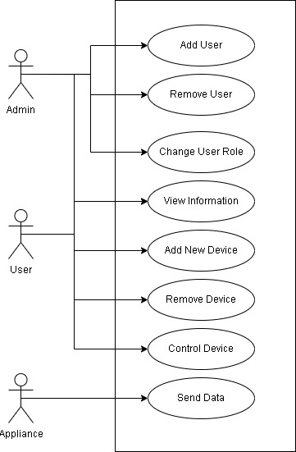

Supplementary Specification

Non-functional Requirements
- Security -Since the app controls physical entry and privacy-sensitive devices, security is paramount. The app must ensure unauthorized users cannot access devices.
- Performance -Quick response time is essential for effective control of the devices and user experience.(eg. The lights should not take 10 min to turn on.)
- Reliability -Since the app handles important devices, the system must have very low down time.(eg The heating and lighting must be always available.)
- Ease of access -The app should be easy to interact and allow for seamless interaction with the devices

Design Constraints
- Programming Language: The core back-end services must be developed in a memory-safe language (such as Java or Python) to reduce vulnerabilities.
- Legacy Support: The system must maintain backward compatibility with smart devices manufactured within the last 3–5 years.
- Local Hub Resource Limits: The app should operate on low-power hardware to allow for local management of devices.

Glossary

Deliverable 2

Domain Model
[Define the domain model and create the conceptual class diagrams]

Architectural Design

Conceptual Architecture
[Define the system’s conceptual architecture; use an architectural style and pattern - highlight its use and motivate your choice.]

Package Design
[Create a package diagram]

Component and Deployment Diagram
[Create the component and deployment diagrams.]

Deliverable 3

Design Model

Dynamic Behavior
[Create the interaction diagrams (2 sequence) for 2 relevant scenarios]

Class Diagram
[Create the UML class diagram; apply GoF patterns and motivate your choice]

Data Model
[Create the data model for the system.]

System Testing
[Describe the testing methides and some test cases.]

Future Improvements
[Present some features that apply to the application scope.]

Conclusion

Bibliography

