**1. Smart Home:**

**--Introduction**

Smart home is a high-efficiency, comfortable, safe, convenient, and environmentally friendly living environment that integrates architecture, network communication, information appliances, and equipment automation. Smart home uses advanced computer technology, network communication technology, and integrated wiring technology to organically integrate various subsystems related to home life, and makes home life more comfortable and safe through overall management.

**--Aims**

The basic goal of home intelligence is to connect various information-related communication equipment, household appliances and home security devices in the home to a home intelligent system through home bus technology (HBS) for centralized or off-site monitoring, control and Family affairs management, and maintain the harmony and coordination between these family facilities and the residential environment.

**--Smart Home and Internet of Things**

Smart home is almost arguably the most extensive application scenario of IoT technology. According to 2015-2019 IoT output value public data, the application area with the highest share of IoT technology output value is smart home, followed by industry, automotive and medical

The concept of smart home involves a wide range of IoT-based applications, which helps to improve the energy use and efficiency of homes, as well as the convenience, productivity and quality of life of occupants. Wth the development of IOT and AI technology, the application of machine learning, especially in the field of vision, in smart homes is also increasing.

**2. System architecture of smart home:**

Three conditions must be met to realize a smart home: a home network bus system; the ability to provide various service functions through this network (bus) system; and the ability to connect to the outside of the house. By summarizing various smart home systems, the architecture diagram shown in following figure can be obtained.

It can be seen from the figure that the entire system connects home devices, home gateways/family service centers and remote terminals through home networks and external networks, in order to realize the functions of smart home.

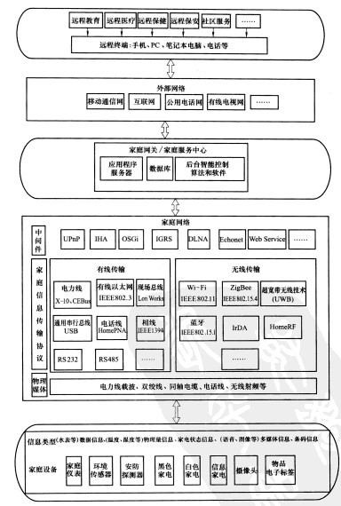

**3. Internet of Things technology for smart home applications:**

**--Remote control of smart home**

The smart home control system is strictly divided into two parts in structure: one is the control system inside the home, that is, the internal control system; the second is the control system in a remote environment after leaving home, that is, the remote control system. The shortcoming of the internal control system is that its scope of application can only control household appliances within the home. The remote control system expands the application range of the smart home control system, and truly allows home control to go out of the house. This is divided into wired remote control and wireless remote control.

Wired remote control technology, that is, the control of the target is based on visible line transmission. At present, wired network control is generally divided into two types: the first is Internet control, and the second is wired telephone network control.

Whereas, the wireless remote control of the home uses GPRS or WIFI control in general.

**-- GPRS control**

GPRs (General Packet Radio service) control technology to achieve wireless remote control through mobile phone GPRs wireless network, it is an extension of GSM network.

**-- Wi-Fi control**

Wi-Fi (Wireless Fidelity) is a commercial name for products that comply with the IEEE 802.11 protocol in the wireless LAN market. It works in the 2.4GHz ISM band, supports speeds up to 54Mbit/s, transmission speed is much faster than Bluetooth, and provides users with wireless broadband Internet access, capable of supporting Internet access within hundreds of feet Radio signal.

**4. Deep learning technology for smart home applications: AI+IOT**

Image recognition is an important field in artificial intelligence, and its application in smart homes is mainly at the security level.



Smart camera: The camera intercepts the image, and can recognize the content of the image through image recognition technology, so as to make different responses.

Smart lock: Under the empowerment of AIoT, smart lock can achieve the integration of face recognition through face recognition, remote visualization, and smart door lock linkage defense. It can accurately, quickly and efficiently perform face recognition. To pass without perception.

Access control system: Under the large system of smart communities, smart access control has become the standard of the community. Artificial intelligence + video surveillance can realize face recognition, vehicle analysis, video structured algorithms to extract video content, detect moving targets, classify into various target information such as personnel attributes, vehicle attributes, human attributes, etc. Combine with the public security system to analyze criminal suspects clue.

The AI ​​identification security system has been applied in the Pearl River Delta region of my country. Various relevant departments in Shenzhen have joined hands to launch the "Xueliang" video project, install public security monitoring and intelligent access control card readers in residential buildings, and combine AI and IOT to achieve intelligent security.

Nowadays, home appliances can be connected to the Internet to provide smart services.



For example, a collaborative project between Microsoft and Liebherr applied Cortana deep learning to the information collected from the refrigerator.

These analyses and predictions can help families better control their household supplies and expenditures, and in combination with other external data, can be used to monitor and predict health trends.\

References:

1. MBA智库-智能家居

<https://wiki.mbalib.com/wiki/>智能家居

1. 详解人工智能图像技术在智能家居中的应用-科技猎

<http://www.kejilie.com/iyiou/article/fiEfuu.html>