**GAME DESIGN DOCUMENT**

Take a Load Off

Relax

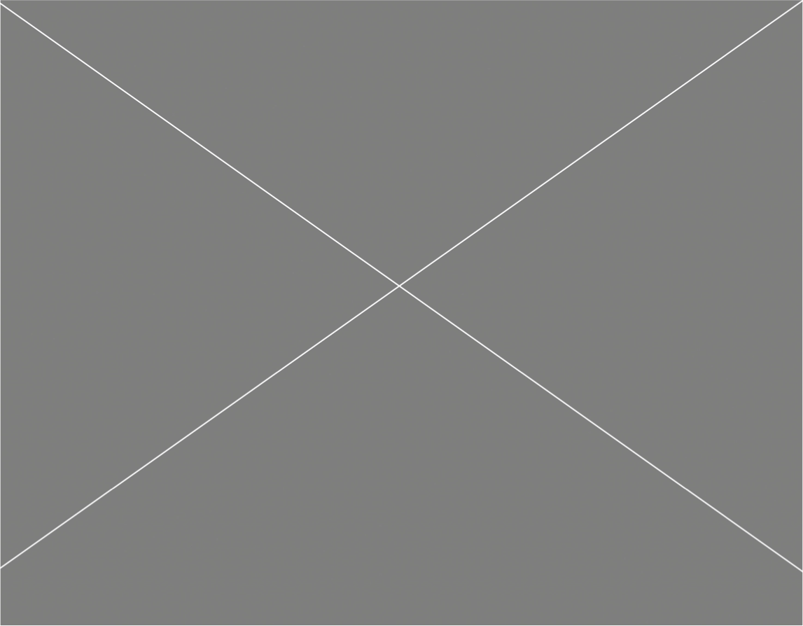

**Last Updated:**

4/1/23

**Prepared By:**

Christopher Fernandez

**TABLE OF CONTENTS**

Game Analysis 3

Mission Statement 3

Genre 3

Platforms 3

Target Audience 3

Storyline & Characters 4

Gameplay 5

Overview of Gameplay 5

Player Experience 5

Gameplay Guidelines 5

Game Objectives & Rewards 5

Gameplay Mechanics 5

Level Design 6

Control Scheme 7

Game Aesthetics & User Interface 7

Schedule & Tasks 8

# Game Analysis

Relax will help the player relax and ease the stress of life by at least a bit by giving them time to breathe. The player will be directed to do various exercises to help them relax and unwind. Once they complete and exercise, they will be gain points and be able to unlock more exercises. Relax trusts the player to actually do the exercises because ultimately, this is a tool for them to use.

# Mission Statement

Relax will be for PC and is a simple health game designed to help you relax and unwind. This game will guide you through simple exercises to help you reach calmness.

# Genre

Health simulator.

# Platforms

PC

# Target Audience

The target audience is anyone who wishes to have some guidance towards an inner peace during a stressful time they cannot shake.

# Gameplay

## Overview of Gameplay

The genre is a health game where the goal instead of going for strength or pushing the player’s limits, is to help them relax and be less stressed about their life. This will be on PC so the game trusts the player to be doing the exercise. It will only have one mode, but multiple people can do the exercises at the same time.

## Player Experience

You will be met with a screen where you can choose to do an exercise, once you do, you earn points which they can use to unlock other exercises and then chose to do those exercises.

## Gameplay Guidelines

This game will be children friendly. No obscene images or language.

## Game Objectives & Rewards

|  |  |  |
| --- | --- | --- |
| Rewards | Penalties | Difficulty Levels |
| Once they complete and exercise, they will get points | Nothing, they can take as long as they need. | Just one difficulty, the player can choose how long they wish to do the exercise. |

## Gameplay Mechanics

|  |  |
| --- | --- |
| **Character Attributes** |  |
| **Character** | **Movement Abilities / Actions Available** |
| The Player | They’re able to use the mouse to choose which exercise to do. |
|  |  |
| **Game Modes** |  |
| Singleplayer Normal | The player chooses which exercise to do and does it for an amount of time. |
| **Scoring System** |  |
| **Points/Coins/Stars/Grades/Etc.** | **How it’s Awarded & Benefits** |
| Points | Once they complete an exercise they will be awarded points, and they can use them to unlock other exercises. |

## Level Design

Discuss the levels. How many levels will the game have, what will be included in each level. Include overall look and feel, hazards the level presents, difficulty, objectives, etc.

|  |  |
| --- | --- |
| **Levels** |  |
| Breathing | This exercise has a circle in the middle where the player will be instructed to breath in when the circle is being filled with one color, and breathe out when it’s another. |
| Stretching | This exercise has a bar the player will follow with their arms, leaning from one side to another methodically. |
| Eye movement | This will have the player look at a dot on the screen and have them follow it around slowly. |

# Control Scheme

Mouse and keyboard

|  |  |
| --- | --- |
| **Button/ Touch Input** | **Action it Performs** |
| Left click | Selects the button the mouse is currently on |

# Game Aesthetics & User Interface

The game will just be a simple UI with the basic assets that Unity gives for their UI system.