… CubeSat Networks …



Stephen Ennis

Supervisor: Jonathan Dukes

School of Computer Science and Statistics

Trinity College Dublin

M.A.I. Computer Engineering

--/--/2017

Acknowledgements

…

Abstract

…

Contents

Acknowledgements ii

Abstract iii

Figures vii

Tables ix

Abbreviations x

Chapter 1: Introduction 1

1.1 Background 1

1.2 Objectives 6

1.3 Thesis Structure 8

Chapter 2: State of the Art 11

2.1 CubeSats 11

2.1.1 Capabilities 15

2.1.1.1 Space-to-Ground Communication Systems 16

2.1.1.2 Satellite-to-Satellite Communication Systems 17

2.1.1.3 Other Capabilities 19

2.1.2 Applications 21

2.1.2.1 Sensing Missions 21

2.1.2.2 CubeSat Network Missions 25

2.2 Terrestrial Communications 33

2.2.1 Wireless Sensor Networks 34

2.2.2 Mobile Ad-Hoc Networks 42

2.3 CubeSat Communications 43

2.4 Other Areas of Note 45

2.4.1 Energy Aware Scheduling 45

2.4.2 Delay Tolerant Networking 45

2.5 Summary 45

Chapter 3: Proposed Protocols 46

3.1 Introduction 46

3.2 Objectives 46

3.3 Assumptions 46

3.4 Restrictions 47

Chapter 4: Simulation 48

4.1 Introduction 48

4.2 OMNeT++ 48

4.3 Protocol Implementation 48

4.4 Simulation Design 48

4.5 Simulation Analysis 48

4.6 Discussion 48

Chapter 5: Results 49

5.1 Introduction 49

5.2 Key Metrics 49

5.3 Simulation Results 49

5.3.1 Scenario 1 49

5.3.2 Scenario 2 49

5.3.3 Scenario 3 49

5.4 Discussion 49

Chapter 6: Conclusions 50

6.1 Discussion 50

6.2 Future Work 50

Chapter 7: References 51

Figures

Figure 1 A projection of unit costs to LEO as the number of launches of a particular vehicle type increases. Image Credit: ARK Investment Management LLC. 2

Figure 2 An illustration of the CubeSat form factor and a deployment approach. Here CubeSats are deployed prior to delivery of the primary payload using a dispenser attached to the final stage of the launch vehicle. Image Credit: United Launch Alliance 3

Figure 3 An illustration of EDSN CubeSats in orbit forming a star topology style network. Image credit: NASA Ames Research Centre. 5

Figure 4 A basic illustration of a multi-hop CSN in orbit. S2S links are shown in blue while the S2G link is shown in red. 7

Figure 5 Three 1U CubeSats beside a 3U (Poly Picosatellite Orbital Deployer) P-POD developed at CalPoly. The spring mechanism used by P-PODs to deploy CubeSats can be seen within the main housing. Image Credit: Montana State University 14

Figure 6 An illustration of the dedicated secondary payload deployers built into the “Orion Stage Adapter” of NASA’s upcoming Space Launch System. Existing launch vehicles are generally retroactively fitted with such deployers. Image Credit: NASA. 15

Figure 7 Unlike with NASA’s EDSN approach, Gamalink seeks to establish multi-hop CubeSat networks capable of communicating with multiple ground stations. Image Credit: [45] 18

Figure 8 An off-the-shelf CubeSat attitude control unit. The rotational velocity of the three reaction wheels shown above can be altered in order to adjust attitude. Image Credit: Clyde Space. 20

Figure 9 A conceptual illustration of the proposed RAVAN constellation. Image Credit: John Hopkins University Applied Physics Laboratory. 24

Figure 10 The Cpt/Lt protocol. EDSN designers refer to S2S communication as crosslinking. The Captain pings a Lieutenant before receiving state-of-health and science data packets. Image Credit: NASA Ames Research Centre 28

Figure 11 A timeline of the Captaincy negotiation process carried out between the two Nodes spacecraft. Image Credit: NASA Ames Research Centre 31

Figure 12 An illustration of information that may be passed between layers. This is a departure for the treatment of each layer as an isolated black box. Image Credit: [71] 36

Figure 13 A mobile peer architecture which bears clear similarities to CubeSats in orbiting passing over a ground station. Image Credit: [74] 38

Figure 14 An example of network cluster forming with the election of cluster heads. With the introduction of a mobile sink clustering can be adapted to insure election of optimal cluster heads in order to maximize throughput [81]. Image Credit: [84] 41

Tables

Table 1 The requirements of several WSN application domain. RT – Round Trip, QoS – Quality of Service. Credit: [66] 35

Table 2 An extension of Rault et. al’s table shown in Table 1 to include a number of CSN applications. ET – Extra-Terrestrial. ET Science examples: measuring solar radiation, performing astronomical measurements etc. 35

Abbreviations

**Will populate and format last­**

LEO Low Earth Orbit

SMB Small to Medium Business

COTS Commercial Off-The-Shelf

ADCS Attitude Determination and Control Sub-systems

C&DH Command And Data Handling

ISS International Space Station

CSN CubeSat Network

NASA National Aeronautics and Space Administration

EDSN Edison Demonstration of Smallsat Networks

CNSA China National Space Administration

S2G Space To Ground

WSN Wireless Sensor Network

MANET Mobile Ad-hoc Network

ISC Inter-Satellite Communication

# Introduction

In this chapter the details of the general background and motivation for this project are provided. The content herein is intended to provide a brief overview of the CubeSats and inter-CubeSat communications. The core objectives of this work and the general structure of this document are also covered.

## Background

Due to prohibitive costs and technical requirements access to low Earth orbit (160 – 2,000km) (LEO) has typically been restricted to military, government and large corporate institutions [1]. Over the past decade, two factors have disrupted the status quo and opened access to LEO for academic intuitions and SMBs alike. The first factor is the private space race. Renewed competition has caused a dramatic drop in the “unit cost to LEO”, which refers to the cost of launching one kilogram to LEO. In 2001 the NASA’s Space Transport System’s space shuttle unit cost to LEO was approximately $60,000, with a fully loaded cargo bay. Thanks in large part to the competitive prices of SpaceX, the minimum unit cost to LEO is in the region of $4,000 [2]. Analysis of launch vehicles currently under development has led to predictions of further drops in this cost as a result of increased reusability (Figure 1).

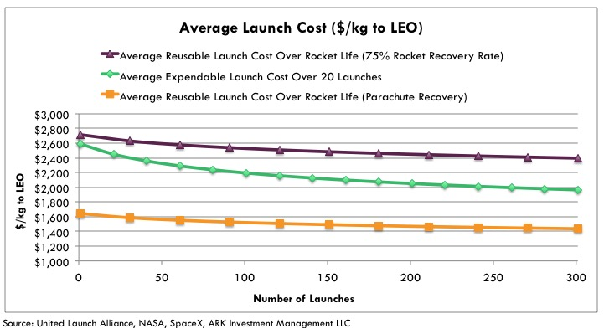

Figure 1 A projection of unit costs to LEO as the number of launches of a particular vehicle type increases. Image Credit: ARK Investment Management LLC.

The second, and perhaps most influential factor influencing affordable access to LEO, is the induction of new small satellites classifications. This work focuses on the capabilities and applications of CubeSats which, almost always, fall into the Nanosatellite (NanoSat) class. NanoSats have a wet mass of between 1kg and 10kg. The wet mass refers to the mass of the satellite along with the mass of the propellant required to ‘lift’ the satellite to its desired orbit. Like almost all satellites, the form factor of NanoSats is tailored to match the utilized launch vehicle or deployment mechanism. However, unlike many larger classes, there is considerable open-sourcing of the design and implementation of CubeSat components [3]. Such open-sourcing is historically rare in the satellite industry.

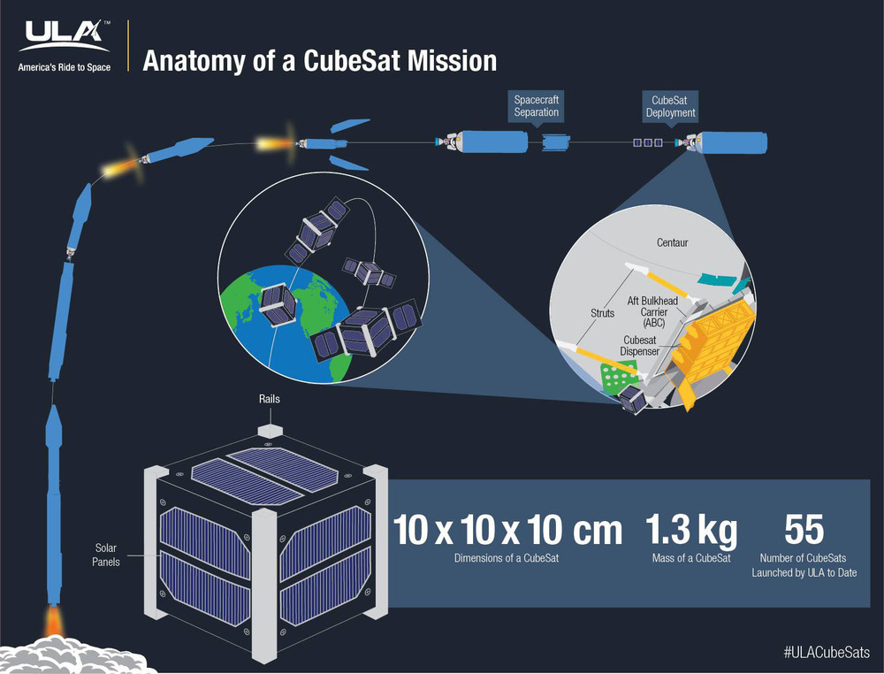

Figure 2 An illustration of the CubeSat form factor and a deployment approach. Here CubeSats are deployed prior to delivery of the primary payload using a dispenser attached to the final stage of the launch vehicle. Image Credit: United Launch Alliance

CubeSats, as the name suggests, adopt a cube form factor. Each Cube, often referred to as a ‘unit’, is 10cm to a side (Figure 2). Multiple units are often combined in order to form larger CubeSat. Six unit configurations are typically the largest form factor used [4, 5]. CubeSats are generally constructed solely of commercial off-the-shelf components (COTS) components instead of those designed specifically for the extremes of space environments. Single unit CubeSats have been shown capable of containing many of the standard sub-systems that one may find on larger class satellites such as: orbital control [6], attitude determination and control (ADCS) [7], communications [8-10], command and data handling (C&DH) [11, 12], power management and so on. Along with several sub-systems, a CubeSat may carry a small ‘payload’ which is often a scientific instrument or some previously ‘unflown’ implementation of a sub-system such as an experimental antenna [13]. CubeSats have become increasingly popular with the space industry both for testing new technologies and for commercial applications. However, the primary applications for CubeSats remain within the educational and academic domain [14].

What gives CubeSats, and other small satellites, an advantage over other larger satellites is their ability to ‘hitch’ a ride alongside larger launch payloads. Effectively all modern launch payloads are designed to match the capabilities of the launch vehicle. Frequently, launch vehicles will have some spare volume and lift capacity. Multiple CubeSat launchers have been developed which make use of this spare volume and lift capacity [15, 16]. In cases where cargo and/or personnel are being delivered to the ISS for instance, CubeSats often hitch a ride. These CubeSats are then launched from the ISS’s dedicated CubeSat launcher.

As a result of the lowering unit costs to LEO and the increasing affordability, availability and capabilities of CubeSat components, CubeSat mission have become increasing ambitious [17-19]. This project focuses on a particular subset of emerging CubeSat missions which involve networked swarms of CubeSats; these will simply be referred to as CubeSat networks (CSNs). The multi-CubeSat missions offer greater redundancy which addresses the platform’s limited power and durability. Missions which involve CSNs seek to advance the platform by introducing varying degrees of autonomous cooperation and coordination between CubeSats. It is this cooperation and coordination that presents various new CubeSat mission applications. CSNs stand to enable the collection of greater volumes of scientific data, novel interferometry [20], high fidelity sensory data, inexpensive low-data rate terrestrial communications and improved air traffic monitoring [21]. The space industry has taken the first crucial steps into designing and testing CSNs with missions such as NASA’s EDSN (Edison Demonstration of Smallsat Networks) [22] (Figure 3) and Nodes (Network & Operation Demonstration Satellites) [12] and the CNSA’s Tianwang-1 [23].

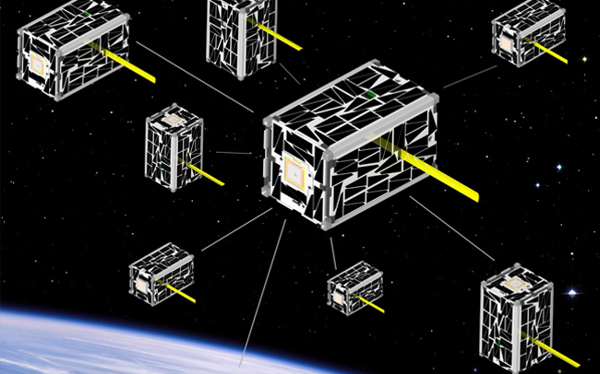

Figure 3 An illustration of EDSN CubeSats in orbit forming a star topology style network. Image credit: NASA Ames Research Centre.

This work seeks to build upon data from the aforementioned missions. The overall aim being the exploration of fundamental aspects of the communication approaches employed in CSNs. In particular, this work attempts to identify how CSN based missions may approach communication in order to optimize space to ground (S2G) data throughput while remaining sensitive to CubeSat power consumption.

## Objectives

CSNs share many similarities with terrestrial concepts such as wireless sensor networks (WSNs) and mobile ad-hoc networks (MANETs). The state of the art in CSNs has its basis in work in these fields. However, much of the existing work relating to CSNs was published prior the design and launch of the first CSN. As a result, authors were often forced to make several assumptions as to the capabilities and constraints of CSNs.

The general motivation of this work is to assess CSN network and MAC layer protocol design. This assessment requires the analysis of existing work relating to WSNs, MANETs, CSNs, and the design and implementation of CubeSat missions. As mentioned, there are numerous and varied applications of CSNs. This work narrows the scope of interest to a generic and common scientific mission. This chosen mission employs a number of CubeSats each of which carries an identical scientific instrument. This scientific instrument produces some data which must be communicated to ground. It is then objective of the CSN to coordinate in order to efficiently route this data to ground. For the scientist on the ground the core concern is the quality and the quantity of the data received. It is assumed that issues relating to data quality are fully addressed. This leaves the quantity of data received as the metric for success for this hypothetical mission. With this the core objective of this work becomes the exploration CSNprotocol designin order to maximize S2G data throughput.

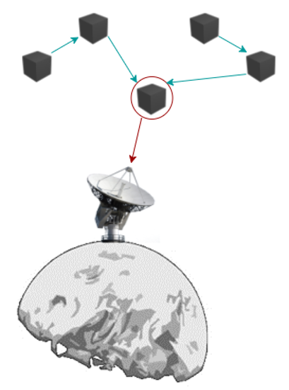

Figure 4 A basic illustration of a multi-hop CSN in orbit. S2S links are shown in blue while the S2G link is shown in red.

In terms of power, satellite-to-satellite S2S is generally considerably less expensive than S2G communication. S2S data rates are more likely to lie within the region of Mbps whereas S2G data rates are frequently as low as 12kbps. These imbalances present an optimization problem. Increasing the amount of S2G communication will increase S2G throughput but, it will also consume more power overall and reduce the mission’s lifetime. S2S may be used to communicate data to a CubeSat which has more battery power and/or a better window of opportunity for S2G communications. Of course, too much S2S communication may prove wasteful when all CubeSats have enough battery and suitable S2G communication windows. Any solutions proposed by this work intend to address such fundamental challenges which arise when attempting to balance power consumption with S2G throughput.

This work presents simulations, carried out using OMNeT++ [24], of modified communications protocols. These protocols were chosen and implemented with consideration to the aforementioned power v. throughput (PvTP) challenge. As far as possible, simulations of CubeSat S2G and S2S communication as well as power consumption are modelled on the current state of the art.

## Thesis Structure

This document is divided into six chapters. The Introduction chapter offers a basic overview of the background of the project and the motivations and objectives thereof. This chapter aims to provide suitable material for lay-readers to understand the context, aims and general scope of the project.

The State of the Art chapter seeks to examine the relevant prior art relating to CubeSat and terrestrial communications as well as detailing the current capabilities and applications of CubeSats. This chapter presents varying levels of depth on differing sections. Works relating CubeSat communications and applications are explored with the greatest depth. Prior art relating to terrestrial communications, much of which provides the basis for CubeSat communications, is addressed in less depth. This chapter serves as an extension to the background of PvT challenge and as the rationale behind many of the choices made during protocol and simulation design.

The Proposed Protocols chapter following directly from the State of the Art chapter, this chapter identifies key points within the state of the art. These points serve as the basis to the final protocol design intended to address the PvTP challenge. In some cases, references are made to restrictions placed open protocol design which are discussed further in the Simulation chapter. In parallel to the justification of design choices, this chapter presents in-depth explanations and illustrations of the final protocols. This chapter serves as a bridge between the State of the Art and Simulation chapters. It draws from both in order to describe and justify, as clearly as possible, this work’s approach to the PvTP challenge.

The Simulation chapter deals primarily with the experimental setup, implementation and analysis of the proposed protocols using OMNeT++. Detailing the experimental setup involves examining the assumptions made regarding CubeSats and space-bound wireless communications. These assumption are important in establishing the fidelity of the final simulation. This chapter also places a focus on the challenges relating to the implementation and analysis of the proposed protocols. As such, this chapter serves, not only to provide experimental context to the Results chapter but also, as a general guide to the production of similar OMNeT++ based work.

The Results chapter introduces the key metrics chosen for the analysis of performance of the implemented protocols. These key metrics are then presented graphically in a number of figures across several simulations scenarios. Scenarios are divided into chapter sub-headings. Each scenario represents a particular parameterization or configuration of the base simulation described in the Simulation chapter. Discussion is provided for each scenario and a final short summary of the results collection concludes the chapter.

Finally the Conclusions chapter presents several areas of discussion and closing thoughts relating to the work reviewed and carried out. The core intention of the chapter is present the findings of this work in the larger contexts of CubeSats, satellites and the space industry. The chapter concludes by detailing potential future work in the development of the proposed protocols and in simulating CubeSat communications.

# State of the Art

The major literature informing this work can be roughly divided into three broad section: CubeSats, terrestrial communications, and CubeSat communications. The first of these sections provides an in-depth exploration into the CubeSat platform along with the relevant capabilities and applications thereof. The section is followed by an examination relevant terrestrial communication technologies which focuses on Wireless Sensor Networks (WSNs) and Mobile Ad-Hoc Networks (MANETs). Detailing relevant terrestrial technology provides important context for the following section on CubeSat communications. This final primary section seeks to explore, in depth, examples of the latest proposed approaches to CubeSat communications. Finally several notable secondary areas of research are highlighted. These areas fall outside of the scope of this work but are nonetheless influential in the greater context of space-bound communications.

## CubeSats

CubeSats typically fall within the satellite weight classification of ‘Nano’ satellites (1-10kg). CubeSats are further classified by the number of ‘units’ which they contain, where a unit is a 10cm cube. A one unit CubeSat is referred to as a ‘1U’. Configurations of 1U, 2U, 2.5U, 3U and 6U are all common.

CubeSats were first proposed by Bob Twiggs of Stanford University and Jordi Puig-Suari of California Polytechnic State University in 1999 [25]. In 2000 the first published work detailing a new CubeSat standard was published [26]. The platform was intended as an answer to the prohibitive costs and challenges involved in low-resource academic satellite development. At the time, there were effectively no standard approaches or components for the design and implementation of small satellites. Researchers relied almost entirely on acquiring a place for instruments on larger satellites or pursuing the development of research satellites as lengthy collaborations across multiple research institutions. This was despite the fact that, frequently, research only required satellites with basic capabilities.

2003 saw the first launch of a CubeSat on-board a Russian Eurorockot [25]. At the time of writing there have been 487 CubeSats successfully launched or deployed into orbit [27] since 2003. Spread across 14 years this number may seem unimpressive, however, approximately 75% of all these launches have taken place during the previous 5 years. This is due largely to the recent boom in the private space industry which has greatly lowered the cost of access to LEO [1].

Thanks in large part to a San Francisco based company named Planet Labs [28], roughly 40% of all launched CubeSats were developed by commercial entities. Comparatively, academic/research institutions have developed approx. 40% and the remaining 20% is divided between civilian and military institutions. In terms of use cases, roughly 60% of all missions are dedicated to Earth imaging, 20% to technology demonstration, 10% to education, and the remaining 10% is divided between various commercial, military and science applications [27].

Unsurprisingly, the core motivation behind the recent popularity of CubeSats is their cost. Costs are driven down by three factors, the use of COTS components, open sourcing, and reduced launch costs. Effectively every component of a modern CubeSat is available in COTS form. Retailers such as Clyde Space offer a wide range of products from power to attitude determination and control systems [29]. COTS components reduce costs significantly by removing the need to develop or source custom components from third parties.

Combined with COTS components open sourcing lowers costs further by reducing development time and the need for expertize. Open and often proven approaches for both software and hardware CubeSat systems are becoming widespread as the platform develops [3]. Although this may seem intuitive, such sharing and open-sourcing of work in the satellite industry has been historically rare. To date, there is no accepted standards body for the domain. Researchers such as Puig-Suari at the California Polytechnic State University (CalPoly) have driven the domain forward since its inception, creating a number of pseudo-standards. Crucially, CalPoly lead the development and design of standard CubeSat deployers [30]. Such deployers became common place and have come to defined the de-facto standards for the domain. A similar pattern can be seen elsewhere in the domain such as with the development of a pseudo-standard satellite bus design [31]. Recently, “OpenOrbiter” by Straub et al. from the University of North Dakota is a prime example of open pseudo-standard framework for CubeSat development [32].

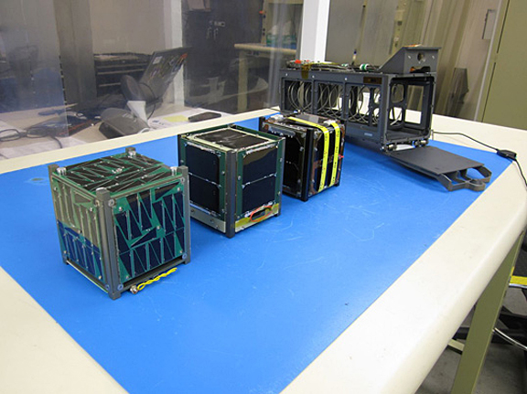

Figure 5 Three 1U CubeSats beside a 3U (Poly Picosatellite Orbital Deployer) P-POD developed at CalPoly. The spring mechanism used by P-PODs to deploy CubeSats can be seen within the main housing. Image Credit: Montana State University

Depending on the complexity of the CubeSat, development costs may range anywhere from $50,000 to $250,000 [33]. This can be compared to a development cost in the order of millions of dollars for larger satellites weighing over 100kg. A similar gap has emerged in terms of launch costs. Satellites over 100kg may see launch costs in the order of hundreds of thousands if not millions of dollars. This of course depends heavily on the launch vehicle used and the orbital requirements (Low, High, Medium, Solar etc.). CubeSats avoid these costs by ‘hitching’ a ride as secondary payloads by using volume and lift capacity not required by a primary payload. Providers such as SpaceX have disrupted the satellite industry by offering greatly reduced cost access to LEO [34]. These factors have led to CubeSat launch costs as low as $10,000 [33]. With recent development towards multi-CubeSat and CSN missions, multiple CubeSats may take the place of their larger counterparts at a fraction of the cost. CubeSats are also making the move beyond LEO with new developments towards deep space and lunar applications [16, 18].

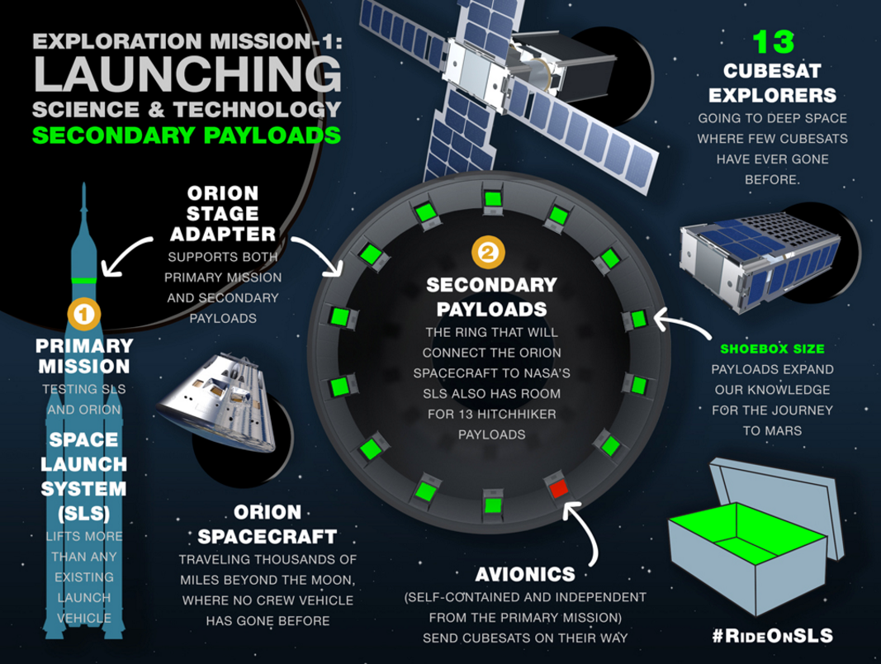

Figure 6 An illustration of the dedicated secondary payload deployers built into the “Orion Stage Adapter” of NASA’s upcoming Space Launch System. Existing launch vehicles are generally retroactively fitted with such deployers. Image Credit: NASA.

### Capabilities

This section provides an overview of the state of the art technical capabilities of CubeSats. In line with this work’s objectives, a focus is placed on technologies relating to communication and power. This section aims to provide context to the upcoming sections on terrestrial and CubeSat communications. In many cases, there is a need to reality check potential communications strategies with the current and emerging capabilities of the CubeSat platform.

#### Space-to-Ground Communication Systems

There is considerable variance in the implementation of S2G CubeSat communication sub-systems. The choice of and design of a system is application dependent however there are some broad patterns worth noting. For instance, the most common protocol for S2G communications is AX.25 [35]. Implementations using AX.25 at the link layer generally utilize a flavour of UDP/IP at higher protocol layers. CubeSat S2G communications sub-systems typically consume between 1W to 3W of power during transmission and can achieve data rates between 9.6kbps and 12kbps when using AX.25 [36].

There are some notable outliers to the trends in CubeSat S2G commutations which have considerably advanced domain. In particular, NASA’s Dynamic Ionosphere CubeSat Experiment (DICE) mission achieved a remarkable S2G maximum data rate of 3Mbps [37]. Such rates were achieved using a custom SDR based sub-system consuming roughly 9W of power and operating within the UHF band. The DICE mission holds the current record for the highest S2G data rate achieved by a CubeSat. At present there are few missions that attempt S2G rates in the order of Mbps, with the notable exception of JPL’s ISARA mission [38]. The majority of upcoming missions aim to operate communication rates in the order of hundreds of kbps.

In order to approach protocol design for the throughput v. power consumption problem, ‘baseline’ state of the art S2G characteristics were chosen. One of the primary inspirations for the work was the CNSA’s Tianwang-1 (TW-1) mission [39]. This mission is an ideal candidate to use as a baseline for S2G communication modelling as the mission was designed specifically to test CubeSat inter-communications. As such, it is representative of the capabilities future CSN missions may achieve. TW-1 achieved S2G data rates of 125kbps. Details regarding the power consumption of the TW-1 S2G sub-systems are unavailable. However, by examining previous and upcoming missions as well as work on energy budget analysis [40] one may safely assume a peak transmission power consumption of 3W.

#### Satellite-to-Satellite Communication Systems

S2S communications is by no means a new concept. CubeSat based S2S communication began to gain popularity following a paper published in 2008 on the “Development of a Satellite Sensor Network for Future Space Missions” by Vladimirova et al. CubeSat S2S communication remained purely conceptual until 2016 that the NASA Nodes mission made it a reality [12].

Unlike the case of S2G communications there is little prior art regarding the S2S capabilities of CubeSats. This is unsurprising considering the age of the domain. There are effectively two cases which inform the state of the art S2S capabilities of CubeSats: The NASA’s Nodes mission and Gamalink [41]. Comparatively, Gamalink is considerably more advanced than the systems employed on the Nodes mission. Nodes utilized a UHF transceiver and the AX.25 protocol to achieve S2S data rates of 1.2kps. As Nodes was a first in many regards it is unsurprising that the mission designers opted for a well-known and basic approaches to CubeSat communications.

Gamalink is a proprietary SDR based technology developed by a Portuguese Aerospace and Defence company by the name of Tekever. Gamalink is unquestionably the current state of the art in CubeSat S2S communications. Gamalink has been successfully tested on the TW-1 mission [23] it is also marked for use by several other missions such as i-INSPIRE II [42], DelFFi [43] and ESA’s Proba 3 [44].

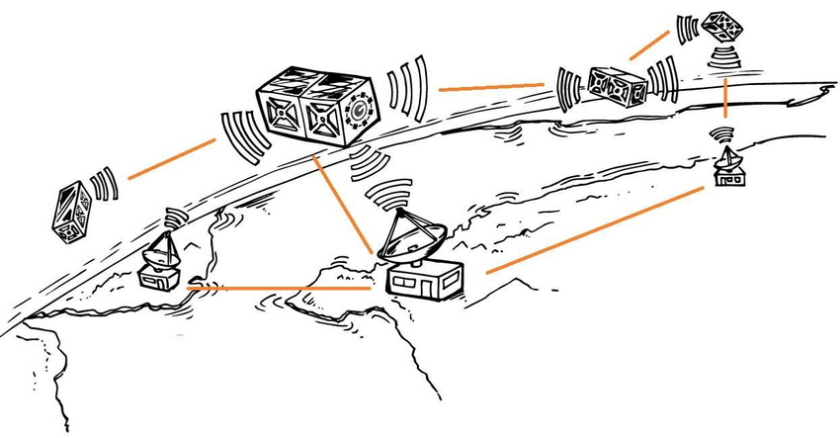

Figure 7 Unlike with NASA’s EDSN approach, Gamalink seeks to establish multi-hop CubeSat networks capable of communicating with multiple ground stations. Image Credit: [45]

Due to the Gamalink’s proprietary nature and its potential military applications details regarding Gamalink are exceptionally sparse. During research no information regarding protocol use or design was available. Tekever make several allusions to MANETs even stating that Gamalink implements an “SDR-based Ad hoc Space Network” (SASNET). This is a clear indication that the state of the art in MANET technology is integral to the design and development of Gamalink.

Despite the lack of protocol stack information, several key data points regarding Gamalink are available. According to promotional material presented to ESA Gamalink is capable of achieving data rates up to 2Mbps however, i-INSPIRE mission designers state that the maximum data rate as 1Mbps [42]. Gamalink operates in the S-Band (2.40-2.45 GHz) with a bandwidth of 40Mhz, making the Mbps scale data rates believable. While transmitting Gamalink consumes up to 1.5W and while receiving up to 200mW [43]. Using these details and assuming a maximum data rate of 2Mbps, a state of the art baseline can be established for CubeSat S2S communications to be used alongside the S2G baseline.

#### Other Capabilities

Although the primary relevant CubeSat capabilities have been covered in the preceding sections, there are certain other capabilities worth discussing in brief. In general, the capabilities of CubeSats have progressed closer and closer to those of larger satellites. Despite strict power, weight and size constraints effectively all major large satellite sub-systems have a corresponding, scaled down, CubeSat equivalent.

Attitude determination and control sub-systems (ADCS) are implemented to ensure correct spacecraft orientation. ADCS are critical to insuring correctly positioned solar panel, antennae and or payload instruments. In almost all cases craft will also be required to ‘de-tumble’ prior to launch. There are numerous tested examples of ADCS technologies for CubeSats [7, 46, 47] including several which are available COTS. Along with ADCS some basic orbital control and manoeuvrability systems have also been tested at the CubeSat scale [6]. Such systems provide CubeSats with the basic capabilities to maintain regular orbits and formations.

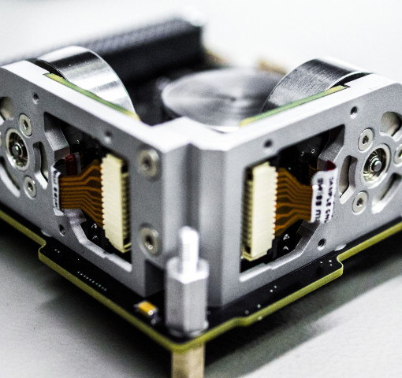

Figure 8 An off-the-shelf CubeSat attitude control unit. The rotational velocity of the three reaction wheels shown above can be altered in order to adjust attitude. Image Credit: Clyde Space.

Determining accurate time and position are two classic challenges for spacecraft that have been long solved in the domain of CubeSats. By communicating with larger satellites within the Global Navigation Satellite System (GNSS) CubeSat may acquire precise GPS time and position. CubeSat missions often regularly update such information in order to coordinate in-orbit operations and S2G communications. One work by Glennon et al. entitled “Synchronization and syntonization of formation flying CubeSats using the namuru V3. 2 spaceborne GPS receiver” provides a clear overview of necessary CubeSat capabilities within multi-CubeSat missions [48].

Finally, it is worth noting that the aforementioned Gamalink technology provides functionality beyond that of S2S communications. Gamalink also provides the secondary functions of GNSS receiving, attitude determination, ranging (5m resolution) and distributed clock synchronization.

### Applications

This section examines a number of CubeSat missions. References to CubeSat ‘applications’ should be considered synonymous with CubeSat mission objectives. Two categories of application are considered, sensing missions and CubeSat network missions. This is not intended to assert that sensing missions and CSN missions are disjoint. CSN missions are highly suited to collaborative sensing applications and may, within the context of this work, be consider to be a class of specialized sensing application.

#### Sensing Missions

When approaching the challenges relating to balancing S2G throughput with energy consumption, it is beneficial to establish a broad application case. As discussed, Earth observation is the most popular application of CubeSats to date. More generally, the majority of CubeSat missions have involved, to varying extents, some form of sensing. The application case chosen by this work is a simplified CubeSat mission involving a number of CubeSats. Each CubeSat is assumed to carry some sensing instrument. This instrument is considered to be a black box which performs some sensing and produces some data. The goal of each CubeSat then becomes communicating as much of its data to ground as possible. This scenario is detailed further in the Simulation chapter.

Two recent sensing missions are worth detailing: 3Cat-2 [49] and RAVAN (Radiometer Assessment using Vertically Aligned Nanotubes) [50]. 3Cat-2 is 6U CubeSat developed at the Universidad Politécnica de Cataluña. It was launched in August of 2016 aboard a CZ-2D (Chang Zheng-2D) operated by the CNSA. 3Cat-2 represents a significant mission in the state of the art for Earth Observation missions. It’s extensive use of GNSS based systems make it an interesting case for the application of CSNs. Also, 3Cat-2’s S2G downlink operates at a maximum of 115kps. Recall that this is a similar rate as achieved by the Tianwang-1 mission which forms the basis for this work’s chosen model for S2G communications.

3Cat-2’s particular application case is ocean altimetry by means of GNSS-Reflectometry. 3Cat-2 performs altitude observations by examining the scattering and reflection of signals off of bodies of water. These are an ‘active’ form of measurement which depend on incident signals; RADAR is another example of an active sensing.

Mission developers of 3Cat-2 have not stated a direct desire to pursue a multi-CubeSat mission. However, 3Cat-2’s active sensing is uniquely suited to a CSN adaptation. Coordinated and synchronized measurement of signals by multiple craft in orbit could greatly improve observation fidelity and provide unique multi-dimensional data. Comparatively, ‘passive’ EO such as direct imaging benefits less from adaptation with CSNs.

RAVAN is a 3U CubeSat developed at the Johns Hopkins Applied Physics Laboratory. RAVAN was launched November of 2016 aboard an Atlas-5 as part of NASA’s ELaNa (Educational Launch of Nanosatellites) program. RAVAN is highly relevant to this work as the mission designers clearly specify future intentions to develop a constellation of RAVAN craft. In satellite nomenclature a constellation is considered a formation of satellites evenly distributed over the surface of the Earth. In this work we treat the physical formation of craft as unimportant.

RAVAN carries an experimental carbon nanotube based radiometer. RAVAN’s instrument performs multi-spectral measurements of outgoing radiation from Earth’s surface. These measurements reveal trends regarding Earth’s Radiation Budget (ERI) which are valuable to climate scientists. As mentioned, RAVAN is intended as a first test in a larger plan to develop a constellation of craft [51] (Figure 9). The spacing of the forty proposed RAVAN craft which would make S2S communication infeasible using current technologies. Nonetheless, RAVAN is strong example of the growing interest in multi-CubeSat missions.

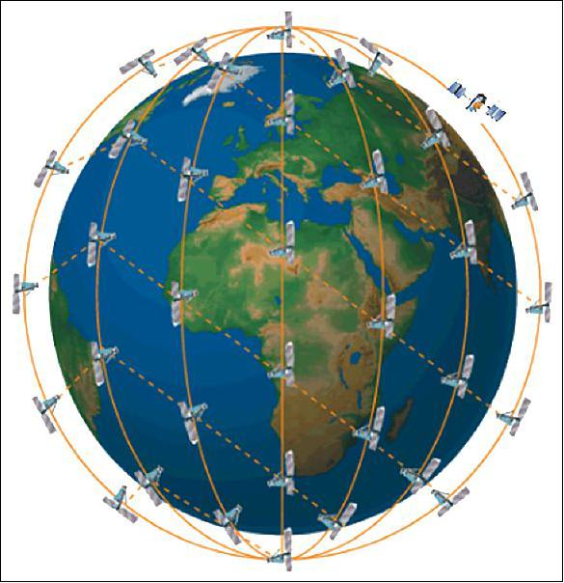

Figure 9 A conceptual illustration of the proposed RAVAN constellation. Image Credit: John Hopkins University Applied Physics Laboratory.

It should be noted that CubeSat sensing is a deep and broad field. The examples of RAVAN and 3Cat-2 are in no way intended to illustrate a comprehensive study of the field. Notable upcoming missions such as CeREs (a Compact Radiation belt Explorer) [52], LAICE (Lower Atmosphere/Ionosphere Coupling Experiment) [53], and SOCON (Sustained Ocean Observation from Nanosatellites) [54] seek to advance the diverse applications of CubeSat mission. In several regards, it is these advanced applications that drive interest in CSN style missions. As applications develop so too does interest in advancements such as multi-point measurements, in-orbit interferometry [55] and synchronized observation. These advances call for the introduction of CSNs. CSNs are, in many regards, an obvious next step in the development of CubeSat sensing missions.

#### CubeSat Network Missions

There are three major missions to consider in the area of CSNs: NASA’s EDSN and Nodes, and CNSA’s Tianwang-1 (TW-1). Of these missions, both Nodes and TW-1 have successfully flown. The eight CubeSat “Edison Demonstration of Smallsat Networks” (EDSN) mission was lost due to a failure during launch. The mission is still worth examining however as two of the remaining EDSN craft we used during the successful Nodes missions.

Two articles detailing the EDSN mission were published in 2014 prior to the loss of the mission in November 2015. The first work examines the inter-satellite communications architecture of the mission [56]. While the second work details lessons learned during development [57]. The primary objective of the EDSN mission was to implement autonomous communication and coordination of CubeSat’s in orbit. Each ESDN craft is a 1.5U CubeSat weighing ~1.73kg. A Samsung smartphone provides each craft’s activity scheduling and execution. Several secondary COTS micro-controllers handle various activities involving GNSS, data handling, scientific measurements, ADCS and additional sensor inputs. The scientific payload is an instrument designed to characterize radiation in LEO called the “Energetic Particle Integrating Space Environment Monitor” (EPISEM). Although the scientific objectives of the mission were secondary to the implementation of an in-orbit CubeSat network, it is clear that EDSN falls within the category of sensing applications and is not entirely dissimilar to the RAVAN mission.

In terms of communications and power, the works published on EDSN provide a wealth of information. These works go as far as to state exactly which COTS components were used in the construction of EDSN craft. Each craft houses three primary radios: A MicroHard MHX2420 transceiver for S-Band S2G communication, an AstroDev Lithium 1 UHF transceiver for S2S communication and a StenSat UHF transmitter for beaconing. Satellite beaconing is required by the North American Aerospace Defense Command (NORAD). The AstroDev transceiver enables a 9.6kbps S2S communications using AX.25 as the link layer protocol. The Nodes mission scaled this data rate back to 1.2kbps, potentially to increase the maximum S2S communication range. Details regarding the MHX2420’s S2G data rate are not provided.

Each EDSN craft carries four lithium ion batteries which combine to provide a maximum energy storage of 5.2 amp hours. The craft’s bus operates at around 8 volts. This implies a total energy provision of approx. 41.6 watt hours. Six solar panels provide an average recharge of 1 watt during operation. These figures provide important context to the power consumption simulation results discussed in later chapters.

As mentioned EDSN employs AX.25 at the link layer for S2S communication. The link layer, as detailed by the OSI reference model [58], is concerned primarily with medium access control (MAC). For the majority of CubeSat missions, AX.25 along with a basic application layer which communicates directly with the link layer is sufficient for S2G communication [36]. However, S2S communication introduces new challenges which warrant more complex approaches. In the case of EDSN a custom “Captain – Lieutenant” (Cpt/Lt) protocol was designed on top of AX.25. T

he network formed by the EDSN craft is referred to as a “hub-and-spoke” (or star) network. Once craft is designated as the “Captain” (Cpt) and all others are designated as “Lieutenants” (Lts). In general terms the Cpt acts as a central router to ground. All Lts send their data exclusively to the Cpt (Figure 10). The Cpt then communicates as much of this data to ground as possible. Lt communication in EDSN purely is reactive. The Cpt sends six pings over 50s seconds. Each set of pings specifies only one Lt from which the Cpt is requesting data. Only after receiving a valid ping does an Lt forward its data to the Cpt. This scheme of Cpt request followed by Lt response suggests no overlapping Lt on the shared S2S frequency thus greatly reducing the possibility of collisions.

There is no acknowledgment scheme employed in EDSN’s Cpt/Lt protocol. Lts send one “state-of-health” (SOH) packet followed by all queued science packets. The Cpt prioritizes the communication of these SOH packets to ground and treats science packets generated by Lts or by its own instrument in a LIFO manner. After ending a communication with an Lt, the Cpt will then proceed to ping each remaining Lt in a fixed order. The Cpt will wait up to four minutes for a response from a pinged Lt before moving onto pinging the next Lt.

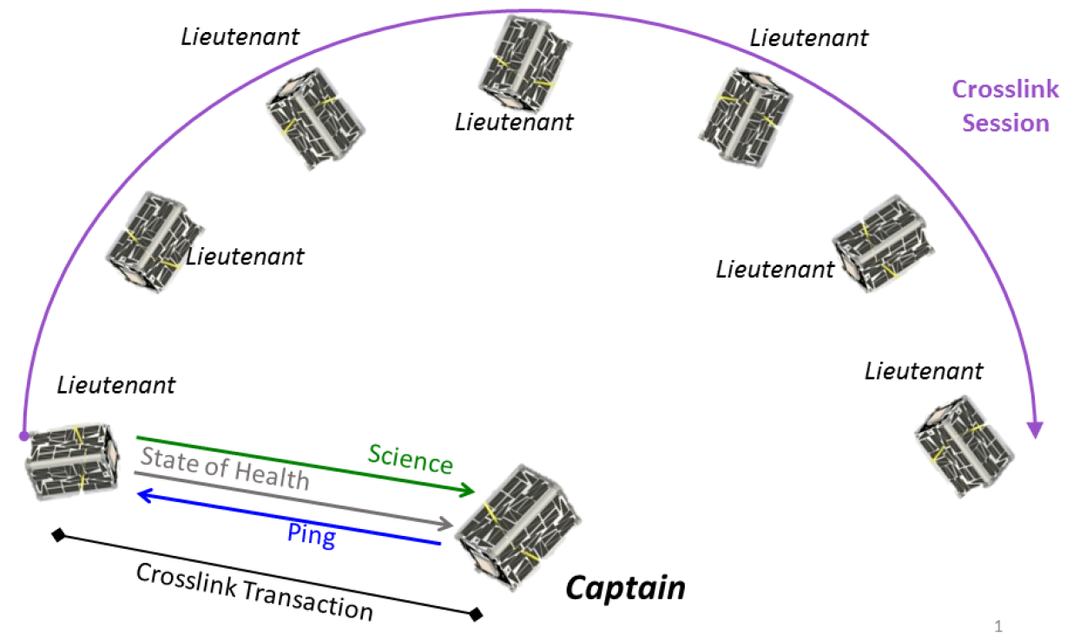

Figure 10 The Cpt/Lt protocol. EDSN designers refer to S2S communication as crosslinking. The Captain pings a Lieutenant before receiving state-of-health and science data packets. Image Credit: NASA Ames Research Centre

The Cpt role is “rotated” amongst the EDSN craft in a pre-defined fixed pattern. There is no real-time logic or election employed. Each craft periodically receives GPS time in order to determine whose turn it is to assume the role of Cpt. If a craft cannot get GPS time it does not participate in either S2S or S2G communications. The duration a craft holds the Cpt role is referred to as a “minor cycle”. Each minor cycle lasts roughly 25 hours and includes 3-4 S2S sessions. Each session being an attempt by the Cpt to communicate with each Lt in the network. The Cpt self-determines one, and only one, S2G session during its minor cycle. This session is scheduling by predicting the next ground station fly-over period (window) based on the craft’s GPS location and velocity data. As S2G communication occurs using a separate radio at a separate frequency to S2S communication, S2G sessions can take place in parallel with an S2S session. Eight minor cycles, one for each craft, come together to form a major cycle. A major cycle lasts for roughly eight days. EDSN mission planners predicted that after three major cycles (three and one half weeks) the craft would have drifted too far apart (>120km) for S2S communication to be feasible.

During a minor cycle it is not feasible for all Lts to keep they S2S transceivers continually on and in receiver mode. As such, along with the Cpt pinging scheme, all S2S sessions are scheduled. An Lt will only turn start listening for Cpt pings at a predetermined time during each minor cycle. During a minor cycle each craft updates it’s GPS time, position and velocity only once. Mission designers predict the maximum relative clock drift between an Lt and the Cpt to be 12 seconds. As such, an Lt will begin listening for Cpt pings 30 seconds before the scheduled time and will continues listening 30 seconds after the expected final, sixth, ping. Each session start time is determined by a table of offsets. This offsets are relative to the start times of each minor cycle. Each craft is pre-programmed with the same minor-cycle start times and offset tables.

Following directly from the work on EDSN, the Nodes mission was successfully deployed from the ISS in May of 2016. Nodes included two leftover CubeSat’s from the EDSN mission which were used during the testing and development of EDSN. Effectively all aforementioned salient aspects of the EDSN mission remain. Despite only involving two craft, Nodes was able to achieve many of the objectives of EDSN. Nodes makes small changes to mission objectives and some notable changes to the custom Cpt/Lt communication protocol. These changes are detailed in a work published in 2016 following the mission’s successful launch, deployment and conclusion [12].

Where EDSN was focus purely on S2G communication, Nodes advances one step further by introducing a demonstration of G2S remote commands. In Nodes, the objective was set to communicate a command to the elected Cpt. The Cpt would could then forward this command to the Lt for execution. Unlike with science and state-of-health packets, command packets are implement specialized command acknowledgements and responses. Although this work focuses purely on S2G communications, it is worth noting that Nodes was the first demonstration of indirect command and control using only CubeSats.

There are several notable changes made in Nodes to the Cpt/Lt protocol. Firstly, 12 pings over 110 seconds are used rather than 6 pings over 50 seconds. Rather than a fixed order of minor-cycles, the captaincy is negotiated between the Nodes craft (Figure 11) . A default Cpt craft compares metrics relating to battery voltage, amount of science data collected and the predicated duration of the next pass over the ground station. At the start of each minor cycle a default Cpt is selected which manages the negotiation. Once the default Cpt has compared its own metrics with that of the Lt it will either continue as Cpt or send a “promote” command to the Lt. The default Cpt will demote itself to the Lt role once the promote command has been acknowledged. As before, the Cpt will continue operations regardless of the presence of any communication with the Lt. All other aspects of the Cpt/Lt protocol are unchanged.

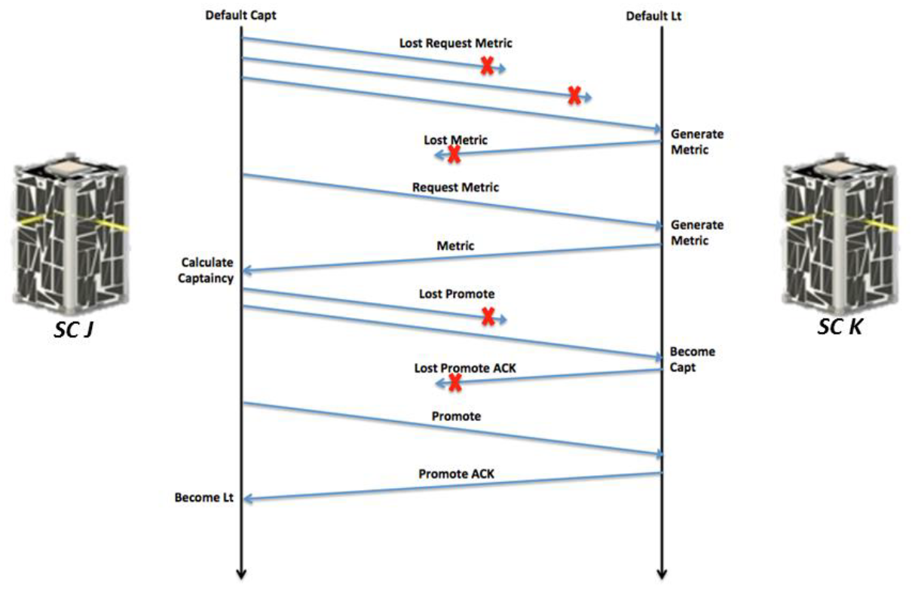

Figure 11 A timeline of the Captaincy negotiation process carried out between the two Nodes spacecraft. Image Credit: NASA Ames Research Centre

Over the course of its three week mission, Nodes completed and/or exceeded all five of its mission objectives: The collection and receipt of five ‘sets’ of science data, five successfully S2G sessions, one successfully executed indirect command, two successful captaincy negotiations and the collection and receipt of 20 days of spacecraft state-of-health. Of a total 470 science packets generated (science undisclosed) a total of 356 were successfully received at ground, ~25% packet loss. Five successful negotiations were carried out and 165 commands were executed by Nodes craft. Following the success of Nodes, mission designer clearly lay out numerous desirable enhancements: improved clock synchronization, inter-sat ranging, multi-hop routing, further acknowledge systems and/or delay tolerant networking principles, multiple ground stations and the interlinking of multiple Cpts to form clusters of clusters. Several of these suggested areas of future work are addressed in the protocols proposed and simulated in this work.

The CNSA’s Tianwang-1 (TW1) mission, also referred to as STU-2, was a three CubeSat CSN mission involving numerous commercial and academic entities lead by the Shanghai Engineering Centre for Microsatellites (SECM). The majority of the published work relating to TW1 details its ADCS and novel propulsion systems [46, 59]. A presentation by Wu et al. during the 30th Annual AIAA/USU Conference on Small Satellite in 2016 offered a brief overview of the mission’s Gamalink communication system [39]. However, as discussed, the details of the proprietary Gamalink technology are closely guarded. For known details on Gamalink see the preceding “Satellite-to-Satellite Communication Systems” sub-section. In comparison to EDSN and Nodes there is little information available regarding TW-1.

TW-1 was launched in late September of 2016 three months after the deployment from the ISS of the Nodes mission. TW-1 was, like Nodes, was primary a technology demonstration mission. TW-1’s objectives were to flight test Gamalink, an ADCS and a propulsion (orbital control) system. TW-1 consisted of one 3U CubeSat (TW-1A) and two 2U satellites (TW-1B/C). TW-1A housed the experimental propulsion systems. This propulsion system allowed TW-1A to remain within range of TW-1B for a time far longer than would have been possible with an uncontrolled orbit. TW-1 collected data on aircraft flight patterns using an on-board Automatic Dependent Surveillance (ADS) receiver. TW-1 also performed earth observation by using visual spectrum cameras to image polar regions. In line with its objective, TW-1 performed a number of in-orbit tests on its experimentation sub-systems. S2G communication of the mission’s various results was demonstrated at a rate of 125kbps, far beyond the rates achieved by Nodes. Apart from this figure, there is effectively no further relevant published information regarding TW-1’s energy or communication capabilities.

There are several other missions, besides EDSN, Nodes, and TW-1, that can provide insight into the state of the art of CSNs: ESA’s AIM COPINS [60], GomX-4 [61, 62] and Proba-3 [44], NASA’s CPOD [63] and TROPICS [64], QB50 [65] and OLFAR [55]. With the exception of COPINS which was defunded, these missions are, at the time of writing, in development or awaiting launch.

## Terrestrial Communications

When approaching the design for communication protocols in space environments, inspiration can be drawn from the state of the art in similar terrestrial fields of research. In this section we examine two such fields, both of which bear numerous similarities to the challenges faces by CSNs.

At the highest level these fields are Wireless Sensor Networks (WSNs) and Mobile Ad-Hoc Networks (MANETs). Both fields have considerable depth, as such a focus is placed on survey and review style publication. More focused publications are examined in the following section which examines works relating directly CubeSat communications.

The following sections on WSNs and MANETs attempt to identify the most relevant sub-domains within each field. Within the field of WSNs works relating to data collection, energy aware communication protocols are of interest. As discussed the primary application of CubeSat is sensing which leads to obvious similarities to terrestrial wireless sensor networks. MANET related works are relevant in their treatment of the mobility of network members. Particular attention is paid to Vehicle Area Networks (VANETs). VANETs share many of the same properties as CSNs. Like CSNs, VANETs are expected to experience intermittent, potentially unpredictable, access to a greater and more ‘static’ network. In the case of CSN’s this static network is represented by one or more ground stations.

### Wireless Sensor Networks

Common WSNs challenges relate to the unpredictable or intermittent failure of network elements and their resource and/or capability constraints. These challenges impact, to varying degrees, a WSN’s ability to perform data collection or data dissemination. The sink (collection) or originator (dissemination) of data in the context of this work is the earth based ground station. In this work we are concerned with energy efficient data collection (PvTP) with the added complication of node (CubeSat) mobility.

A survey by Rault et al. focuses on energy efficiency in WSNs [66]. The authors approach the domain by examining a number of areas of WSN application such as healthcare, transportation and industry. For each area the authors outline characteristic WSN application requirements such as scalability, mobility, security and so on (Table 1). Table 2 extends this table with a number of application cases relevant to CSNs.

Table 1 The requirements of several WSN application domain. RT – Round Trip, QoS – Quality of Service. Credit: [66]

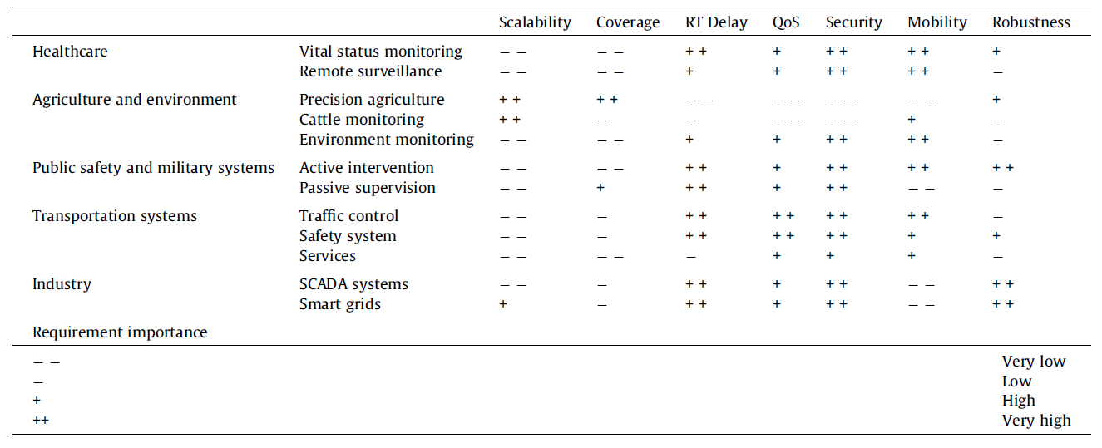

Table 2 An extension of Rault et al.’s table shown in Table 1 to include a number of CSN applications. ET – Extra-Terrestrial. ET Science examples: measuring solar radiation, performing astronomical measurements etc.

|  |  |  |  |  |  |  |  |  |
| --- | --- | --- | --- | --- | --- | --- | --- | --- |
|  |  | Scalability | Coverage | RT Delay | QoS | Security | Mobility | Robustness |
| Space | CSNs – Earth Observation | - | + | -- | + | - | ++ | + |
|  | CSNs – ET Science | -- | - | -- | + | - | + | + |

Rault et al. address several aspects of low-power WSNs and the trade-offs required when attempting to increase energy efficiency. Several low power WSN standards are explored such as IEEE 802.15.4 [67], Bluetooth Low Energy (BLE) [68], and Routing Protocol for Low power and lossy networks (RPL) [69]. No one standard presents itself as being an obvious choice for the CSN PvTP challenge. However, clear benefits can be seen in elements of RPL and ISA100.11a [70], one of many extensions of 802.15.4.

Beyond low power WSN standards, several core WSN approaches are highlighted by Rault et al. Although all of these areas are relevant in some regard to CSNs, the areas of highest relevancy to this work are: Duty cycling schemes, cluster architectures, energy as a routing metric and sink mobility. Each of these areas are explored, to some extent, in the Proposed Protocols chapter.

Rault et al. discuss a number of approaches to the trade-offs involved in the implementation of energy efficient WSNs. Three techniques are discussed: Multimetric protocols, Cross layer approaches, or cross layer optimization (CLO), and Multi-objective optimisation (MOO). Of the three techniques, CLO bears the most relevance to CSNs.

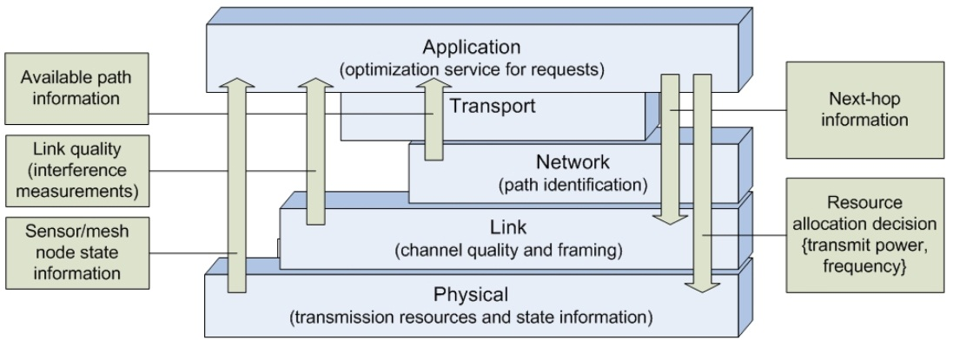

Figure 12 An illustration of information that may be passed between layers. This is a departure for the treatment of each layer as an isolated black box. Image Credit: [71]

The authors define CLO as “solutions exploit(ing) interactions between different layers to optimise network performances” (Figure 12). Here ‘layers’ may refer to several communication models, but it can be safely taken as relating to the OSI reference model [58]. This work adopts Rault et al.’s definition of CLO from here on. Two particular surveys are cited as being authoritative on the CLO domain [72, 73]. Rault et al. highlight the communication of the energy metrics by the Physical layer to the MAC and network layers as being a key example of the application of CLO. Other examples given include: Communicating clustering formations achieved at the MAC layer and to higher layers and the explicit scheduling of communications at higher layers allowing lower layers to reduce activity.

No one approach or standard is singled out as the obvious choice for energy efficient WSNs. Rather, Rault et al. point to the importance of adapting approaches to applications. The authors state clearly that regardless of the application or approach, the introduction of greater CLO is expected to advance the field. CLO is a common and favoured theme throughout recent literature relating to WSNs and MANETs. The exact meaning of CLO differs somewhat depending on the author, application and domain. Despite this, it is clear that it is an active topic in both WSN and MANET energy efficiency research.

WSN data collection is examined by Francesco et al. in extensive survey paper published in 2011 [74]. The work is particularly useful as it focuses on WSNs with Mobile Elements (WSN-MEs). The authors concentrate on mobility while maintaining and referencing the existing relevant state of the art in WSN routing and energy management.

Francesco et al. lay out a number of WSN mobility scenarios the most relevant of which is the “Mobile Peer” scenario (Figure 13). With CSNs, there is no appreciable difference whether one considers the ground station as moving into range of a satellite or a satellite moving over ground. In either case, a network of satellites in some formation must contend with a finite but predictable communication window with ground.

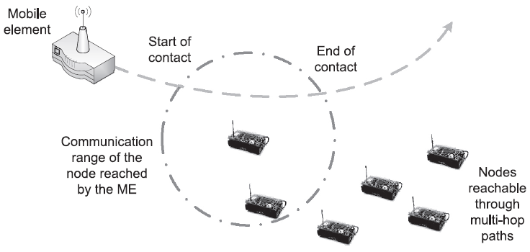

Figure 13 A mobile peer architecture which bears clear similarities to CubeSats in orbiting passing over a ground station. Image Credit: [74]

Data collection is divided by Francesco et al. into three distinct phases ‘Discovery’, ‘Data Transfer’ and ‘Routing’. The authors outline that the treatment of the Discovery phase is critical to the performance of WSN-MEs. In particular, the authors highlight issues with discovery protocols which rely on schedule based discovery of reachable nodes. The timeliness of the discovery of a mobile element defines the maximum windows for communication. Schemes based on periodic or scheduled discovery attempts are liable to suffer from reduced communication windows due to ill-timed discovery attempts. The authors highlight an approach that utilizes low-power short-range radios to asynchronously waken nearby nodes prior to data communication using a longer range higher power radio [75]. Other methods involving learning are noted for their potential to avoid the pitfalls of periodic/scheduled listening. Such methods may, with or without prior heuristics or topology knowledge, converge on optimal discovery schedules over time [76]. In the case of CSNs, CubeSats can easily determine their next communication window with ground through the use of GPS time, positon and velocity. However, discovery of S2S windows closely mirrors the challenge of WSN node discovery.

The data transfer phase, which follows the discovery phase, is primarily concerned with the quality of communications and MAC schemes. The authors clearly identify WSN-ME data transfer as a field that requires further work. The authors note a stop-and-wait protocol [77] as well as an automatic repeat request (ARQ) scheme [78]. Further references to specific well-established MAC schemes are sparse. Francesco et al. make a clear recommendation that network coding schemes require greater attention in relation to WSN-ME data transfer. MANETs and WSN-ME bear numerous similarities. Work on data transfer within the domain of MANETs tends to be broadly applicable to WSN-MEs. Why Francesco et al. avoid the direct evaluation of relevant MANET related work is unclear. It is possible the authors intend to stress the importance of adapt approaches for WSNs.

Routing in WSN’s, as highlighted by Francesco et al., is considerably more developed than discovery or data transfer. The authors make an assumption that the motion of network elements is not controlled. In this regard, the works discussed are relevant to S2S communications of CubeSats which have no orbital control capabilities (In simulating CSN communications this work assumes no orbital control capabilities). Routing for uncontrolled mobile WSN elements is classified by the authors into flat routing and proxy-based routing. In flat routing schemes all nodes behave in the same fashion whereas in proxy-based schemes certain nodes may take on routing or proxy style roles.

Several approaches to routing are discussed by Francesco et al. Three are worth noting in brief: A modified Optimized Link State Protocol (OLSR+) [79], Energy-Aware Routing to Mobile gateway (EARM) [80], and a cluster based approach by Somasundara et al. [81]. OLSR+ adapts to the mobility of element by passing velocity information between nodes. With this added information nodes can estimate the future stability of a link and avoid unnecessary abandonment or predict upcoming suitability. EARM implements an adaptive approach wherein node may boost their transmission power to a mobile node as the node moves out of reach. EARM’s core logic allows nodes to decide the point at which a direct link should be abandoned in favour of an multi-hop route. Somasundara et al.’s approach employs adaptive clustering. Nodes collaboratively and dynamically form clusters and elect a cluster heads based on their distance from a mobile sink. These cluster heads act as routers to the mobile sink and manage inter-cluster communication. Somasundara et al.’s approach is similar to the cluster based MAC approach developed by this work. This work does not employ a cluster based routing strategy such as the Cluster Based Routing Protocol (CBRP) [82] (Figure 14). Rather, this work adapts a routing protocol known as the “Dynamic MANET On-demand routing protocol” (DYMO) [83] for use with the cluster based MAC approach.

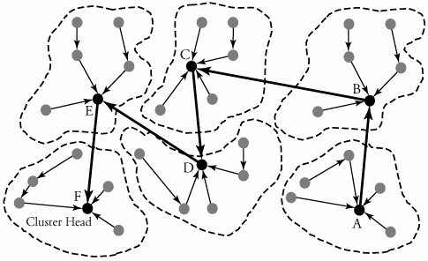

Figure 14 An example of network cluster forming with the election of cluster heads. With the introduction of a mobile sink clustering can be adapted to insure election of optimal cluster heads in order to maximize throughput [81]. Image Credit: [84]

Finally, to compliment the discussed WSN survey materials a more targeted work is considered. "Efficient data collection in wireless sensor networks with path-constrained mobile sinks" by Gao et al. approaches the PvTP challenge directly through the design of novel routing protocol [85]. Increasing the relevancy of this work to the CSN domain is the focus by Gao et al. on WSN’s with mobile sinks. Each mobile sink can be considered analogous to a CSN ground station. The proposed protocol is given the name “Maximum Amount Shortest Path” (MASP). The authors determined the formal properties of MASP and used OMNeT++ to simulate and analyse its performance.

MASP outperforms a common approach to the determination of the most efficient routes to adopt called Shortest Path Tree (SPT). There are several implementations of SPT, but a common approach is to construct a tree of possible routes to a destination. This tree can then be search with an algorithm such as A* while using a heuristic cost function which represents the energy cost of using a given route. MASP beats SPT by provided a genetic algorithm which solves a multi-dimensional optimization problem based on known and computable routes and route heuristics.

The work of Gao et al. represents a state of the art approach to the PvTP challenge in WSNs. Energy as a routing metric was clearly noted by Rault et al. as critical when attempting to optimize data collection with energy efficiency. MASP develops on this concept of energy as a routing metric and introduces a complex yet performant solution. However, MASP can only determine efficient routes given successful and timely discovery. Without the introduction of an appropriate discovery scheme MASPs performance is fundamentally limited. This lack of development in the area of discovery is noted by Francesco et al.

From the analysis of WSN based prior art one can identify several similarities to the CSN PvTP challenge. There are clear recommendations for further development CLO and discovery in the area of energy efficient data collection. Although the CSNs diverge in certain regards from WSNs, prior art therein provides a considerable basis for the development of the CSN domain.

### Mobile Ad-Hoc Networks

…

There is, as suggested by the existence of WSN-MEs, often considerable overlap between paradigms within the fields of MANETs and WSNs. This overlap is quite obvious when comparing the work of Aung et al in their review of “group mobility models for mobile ad hoc networks” [86] and the aforementioned work on WSN-MEs by Francesco et al.

In general, the most discussed and active topic within MANETs is that of routing. In this regard the work of Mohseni et al. in their survey of routing protocols in MANETs [87]. (*Packet loss, delay, jitter, bandwidth. (DREAM) protocol (Pr), DSR praised. Reactive recommended.*)

As mentioned the area of MANET sub-domain of Vehicular Ad-hoc Networks (VANETs), contains many parallels to CSNs. “VANET architectures and protocol stacks: a survey” [88] … (*V2V/V2I, focus MAC/Net+, Mobile IPv6 / 802.11 stack based, far less resource constrained, C2C CC*)

… There is a further concentration of VANETs dubbed FANETs (Flying Ad-Hoc Networks). A survey by Bekmezci et al. [89] introduces FANETs in the context of MANETs and the VANETs sub-domain. The authors deal primarily with unmanned aerial vehicles (UAVs). … (*Cross-layer architecture (IMAC-UAV), DOLSR) Cooperative Autonomous Reconfigurable UAV Swarm (CARUS), predictable movement*)

## CubeSat Communications

…

Even before missions implementing CSNs had begun development the academic community produced several works examining the inter-communication of CubeSats. Most notably Challa and McNair of University of Florida provide extensive explorations of distributed applications implemented on CSNs [36, 90-93]. These works are somewhat out of the scope of this project as they deal more with applications running upon CSNs rather than communications within the CSN itself. Despite this, these works provide an interesting insight into potential future applications of CSNs .

The most relevant work in this area is the extensive survey of “Inter-Satellite Communication for Small Satellite Systems” by Radhakrishnan et al. [9]. The survey provides an overview of the state of the art as well as a roadmap for exploring numerous areas within the field. The survey focuses on the physical, data link and network layers of the OSI networking reference model [58]. The authors detail relevant prior art in these areas and provide analyses of the relevant efficacies of the various approaches.

… Another work involving authors of the aforementioned survey paper provides the starting point for this work’s proposed MAC protocol. The work examines potential optimal MAC protocol implementations for small satellite systems [94]. …

Although the work by Radhakrishnan et al. is by far the most relevant there are other works worth mentioning which inform the current state of the art. Wong et al., operating mainly out of NASA’s Goddard Flight Center, examine a potential future for CSNs where space to ground communications are performed through relay with existing space bound communication networks [10]. This concept is explored for deep space missions in much of the preliminary development of the COPINS mission [60]. Another survey style paper on inter-satellite link for CubeSats by Budianu et al. [8] published in 2013 provides a broader overview of the field with more attention to antenna design and link budget analysis. The authors only touch briefly on networking protocols making the work less relevant in this case.

… *Mention Gamalink briefly*

## Other Areas of Note

…

### Energy Aware Scheduling

… *GomX-3*

### Delay Tolerant Networking

…

## Summary

…

# Proposed Protocols

## Introduction

*Edit this:* Two CubeSat communication protocols have been mentioned thus far, AX.25 [35] and the custom Cpt/Lt protocol of EDSN [56] and Nodes [12]. Unlike the Cpt/Lt protocol, AX.25 was not designed with space bound communications in mind. AX.25 is an amateur radio protocol which roughly falls within the OSI [58] Data Link layer which is concerned mainly with Medium Access Control (MAC). AX.25 implements a style of MAC called Carrier Sense Multiple Access / Collision Recovery (CSMA/CR). This work uses a CSMA MAC implementation as a control for measuring performance of the proposed MAC protocol.

… Objectives, Requirements, Restrictions

## Objectives

…

## Assumptions

… Large sections covering basis, defense and compromise of all relevant assumptions

## Restrictions

…

# Simulation

## Introduction

… Include formations/scenarios examined

## OMNeT++

…

## Protocol Implementation

…

## Simulation Design

… Assumptions, simplications etc.

## Simulation Analysis

…

## Discussion

…

# Results

## Introduction

…

## Key Metrics

…

## Simulation Results

…

### Scenario 1

…

### Scenario 2

…

### Scenario 3

…

## Discussion

# Conclusions

## Discussion

…

## Future Work

…

**Will format and edit references section last**

# References

[1] L. Brennan and A. Vecchi, *The business of space: The next frontier of international competition*: Palgrave Macmillan, 2011.

[2] G. Johnson. (2012, January, 15). *Revised, Expanded Launch Cost Data*. Available: <http://exrocketman.blogspot.ie/2012/05/revised-expanded-launch-cost-data.html>

[3] A. Scholz and J.-N. Juang, "Toward open source CubeSat design," *Acta Astronautica,* vol. 115, pp. 384-392, 2015.

[4] S. Padmanabhan, S. Brown, B. Lim, P. Kangaslahti, D. Russell, and R. Stachnik, "Airborne Deployment and Calibration of Microwave Atmospheric Sounder on 6U CubeSat," in *AGU Fall Meeting Abstracts*, 2015.

[5] V. Hernandez, P. Gankidi, A. Chandra, A. Miller, P. Scowen, H. Barnaby*, et al.*, "SWIMSat: Space Weather and Meteor Impact Monitoring using a Low-Cost 6U CubeSat," 2016.

[6] U. Kvell, M. Puusepp, F. Kaminski, J.-E. Past, K. Palmer, T.-A. Grönland*, et al.*, "Nanosatellite orbit control using MEMS cold gas thrusters," *Proceedings of the Estonian Academy of Sciences,* vol. 63, p. 279, 2014.

[7] X. Sun and X. Wu, "A cubesat attitude control system with linear piezoelectric actuator," in *Piezoelectricity, Acoustic Waves, and Device Applications (SPAWDA), 2014 Symposium on*, 2014, pp. 72-75.

[8] A. Budianu, T. J. W. Castro, A. Meijerink, and M. J. Bentum, "Inter-satellite links for cubesats," in *Aerospace Conference, 2013 IEEE*, 2013, pp. 1-10.

[9] R. Radhakrishnan, W. W. Edmonson, F. Afghah, R. M. Rodriguez-Osorio, F. Pinto, and S. C. Burleigh, "Survey of Inter-satellite Communication for Small Satellite Systems: Physical Layer to Network Layer View," *IEEE Communications Surveys & Tutorials,* vol. 18, pp. 2442-2473, 2016.

[10] Y. F. Wong, O. Kegege, S. H. Schaire, G. Bussey, S. Altunc, Y. Zhang*, et al.*, "An Optimum Space-to-Ground Communication Concept for CubeSat Platform Utilizing NASA Space Network and Near Earth Network," 2016.

[11] W. Harrington and J. Heath, "Development of a Low-Cost, Open Software/Hardware Command, Control and Communications Module for CubeSats," in *AIAA SPACE 2016*, ed, 2016, p. 5616.

[12] J. Hanson, A. G. Luna, R. DeRosee, K. Oyadomari, J. Wolfe, W. Attai*, et al.*, "Nodes: A Flight Demonstration of Networked Spacecraft Command and Control," 2016.

[13] A. Tatomirescu, G. F. Pedersen, J. Christiansen, and D. Gerhardt, "Antenna system for nano-satelite mission GOMX-3," in *Antennas and Propagation in Wireless Communications (APWC), 2016 IEEE-APS Topical Conference on*, 2016, pp. 282-285.

[14] M. Swartwout, "The first one hundred CubeSats: A statistical look," *Journal of Small Satellites,* vol. 2, pp. 213-233, 2013.

[15] K. Kelley, "Launch systems to support the booming nanosatellite industry," in *Aerospace Conference, 2015 IEEE*, 2015, pp. 1-6.

[16] D. Hitt, K. F. Robinson, and S. D. Creech, "NASA's Space Launch System: A New Opportunity for CubeSats," 2016.

[17] D. Masutti, T. Banyai, J. Thoemel, T. Magin, B. Taylor, and D. Kataria, "Investigating the Middle and Lower Thermosphere using a Cubesat Constellation: the QB50 Mission and its Particular Challenges," in *EGU General Assembly Conference Abstracts*, 2015, p. 9016.

[18] M. Tsay, J. Frongillo, K. Hohman, and B. K. Malphrus, "LunarCube: A Deep Space 6U CubeSat with Mission Enabling Ion Propulsion Technology," 2015.

[19] R. W. Ridenoure, D. A. Spencer, D. A. Stetson, B. Betts, R. Munakata, S. D. Wong*, et al.*, "Status of the Dual CubeSat LightSail Program," in *AIAA SPACE 2015 Conference and Exposition*, 2015, p. 4424.

[20] R. Glumb, C. Lietzke, S. Luce, and P. Wloszek, "Cubesat Fourier Transform Spectrometer (CubeSat-FTS) for Three-Dimensional Global Wind Measurements," in *American Meteorological Society Annual Meeting,(January 2015)*, 2015.

[21] S. Nag, J. L. Rios, D. Gerhardt, and C. Pham, "CubeSat constellation design for air traffic monitoring," *Acta Astronautica,* vol. 128, pp. 180-193, 2016.

[22] D. Westley, A. Martinez, and A. Petro, "Edison Demonstration of Smallsat Networks," 2015.

[23] R. Barbosa. (2015, September, 24). *China debuts Long March 11 lofting Tianwang-1 trio*. Available: NASASpaceFlight.com

[24] A. Varga, "OMNeT++," *Modeling and tools for network simulation,* pp. 35-59, 2010.

[25] H. Helvajian and S. W. Janson, *Small satellites: past, present, and future*: Aerospace Press, 2008.

[26] H. Heidt, J. Puig-Suari, A. Moore, S. Nakasuka, and R. Twiggs, "CubeSat: A new generation of picosatellite for education and industry low-cost space experimentation," 2000.

[27] M. Swartwout, "Cubesat database," *St. Louis University.[Online].[Accessed 7 February 2015],* 2015.

[28] C. Boshuizen, J. Mason, P. Klupar, and S. Spanhake, "Results from the planet labs flock constellation," 2014.

[29] R. A. Deepak and R. J. Twiggs, "Thinking out of the box: Space science beyond the CubeSat," *Journal of Small Satellites,* vol. 1, pp. 3-7, 2012.

[30] J. Puig-Suari, J. Schoos, C. Turner, T. Wagner, R. Connolly, and R. Block, "CubeSat developments at Cal Poly: the standard deployer and PolySat," in *Proceedings of SPIE-The International Society for Optical Engineering*, 2000, pp. 72-78.

[31] J. Farkas, "CPX: Design of a standard cubesat software bus," *California State University, California, USA,* 2005.

[32] J. Straub, C. Korvald, A. Nervold, A. Mohammad, N. Root, N. Long*, et al.*, "OpenOrbiter: A low-cost, educational prototype CubeSat mission architecture," *Machines,* vol. 1, p. 1, 2013.

[33] A. K. Nervold, J. Berk, J. Straub, and D. Whalen, "A Pathway to Small Satellite Market Growth," *Advances in Aerospace Science and Technology,* vol. 1, p. 14, 2016.

[34] K. Hayward, "The Economics of Launch Vehicles: Towards a New Business Model," in *Yearbook on Space Policy 2015*, ed: Springer, 2017, pp. 247-256.

[35] W. A. Beech, D. E. Nielsen, J. T. Noo, and L. K. Ncuu, "AX. 25 Link Access Protocol for Amateur Packet Radio, Version: 2.2 Rev," in *Tucson Amateur Packet Radio Corp*, 1997.

[36] P. Muri and J. McNair, "A survey of communication sub-systems for intersatellite linked systems and CubeSat missions," *JCM,* vol. 7, pp. 290-308, 2012.

[37] C. Fish, C. Swenson, T. Neilsen, B. Bingham, J. Gunther, E. Stromberg*, et al.*, "Dice mission design, development, and implementation: Success and challenges," 2012.

[38] R. Hodges, B. Shah, D. Muthulingham, and T. Freeman, "ISARA–Integrated Solar Array and Reflectarray Mission Overview," 2013.

[39] S. Wu, W. Chen, and C. Chao, "The STU-2 CubeSat Mission and In-Orbit Test Results," 2016.

[40] S. S. Arnold, R. Nuzzaci, and A. Gordon-Ross, "Energy budgeting for CubeSats with an integrated FPGA," in *Aerospace Conference, 2012 IEEE*, 2012, pp. 1-14.

[41] A. Oliveira. (2015, 02-02). *Final Report Summary - GAMALINK (Generic SDR-bAsed Multifunctional spAce LINK)*. Available: <http://cordis.europa.eu/result/rcn/172006_en.html>

[42] (2016, April 14th). *CubeSat Design Overview Report*. Available: <http://sydney.edu.au/engineering/aeromech/AERO3760/private/CDR/1%20%20Critical%20Design%20Overview%20i-INSPIRE%EF%BC%92.pdf>

[43] J. Guo, J. Bouwmeester, and E. Gill, "From Single to Formation Flying CubeSats: An Update from the Delft Programme," 2013.

[44] M. Focardi, V. Noce, S. Buckley, K. O'Neill, A. Bemporad, S. Fineschi*, et al.*, "The shadow position sensors (SPS) formation flying metrology subsystem for the ESA PROBA-3 mission: present status and future developments," in *SPIE Astronomical Telescopes+ Instrumentation*, 2016, pp. 99044Z-99044Z-17.

[45] P. Rodrigues, A. Oliveira, R. Mendes, S. Cunha, R. Garcia Von Pinho, C. Salotto*, et al.*, "GAMANET: Disrupting communications and networking in space," presented at the 64th International Astronautical Congress, Beijing, China, 2013.

[46] G. Sun, X. Xia, S. Wu, Z. Wu, and W. Chen, "Attitude Determination and Control System Design for STU-2A CubeSat and In-Orbit Results," 2016.

[47] J. Li, M. Post, T. Wright, and R. Lee, "Design of attitude control systems for cubesat-class nanosatellite," *Journal of Control Science and Engineering,* vol. 2013, p. 4, 2013.

[48] E. Glennon, J. Gauthier, M. Choudhury, A. Dempster, and K. Parkinson, "Synchronization and syntonization of formation flying cubesats using the namuru V3. 2 spaceborne GPS receiver," in *Proceedings of the the ION 2013 Pacific PNT Meeting, Honolulu, HI, USA*, 2013, pp. 23-25.

[49] A. Cortiella, D. Vidal, J. Jané, E. Juan, R. Olivé, A. Amézaga*, et al.*, "3CAT-2: Attitude Determination and Control System for a GNSS-R Earth Observation 6U CubeSat Mission," *European Journal of Remote Sensing,* vol. 49, pp. 759-776, 2016.

[50] W. H. Swartz, S. R. Lorentz, P. M. Huang, A. W. Smith, D. M. Deglau, S. X. Liang*, et al.*, "The Radiometer Assessment using Vertically Aligned Nanotubes (RAVAN) CubeSat Mission: A Pathfinder for a New Measurement of Earth's Radiation Budget," 2016.

[51] W. H. Swartz, L. P. Dyrud, S. R. Lorentz, D. L. Wu, W. J. Wiscombe, S. J. Papadakis*, et al.*, "The RAVAN CubeSat mission: advancing technologies for climate observation," in *Geoscience and Remote Sensing Symposium (IGARSS), 2015 IEEE International*, 2015, pp. 5300-5303.

[52] S. Kanekal, P. O'Brien, D. N. Baker, K. Ogasawara, J. Fennell, E. Christian*, et al.*, "Radition belt dynamics: Recent results from van Allen Probes and future observations from CeREs," in *41st COSPAR Scientific Assembly, abstracts from the meeting that was to be held 30 July-7 August at the Istanbul Congress Center (ICC), Turkey, but was cancelled. See* <http://cospar2016>*. tubitak. gov. tr/en/, Abstract PRBEM. 2-1-16.*, 2016.

[53] J. Westerhoff, G. Earle, R. Bishop, G. R. Swenson, S. Vadas, J. Clemmons*, et al.*, "LAICE CubeSat mission for gravity wave studies," *Advances in Space Research,* vol. 56, pp. 1413-1427, 2015.

[54] J. M. Morrison, H. Jeffrey, H. Gorter, P. Anderson, C. Clark, A. Holmes*, et al.*, "SeaHawk: an advanced CubeSat mission for sustained ocean colour monitoring," in *SPIE Remote Sensing*, 2016, pp. 100001C-100001C-11.

[55] M. Bentum, A. Meijerink, A.-J. Boonstra, C. Verhoeven, and A.-J. v. d. Veen, "OLFAR: the orbiting low frequency array, how a cube sat swarm becomes a novel radio astronomy instrument in space," *De Vonk,* vol. 25, pp. 1-5, 2010.

[56] J. Hanson, J. Chartres, H. Sanchez, and K. Oyadomari, "The EDSN intersatellite communications architecture," 2014.

[57] J. Chartres, H. Sanchez, and J. Hanson, "EDSN development lessons learned," 2014.

[58] G. Bora, S. Bora, S. Singh, and S. M. Arsalan, "OSI reference model: An overview," *International Journal of Computer Trends and Technology (IJCTT,* vol. 7, 2014.

[59] K. I. Parker, "State-of-the-Art for Small Satellite Propulsion Systems," 2016.

[60] O. Barnouin, J. Biele, I. Carnelli, V. Ciarletti, A. Cheng, A. Galvez*, et al.*, "The Asteroid Impact and Deflection Assessment (AIDA) mission: Science Proximity Operations," in *LPSC 2016 47th Lunar and Planetary Science Conference*, 2016, p. 1427.

[61] M. Bisgaard, D. Gerhardt, H. Hermanns, J. Krčál, G. Nies, and M. Stenger, "Battery-Aware Scheduling in Low Orbit: The GomX–3 Case," in *FM 2016: Formal Methods: 21st International Symposium, Limassol, Cyprus, November 9-11, 2016, Proceedings 21*, 2016, pp. 559-576.

[62] B. Niels, "ESA and GomSpace Sign Contract to Launch Advanced Nanosatellite," ed. Web: GOMspace, 2016.

[63] M. Villa, A. Martinez, and A. Petro, "Cubesat Proximity Operations Demonstration (CPOD)," 2015.

[64] D. Cecil, "Potential Future NASA Satellite Data and Applications for Tropical Cyclones," 2016.

[65] E. Gill, P. Sundaramoorthy, J. Bouwmeester, B. Zandbergen, and R. Reinhard, "Formation flying within a constellation of nano-satellites: The QB50 mission," *Acta Astronautica,* vol. 82, pp. 110-117, 2013.

[66] T. Rault, A. Bouabdallah, and Y. Challal, "Energy efficiency in wireless sensor networks: A top-down survey," *Computer Networks,* vol. 67, pp. 104-122, 2014.

[67] J. Zheng and M. J. Lee, "A comprehensive performance study of IEEE 802.15. 4," ed: IEEE Press book Los Alamitos, 2004.

[68] C. Gomez, J. Oller, and J. Paradells, "Overview and evaluation of bluetooth low energy: An emerging low-power wireless technology," *Sensors,* vol. 12, pp. 11734-11753, 2012.

[69] N. Accettura, L. A. Grieco, G. Boggia, and P. Camarda, "Performance analysis of the RPL routing protocol," in *Mechatronics (ICM), 2011 IEEE International Conference on*, 2011, pp. 767-772.

[70] P. T. A. Quang and D.-S. Kim, "Throughput-aware routing for industrial sensor networks: Application to ISA100. 11a," *IEEE Transactions on Industrial Informatics,* vol. 10, pp. 351-363, 2014.

[71] O. M. Sheikh and S. A. Mahmoud, *Cross-Layer Design for Smart Routing in Wireless Sensor Networks*: INTECH Open Access Publisher, 2012.

[72] L. D. Mendes and J. J. Rodrigues, "A survey on cross-layer solutions for wireless sensor networks," *Journal of Network and Computer Applications,* vol. 34, pp. 523-534, 2011.

[73] G. Miao, N. Himayat, Y. G. Li, and A. Swami, "Cross‐layer optimization for energy‐efficient wireless communications: a survey," *Wireless Communications and Mobile Computing,* vol. 9, pp. 529-542, 2009.

[74] M. Di Francesco, S. K. Das, and G. Anastasi, "Data collection in wireless sensor networks with mobile elements: A survey," *ACM Transactions on Sensor Networks (TOSN),* vol. 8, p. 7, 2011.

[75] C. Schurgers, V. Tsiatsis, S. Ganeriwal, and M. Srivastava, "Optimizing sensor networks in the energy-latency-density design space," *IEEE Transactions on mobile computing,* vol. 99, pp. 70-80, 2002.

[76] L. Bölöni and D. Turgut, "Should I send now or send later? A decision‐theoretic approach to transmission scheduling in sensor networks with mobile sinks," *Wireless Communications and Mobile Computing,* vol. 8, pp. 385-403, 2008.

[77] A. Kansal, A. A. Somasundara, D. D. Jea, M. B. Srivastava, and D. Estrin, "Intelligent fluid infrastructure for embedded networks," in *Proceedings of the 2nd international conference on Mobile systems, applications, and services*, 2004, pp. 111-124.

[78] G. Anastasi, M. Conti, E. Gregori, C. Spagoni, and G. Valente, "Motes sensor networks in dynamic scenarios: an experimental study for pervasive applications in urban environments," *Journal of Ubiquitous Computing and Intelligence,* vol. 1, pp. 9-16, 2007.

[79] K. Dantu and G. S. Sukhatme, "Connectivity vs. control: Using directional and positional cues to stabilize routing in robot networks," in *Robot Communication and Coordination, 2009. ROBOCOMM'09. Second International Conference on*, 2009, pp. 1-6.

[80] K. Akkaya and M. Younis, "Energy-aware routing to a mobile gateway in wireless sensor networks," in *Global Telecommunications Conference Workshops, 2004. GlobeCom Workshops 2004. IEEE*, 2004, pp. 16-21.

[81] A. A. Somasundara, A. Kansal, D. D. Jea, D. Estrin, and M. B. Srivastava, "Controllably mobile infrastructure for low energy embedded networks," *IEEE Transactions on Mobile Computing,* vol. 5, pp. 958-973, 2006.

[82] S. A. Awwad, C. K. Ng, N. K. Noordin, and M. F. A. Rasid, "Cluster based routing protocol for mobile nodes in wireless sensor network," in *Collaborative Technologies and Systems, 2009. CTS'09. International Symposium on*, 2009, pp. 233-241.

[83] C. Perkins and I. Chakeres, "Dynamic MANET on-demand (DYMO) routing," *draft-ietf-manet-dymo-26 (work in progress),* p. 127, 2013.

[84] N. F. Mir, *Computer and communication networks*: Pearson Education, 2014.

[85] S. Gao, H. Zhang, and S. K. Das, "Efficient data collection in wireless sensor networks with path-constrained mobile sinks," *IEEE Transactions on Mobile Computing,* vol. 10, pp. 592-608, 2011.

[86] C. Y. Aung, B. C. Seet, M. Zhang, L. F. Xie, and P. H. J. Chong, "A review of group mobility models for mobile ad hoc networks," *Wireless Personal Communications,* vol. 85, pp. 1317-1331, 2015.

[87] S. Mohseni, R. Hassan, A. Patel, and R. Razali, "Comparative review study of reactive and proactive routing protocols in MANETs," in *Digital ecosystems and technologies (DEST), 2010 4th IEEE international conference on*, 2010, pp. 304-309.

[88] S. A. Mohammad, A. Rasheed, and A. Qayyum, "VANET architectures and protocol stacks: a survey," in *International Workshop on Communication Technologies for Vehicles*, 2011, pp. 95-105.

[89] I. Bekmezci, O. K. Sahingoz, and Ş. Temel, "Flying ad-hoc networks (FANETs): A survey," *Ad Hoc Networks,* vol. 11, pp. 1254-1270, 2013.

[90] O. N. Challa, "CubeSat Cloud: A framework for distributed storage, processing and communication of remote sensing data on cubesat clusters," 2013.

[91] O. N. Challa and J. McNair, "Cubesat torrent: Torrent like distributed communications for cubesat satellite clusters," in *MILCOM 2012-2012 IEEE Military Communications Conference*, 2012, pp. 1-6.

[92] O. Challa and J. McNair, "Distributed Computing on CubeSat Clusters using MapReduce," in *Proceedings of the 1st Interplanetary CubeSat Workshop, Cambridge, MA*, 2012.

[93] O. N. Challa and J. McNair, "Distributed Data Storage on CubeSat Clusters," *Advances in Computing,* vol. 3, pp. 36-49, 2013.

[94] R. Radhakrishnan, W. W. Edmonson, F. Afghah, J. Chenou, R. M. Rodriguez-Osorio, and Q.-A. Zeng, "Optimal multiple access protocol for inter-satellite communication in small satellite systems," in *4S Small Satellite Systems and Services Symposium*, 2014.