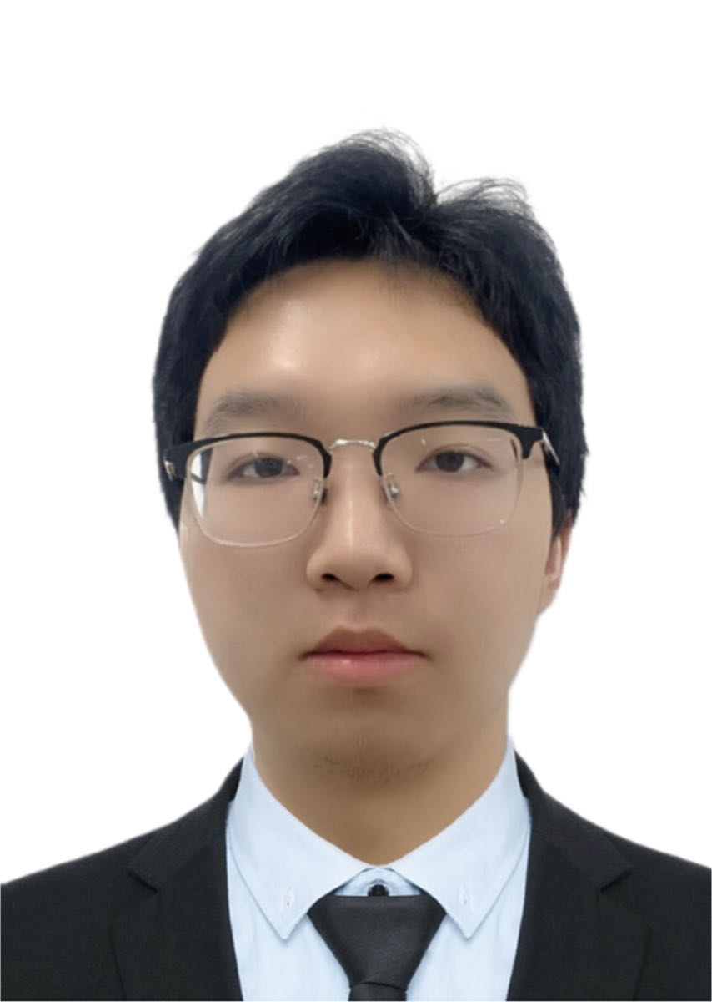**Xingyu Li**

Email: whiteli1925@outlook.com Mob: 15541911139

GitHub: [StarUniversus (Xingyu Li) (github.com)](https://github.com/StarUniversus)

[HomePage](https://staruniversus.github.io/)

**EDUCATION**

**Northeastern University Shenyang, China**

*Bachelor of Intelligent Medical Engineering 2019.09-2023.06*

*College of Medicine and BiologicalInformation Engineering*

**RESEARCH EXPERIENCES**

* **Topic:**

[Global Contrast Masked Autoencoders Are Powerful Pathological Representation Learners](https://doi.org/10.1016/j.patcog.2024.110745)

* *Co first author*  ***Journal: Pattern Recognition 2024*** *Times Cited:20*
* *Code:* [*https://github.com/StarUniversus/gcmae*](https://github.com/StarUniversus/gcmae) *Stars: 34*
* **Highlights:**
* We have designed two self-supervised pretext tasks: masking image reconstruction and contrastive learning, which can train the encoder to have the ability to represent local-global features.
* We discuss the mask ratio, which is suitable for pathology-specific training methodologies based on the masked image modeling paradigm.
* We selected three pathological image datasets and proved the effectiveness of GCMAE algorithm through extensive experiments.
* An automatic pathology image diagnosis process was designed based on the GCMAE to improve the credibility of the model in clinical applications.
* **Topic:**

Attention-based Feature Distillation Multi-Instance Learning for Pathological Image Classification (Under Review)

* *Journal: IEEE Journal of Biomedical and Health Informatics*
* *Code:* [*https://github.com/MasyerN/AFD-MIL*](https://github.com/MasyerN/AFD-MIL)
* **Highlights:**
* The integration of attention-based feature distillation with MIL for WSI classification, for the first time, addresses the challenge of excessive redundant features and achieves optimal performance in cancer classification tasks (Camelyon16 and NSCLC).
* AFD-MIL achieves high interpretability as it automatically selects regions similar to ground truth. Additionally, its compatibility with various existing models enhances performance, demonstrating high scalability.
* **Topic:**

Enhancing Diagnostic Accuracy in Renal Cell Carcinoma: A Transformer-based Multi-Instance Learning Approach for ChRCC and Oncocytoma Differentiation (Under Review)

* *Journal: Heliyon*
* **Highlights:**
* We conducted experiments on pathological slides at different magnifications. These experiments deeply analyzed the impact of pathological image features at different magnifications on the model, revealing the importance of high-magnification image features for diagnostic classification.
* We conducted cross-center experiments on high-magnification datasets from multiple centers. This allowed us to validate the generalization ability and robustness of deep learning models on pathological images collected under different geographical locations and equipment conditions.
* In diagnosing kidney tumors, particularly renal cell carcinoma and oncocytoma, these two lesions are difficult to distinguish due to their histological similarity. Doctors rely on observing subtle differences in nuclear structures to make a diagnosis. By integrating these key nuclear features, we significantly improved the performance of our diagnostic model. Specifically, the model achieved an average ACC of 92.50%, an AUC of 96.42, a Precision of 90.32, and a Recall of 100%.

**Project Experience**

**Pathology Slide Review Software Platform "EasyPathology" Based on Gaze Analysis**

* Gaze Information Analysis and Eye Movement Metric Calculation
  + Cleaning gaze data and calculating eye movement metrics.
  + Data collaborated with 13 pathologists from 3 hospitals by Tobii eye trackers
* Deployment of the Segment Anything Model Integrated with Gaze Information
  + Converting the SAM ViT-B model to ONNX format.
  + Invoking the ONNX-formatted SAM model in C#.
  + Using gaze points as prompts for segmentation on pathology images.

**WORK EXPERIENCES**

**Microsoft Opensource Study Community (MOSC), China Aug 2021 - Sep 2021**

* Research Sharing: Attention
  + Attention is all you need
  + An Image is Worth 16x16 Words: Transformers for Image Recognition at Scale

**Microport Ltd, Shanghai, China June 2022 - Sep 2022**

* Research and Development Intern
  + Employing YOLOv7 for Object Detection of Lung Nodules in Chest CT Scans

**Tanka Ltd, Shenyang, China Sep 2023 - Now**

* Deploying Auto Speech Recognition(ASR) on Software
  + Alidamo: FunASR
  + Python, C#, Onnx, Pytorch, Github
* Deploying SAM Annotation Algorithm Service with FastAPI
  + Python, Fastapi, Linux, Openapi, Pydantic, Docker, Cloud, React, JS, HTML
* Multi-Instance Learning Approach for ChRCC and Oncocytoma Differentiation
  + Python, Pytorch, Mlflow, DVC, Huawei NPU, Cloud, Docker, HuggingFace, Gradio

**Competitions/Awards**

* National Student Biomedical Engineering Innovation Design Competition: National Second Prize
* ISICDM 2023 Chest X-ray Posture Assessment Competition: The Second Prize
* Software Copyright: EasyPathology —— Pathology slide analysis software
* Northeastern University Technology Innovation Individual