Final Project Design Phase
Computer Science - Week 11
Oct 3, 2026 - Version 0.0.4

For complete instructions and project ideas, refer to the assignment in Canvas. Specifically, review the final project requirements before you continue below. If you have not reviewed the project requirements in Canvas (you might have to go to the modules view and check the current or past week's content), you will not be able to properly complete the parts below. In addition, it may be helpful to review the information on this Drafter documentation page.

0) Project Planning and Preparation
Successful programmers spend time planning before they begin coding. After reviewing the project requirements, answer the following questions to help guide your design and development process.
- What concepts from class or previous assignments might help you complete this project? Which programming concepts (loops, conditionals, lists, classes, etc.) do you expect to use? What programming skills do you want to improve while completing this project?
The concepts from extracting data from files will be useful to this project. I expect to use primarily loops and nested data (lists of dataclasses with lists in them) in this project. I want to improve my ability to “think” in code, increasing my fluency in problem solving natively in python. I also want to improve my drafter skills.

- Which parts of the project do you expect to be the easiest for you? The hardest? Why?
Extracting data from the files will be easy, as it just involves basic loop appending to a list. However, it will be much harder to format that data in logical lists of dataclasses, as that involves complex construction and nested data.

- Even though you have not yet designed the final project, estimate which tasks will likely require the most time and effort? Which features or components should be implemented first?
The most time and effort will be spent on the backend data processing formatting, while the actual presentation of the data in drafter should be relatively easy. I will implement turning a datafile into some list of dataclasses with only relevant information first, so that I can construct more specific data classes using that data. I estimate the time to complete the backend portion will be around 4 hours. The frontend programming should only take 1-2 hours.

- What distractions might interfere with your work and how will you minimize them? What resources will you need available while working? What questions, if any, do you still have about the assignment requirements?
Other classes and assignments will interfere with my work. I will minimize them by strategically allocating time for all of my class assignments. I don’t have any more questions about requirements.

1) Site Diagram
Create a mock-up of your planned website. We suggest you make the mockup on paper, although you can also use software like PowerPoint or Slides to make a mockup. There is other design software that could also be used, but we strongly encourage you to keep it simple. Do not spend more than 15-30 minutes detailing the mock-up. Your goal should be to make a very quick and dirty diagram, to show that you have some kind of idea.

We recommend drawing each page as a rectangle, and laying out the text, buttons, and other components inside. Then, use arrows to indicate links between pages. Label each page the way you will name each function, and then put labels on the arrows to indicate what the button links. Also write down any parameters that should come into the pages.

In addition to the pages and routes, write down what fields your `State` will have, both their names and types. Think clearly about what data will need to be persistent across the entire website.

Add photo(s) or screenshot(s) of your website mock-up and labeled diagram on the next page.
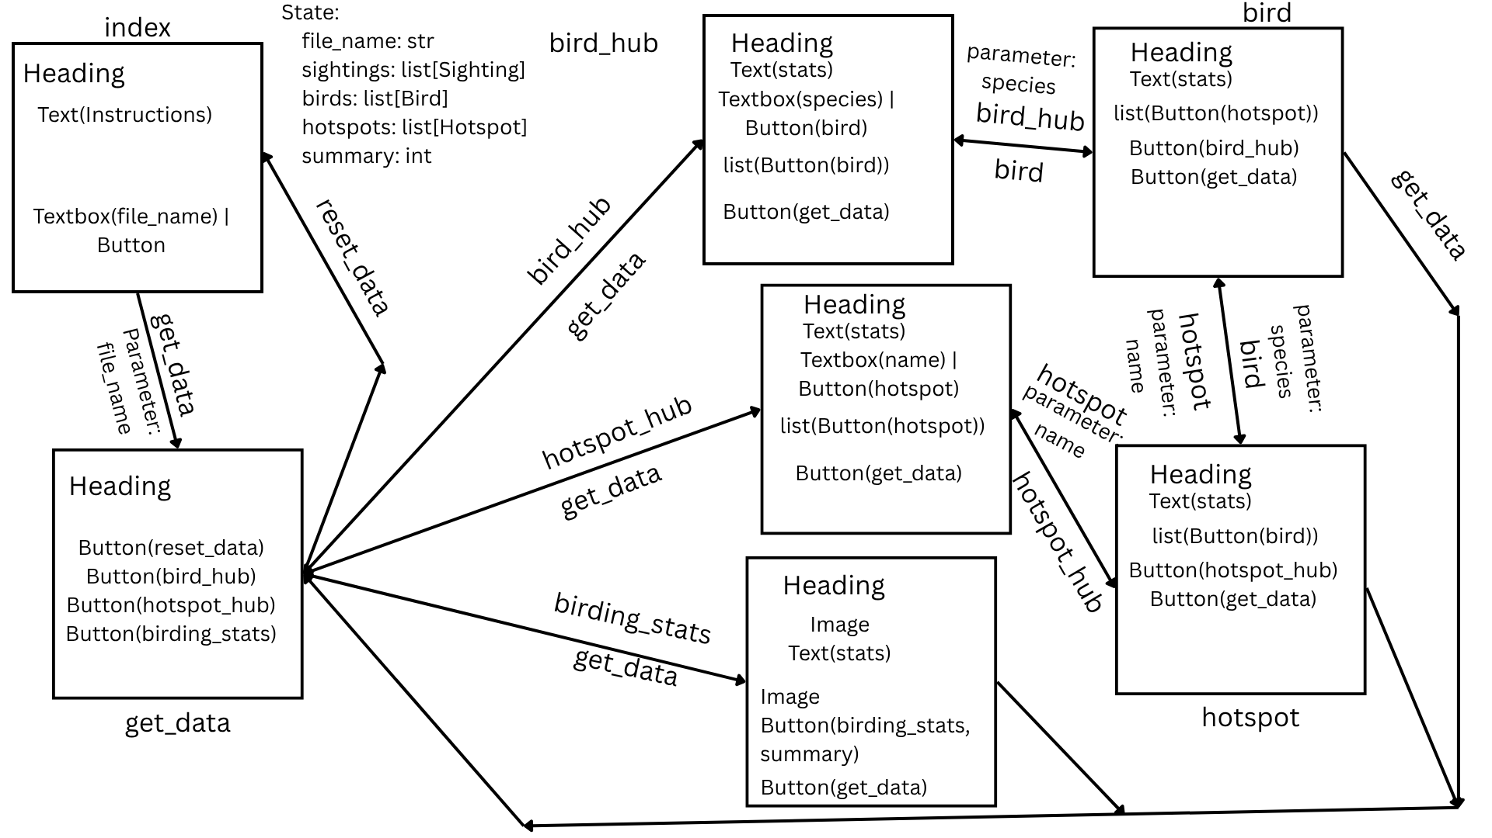

2) Implementing Requirements
This table should serve as a draft for how you will implement the requirements into your final project. You may change your ideas later on, but your final site must fulfill all the requirements.

Requirement | Implementation
Purpose/Functionality  A 1-2 sentence description of the purpose or functionality of your site | The site will process eBird data and allow the user to inspect specific aspects of it such as sightings/counts of a specific bird, or at a specific location. It will also create a spotify wrapped style “summary” of the users birding statistics.
State Dataclass Attributes  Minimum of 4 attributes, one of which must be a list/dict of instances of your second dataclass.  Briefly describe each attribute, its type, and how it will be meaningfully modified throughout the site. | file_name: str  The name of the user’s ebird data file (csv). This will be filled by the typed name of a user’s file.Reset to ‘’ by reset_data route.  sightings: list[Sighting]  A list of Sighting dataclasses. This will be constructed in the get_data route route (from [] to a full list), based on the user’s data. Reset to [] by reset_data route.  birds: list[Bird]  A list of Bird dataclasses. This will be constructed in the get_data route route (from [] to a full list), based on the sightings attribute. Reset to [] by reset_data route.  hotspots: list[Hotspot]  A list of Hotspot dataclasses. This will be constructed in the get_data route route (from [] to a full list), based on the sightings attribute. Reset to [] by reset_data route.  summary: int  An integer representing which page of the summary should be displayed. This will be increased by one every time a page is displayed, and reset to 0 on the final summary page. Reset to 0 by reset_data route.
Second Dataclass  Your second dataclass, including its attributes, their types, and how they will be meaningfully modified (if they are modified) | Sighting:  species: str  count: str  state: str  county: str  name: str  These will not be modified, only created by get_data and reset by reset_data.  Bird:  species: str  count: int  hotspots_bird: list[str]  Hotspot:  name: str  total: int  birds_local: list[str]  location: str  Both Bird and Hotspot will be updated during get_data. If a sighting has a bird or hotspot name that already has an existing dataclass instance, the count/total integer, and birds_local/hotspots_bird list[str] will be updated to reflect this. Also reset by reset_data.
Routes (minimum 7)  The names of your route functions | index  get_data  reset_data  bird_hub  hotspot_hub  birding_stats  bird  hotspot
Pages (minimum 5)  A brief description of the pages in your site | index  - Lets the user input the name of their file to start the site  get_data  - Home page, has buttons to bird and hotspot hubs, as well as the summary stats page.  - Has a button to reset the state dataclass and go back to index  bird_hub  - Stats about how many birds you have seen.  - Textbox to search for a species of bird  - List of buttons that take you to bird pages with their corresponding species.  - Button to go back to get_data  hotspot_hub  - Stats about how many hotspots you have visited.  - Textbox to search for a name of hotspot  - List of buttons that take you to hotspot pages with their corresponding name.  - Button to go back to get_data  birding_stats  - A stack of pages that displays an image of a bird, a statistic calculated based on their data, and a button linking to the next birding stats page.  - On the last page, a button to get_data  bird  - Species name  - Text with number of this species seen  - Button for all hotspots the bird was sighted at, that link to hotspot pages.  - Button to bird_hub, get_data  hotspot  - Hotspot name, location, number of birds seen there  - Button for all birds seen at hotspot, that link to bird pages.  - Button to hotspot_hub, get_data
User Input (minimum 3)  Description of user input components (TextBox, TextArea, CheckBox, or SelectBox) and their purposes  For more information on these input types, see Drafter Documentation. | TextBox 1: Allows the user to type in the name of their eBird data export file.  TextBox 2: Allows the user to type in the name of a bird species to bring up that bird page.  TextBox 3: Allows the user to type in the name of a hotspot to bring up that hotspot page.
If Statements (minimum 3)  Brief description of what will be evaluated in your if statements and how they will meaningfully change the logic of the site | - Statements to check the value of summary, which will be used to display different summary data pages (5 if statements)  - If statements to check if the typed name or species of a bird/hotspot is on the list of birds/hotspots (2 if statements)  - Statement to check if a sighting was reported as x in raw data (meaning count unknown) -> will replace it with 1, minimum conservative estimate  - Statement to check if hotspot/bird species/name already has a dataclass, will update the data in that class if preexisting, or create a new instance of Bird/Hotspot dataclasses
Loop (minimum 1)  This loop must iterate over the list/dict of dataclass instances in your State attribute.  Description of this loop and why it is meaningful to the site | - For loops to add buttons to the bird_hub/hotspot_hub pages. THis is meaningful to let users access related information.  - For loops for summary statistics. Some summary stats (like total birds seen, or most birds seen at a hotspot) will use the sum and max patterns to calculate the relevant statistics. These will be displayed to the user, which is a key part of the site. (2 loops)  - For loops using search patterns to bring up bird/hotspot pages. Meaningful for user convenience, not having to scroll down an entire list (2 loops).  - For loops to check if a Hotspot/Bird dataclass with a matching name/species already exists. Meaningful to accurately calculate statistics for birds and hotspots (2 loops).  - For loop to parse raw data and create sighting dataclasses. Meaningful because it is the way the site will access eBird data.

LLM Conversation
If you used an LLM in any part of this work, copy and paste every part of that conversation below. Otherwise, you may be given a zero for the assignment. Obviously, these words will not all be yours, and this is the exception to the requirement at the top of this assignment that all responses be in your own words. If you did not use an LLM to assist you in this assignment, simply say so below.
No LLM use.

Final Submission
When you are finished, download this file as a Word Document (docx) and upload the file to the appropriate assignment on Canvas.

