1. First screen is a login / register

On registration form, user or company must enter this information’s :

* Company trade name
* Company legal name
* Company address ( country, state town, building number, phone number)
* Company must enter Wallet address’s for :
* Polygon nightfall wallet address for ( Mumbai testnet, polygon mainnet)
* BNB wallet wallet address

1. the main screen after login :

Buttons and screens :

1. add business partner :

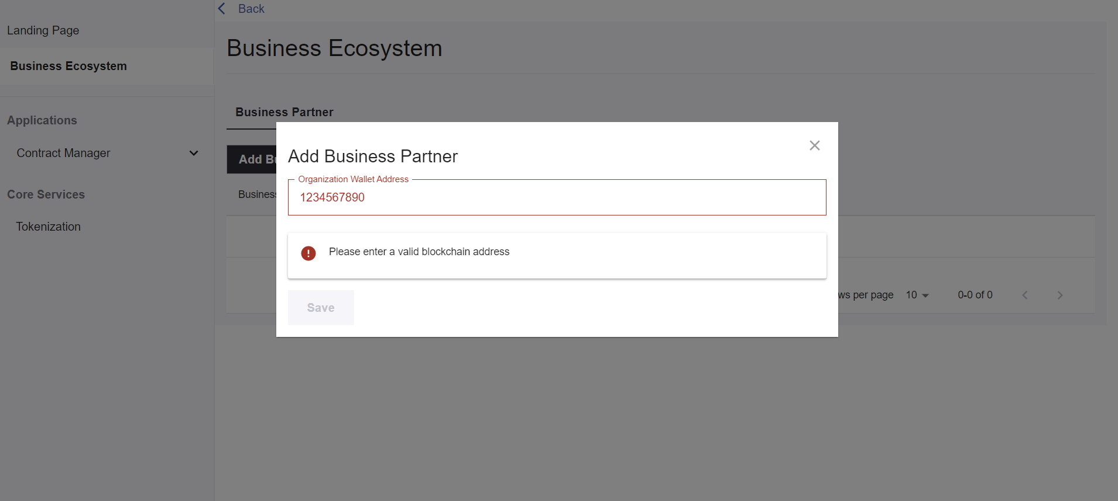

Note : An Ethereum address is a 42-character hexadecimal address derived from the last 20 bytes of the public key controlling the account with 0x appended in front. e.g., 0x71C7656EC7ab88b098defB751B7401B5f6d8976F.

If partner address is not found in the users database :

This msg will showing :

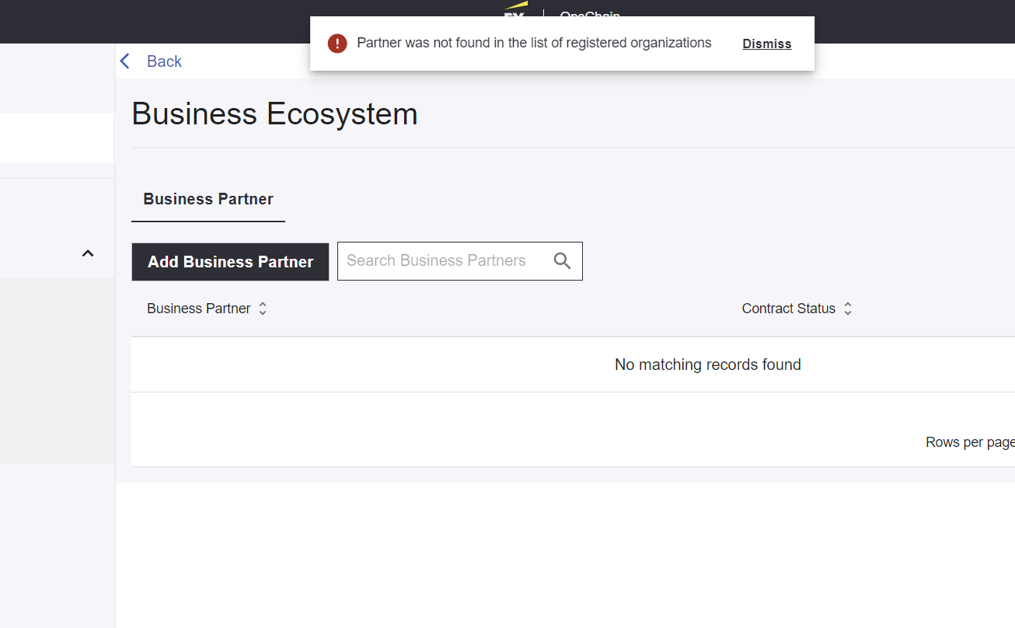

We need to add option to send invitation link via email with this msg : partner not registered, No worries send them invitation email to Join SERA

Enter partner email address “Test box”

Once invitation is sent partner will be asked that he is invited by “ X company” to register on SERA.

1. Authorized parties

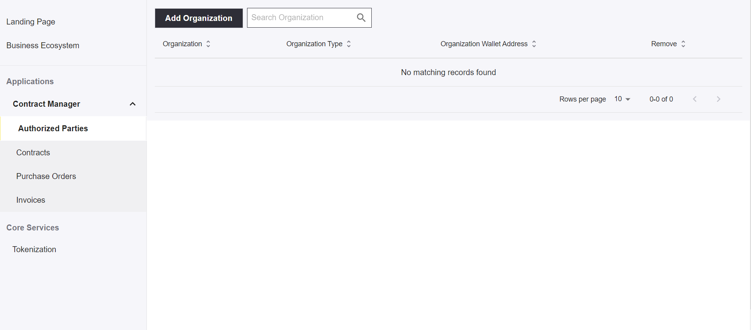

Add organization button :

Under organization type :

1. Contracts button :

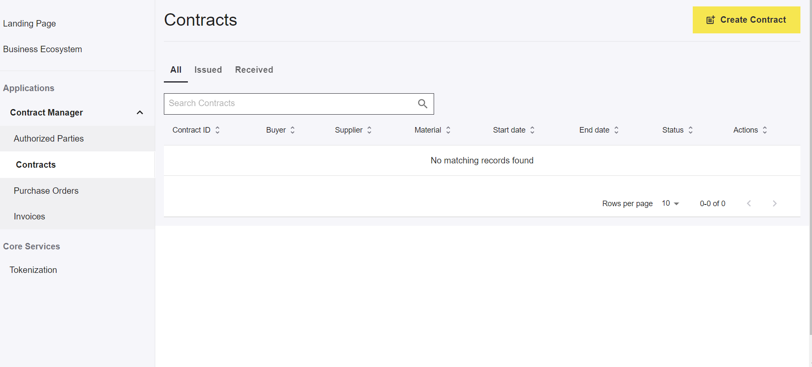

1. Create contract Button :

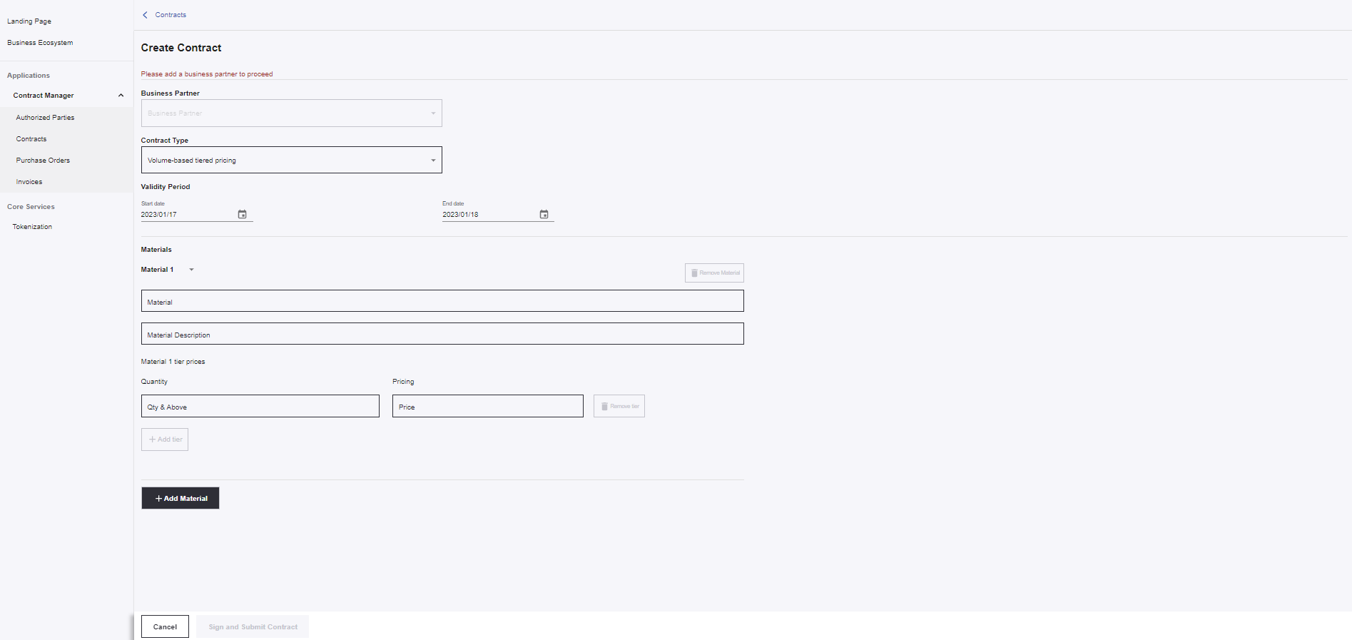

1. Under purchase order button :

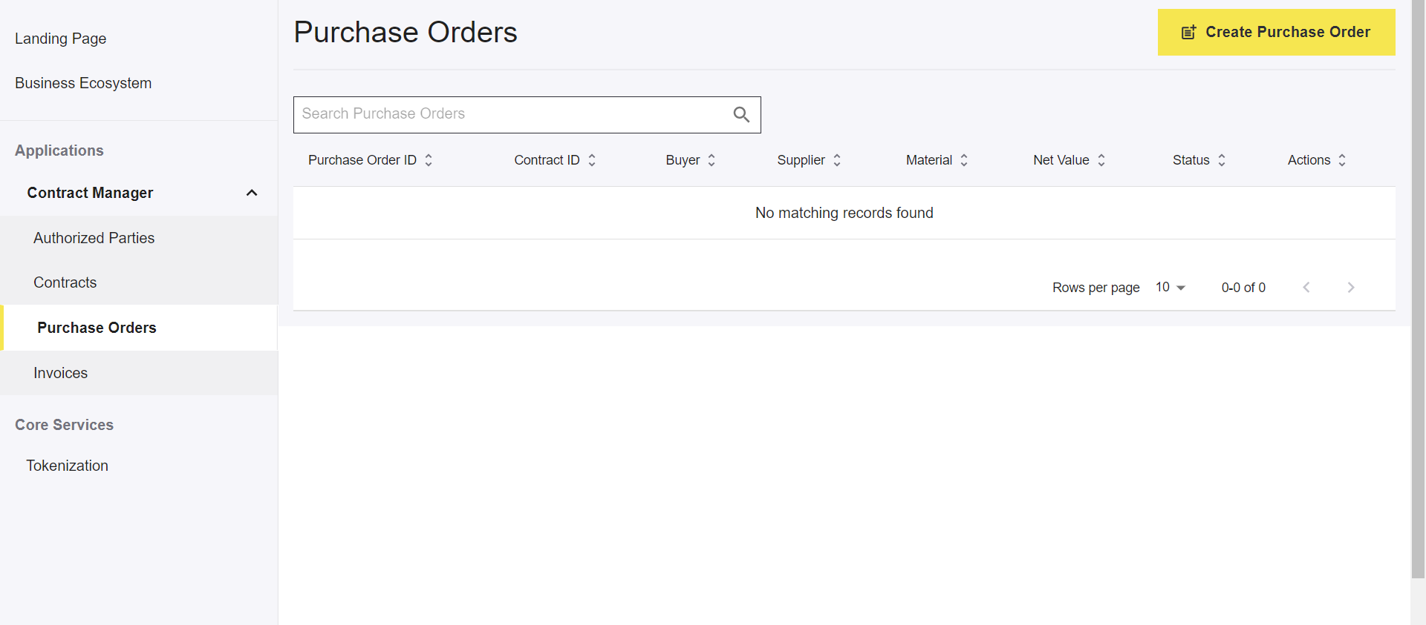

1. Under create purchase order button :

1. Under invoice button :

1. Under issue invoice button:

1. Under tokenization button:

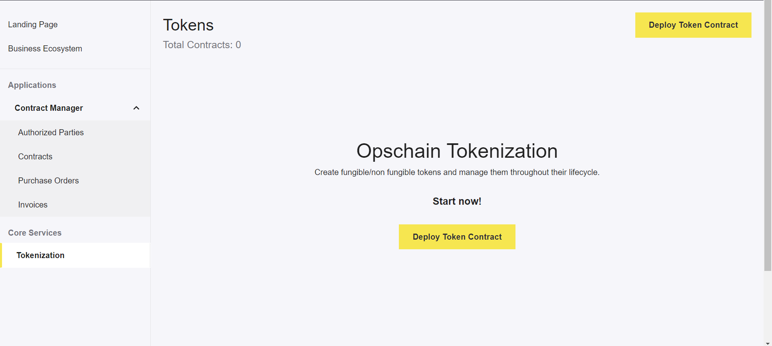

1. Under deploy token contract:

Under select contract type:

