**Members**

Jeremy, Andrea, and Jude

**Project Description**

An automated mentorship platform for navigating the transition to college or career change by curating a range of useful media. The scope and specificity of the media provided will change in accordance with the user’s comfort level, starting from complete uncertainty and growing to specific career fields/academic avenues.

**APIs**

YouTube, articles, podcasts, and other information resources

**Tasks**

For Thursday, September 1st

**Jeremy –** Researching infographics, artiles, and information resources API. Possibly some code to see if/how these APIs function.

**Andrea –** Cleaner wireframe/website skeleton. Generating GitHub repo.

**Jude –** Youtube, Podcast, other media information resources APIs. Possibly comes code to see if/how these API’s function.

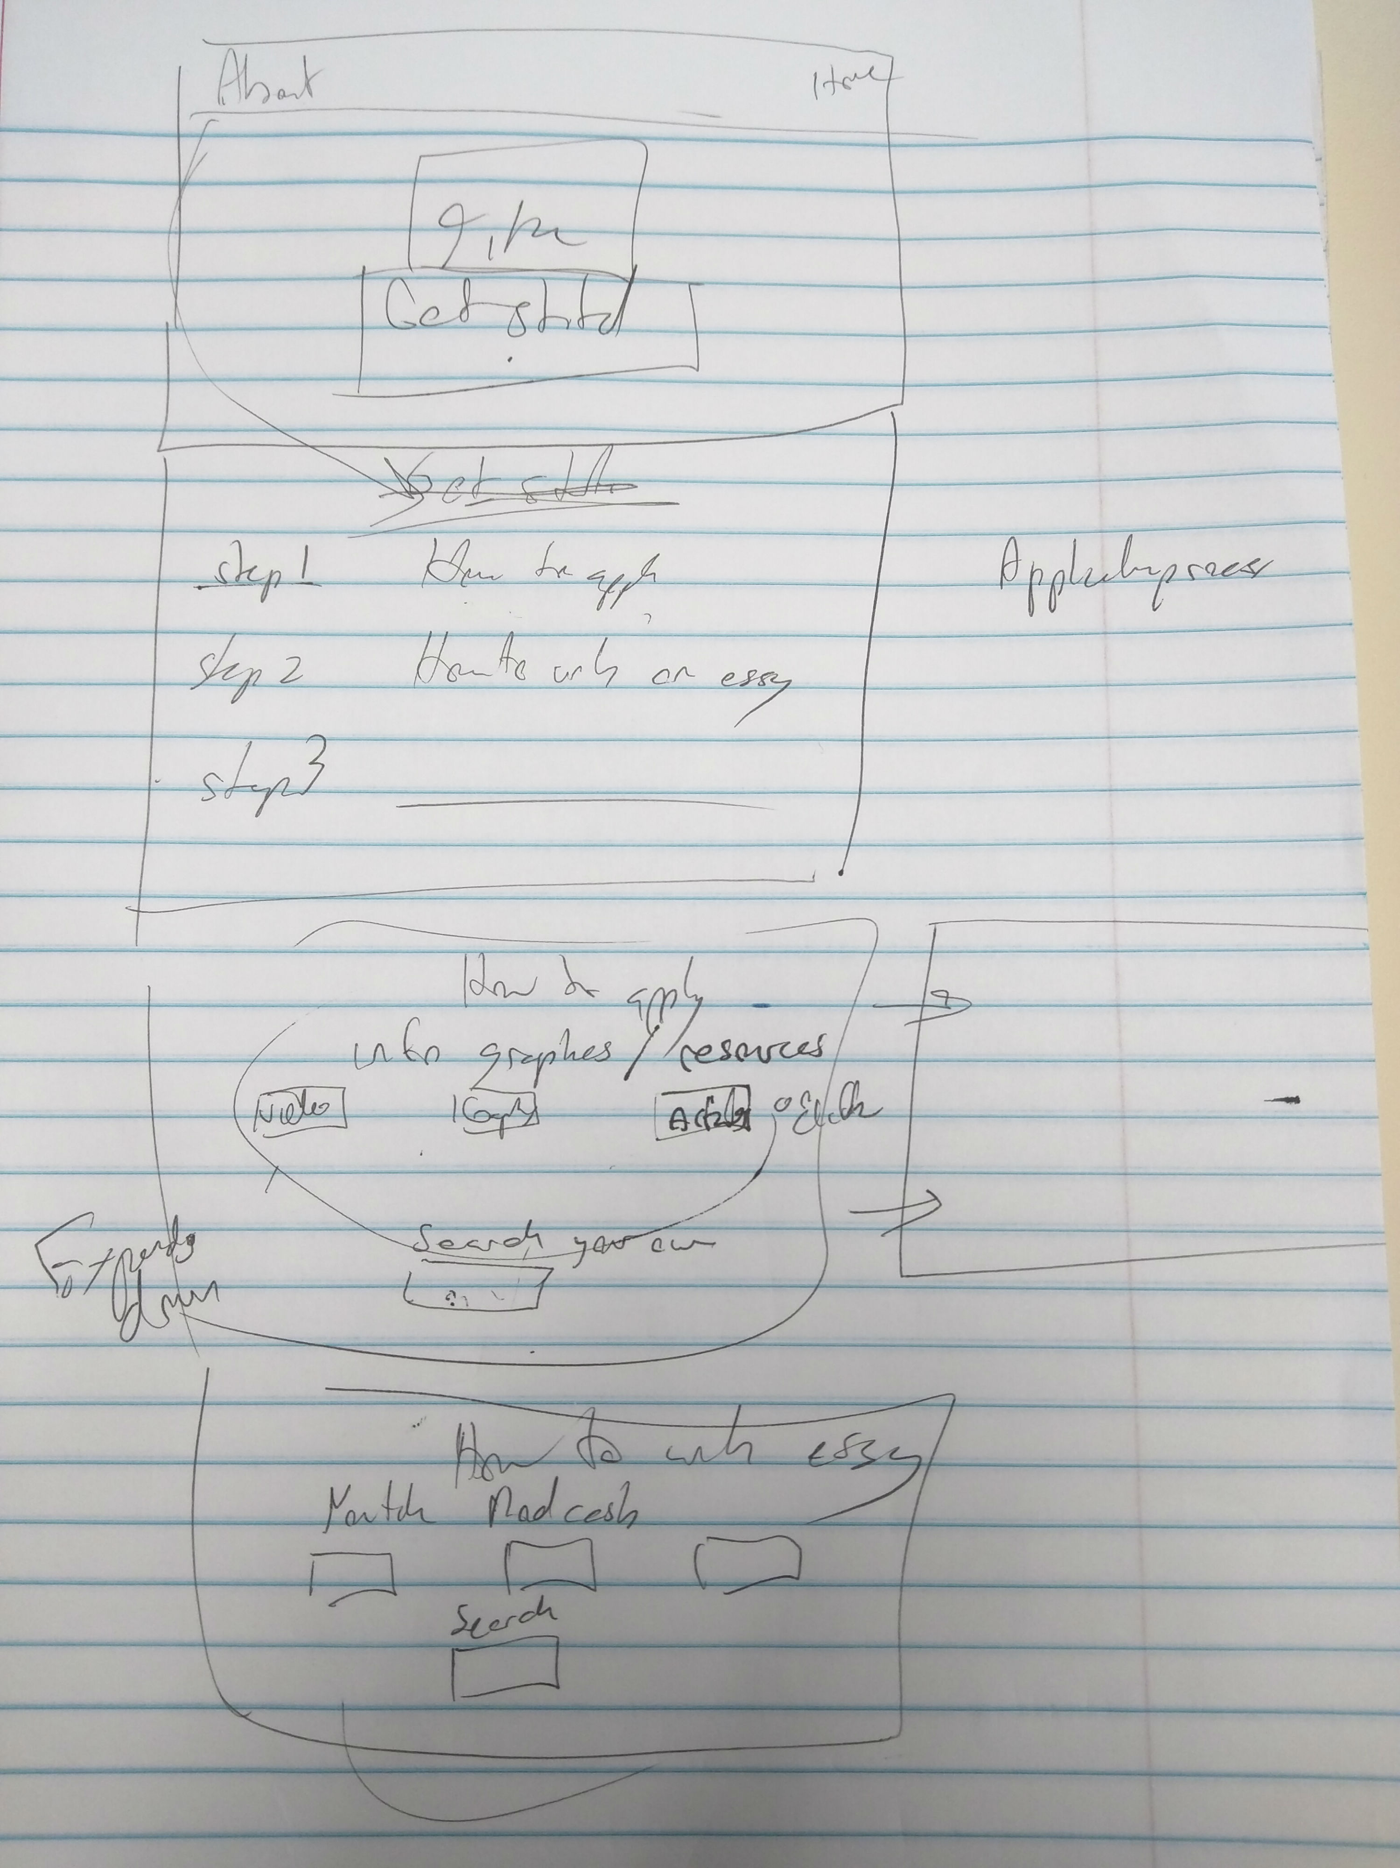

**YouTube**

* https://developers.google.com/youtube/v3/getting-started

**Podcast**

Other media information resources APIs:

**Messanger API**

* https://firebase.google.com/docs/cloud-messaging/

**Quora API**

* https://github.com/csu/quora-api
* http://quora.christopher.su (base url)
* http://quora.christopher.su/questions/<question>
* http://quora.christopher.su/answers/<answer_short_link>

**IPEDS** (Not an API, but can download dataset and host it on server to deliver – note max of 250 variables per report… likely not a great source to use, but unable to find better API for university info)

**US Department of Education**

* <http://www.ed.gov/developer>

**Wikipedia**

* <http://www.programmableweb.com/api/wikipedia>

**Reddit** (possibly useful for ground-level info on the university/career path)

* <http://www.programmableweb.com/api/reddit>

Possibly comes code to see if/how these API’s function.