**Investment Homework I**

*Author: Xingqi Li, Yue Zhao*

**1. (a)**

The following five figures show the time series plot and density plot for the five factors

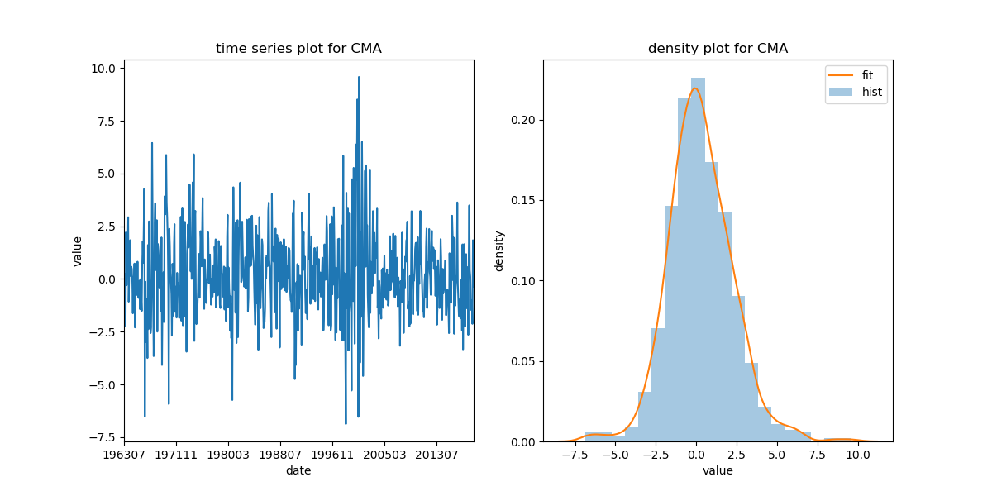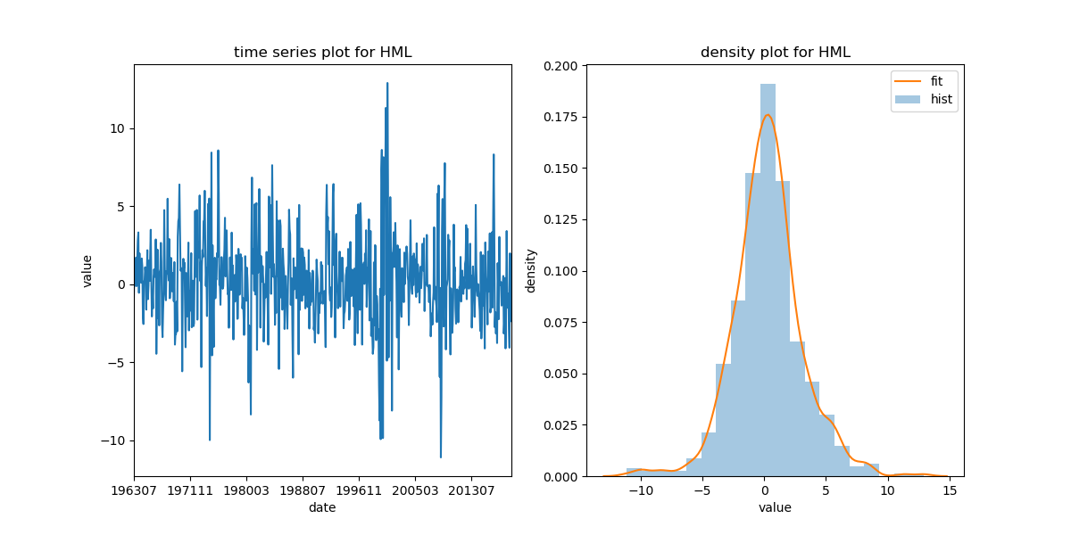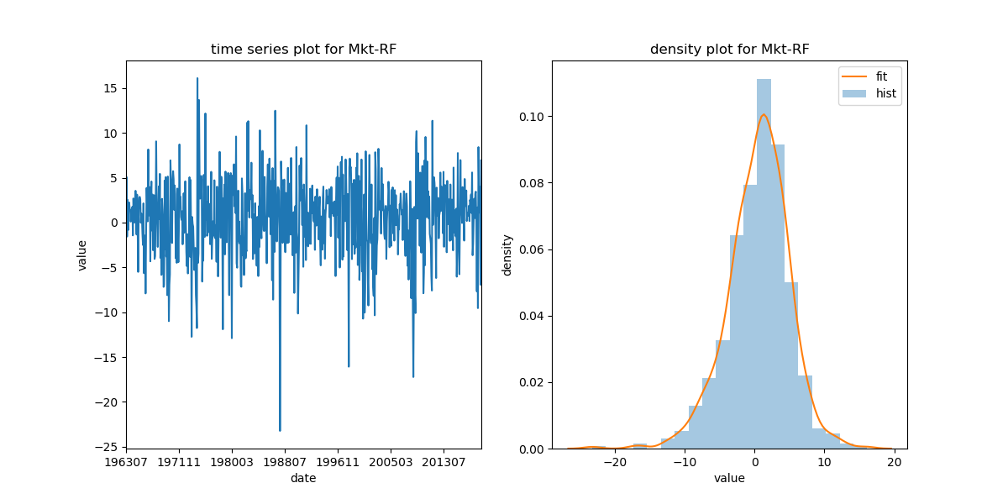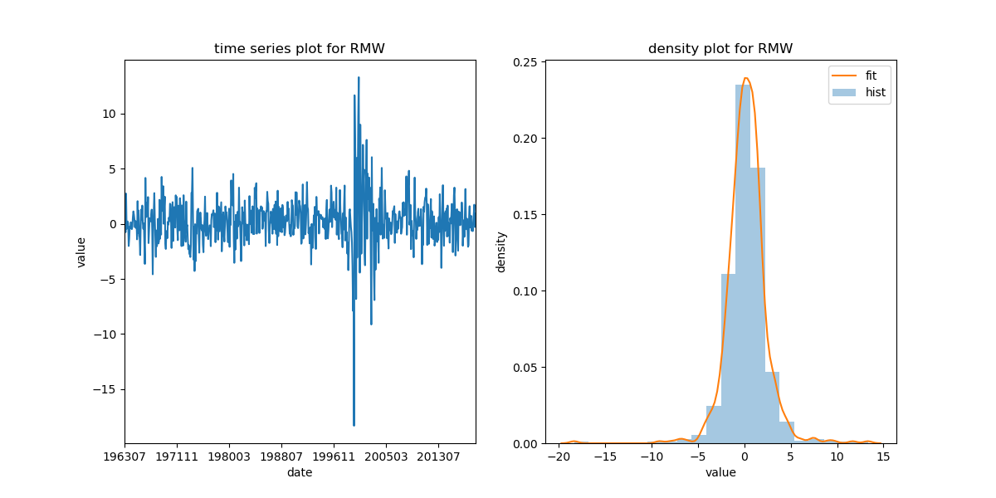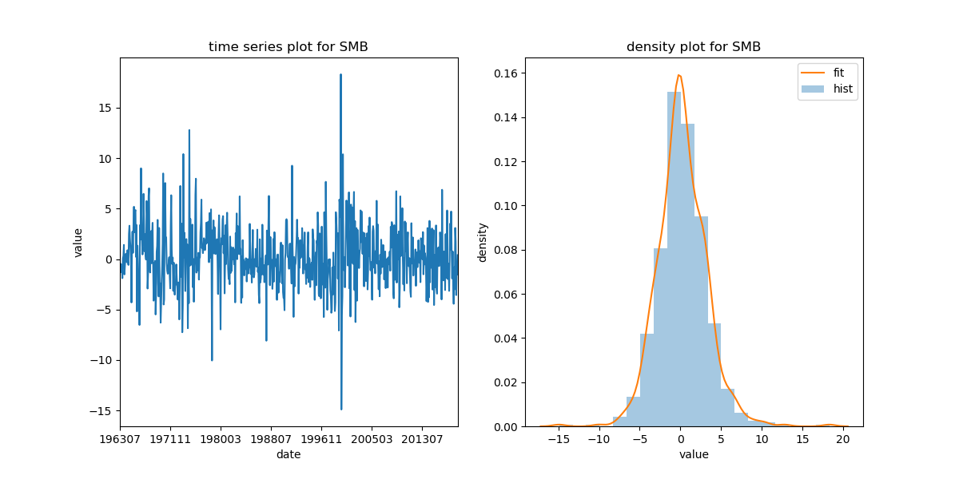

From the time series plots, we find that there is no significant trend or seasonality in these factors. Meanwhile, the factors do not have constant variance, which suggests that they may not be stationary.

From the density plots, we find that all the factors are nearly normal distributed. The SMB, RMW, HML and CMA factors distribute more normally, while the Mkt-RF factor is most left skewed.

|  |  |  |  |  |  |
| --- | --- | --- | --- | --- | --- |
|  | Mkt-RF | SMB | HML | RMW | CMA |
| Mkt-RF | 1.0000 | 0.2763 | -0.2554 | -0.2273 | -0.3866 |
| SMB | 0.2763 | 1.0000 | -0.0681 | -0.3475 | -0.1053 |
| HML | -0.2554 | -0.0681 | 1.0000 | 0.0610 | 0.6930 |
| RMW | -0.2273 | -0.3475 | 0.0610 | 1.0000 | -0.0374 |
| CMA | -0.3866 | -0.1053 | 0.6930 | -0.0374 | 1.0000 |

The table above is the correlation matrix of the five factors. We find that the CMA and HML factors have highest correlation coefficient, which is nearly 0.7. The correlation between other pairs of factors is relatively small.

**1. (b).**

Let PT denotes contractions, TP denotes expansions. The averages and SDs of factors conditional on economic cycles are shown below

|  |  |  |  |  |  |
| --- | --- | --- | --- | --- | --- |
|  | Mkt-RF | SMB | HML | RMW | CMA |
| average PT | -1.2431 | -0.0617 | 0.6452 | 0.3969 | 0.8601 |
| average TP | 0.6788 | 0.3412 | 0.3621 | 0.2632 | 0.2275 |
| SD PT | 6.5772 | 3.6928 | 3.7805 | 2.2017 | 2.6220 |
| SD TP | 3.9730 | 3.0193 | 2.6944 | 2.2933 | 1.9701 |

From the table, we find that during contractions, Mkt-RF and SMB have lower average value than during expansions. However, HML, RMW and CMA are in the opposite situation. As for the SDs, all the factors except RMW have lower volatilities during expansions, while the SDs of RMW during contractions and expansions are roughly the same.

**2.**

**## todo Yue Zhao**

**3.**

**## todo together**