Software Requirements Specification

for

Science & Tech Fest

Version 1.0 approved

Prepared by Kasiet Ryspaeva

Science & Tech Fest

10/09/2019

|  |  |  |  |
| --- | --- | --- | --- |
| **Name** | **Date** | **Reason For Changes** | **Version** |
| W1 | 17/09/19 | Demo version released |  |
| W1 | 19/09/19 | Update design |  |

Table of Contents

Table of Contents 2

Revision History 2

1. Introduction 1
   1. Purpose 1
   2. Document Conventions 1
   3. Product Scope 1
   4. References 1
2. Overall Description 1
   1. Product Perspective 1
   2. Product Functions 2
   3. User Classes and Characteristics. Speakers: All Speakers should have a registration at least a 5 days before and highlight his/her status as “Speaker” . Participants: No matter of age, nationality and status can apply at least a day before of this Fest. 2
   4. Operating Environment 2
   5. Design and Implementation Constraints 2
   6. User Documentation 2
   7. Assumptions and Dependencies 3
3. External Interface Requirements 3
   1. User Interfaces 3
   2. Hardware Interfaces 3
   3. Software Interfaces 3
   4. Communications Interfaces 4
4. System Features 4
   1. Using no backend 4
5. Other Nonfunctional Requirements 4
   1. Performance Requirements 4
   2. Safety Requirements 4
   3. Security Requirements 4
   4. Software Quality Attributes 4
   5. Business Rules 5
6. Other Requirements 5

Appendix A: Glossary 5

Appendix B: Analysis Models 5

Appendix C: To Be Determined List 5

Revision History

# Introduction

## Purpose

*The purpose of this project is to inform people about great fest “Science and Tech Fest”. In order to save time, money, resources, avoid false information, bots and malware*.

## Document Conventions

Font of Bold text is Times (Shows the topic of each one) size is 14 ; for text is Arial and size is 11. Document consist of 6 pages, 1st page is title page, 2nd page is overview page.

**Intended Audience and Reading Suggestions**

Reader that the document is intended for, are developers, project managers, users, testers, and documentation writers. We highly suggest to read the document, beginning with the overview sections and proceeding through each section and read carefully.

## Product Scope

Project goals:

1. Share information about the upcoming festival

Project objectives:

1. Agile

This project presents information about Tech and Science Festival. Project made in the form of a web-site. The site is put on the Internet using GitHub Pages. Website is open source project. It is available for all devices.

## References

This document and demo version are stored in the web browser:

https://techsciencefest.github.io/

# Overall Description

## Product Perspective

This site presents information about Tech and Science Festival. Project made in the form of a web-site. The site is put on the Internet using GitHub Pages. Website is open source project. It is available for all devices.

## Product Functions

1. Single-page site
2. 5 sections
   1. About festival
   2. Schedule
   3. Speakers
   4. Sponsors
   5. Contacts
3. Registration ability
4. Google map which show location of festival

## User Classes and Characteristics. Speakers: All Speakers should have a registration at least a 5 days before and highlight his/her status as “Speaker” . Participants: No matter of age, nationality and status can apply at least a day before of this Fest.

## Operating Environment

1. The software runs on PCs, laptops, mobile phones, all types of OS and phone types.

## Design and Implementation Constraints

Project made only by fronted side. To deploy project we used GitHub Pages.

## User Documentation

In repository exist two documentations: Software Requirements and Developer’s Documentation.  
Also in website <https://techsciencefest.github.io> exist contact section where user can ask. Actually, website use UI and it is client oriented.

In addition, we used user stories which made in [www.easybacklog.com](http://www.easybacklog.com)  
Here is screen of user stories: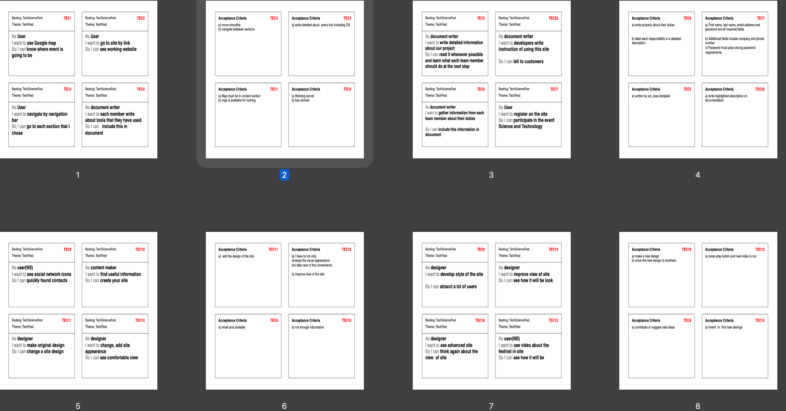

## Assumptions and Dependencies

In future we plan to use Django Backend to sign up users in website.

Add JavaScipt’s scripts to make website more attractive.

# External Interface Requirements

## User Interfaces

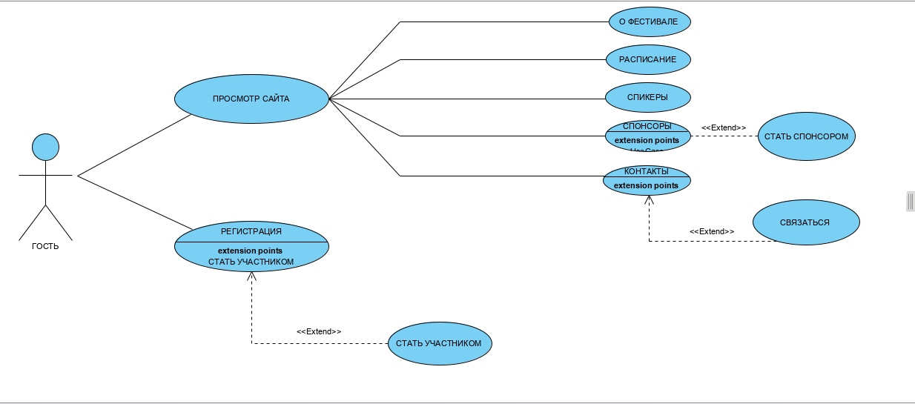

## Hardware Interfaces

Interface made by Bootstrap. The sections in navigation bar connected by links in HTML file.   
Connect with festival owner and social media icons use links from another websites.

Location shown by Google Map at the bottom of website.

## Software Interfaces

Bootstrap 4 - used to make website adaptive to all devices

GitHub Pages - used to deploy project

Google Map - used to show location

Google Form - used to replace backend poll function

## Communications Interfaces

1. Get daily report from each team member
2. Checking Git repository (including comments and issues)
3. Communicate in Telegram group which is used specially for this project

# System Features

## Using no backend

We use only Frontend side of developing to save developing time. We replace some features with ready solutions. For example “Connect” link.

4.1.1 Description and Priority

It has high priority. Because of short time to create project.

The project is making for study and practice purposes.

Amount of required money 0

Amount of spent money 0

# Other Nonfunctional Requirements

## Performance Requirements

Main colours of website are red, white and black. Project requires combination of colours with pictures. For example: Bright with Dark.

No Gradient in project or you need to redesign it.

## Safety Requirements

Project is in open-source repository to use free domain. So, it is risk to be in spam category become.

## Security Requirements

Don’t put any secret and private information. Project is in public GitHub repository.

## Software Quality Attributes

Project must have intuitive interface. Website must be adaptive in all devices. Must be available to users all time.

## Business Rules

Project Manager: The project manager is responsible for creating the project plan (with input from those doing the work), managing risks, running the weekly team meeting and providing monthly status reports to senior management.

Documentation: The documentation manager is responsible for writing and editing documentation of website project.

Front-end developer: The front-end developer is responsible for writing of code and supporting project

QA:The QA is responsible for testing, running and debugging the results of the written code.

Designer:The designer is responsible for making visual effects on website.

Content maker: The content maker is responsible for making content of project.

# Other Requirements

Project must be in independent Gmail to have availability to share project to another developers.

Appendix A: Glossary

Any acronyms and abbreviations have not used .

Appendix B: Analysis Models

To connect with administration of Festival we used 4 forms:

1. Email Address
2. Name
3. Phone Number
4. Message

First and Second ones are required to fill them.

Appendix C: To Be Determined List

QA: Quality Assurance  
GitHub: [www.Github.com](http://www.Github.com)

Bootstrap: Library that helps to developers [www.getbootstrap.com](http://www.getbootstrap.com)

PC: Personal Computer