Disease Prediction System

ITS307 DATA ANALYTICS

BACHELOR OF SCIENCE IN INFORMATION TECHNOLOGY (YEAR III, SEMESTER I)

**RESEARCHER (S)**

PEMA DENDUP (12200070)

SONAM PELKI (12200081)

UGYEN KEZANG (1222094)

UGYEN LHAMO (12200095)

**GUIDED BY**

NIMA DEMA

*Gyalpozhing College of Information Technology Gyalpozhing, Mongar*

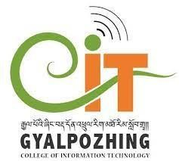

1. Problem statement

The traditional approach of diagnosis entails a patient visiting a doctor, undergoing many medical tests, and then reaching a conclusion. This process is time-consuming and indolence people may ignore the checkup.

* 1. Aims

To propose an automated disease prediction system.

* 1. Scope and Limitations

1. User Scope:

* World

1. System Scope:

* Website (online)
* Phone
* Laptop

1. Limitations:

* Limited Disease Prediction:   
  The model predicts Diabetes and Heart Disease. All the diseases cannot be predicted.
* No Recommendation:   
  The model just predicts the disease. There will be no recommendation of what to do after predicting the disease.