

**Proposal**

**For**

**Year Project**

**Bachelor of Science in Information Technology**

**Gyalpozhing College Facility Booking System**

**Submitted by**

**Madav Dhaurali(12200064)**

**Karma Nima(12200051)**

**Dorji Wangda(12200044)**

**Kinzang Wangchuk(12190062)**

**Sonam Pelki(12200081)**

**Sonam Wangchuk(12200083)**

**Gyalpozhing College of Information Technology**

**Read carefully before filling the form.**

1. Please do not alter the layout of the application form. Information must be filled in the spaces provided, under set format. 2. Guidance notes in various fields should not be deleted. 3. Required information should be duly filled in the specified fields.

**Guidelines and Forms**

**Submission Procedure**

Duly filled proposal forms completed in all respects should be submitted in form of soft copy in the VLE. On receipt of the applications the proposals will be evaluated by the examiner and proposal would then be defended by student groups. The project group may need to revise the proposal in light of the examiner’s recommendations.

**For further information, please contact:**

Module Coordinator

Tshering

tshering.gcit@rub.edu.bt

**Table of Contents**

Description Page #

**Note:** To update the table of contents, right click in the table and select ‘*update field*’ and then select ‘Update Entire Table’.

**Table of Contents**

**1. Project Identification** **5**

1.1 Reference Number 5

1.2 Problem statement 5

1.3 Project Title: 5

1.4 Key Words: 6

1.5 Project Guide: 6

1.6 Project Duration: 7

**2. Aims, Goals, Objectives and scope of the Project** **7**

2.1 Aims of the Project: 7

2.2 Goals of the Project: 7

2.3 Objectives of the Project: 7

2.4 Scope of the Project: 8

**3. Project features** **8**

3.1 Background 8

3.2 Literature Review: 9

3.3 Requirements 10

3.3.1 Software Requirements 10

3.4 Technology 10

3.5 System Architecture 10

3.5.1 System Design 10

3.5.2 Workflow 10

**3.6 Deployment** **11**

**4. Team Members Role** **12**

**5. Examiner Comments** **14**

**6. Project Schedule / Milestone Chart /Work plan** **15**

**7. Bibliography** **16**

**Application for the Project**

#### 1. Project Identification

| 1.1 Reference Number **4th_Year_Module_groupNo_2**  (for office use only) |
| --- |
| 1.2 Problem statement ***(Please refer here on how to write a problem statement.)***  In order to effectively manage and coordinate the booking of its numerous facilities, GCIT College, a college of higher learning in information technology, has difficulties. Included in these amenities are a football field, guest house, conference room, basketball court, MPH (for concerts and indoor sports), volleyball, badminton, table tennis, and college transportation services (buses and Hilux truck). Due to the time-consuming, prone to mistakes, and opaque nature of the present manual booking procedure, schedule problems, resource waste, and staff and student annoyance result.  For GCIT College, we recommend creating and putting into use a thorough facility booking system. The system will provide a simplified, user-friendly platform for scheduling and administering college amenities while addressing the aforementioned issues. |
| 1.3 **Project Title:** ***(Provide a concise, accurate and informative title which immediately orientates your reader to the focus of your project.)*** Gyalpozhing College Facility Booking System. |
| 1.4 Key Words: *(Please provide a maximum of 5 key words that describe the project. The key words will be incorporated in our database.)*   * GCIT * Facility Reservation * Venue Booking * Book My Space * Facility Finder * QuickReserve |

| 1.5 **Project Guide:**  Name: Sonam Pemo  Designation: Associate Lecturer  Mobile # : 77634941 Tel. # :  Email: sonampemo.gcit@rub.edu.bt |
| --- |
| **1.4.1. Project examiner 1:**  Name:  Designation:  Mobile # : Tel. # :  Email: |
| **1.4.2. Project examiner 2:**  Name:  Designation:  Mobile # : Mobile # :  Email: |

| 1.6 **Project Duration:**  Starting Date: 15-08-2023  Completion Date: 23-11-2023 |
| --- |

#### 2. Aims, Goals, Objectives and scope of the Project

| 2.1 Aims of the Project: The project sets out to revolutionise GCIT College by developing an innovative online platform that effortlessly manages facility bookings. |
| --- |
| 2.2 Goals of the Project:  * Develop a user-friendly online system for seamless facility bookings at GCIT College. * Optimise resource utilisation and user experience by minimising conflicts and enhancing scheduling efficiency. |
| 2.3 Objectives of the Project:  * Automated Booking Process: Implement an automated facility booking process that eliminates manual intervention, reducing administrative workload and accelerating the reservation procedure. * User-Centric Interface: Design a user-friendly interface catering to different user roles, enabling easy booking, modification, and cancellation of facility reservations. * Conflict Resolution Algorithm: Develop an intelligent scheduling algorithm that prevents scheduling conflicts, ensuring smooth and efficient utilisation of college facilities. * Seamless Integration: Integrate the facility booking system with popular calendar applications, allowing users to effortlessly synchronise their bookings with their personal schedules, enhancing convenience and coordination. |
| 2.4 Scope of the Project:The scope of the project is within Gyelposhing College of Information Technology. |

#### 3. Project features

##### 3.1 Background

*(Explains why you are doing the project. It provides a brief overview of the background to the project and establishes a particular area, or problem, that needs to be investigated further. It provides a clear statement of the topic of the proposed work.)*

In the dynamic landscape of education, where seamless operations and exceptional user experiences are paramount, GCIT College stands as a beacon of learning and progress. However, even in its pursuit of excellence, the institution faces the challenge of efficiently managing its myriad facilities. The current manual booking process often falls short of meeting the institution's ambitions. Scheduling conflicts, wasted resources, and frustration among students, faculty, and staff have cast a shadow on the otherwise vibrant campus. In response to this clarion call for innovation, the proposal for a Facility Booking System emerges as a game-changer, promising a new era of efficiency, transparency, and harmony within the college's daily operations.

Envisioned as more than just a technological advancement, this project holds the promise of transforming the very core of how GCIT College functions. The Facility Booking System seeks to weave together the threads of automation and accessibility, uniting them into a tapestry of streamlined processes. As the world advances, so should the tools of academia; the proposed platform stands as a testament to this ideology. By offering an intuitive user interface that empowers students, faculty, and staff to effortlessly reserve spaces, make modifications, and receive timely notifications, the project aims to create an ecosystem of seamless coordination. With a keen focus on innovation, inclusivity, and forward-thinking, this initiative aspires to not only resolve the challenges of the past but also to elevate the college's reputation as a beacon of modern education in the digital age.

##### 3.2 Literature Review:

*(Detailed review of what all has been done internationally in the proposed area quoting references and bibliography. This section demonstrates the evolution of Technology, the depth of the project team literature search and builds the confidence of the evaluators about capability of the team in achieving the stated objectives.)*

Case Study 1: Harvard University's RoomBook System

Background: Harvard University, renowned for its academic excellence, faced challenges in efficiently managing its extensive array of facilities. The traditional booking process led to confusion, double-bookings, and suboptimal resource usage.

Solution: Harvard developed the RoomBook system, an advanced facility booking website. The system integrated with the university's existing infrastructure, allowing students and faculty to easily check room availability, book spaces, and receive confirmations. The platform employed an algorithm to prevent scheduling conflicts, optimising room utilisation.

Impact: The RoomBook system transformed the facility management landscape at Harvard. Students and staff could effortlessly find suitable spaces for lectures, meetings, and events, reducing time wasted on manual coordination. This improved resource allocation and increased overall satisfaction within the university community.

Case Study 2: University of California, Berkeley's Event Services

Background: The University of California, Berkeley, with its diverse range of events and activities, struggled to efficiently manage its facilities. The manual booking process resulted in inefficiencies, event clashes, and limited transparency.

Solution: UC Berkeley introduced an Event Services platform, a comprehensive facility booking website. The platform allowed students, faculty, and external organisers to browse available venues, submit booking requests, and receive automated confirmations. The system included features for event planning, equipment requests, and catering coordination.

Impact: The Event Services platform streamlined the event management process. With easy access to venue information and availability, event organisers could plan and schedule seamlessly. The system's integration with other university systems enhanced coordination, leading to fewer scheduling conflicts and improved resource utilisation.

Key Takeaways: These case studies highlight how leading universities have successfully addressed facility management challenges through dedicated booking platforms. These systems have not only improved resource allocation and scheduling but have also enhanced the overall user experience, demonstrating the potential benefits of adopting a similar approach for GCIT College.

##### 3.3 Requirements

###### 3.3.1 Software Requirements

1. **Functional Requirements**

1. User-Friendly Interface:

* The intuitive and easy-to-navigate user interface for seamless booking and management of facilities.
* Responsive design for access from various devices, including desktops, tablets, and smartphones.

2. Facility Availability and Scheduling:

* Real-time availability display of facilities, allowing users to see open time slots.
* Calendar view for users to visualise and select desired booking dates and times.
* Option to check for recurring bookings and set booking durations.

3. Role-Based Access:

* Different user roles (students, faculty, staff) with specific permissions for facility booking and management.
* Administrative control to review and approve bookings, if required.

4. Customizable Booking Requests:

* Users can provide specific details for their booking requests, such as the purpose of booking, equipment needed, and expected attendance.

5. Automated Confirmations and Reminders:

* Automated email confirmations upon successful booking.
* System-generated reminders for upcoming bookings.

6. Cancellations and Modifications:

* Users can easily cancel or modify their bookings within a specified timeframe.

7. Resource Allocation and Reporting:

* Generate reports on facility usage, popular booking times, and utilisation trends.
* Monitor resource allocation and optimise facility management based on usage patterns.

8. Integration with College Calendar:

* Seamless integration with the college's academic calendar to avoid clashes with academic activities.

10. Feedback System:

* Users can provide feedback for facilities they have booked, helping to maintain quality standards.

11. Support and Help Center:

* Access to a comprehensive help centre and customer support for any issues or inquiries related to the booking system.

1. **Non-Functional Requirements**

1. Scalability:

* The system should be able to handle a growing number of users and bookings without performance degradation.

2. Security:

* Ensure data security through encryption and access controls.
* Regular data backups to prevent data loss.

3. Reliability:

* High system uptime to minimise disruptions in facility booking services.
* Regular maintenance and updates to address potential issues and vulnerabilities.

4. User Training and Onboarding:

* Provide training resources and documentation for users to easily understand and utilise the system.

5. Compliance:

* Ensure compliance with relevant data protection and privacy regulations.

6. Performance:

* Fast response times for user interactions and booking requests.

##### 3.4 Technology

**Front-End Technology:**

* HTML: The project will use HTML for structuring the web pages, creating a foundation for displaying content and user interfaces.
* CSS: Cascading Style Sheets (CSS) will be employed to design and style the user interface, ensuring a visually appealing and consistent look across the platform.
* JavaScript (JS): JS will be utilised for implementing interactive elements, enhancing user engagement, and enabling real-time updates on the front end.
* Bootstrap: The use of the Bootstrap framework will provide responsive design components and pre-styled elements, expediting the development process and ensuring compatibility across various devices and screen sizes.

**Back-End Technology:**

* Programming Language: PHP will serve as the primary programming language for the back end, handling server-side logic and processing user requests. It will facilitate dynamic content generation and interactions with the database.
* Database: MySQL will be employed as the relational database management system to store and manage data related to facility bookings, user information, availability, and more. It will enable efficient data retrieval and manipulation.

##### 3.5 System Architecture

###### 3.5.1 System Design

The Facility Booking System will adopt a scalable and modular architecture to ensure efficient resource management and a seamless user experience. The architecture will consist of multiple layers, each responsible for specific functionalities, ensuring separation of concerns and ease of maintenance.

1. Presentation Layer:

This layer encompasses the user interface and user interaction components.

* User Interface: Developed using HTML, CSS, JavaScript, and Bootstrap, it provides a responsive and user-friendly front-end for users to access the system.
* Booking Interface: Users can select facilities, specify booking details, and submit requests through an intuitive interface.

2. Application Layer:

The application layer handles the core application logic and acts as an intermediary between the presentation and data layers.

* API Services: RESTful APIs, developed using PHP, facilitate communication between the front-end and back-end. They manage booking requests, availability checks, and interactions with the database.
* Scheduling Algorithm: This layer incorporates an intelligent algorithm to prevent double-bookings, optimise facility usage, and resolve scheduling conflicts.

3. Data Layer:

The data layer manages the storage and retrieval of application data.

* Database Management: Utilises MySQL to store information about users, facilities, bookings, availability, and more.
* Database Access: APIs interact with the database for data retrieval, storage, and updates.

###### 3.5.2 Workflow

User workflow

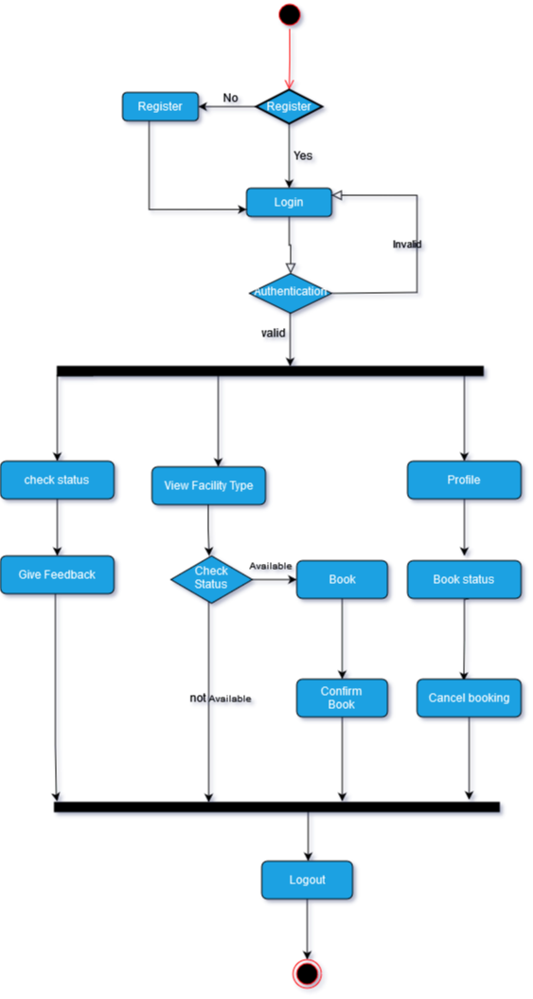

To begin using the website, the user must first register. After completing registration, the user must connect to their account for validation. After validation, the user has full access to all features.After successfully logging in, the user can check to see if the amenities are available. They can be booked if they are available. We also offer cancellation services to our customers. They can then log out of the website.

Admin Workflow

#### 

To begin, the administrator must log in. If the login is invalid, the administrator must try again. Once the login is successful, the administrator can access several features, including adding facilities, modifying facility details, viewing feedback and ratings, and checking the status of bookings. With the check status feature, the administrator can confirm or decline a booking based on availability. This will update the status and send an email notification to the user to inform them of the decision.

#### 

#### 3.6 Deployment

**serv00.com**

The websites at Serv00.com are powered by an efficient NGiNX server. Additional modules allow you to use the "standard" .htaccess. You can easily edit rewrite rules or autoindex templates, And the proprietary solution of the ADMIN.NET.PL company. A transparent cache ensures an amazing speed of loading pages.

One account at Serv00.com allows you to host more than one website. Configuration is possible using the DevilWeb web panel and by SHELL using the devil www module.

#### 4. Team Members Role

| 4.1 **Sonam Pelki (Backend Developer)** |
| --- |
| 4.2 **Sonam Wangchuk(Backend Developer)** |
| 4.3 **Kinzang Wangchuk(Frontend Developer)** |
| 4.4 **Madav Dhaurali(Frontend Developer and Project lead)** |
| 4.5 **Dorji Wangda(UI/UX and frontend Developer)** |
| 4.6 **Karma Nima( UI/UX and Backend developer)** |

#### 5. Examiner Comments

|  |
| --- |

#### 6. Project Schedule / Milestone Chart /Work plan

*[describes what you will do. It is a plan of the tasks which will enable you to achieve the stated aims of your project. To devise a plan, you need to break the project down into a series of steps or stages, and you then outline the tasks within each stage. The project plan should also include a timetable in which you plan the timing for the main tasks. This timetable can help to keep you on track throughout the project. The plan may also include a list of the resources required to do the project.]*

*(Project schedule using MS-Project (or similar tools) with all tasks, deliverables, milestones, clearly indicated are preferred. Task should be measured in terms of hours)*

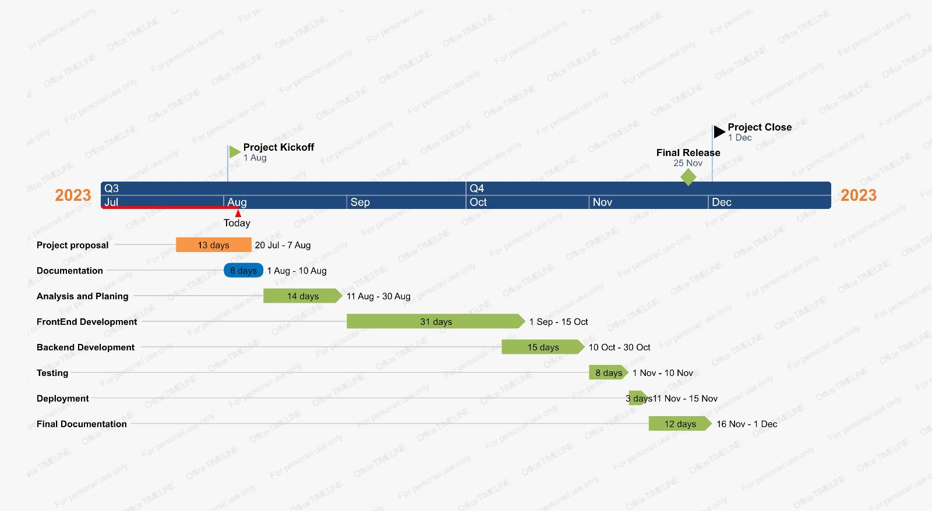

#### 

#### 

#### 

#### 

#### 

#### 7. Bibliography

Advanced Room Search - ESS. (n.d.). Essroombook.fas.harvard.edu. Retrieved August 10, 2023, from <https://essroombook.fas.harvard.edu/search.php>

Home. (n.d.). Event Services. Retrieved August 10, 2023, from https://eventservices.berkeley.edu/