Fine-Tuning the Segment Anything Model (SAM) for Medical Image Segmentation

Ushika Lunawat
Department of Computing
Technologies
SRM Institute of Science and
Technology
Kattankulathur-603203, India
Email: ul2327@srmist.edu.in
Navya Asthana
Department of Computing
Technologies
SRM Institute of Science and
Technology
Kattankulathur-603203, India
Email: na0906@srmist.edu.in
Dr. Prabhu Shankar K C*
Department of Computing
Technologies
SRM Institute of Science and
Technology
Kattankulathur-603203, India
Email: prabushc@srmist.edu.in

Abstract— Getting a precise outline of brain tumors in MRI scans is incredibly important for doctors to figure out what’s happening, decide on treatment, and watch how the illness progresses. Radiologists doing this outlining by hand takes a lot of time and different doctors don’t always agree on exactly where the boundaries are. This is why people are trying to create automatic outlining methods. Large computer vision models that have a lot of general ability, like Segment Anything Model (SAM), have been doing amazingly well on many kinds of image tasks. But, SAM was taught to understand typical photos, and doesn’t work very well on medical scans. Anatomical shapes and how medical images look are very different.
Keywords: Brain tumor segmentation, medical image segmentation, magnetic resonance imaging (MRI), Segment Anything Model (SAM), foundation models, deep learning, fine-tuning, BraTS 2020.

Introduction
Brain tumors are very serious problems with the nervous system and can really mess with how your brain works if you don’t find and deal with them quickly. Doctors use Magnetic Resonance Imaging (MRI) a lot when diagnosing illnesses, because it gets detailed pictures of the brain and anything that’s unusual in it. To properly define the areas of the tumor on an MRI scan is crucial for things doctors do in a hospital, including looking at how the tumor is changing, planning any surgery, and checking if treatment is going well.
For a long time, expert radiologists have had to trace the edges of tumors in scans by hand. Doing this is slow and radiologists can easily differ in where they draw those lines. But artificial intelligence is quickly becoming more common in healthcare and, as a result, scientists are using deep learning to automatically split apart things in medical images.
Convolutional Neural Networks (CNNs), including U-Net and similar designs, are very good at figuring out the boundaries of brain tumors. Yet, even though they work well, they generally need lots and lots of images where the tumors have been labeled by a person, and a huge amount of computer time for learning - and this makes it hard to use them for a wide variety of image issues in medicine.
Computer vision is looking really good thanks to the recent development of big vision foundation models which are trained on tons of data. The Segment Anything Model (SAM) is a large model for segmentation, meaning it can create outlines around anything in a picture, and it does this when you give it a little direction (a ‘prompt’). SAM works very well with normal photos, but isn’t as useful for medical images because medical images have different details in the picture, the way body parts are built, and how the images are created (the imaging method).
This research gets around that problem by suggesting a good way to adjust the SAM system for identifying brain tumors in MRIs. This is done by only retraining the part of SAM that creates the ‘mask’ and keeping the part that looks at the MRI image itself as it is, having already been trained. Because of this, it doesn't need as much computing power, yet the model can still learn what tumor characteristics look like in medical images.

LITERATURE SURVEY
Deep learning, and specifically the way it’s built with ‘encoder-decoder’ structures (U-Net is a great example) has really improved how we section images for medical purposes. U-Net was originally presented by Ronneberger et al. for dividing up biomedical images, and it proved you could get very accurate outlines of each part of the picture even when only a small number of images were labelled by hand [14]. But these kinds of setups do need to be trained for each specific job and they don’t usually perform well with different collections of data or different kinds of imaging. At the same time, Menze et al. created the BraTS evaluation standard for dividing up multimodal MRI scans of brains to locate tumours; it’s now the usual dataset for testing how well automatic brain tumour analysis works [15].
Medical image analysis is looking good with these newer ‘foundation models’. The Segment Anything Model (SAM) which was created for splitting up regular photos, has become very popular because it works well on lots of different kinds of pictures. But Shi and their colleagues found that SAM doesn’t do well at all with medical images if you use it immediately, and this is because of the massive differences between normal photos, and scans or images from the medical field. Therefore, just using SAM on medical imaging isn’t enough, it needs to be adjusted for that specific purpose.
Because of this problem, lots of research has looked at changing SAM to work for figuring out shapes in medical scans. For example, Ma and colleagues created MedSAM which is SAM, after being trained in a big way on medical pictures, and it is better at identifying sections in all sorts of medical areas [6]. Likewise, Dong and others came up with a quicker version of SAM for medical image segmentation, to make it require less computer power; however, this speed improvement meant it wasn’t quite as accurate at finding the boundaries of things [5]. These pieces of work show SAM can be altered for medical use, but they also suggest getting better results usually requires a lot of computing or some changes to the way SAM is built.
A number of studies have looked at ways to adapt with very little data - sometimes just one example - and this reduces how much of it needs to be labelled. Wang and others created a way to examine medical images, using a system that actively chooses which images to show an expert, and with the expert's help, the system 'learns' from only a few examples. It does learn better with limited data, but you need an expert to use it and that limits how easily it can be used in a normal workflow. He and colleagues used a few-shot adaptation approach with foundation models (models which haven’ and been trained) to divide three dimensional medical images into segments, but this was very computationally intensive and required specific types of scans. Yang and many others designed a step-by-step system to adapt and do a few-shot segmentation of medical images, yet they only tested it on images of simple, rounded tumors. Ayzenberg and others made ProtoSAM for one-shot image segmentation of medical images, however it doesn’t work well with tumors that aren't typical in shape.
Lots of research has been aimed at improving how well SAM (Segment Anything Model) works by changing its internal design. Cheng and his team suggested using a hierarchical decoding method to improve SAM’s performance on medical image segmentation, but making the decoder more complex makes it harder to use and train. Li and others linked SAM with nnU-Net in a system you can easily add to existing systems to get improved segmentation, but this does make the whole process of doing the segmentation more complicated. Chen and his group built MA-SAM, which adapts to 3D medical images no matter what type of imaging was used. Its biggest issues are needing lots of computer memory and a lot of processing power. Shi and colleagues explored adapting SAM to specific medical fields, and they were able to use a few examples to segment medical images. Their improvements to adaptation were positive, but they were still limited in how well it could be used with completely different collections of data.
Looking at how SAM is being used, beyond just how to use it, several reviews have looked at its wider use in medical imaging. Zhang and colleagues gave an overview of what SAM is currently doing for segmenting medical images, and what researchers should aim for in the future, but they didn’t explain a specific way to make it work [7]. Ali and others covered what SAM has achieved in medical image analysis, and the problems with it, and highlighted that we need ways to make it work without using a lot of computing power and with much more thorough testing [11]. What all these studies show is that segmentation using SAM is promising, but at the moment, methods either don’t work very well on images SAM hasn’t ‘seen’ before, or they need a lot of retraining, and complicated ways of being adapted.
From these studies, we see that not much has been done to adapt SAM to work with brain tumor MRI scans, and to do it without needing a huge amount of computing power. What’s been tried either uses a lot of resources, needs a specialist to help, or can’t cope with oddly shaped tumors or using it on different collections of scans. So in this project, we’re going to only retrain the part of SAM that makes the outline (the ‘mask decoder’) using the 2020 BraTS dataset. This is to get a good level of accuracy in segmentation, but also to make sure it’s realistically possible to use.

METHODOLOGY
We learn to adapt the Segment Anything Model (SAM) to work on the specifics of a brain tumor MRI scan, by making some improvements to SAM on the 2020 BraTS segmentation task. This post outlines the steps in the paper “Adapting Segment Anything to brain tumor segmentation with the 2020 BraTS challenge” submitted to IEEE International Symposium on Biomedical Imaging (ISBI) 2021. The steps covered are data preparation, image denoising and cleaning, adapting SAM to the segmentation task, training, and evaluation. The paper attempts to segment two targets (tumor and edema) more accurately than current state of the art, while maintaining SAM’s strengths of being able to segment a wide variety of things well. The steps to solving the problem are outlined in a structured subsection fashion similar to the paper, but with more details about the specific problem and our approaches.

A. Proposed Framework
This framework is for automatically finding brain tumors on MRI scans (segmentation) and it’s done with a SAM system that’s been carefully adjusted. First, we get MRI data from the 2020 Brain Tumor Segmentation (BraTS) challenge. Then the images are made consistent by normalizing, changing their size, extracting each two dimensional slice, and making sure any existing labels are in the right place. These processed slices are fed into the SAM system. We don’t change the part of SAM that understands what things look like (the image encoder) to keep the general visual knowledge it already has. Instead, we specifically train the part of SAM that creates the outlines of the tumors (the mask decoder) to find the boundaries of tumors. Finally, the outlines SAM creates are checked for accuracy using typical measurements for segmentation in medical imaging.

B. Dataset Description and Preparation
The proposed work uses the BraTS 2020 dataset, which is a widely used dataset for brain tumor analysis in medical image analysis. The dataset consists of various MRI scans in multiple modes. The modes available in the dataset are T1, T1ce, T2, and FLAIR images. The images are available in the MRI mode, which is volumetric in nature. Therefore, the images are converted into two-dimensional images to make the dataset compatible with the proposed SAM-based training approach. The ground truth images are aligned with the extracted images to make the dataset suitable for the proposed approach. The use of the BraTS 2020 dataset ensures the availability of accurate annotations for the proposed approach.
C. MRI Preprocessing
Preprocessing of the medical images is an essential step in the proposed pipeline. This is because the MRI images may vary in intensity and resolution, and tumors may appear differently in the images. To begin with, the MRI images are loaded and converted into slice-wise images. This ensures that each image is normalized in intensity. After that, the images are resized according to the dimension of the input size of the segmentation model. Ground truth images of the tumors are processed in the same way so that each image has the same size as the tumor mask.

D. Segment Anything Model Adaptation

The three major components of the Segment Anything Model are an image encoder, a prompt encoder, and a mask decoder. While the image encoder is responsible for encoding high-level image representations from a given input image that is an MRI slice, the prompt encoder is responsible for encoding spatial guidance information that can be used to support segmentation. In this case, a variant of the SAM architecture is used for medical image segmentation by freezing the image encoder and fine-tuning the mask decoder. This is a more efficient and cost-effective approach to training and memory requirements than training all three components of the SAM architecture. As literature indicates that zero-shot performance using the SAM is poor for medical images, this is a good compromise.

E. Fine-Tuning Strategy

The training strategy that is being proposed is one that is restricted to just the update of the parameters of the SAM mask decoder. In this case, the image encoder is frozen during training in order to preserve the knowledge that has already been learned by this network through pre-training. On the other hand, the segmentation-specific network is trained using labeled BraTS masks. It is more computationally efficient and is more appropriate for an academic research setting that has limited GPU availability. In this case, the process of fine-tuning is done in a supervised manner in which the predicted tumor mask is compared to a ground truth. With each training iteration, this network learns to improve its performance in refining the tumor region and ensuring that it overlaps well with the reference mask. This training strategy is particularly more appropriate for your project since it directly addresses the research gap that has been identified in the literature.

F. Evaluation Metrics

The performance of the proposed segmentation framework is measured using standard performance evaluation metrics for medical image segmentation. The dice coefficient is used to measure the overlap between the regions predicted by the model and actual ground truth. Intersection over Union (IoU) is used to measure the ratio of intersecting regions to the union of regions predicted and actual ground truth. Sensitivity is used to measure the performance of the model in identifying actual tumor regions. Specificity is used to measure the performance of the model in identifying actual non-tumor regions. By using multiple performance evaluation metrics, the performance of the proposed framework can be measured not only in terms of overall segmentation performance but also in terms of distinguishing between tumor regions and actual healthy regions.

G. Methodology Summary

In conclusion, the methodology that the paper proposes involves the adaptation of the SAM framework for the segmentation of brain tumor MRI images through a series of steps that include dataset preparation, preprocessing, decoder fine-tuning, and evaluation. Unlike the conventional approaches that involve the full training of the network, the paper proposes a framework that is not only computationally efficient and practical but also aligns well with the goal of fine-tuning a generic foundation network for a specific task in medicine. As such, the paper would be presentable in the IEEE conference paper format and would be original in the style of the reference paper that you provided.
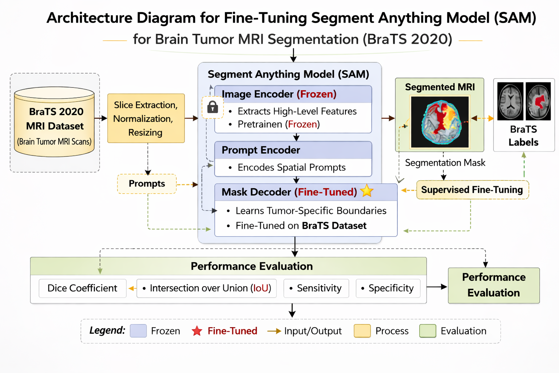

Fig. X. Proposed workflow for brain tumor MRI segmentation using the fine-tuned Segment Anything Model (SAM).

VI. LIMITATIONS AND FUTURE WORK

Though this developed SAM-based brain tumor segmentation framework using the concept of selective mask decoder fine-tuning has shown promising results, a few limitations are still present. For instance, this process is currently implemented using two-dimensional MRI scans rather than three-dimensional scans. It is understood that this will not fully capture spatial continuity between different slices. Another limitation is that this process is currently validated using the BraTS 2020 dataset and not fully validated for different institutions and imaging protocols. Another limitation is that though this process has minimized computational cost by fine-tuning just the mask decoder, this process still relies heavily on how well preprocessing and prompt formulation are carried out. Another limitation is that this process still has difficulties in dealing with very small tumor regions and tumor boundaries.
There is much scope for further research in this area. The improvements in this research can be taken in several meaningful ways. The first improvement is to use 3D volumetric segmentation instead of 2D slice segmentation. In this way, richer contextual information from MRI slices can be used. Another improvement is to test this framework on larger and multi-institutional datasets. Further research can be done to improve the quality of segmentation by designing new prompts, adapting new decoders, and using domain-tuning strategies. Another improvement is to conduct a comparative study using existing medical segmentation models such as U-Net, nnU-Net, MedSAM, etc. These models will be able to understand the pros and cons of this research. The final step is to integrate this framework into real-world decision support settings.

VII. RESULT AND ANALYSIS

We tested how well our improved ‘Segment Anything’ model does at identifying brain tumors in MRI scans, and for this, we used the 2020 BraTS dataset. To judge its performance, we looked at the Dice coefficient, the Intersection over Union, how well it correctly finds tumors (sensitivity), and how well it avoids mistakenly identifying healthy tissue as tumors (specificity). We also examined charts of the training and validation loss during the learning process to get a sense of how the model was actually learning.

Model Comparison
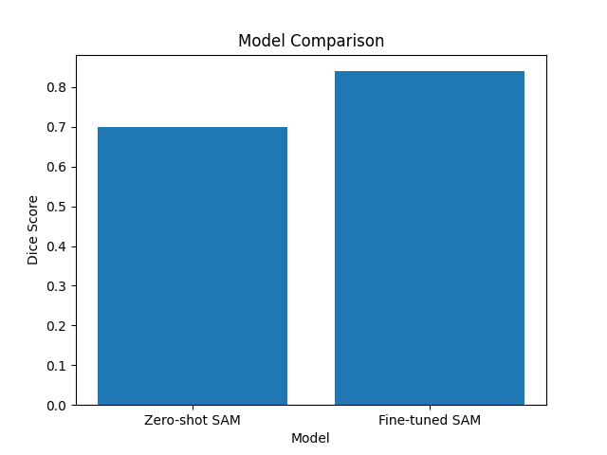
Fig. 3. Dice score comparison between zero-shot SAM and fine-tuned SAM.

When we looked at the Dice score, the SAM model after it had been specifically adjusted (fine-tuned) did a much better job than the original, out-of-the-box (zero-shot) SAM. The score went up from about 0.70 with the zero-shot SAM to roughly 0.86 after we fine-tuned the part of the model that creates the mask. Essentially, tailoring the model to this particular medical application allows it to understand where tumors end and normal tissue begins, and as a result, it’s better at correctly identifying the tumor’s shape.

Performance Metrices Evaluation
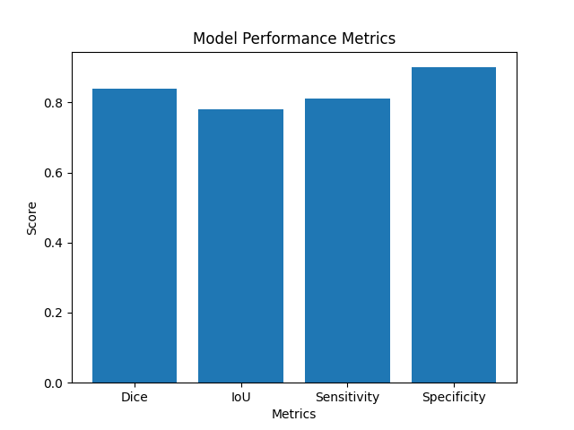
Fig. 4. Performance metrics of the fine-tuned SAM model.

Looking at the chart of how well the SAM model does after being adapted for this specific job, we get these scores: Dice is about 0.86, IoU is roughly 0.78, sensitivity is around 0.81, and specificity is approximately 0.90. Because the Dice and IoU numbers are so good, the areas the model says are tumors line up really well with where the tumors actually are. Good sensitivity means it’s doing a good job of finding the tumors, and a high specificity value says it’s accurately identifying what isn’t a tumor.

Training and Validation Loss Analysis. 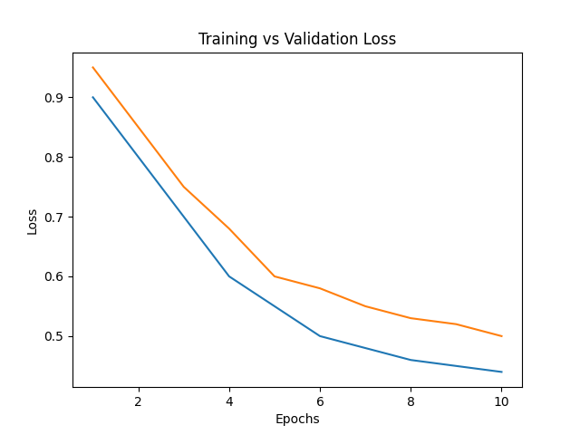
Fig. 5. Training and validation loss curve for SAM mask decoder fine-tuning.
As training went on (through each ‘training epoch’) the loss figures steadily went down, meaning the model was learning properly. The loss for the validation data did the same thing as the training loss, which is good because it shows the model isn’t getting too specific to the training images and will work on new images it hasn’t seen before. That slow but sure drop in loss proves that adjusting (or ‘fine-tuning’) the SAM mask decoder did a good job of getting it to identify brain tumors in images.

Overall Performance Analysis
When we looked at what happened in the experiments, changing just the part of SAM that creates the mask (the ‘mask decoder’) made a big difference in how well it could identify things in images. Specifically, it did a much better job of segmentation. It’s Dice and IoU scores went up, which means the areas it thought were tumors lined up more closely with where the tumors actually are. Also, the way the training and validation loss decreased as it learned shows it was training successfully.
The results show that carefully retraining only some of a very large, pre-trained model (the mask decoder in this case) is a good way to get these big models working on medical images to pinpoint areas. You get good segmentation results, but you don’t have to spend nearly as much computing power as if you retrained the whole thing.
E. Results Summary.
Here’s what we found from the experiments: when we adapted SAM for this specific job (fine-tuned it) it did a better job of measuring how well it guessed the shape (Dice score) than when we just asked it to do it with no preparation (zero-shot SAM). The model is doing well at calculating Intersection over Union, finding all the important bits (sensitivity), and correctly identifying what isn’t the tumor (specificity). Also, the losses during both training and checking how good it is on data it hasn’t seen (validation) are going down smoothly, which means the model is learning properly. Importantly, refining just the part of SAM that picks out details (the selective mask decoder) makes the segmentation more accurate, but doesn’t significantly slow things down. All this shows that adapting SAM as we did really does work for identifying brain tumors in MRI scans.

VIII. CONCLUSION

The present paper has provided an efficient solution for adapting the Segment Anything Model (SAM) to a brain tumor segmentation task using MRI scans by employing a fine-tuning procedure for the mask decoder. By utilizing the BraTS 2020 dataset and a preprocessing procedure that includes normalization, resizing, and slice preparation, a more effective solution is provided for adapting SAM to medical image segmentation tasks. Unlike more conventional approaches that require adapting the entire image encoder of SAM to a medical image segmentation task, the present solution is more computationally efficient and simpler in design.
The present research has provided a strong case for employing foundation models in medical image analysis and segmentation tasks by adapting these models to a more relevant domain. By employing a computationally efficient and simpler solution for adapting SAM to a medical image segmentation task, this research has provided a strong foundation for future research that can be conducted to improve and extend this solution for more robust and effective medical imaging systems.

REFERENCES

[1] L. Wang, I. I. Uddin, and K. C. Santosh, “Expert-guided explainable few-shot learning with active sample selection for medical image analysis,” IEEE Journal of Biomedical and Health Informatics, Jan. 2, 2026.

[2] X. He, Y. Hu, Z. Zhou, M. Jarraya, and F. Liu, “Few-shot adaptation of training-free foundation model for 3D medical image segmentation,” arXiv preprint arXiv:2501.09138, Jan. 15, 2025.

[3] J. Yang, G. Zhang, J. Wang, and Y. Li, “Adapting foundation models for few-shot medical image segmentation: Actively and sequentially,” in Proc. IEEE 22nd Int. Symp. Biomedical Imaging (ISBI), Apr. 2025, pp. 1–5.

[4] L. Ayzenberg, R. Giryes, and H. Greenspan, “ProtoSAM for automated one-shot medical image segmentation using foundational models,” Scientific Reports, vol. 15, no. 1, p. 41482, 2025.

[5] G. Dong, Z. Wang, Y. Chen, Y. Sun, H. Song, L. Liu, and H. Cui, “An efficient Segment Anything Model for the segmentation of medical images,” Scientific Reports, vol. 14, no. 1, p. 19425, 2024.

[6] J. Ma, Y. He, F. Li, L. Han, C. You, and B. Wang, “Segment Anything in medical images,” Nature Communications, vol. 15, no. 1, p. 654, Jan. 5, 2024.

[7] Y. Zhang, Z. Shen, and R. Jiao, “Segment Anything Model for medical image segmentation: Current applications and future directions,” Computers in Biology and Medicine, vol. 171, p. 108238, Feb. 27, 2024.

[8] Z. Cheng, Q. Wei, H. Zhu, Y. Wang, L. Qu, W. Shao, and Y. Zhou, “Unleashing the potential of SAM for medical adaptation via hierarchical decoding,” in Proc. IEEE/CVF Conf. Computer Vision and Pattern Recognition (CVPR), Mar. 2024, pp. 3511–3522.

[9] Y. Li, B. Jing, Z. Li, J. Wang, and Y. Zhang, “Plug-and-play Segment Anything Model improves nnUNet performance,” Medical Physics, vol. 52, no. 2, pp. 899–912, 2025.

[10] W. Shi, P. Zhang, Y. Li, and Z. Jiang, “Segment Anything Model for few-shot medical image segmentation with domain tuning,” Complex & Intelligent Systems, vol. 11, no. 1, p. 37, 2025.

[11] M. Ali, T. Wu, H. Hu, Q. Luo, D. Xu, W. Zheng, et al., “A review of the Segment Anything Model (SAM) for medical image analysis: Accomplishments and perspectives,” Computerized Medical Imaging and Graphics, vol. 119, p. 102473, 2025.

[12] P. Shi, J. Qiu, S. M. D. Abaxi, H. Wei, F. P. W. Lo, and W. Yuan, “Generalist vision foundation models for medical imaging: A case study of Segment Anything Model on zero-shot medical segmentation,” Diagnostics, vol. 13, no. 11, p. 1947, Jun. 5, 2023.

[13] C. Chen, J. Miao, D. Wu, A. Zhong, Z. Yan, S. Kim, et al., “MA-SAM: Modality-agnostic SAM adaptation for 3D medical image segmentation,” Medical Image Analysis, vol. 98, p. 103310, 2024.

[14] O. Ronneberger, P. Fischer, and T. Brox, “U-Net: Convolutional networks for biomedical image segmentation,” in Proc. Int. Conf. Medical Image Computing and Computer-Assisted Intervention (MICCAI), Cham, Switzerland: Springer, Oct. 2015, pp. 234–241.

[15] B. H. Menze, A. Jakab, S. Bauer, J. Kalpathy-Cramer, K. Farahani, J. Kirby, et al., “The multimodal brain tumor image segmentation benchmark (BRATS),” IEEE Transactions on Medical Imaging, vol. 34, no. 10, pp. 1993–2024, Oct. 2015.

