FedGrid Appendix Insert Pack
Prepared from the current repository contents for Appendix A, Appendix B, and Appendix C insertion into the project report.
Appendix A. Publication Details
Paper title: Federated Learning-Based Smart Grid Demand Forecasting for Privacy-Preserving Energy Optimization
Manuscript source in repo: /Users/mrstark/Desktop/Code PlayGround/FedGrid/docs/PAPER_FEDGRID_CORRECTED.md
Conference / journal name: Not recorded in the repository.
Submission status: No verified submission artifact found in the repository.
Acceptance letter: No acceptance letter file found in the repository.
Action required: Replace the three lines above with the official venue name, the actual submission status, and the acceptance letter details if you have them.

Appendix B. Full Code Listings
Add the following code listings after the two starter code blocks already present in the main document. Each listing below is followed by a screenshot generated from the corresponding project source file.
B.1 Flower FL Server Setup Code
This listing shows global model initialization, FedAvg strategy setup, and Flower server startup.
// Source: backend/federated_server.py (lines 1-36)
1 """
2 FedGrid — Flower FL server (FedAvg). Run from project root: python -m backend.federated_server
3 """
4
5 import flwr as fl
6 from model.lstm_model import build_lstm_model
7 from backend.strategy_with_logging import FedAvgWithLogging
8 from backend.fl_state import reset_state
9 from backend.metrics import reset_metrics
10
11 INPUT_SHAPE = (24, 1)
12
13
14 def main():
15 reset_state() # Dashboard shows only this run's rounds
16 reset_metrics()
17 model = build_lstm_model(input_shape=INPUT_SHAPE)
18 initial_weights = model.get_weights()
19 initial_params = fl.common.ndarrays_to_parameters(initial_weights)
20
21 strategy = FedAvgWithLogging(
22 initial_parameters=initial_params,
23 min_fit_clients=3,
24 min_available_clients=3,
25 fraction_evaluate=1.0, # run client evaluation every round so aggregate_evaluate runs
26 )
27
28 fl.server.start_server(
29 server_address="0.0.0.0:8085",
30 config=fl.server.ServerConfig(num_rounds=20),
31 strategy=strategy,
32 )
33
34
35 if __name__ == "__main__":
36 main()
Screenshot for B.1 (backend/federated_server.py)
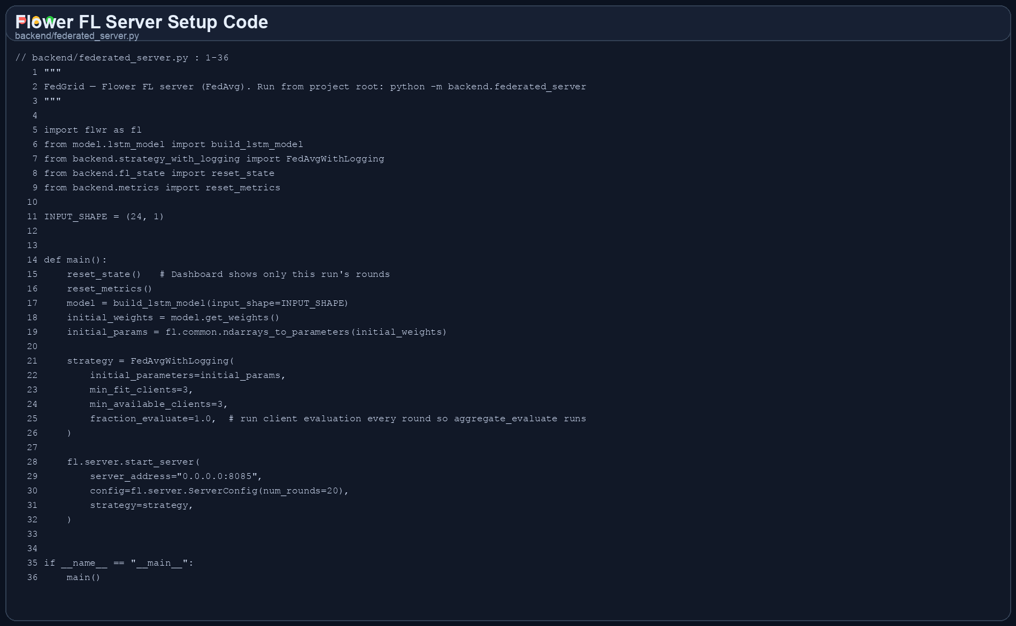

B.2 FL Client Training Loop
This listing covers client-side dataset loading, local fitting, evaluation, and Flower client startup.
// Source: client/client.py (lines 1-63)
1 """
2 FedGrid — Flower FL client. Run from project root: python -m client.client --id 1
3 """
4
5 import argparse
6 import flwr as fl
7 from model.lstm_model import build_lstm_model
8 from backend.metrics import compute_rmse_mae_mape
9 from client.dataset_loader import load_local_dataset
10 from client.local_train import train_local_model, get_weights_from_model, set_weights_on_model
11
12 INPUT_SHAPE = (24, 1)
13
14
15 def split_train_eval(X, y, eval_ratio: float = 0.2):
16 """Chronological split so evaluation uses unseen tail samples."""
17 n = len(X)
18 if n < 5:
19 return X, y, X, y
20 split_idx = max(1, min(n - 1, int(n * (1.0 - eval_ratio))))
21 return X[:split_idx], y[:split_idx], X[split_idx:], y[split_idx:]
22
23
24 class FedGridClient(fl.client.NumPyClient):
25 def __init__(self, client_id: str):
26 self.client_id = client_id
27 self.model = build_lstm_model(input_shape=INPUT_SHAPE)
28 X, y = load_local_dataset(client_id)
29 self.X_train, self.y_train, self.X_eval, self.y_eval = split_train_eval(X, y)
30
31 def get_parameters(self, config):
32 return get_weights_from_model(self.model)
33
34 def set_parameters(self, parameters):
35 set_weights_on_model(self.model, parameters)
36
37 def fit(self, parameters, config):
38 self.set_parameters(parameters)
39 weights, num_examples = train_local_model(
40 self.model, self.X_train, self.y_train, epochs=3, verbose=0
41 )
42 return get_weights_from_model(self.model), num_examples, {}
43
44 def evaluate(self, parameters, config):
45 self.set_parameters(parameters)
46 loss, mae = self.model.evaluate(self.X_eval, self.y_eval, verbose=0)
47 pred = self.model.predict(self.X_eval, verbose=0)
48 _, _, mape = compute_rmse_mae_mape(self.y_eval, pred)
49 return float(loss), len(self.X_eval), {"mae": float(mae), "mape": float(mape)}
50
51
52 def main():
53 parser = argparse.ArgumentParser()
54 parser.add_argument("--id", type=str, default="1", help="Client ID (e.g. 1, 2, 3)")
55 parser.add_argument("--server", type=str, default="127.0.0.1:8085", help="FL server address")
56 args = parser.parse_args()
57
58 client = FedGridClient(client_id=args.id)
59 fl.client.start_client(server_address=args.server, client=client)
60
61
62 if __name__ == "__main__":
63 main()
// Source: client/local_train.py (lines 1-19)
1 """
2 FedGrid — Local training and weight get/set (Keras).
3 """
4
5
6 def train_local_model(model, X_train, y_train, epochs=3, verbose=0):
7 """Train on local data. Returns (updated weights, num_examples)."""
8 model.fit(X_train, y_train, epochs=epochs, verbose=verbose, batch_size=32)
9 return model.get_weights(), len(X_train)
10
11
12 def get_weights_from_model(model):
13 """Keras: list of numpy arrays (for Flower)."""
14 return model.get_weights()
15
16
17 def set_weights_on_model(model, weights):
18 """Set global weights on local model."""
19 model.set_weights(weights)
Screenshot for B.2 (client/client.py)
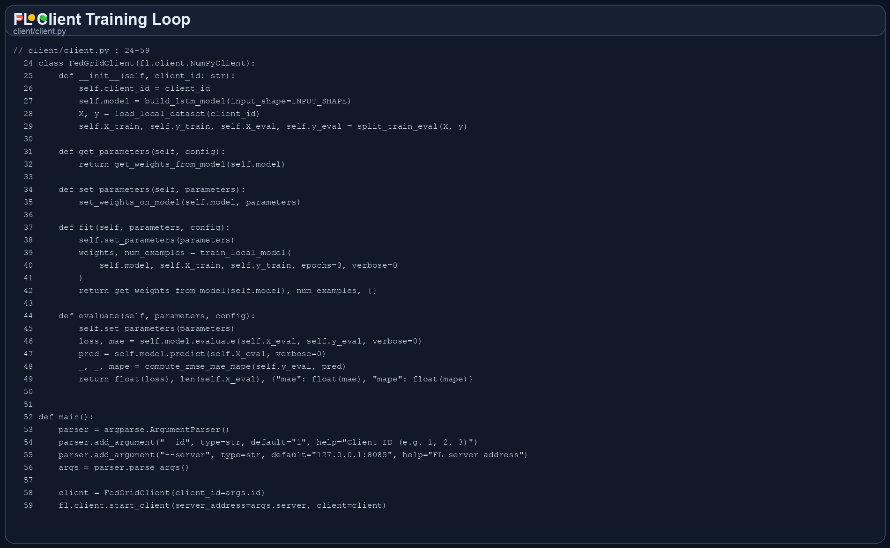

B.3 Flask API Endpoints for Prediction, Metrics, and Rounds
The implemented backend exposes `/metrics`, `/round`, `/prediction`, and `/api/rounds` for the dashboard. This is the repo-aligned equivalent of the requested predict/metrics/round endpoints.
// Source: backend/server.py (lines 295-331)
295 @app.route("/metrics")
296 def metrics():
297 return jsonify(read_metrics())
298
299
300 @app.route("/round")
301 def round_():
302 state = read_state()
303 return jsonify({"current_round": state.get("current_round", 0)})
304
305
306 @app.route("/prediction")
307 def prediction():
308 state = read_state()
309 pred = state.get("prediction") or {}
310 # In simulation mode, current total = live sum (same units as dashboard); prediction is already total kWh
311 if MODE == "simulation":
312 nodes = simulation_service.get_nodes()
313 current_total = sum(n.get("demand_kwh", 0) for n in nodes)
314 else:
315 current_total = pred.get("current_total_demand", 0)
316 return jsonify({
317 "current_time": pred.get("current_time"),
318 "current_total_demand": current_total,
319 "next_hour_prediction": pred.get("next_hour_prediction", 0),
320 "rmse": pred.get("rmse"),
321 "mape": pred.get("mape"),
322 "accuracy_pct": pred.get("accuracy_pct"),
323 })
324
325
326 @app.route("/api/rounds", methods=["GET", "OPTIONS"])
327 def rounds():
328 if request.method == "OPTIONS":
329 return "", 204
330 state = read_state()
331 return jsonify(state)
Screenshot for B.3 (backend/server.py)
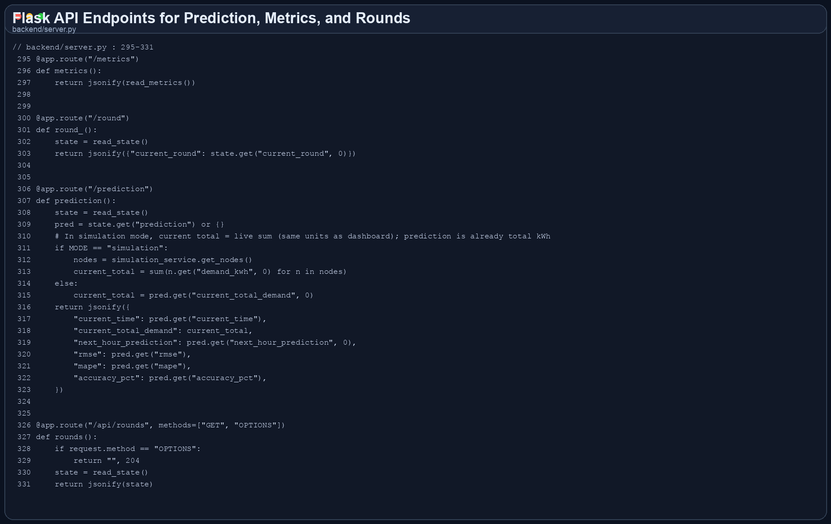

B.4 Next.js Dashboard Demand Chart Component
This React component renders the live telemetry line chart used in the FedGrid dashboard.
// Source: components/LiveChart.tsx (lines 1-177)
1 'use client';
2
3 import { CartesianGrid, Line, LineChart, ResponsiveContainer, Tooltip, XAxis, YAxis } from 'recharts';
4
5 interface ChartDataPoint {
6 time: string;
7 current: number;
8 node1?: number;
9 node2?: number;
10 node3?: number;
11 }
12
13 interface LiveChartProps {
14 data: ChartDataPoint[];
15 }
16
17 const seriesColors = {
18 node1: 'var(--signal-color)',
19 node2: 'var(--success-color)',
20 node3: 'var(--warning-color)',
21 current: 'var(--accent-color)',
22 };
23
24 export default function LiveChart({ data }: LiveChartProps) {
25 const hasMultiMeterData = data.length > 0 && data[0].node1 !== undefined;
26
27 return (
28 <div className="card" style={{ paddingBottom: '18px' }}>
29 <div
30 style={{
31 display: 'flex',
32 alignItems: 'center',
33 justifyContent: 'space-between',
34 marginBottom: '20px',
35 gap: '14px',
36 flexWrap: 'wrap',
37 }}
38 >
39 <div style={{ display: 'grid', gap: '6px' }}>
40 <span className="eyebrow">Live Telemetry</span>
41 <h2 className="panel-title" style={{ margin: 0 }}>
42 Node Current Stream
43 </h2>
44 </div>
45
46 {hasMultiMeterData && (
47 <div style={{ display: 'flex', gap: '14px', flexWrap: 'wrap' }}>
48 {[
49 ['Node 1', seriesColors.node1],
50 ['Node 2', seriesColors.node2],
51 ['Node 3', seriesColors.node3],
52 ].map(([label, color]) => (
53 <span
54 key={label}
55 className="badge"
56 style={{
57 background: 'var(--stat-bg)',
58 borderColor: 'var(--border-color)',
59 color: 'var(--text-secondary)',
60 }}
61 >
62 <span
63 style={{
64 width: '14px',
65 height: '3px',
66 borderRadius: '999px',
67 background: color,
68 boxShadow: `0 0 10px ${color}`,
69 }}
70 />
71 {label}
72 </span>
73 ))}
74 </div>
75 )}
76 </div>
77
78 {data.length === 0 ? (
79 <div
80 style={{
81 height: '320px',
82 display: 'flex',
83 alignItems: 'center',
84 justifyContent: 'center',
85 color: 'var(--text-tertiary)',
86 border: '1px dashed var(--border-color)',
87 borderRadius: '14px',
88 background: 'rgba(6, 12, 22, 0.28)',
89 }}
90 >
91 Waiting for telemetry packets...
92 </div>
93 ) : (
94 <div
95 style={{
96 height: '320px',
97 border: '1px solid rgba(106, 146, 193, 0.14)',
98 borderRadius: '14px',
99 padding: '14px 12px 6px',
100 background: 'rgba(6, 12, 22, 0.45)',
101 }}
102 >
103 <ResponsiveContainer width="100%" height="100%">
104 <LineChart data={data} margin={{ top: 10, right: 20, left: 4, bottom: 4 }}>
105 <CartesianGrid strokeDasharray="3 3" stroke="var(--grid-line)" />
106 <XAxis
107 dataKey="time"
108 stroke="var(--text-tertiary)"
109 tick={{ fill: 'var(--text-tertiary)', fontSize: 11, fontFamily: 'IBM Plex Mono' }}
110 axisLine={{ stroke: 'var(--border-color)' }}
111 tickLine={{ stroke: 'var(--border-color)' }}
112 />
113 <YAxis
114 stroke="var(--text-tertiary)"
115 domain={[0, 5]}
116 tick={{ fill: 'var(--text-tertiary)', fontSize: 11, fontFamily: 'IBM Plex Mono' }}
117 axisLine={{ stroke: 'var(--border-color)' }}
118 tickLine={{ stroke: 'var(--border-color)' }}
119 label={{
120 value: 'Current (A)',
121 angle: -90,
122 position: 'insideLeft',
123 style: { fill: 'var(--text-secondary)', fontSize: '11px', fontFamily: 'IBM Plex Mono' },
124 }}
125 />
126 <Tooltip
127 contentStyle={{
128 backgroundColor: 'rgba(7, 14, 24, 0.96)',
129 border: '1px solid var(--border-color)',
130 borderRadius: '12px',
131 color: 'var(--text-primary)',
132 boxShadow: '0 18px 36px rgba(0, 0, 0, 0.26)',
133 fontSize: '12px',
134 fontFamily: 'IBM Plex Mono',
135 }}
136 labelStyle={{ color: 'var(--text-primary)', fontWeight: 500 }}
137 itemStyle={{ color: 'var(--text-secondary)' }}
138 />
139
140 {hasMultiMeterData ? (
141 <>
142 <Line type="monotone" dataKey="node1" name="Node 1" stroke={seriesColors.node1} strokeWidth={2.4} dot={false} />
143 <Line type="monotone" dataKey="node2" name="Node 2" stroke={seriesColors.node2} strokeWidth={2.4} dot={false} />
144 <Line type="monotone" dataKey="node3" name="Node 3" stroke={seriesColors.node3} strokeWidth={2.4} dot={false} />
145 </>
146 ) : (
147 <Line
148 type="monotone"
149 dataKey="current"
150 name="Current"
151 stroke={seriesColors.current}
152 strokeWidth={2.6}
153 dot={false}
154 activeDot={{ r: 5, fill: 'var(--accent-color)' }}
155 />
156 )}
157 </LineChart>
158 </ResponsiveContainer>
159 </div>
160 )}
161
162 <p
163 className="font-mono"
164 style={{
165 fontSize: '11px',
166 color: 'var(--text-tertiary)',
167 marginTop: '14px',
168 textAlign: 'center',
169 }}
170 >
171 {hasMultiMeterData
172 ? `Displaying ${data.length} recent samples across hardware and reserve nodes`
173 : `Displaying ${data.length} recent samples from the active stream`}
174 </p>
175 </div>
176 );
177 }
Screenshot for B.4 (components/LiveChart.tsx)
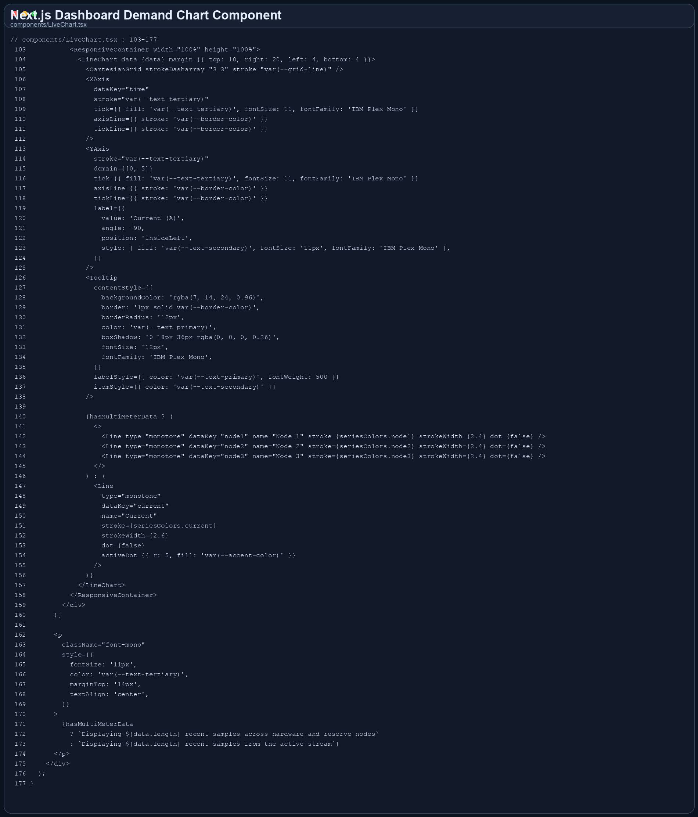

B.5 ESP32 Firmware for Meter Sensing and Telemetry
This firmware excerpt shows ESP32 configuration, RMS sensing, HTTP telemetry push, setup, and the main control loop.
// Source: hardware/esp32_firmware/FedGrid_Meter/FedGrid_Meter.ino (lines 18-49)
18 const bool USE_AP_MODE = true;
19 const char AP_SSID[] = "FedGrid-Node1";
20 const char AP_PASSWORD[] = "fedgrid123";
21 const char WIFI_SSID[] = "YOUR_WIFI_SSID";
22 const char WIFI_PASSWORD[] = "YOUR_WIFI_PASSWORD";
23 const char NODE_ID[] = "1";
24 const char LISTENER_URL[] = "http://192.168.4.2:5002/data";
25
26 const bool RELAY_ACTIVE_HIGH = true;
27 const bool RELAY_DEFAULT_ON = true;
28 const bool AUTO_TRIP_RELAY = false;
29
30 const float ADC_VREF = 3.3f;
31 const int ADC_MAX = 4095;
32 const int NUM_SAMPLES = 320;
33 const int SAMPLE_DELAY_US = 300;
34
35 float VOLTAGE_CAL = 95.0f;
36 float CURRENT_CAL = 1.0f;
37 const float ACS712_MV_PER_A = 185.0f;
38 const float EMA_ALPHA = 0.25f;
39
40 const float NO_LOAD_CURRENT_A = 0.03f;
41 const float WARN_CURRENT_A = 1.5f;
42 const float ALERT_CURRENT_A = 2.5f;
43 const float LOW_VOLTAGE_V = 180.0f;
44 const float HIGH_VOLTAGE_V = 250.0f;
45
46 const unsigned long LCD_ROTATE_MS = 2200;
47 const unsigned long SENSOR_REFRESH_MS = 750;
48 const unsigned long PUSH_INTERVAL_MS = 4000;
49 const unsigned long WIFI_RETRY_MS = 10000;
// Source: hardware/esp32_firmware/FedGrid_Meter/FedGrid_Meter.ino (lines 124-153)
124 float readRmsAdc(int pin) {
125 long sum = 0;
126 int samples[NUM_SAMPLES];
127 for (int i = 0; i < NUM_SAMPLES; i++) {
128 samples[i] = analogRead(pin);
129 sum += samples[i];
130 delayMicroseconds(SAMPLE_DELAY_US);
131 }
132
133 const float avg = static_cast<float>(sum) / NUM_SAMPLES;
134 float sumSq = 0.0f;
135 for (int i = 0; i < NUM_SAMPLES; i++) {
136 const float delta = static_cast<float>(samples[i]) - avg;
137 sumSq += delta * delta;
138 }
139
140 return sqrt(sumSq / NUM_SAMPLES);
141 }
142
143 float readVoltageRms() {
144 const float rmsAdc = readRmsAdc(PIN_VOLTAGE);
145 return (rmsAdc / static_cast<float>(ADC_MAX)) * ADC_VREF * VOLTAGE_CAL;
146 }
147
148 float readCurrentRms() {
149 const float rmsAdc = readRmsAdc(PIN_CURRENT);
150 const float vRms = (rmsAdc / static_cast<float>(ADC_MAX)) * ADC_VREF;
151 const float amps = (vRms / (ACS712_MV_PER_A / 1000.0f)) * CURRENT_CAL;
152 return amps > 0.0f ? amps : 0.0f;
153 }
// Source: hardware/esp32_firmware/FedGrid_Meter/FedGrid_Meter.ino (lines 304-365)
304 void connectWifiIfNeeded() {
305 if (USE_AP_MODE) {
306 if (wifiLinkReady()) {
307 gWifiConnectedOnce = true;
308 return;
309 }
310 if (millis() - gLastWifiAttemptMs < WIFI_RETRY_MS) {
311 return;
312 }
313 gLastWifiAttemptMs = millis();
314 WiFi.mode(WIFI_AP);
315 if (WiFi.softAP(AP_SSID, AP_PASSWORD)) {
316 gWifiConnectedOnce = true;
317 }
318 return;
319 }
320 if (WiFi.status() == WL_CONNECTED) {
321 gWifiConnectedOnce = true;
322 return;
323 }
324 if (millis() - gLastWifiAttemptMs < WIFI_RETRY_MS) {
325 return;
326 }
327 gLastWifiAttemptMs = millis();
328 WiFi.mode(WIFI_STA);
329 WiFi.begin(WIFI_SSID, WIFI_PASSWORD);
330 }
331
332 void pushReading() {
333 if (!canPushToListener() || millis() - gLastPushMs < PUSH_INTERVAL_MS) {
334 return;
335 }
336 gLastPushMs = millis();
337
338 HTTPClient http;
339 http.setTimeout(2500);
340 http.begin(LISTENER_URL);
341 http.addHeader("Content-Type", "application/json");
342
343 String payload = "{";
344 payload += "\"node_id\":\"" + String(NODE_ID) + "\",";
345 payload += "\"voltage\":" + String(gReading.voltage, 2) + ",";
346 payload += "\"current\":" + String(gReading.current, 3) + ",";
347 payload += "\"power_w\":" + String(gReading.powerW, 2) + ",";
348 payload += "\"energy_wh\":" + String(gReading.energyWh, 3) + ",";
349 payload += "\"status\":\"" + String(stateLabel(gState)) + "\",";
350 payload += "\"relay_on\":" + String(gRelayOn ? "true" : "false") + ",";
351 payload += "\"rssi\":" + String(WiFi.RSSI());
352 payload += "}";
353
354 const int code = http.POST(payload);
355 if (code > 0) {
356 const String body = http.getString();
357 bool desiredRelayOn = gRelayOn;
358 if (parseDesiredRelayState(body, &desiredRelayOn) && desiredRelayOn != gRelayOn) {
359 setRelay(desiredRelayOn);
360 }
361 } else {
362 gState = MeterState::Offline;
363 }
364 http.end();
365 }
// Source: hardware/esp32_firmware/FedGrid_Meter/FedGrid_Meter.ino (lines 394-443)
394 void setup() {
395 Serial.begin(115200);
396 delay(100);
397
398 pinMode(PIN_RELAY, OUTPUT);
399 pinMode(PIN_BUZZER, OUTPUT);
400 pinMode(PIN_LED_RED, OUTPUT);
401 pinMode(PIN_LED_BLUE, OUTPUT);
402 digitalWrite(PIN_BUZZER, LOW);
403 digitalWrite(PIN_LED_RED, LOW);
404 digitalWrite(PIN_LED_BLUE, LOW);
405 setRelay(RELAY_DEFAULT_ON);
406
407 analogReadResolution(12);
408 analogSetAttenuation(ADC_11db);
409
410 Wire.begin(I2C_SDA, I2C_SCL);
411 lcd.init();
412 delay(100);
413 lcd.backlight();
414 lcd.clear();
415 lcd.setCursor(0, 0);
416 lcd.print("FedGrid Meter");
417 lcd.setCursor(0, 1);
418 lcd.print("Booting...");
419
420 gState = MeterState::Booting;
421 connectWifiIfNeeded();
422 }
423
424 void loop() {
425 connectWifiIfNeeded();
426 sampleSensors();
427 updateOutputs();
428 updateLcd();
429 pushReading();
430
431 Serial.printf(
432 "[Node %s] V=%.1fV I=%.3fA P=%.2fW E=%.3fWh state=%s wifi=%s relay=%s\n",
433 NODE_ID,
434 gReading.voltage,
435 gReading.current,
436 gReading.powerW,
437 gReading.energyWh,
438 stateLabel(gState),
439 canPushToListener() ? "up" : "down",
440 gRelayOn ? "on" : "off");
441
442 delay(50);
443 }
Screenshot for B.5 (hardware/esp32_firmware/FedGrid_Meter/FedGrid_Meter.ino)
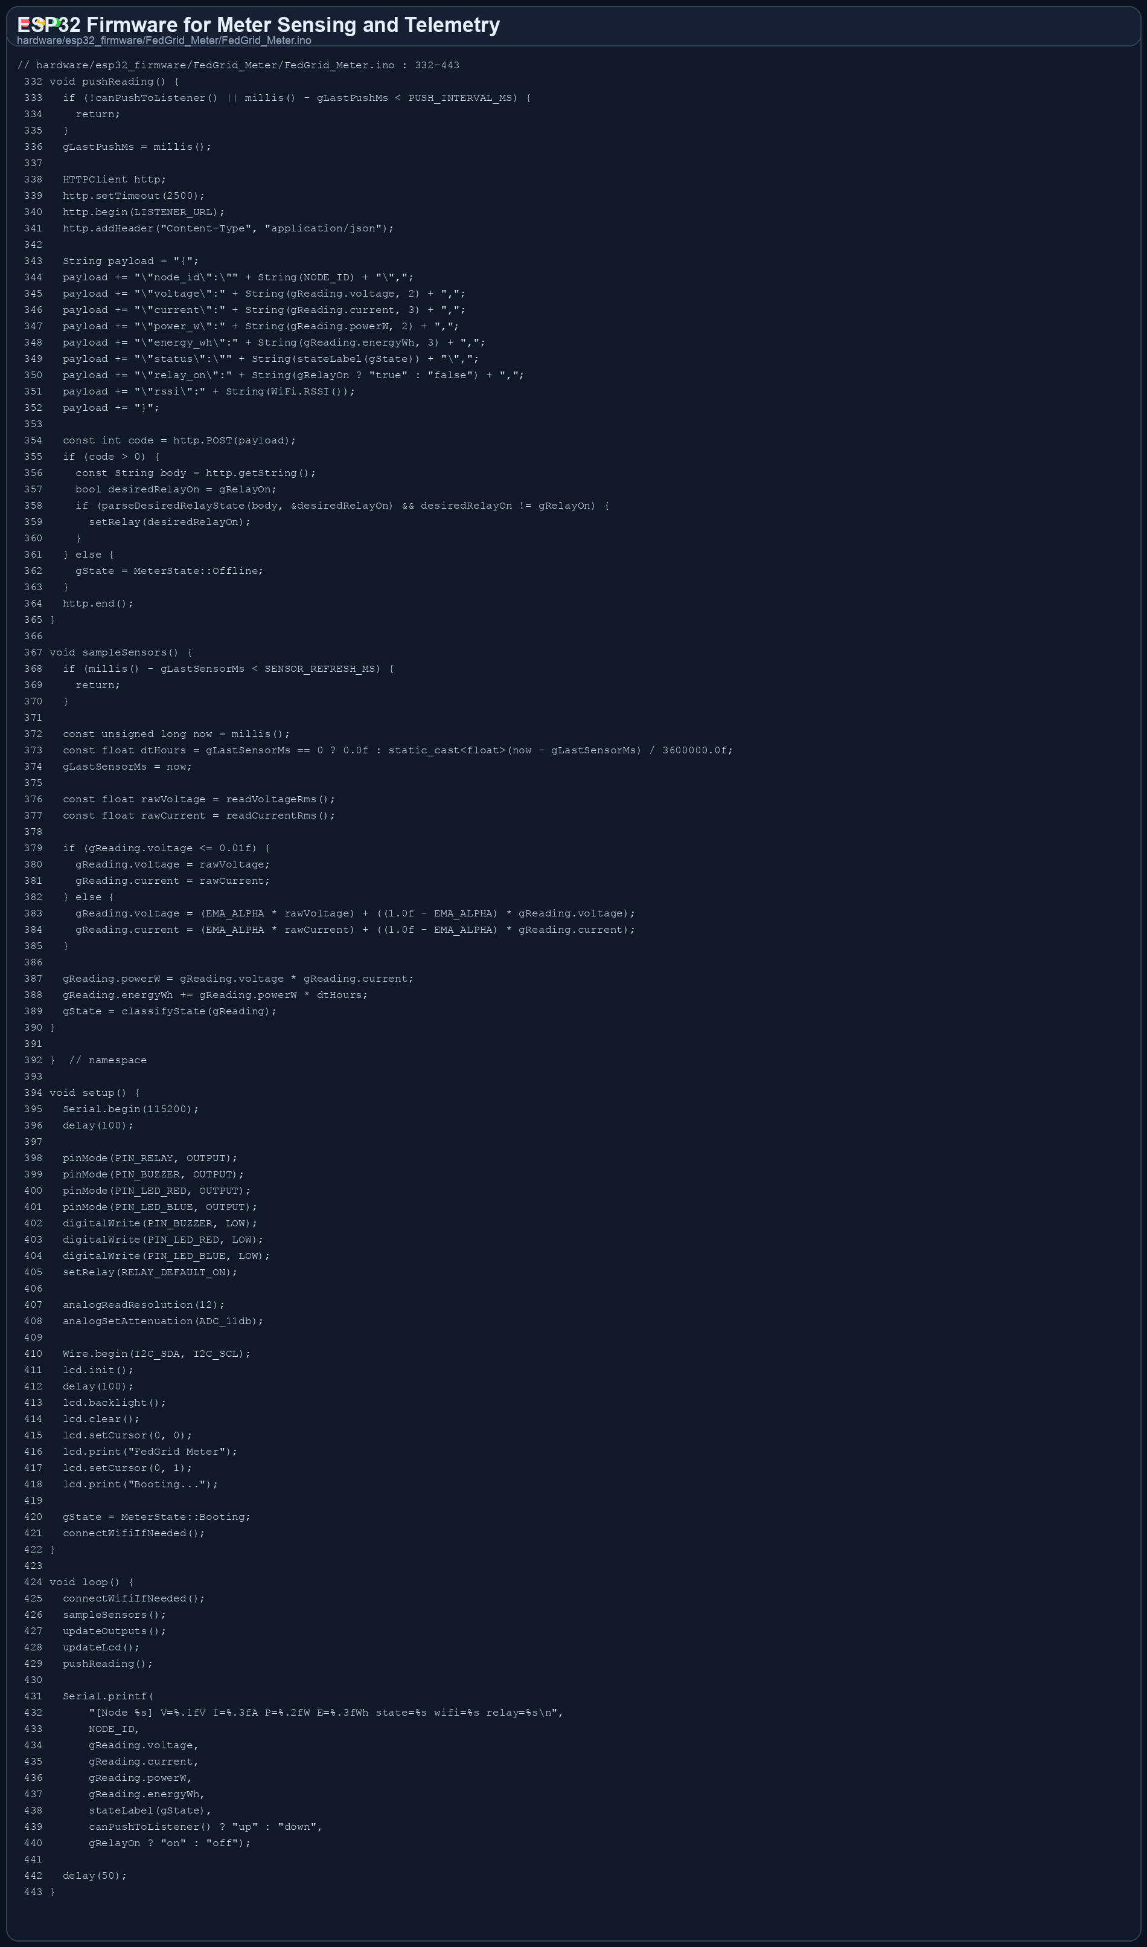

Appendix C. Plagiarism Report
No plagiarism or Turnitin report artifact was found in the repository. To complete Appendix C, attach the official similarity report exported from your institution portal or plagiarism-checking system.
Recommended contents for this appendix:
- Overall similarity summary page
- Detailed matched-source breakdown pages
- Date, report ID, and student/project metadata if available

[Insert official plagiarism report screenshot here - Page 1]

[Insert official plagiarism report screenshot here - Page 2]

