20191101IeeeWalmartCube8x8x8CubeInformation  
Four key functions and 3 music Key functions

WalmartCube8x8x8Cube Parts and placement

|  |  |  |  |  |
| --- | --- | --- | --- | --- |
| # | description | Value | Quantity | location |
| 1 | PCB Board: | 15 x 15cm (The dimension is ~1.5 mm larger on one side) | 1 |  |
| 2 | LEDs | Blue ,Volts? Curve tracer wave form? | Should be 512 min | Cube |
| 3 | amplifier audio | 3W |  |  |
| 4 | speaker |  | 1 | SP! ? 2 Wires ~1.75 inches |
| 5 | Potentiometer 33 | Volume adjust | 8 | K1,K2,K3,K4, S1,S2,S3,? |
| 6 | TF memory card to play music | ? |  |  |
| 7 | U disk slot |  | 1 | Note gouge on board |
| 8 | 3D8 on the machine mode (control animation) |  |  |  |
| 9 | Through the audio line input and output music |  |  |  |
| 10 | 3D8 on the machine music mode* Infrared remote control |  |  |  |
| 11 | Night, daytime control Switch |  |  |  |
| 12 | PWM breathing light Switch |  |  |  |
| 13 | * Switch on the mainboard automatic detection mode |  |  |  |
| 14 | Optocoupler | Input 5ma, Output 60 ma, 100 mW | 3 | U20, U21, U22 |
| 15 | Microcontroller | STC12C5A60S2 | 1 |  |
| 16 | 74HC245D | buffer driver (cascade connection) 6ma drive | 2 |  |
| 17 | 74HC133 D |  | 1 |  |
| 18 | 74HC595N |  | 9 |  |
| 19 | EL 817 C716 PHOTOTRANSISTOR PHOTOCOUPLER |  | 3 |  |
| 20 |  | High-speed scanning chip and serial control cascade chip |  |  |
| 21 |  | Use professional MP3 music chip6. Use professional power amplifier chip 8002B |  |  |
| 22 | Push button or Switch | * key functions | Four |  |
| 23 | LED | Power indicator, |  |  |
| 24 | Resistors | 551 550 OHM | 16 |  |
| 25 | Capacitor | 220 UF,10 V VT | 4 | C2, C6, C13, C18 |
| 26 | Capacitor | Small surface mount | 8 | C10, C11,C12, 14,15,16? |
| 27 | Socket pins for LEDs base | 1/10 inch spacing | 80 |  |
| 28 | Socket | Microcontroller 40 pins | 1 |  |
| 29 | USB Programmer module | USB – TTL, USB – STC- ISP |  |  |
| 30 | Screws |  | 16 |  |
| 31 | Stand off | 9 mm | 4 |  |
| 32 | Stand off | 15 mm | 4 |  |
| 33 | String |  |  |  |
| 34 | Power jack | 3 pins |  |  |
| 35 | TC4953 PDA00707 1S | **Dual P-Channel** **30-V (D-S) MOSFET** 5A high-current MOS tube driver chip (to solve the uneven brightness) may only be rated at 3A | 4 | U1, U2, U3, U5 |
| 36 | Jack 3.5 mm | **5 pins** | 2 | P2, P3 |
| 37 | Switch Slide | **5 pins** | 1 | S2 |
| 38 | Switch push | **8 pins** | 1 | S1 |
| 39 | Crystal | **22.1184 Mhz** | 1 | Y1 under CPU socket |
| 40 | IR Sensor | **CHO 1838, VS1838-Infrared-Receiver-datasheet** | 1 | To the left of K4 |
| 41 | Resistors | **10K ohms** | 5 |  |
| 42 | Resistors | **0 ohm** | 2 |  |
| 43 | Resistors | **22K ohms** | 2 |  |
| 44 | May be music chip | **AB1727CHCC3T.1-82 bent pins** [**https://chipmusic.org/**](https://chipmusic.org/) | 1 | U19?, U15? |
| 45 |  | **8 pin chip hazzie tape** | 1 |  |
| 46 |  | 13-input NAND gate **16 pins** | 1 |  |
| 47 | LED | **Red** | 7 | 4 corners LED1, LED2, LED3, LED4, LED 5 near center of board  2 more un accounted for |
| 48 | Photoresistor automatic dimming function |  | 1 | RG1, next to IR sensor |
| 47 | Resistors | **? ohms pakage red 30P** | 3 |  |
| 48 | connector | 4 pin 90 degree | 1 | J1 |
| 49 | Resistor | **Purple iouy?** | 3 |  |
| 50 | Resistor | **33K** | 2 |  |
| 51 | Resistor | **1K ohms** | 3 |  |
| 52 | Resistor | **4R7 , ?4.7K?** | 2 |  |
| 53 | Resistor | **104, ?10K ohms** | 3 |  |
| 54 | Resistor | **513, 51K ohms** | 2 |  |
| 55 | Resistor | **Red 100P?** | 3 |  |

Sold & shipped by[KWANSHOP](https://www.walmart.com/reviews/seller/18528?offerId=BFD3407CA08C405680674C491F3AA5AA)

This kit is composed of a circuit board and component parts, you need to welding it by yourself,you need to have some knowledge of electronics and ability,beside,eed a lot of soldering, you should have enough patience.512 LED lights to form a three-dimensional square space, built-in MP3 music function,accompanied by music rhythm to jump, show a brilliant effect

* Material:FR-4 Epoxy glass fiber laminate+ Printed Circuit Board(PCB)
* Voltage: 5V DC
* Current:1A-2A(2A effect is better.)
* Size:
* PCB Board:15 x 15cm
* Base Board:17.2 x 15.2cm
* Power supply:mobile phone chargers,computers,charging treasure
* Features:
* * PCB using RF - 4A grade board, LED the spacing between 20 mm
* * Built-in 3W amplifier + 3W high-quality speaker
* * Built-in MP3 music, the volume can be adjusted
* * Built-in music can be controlled by a button on the next song
* * Built-in 42 kinds of off-line stunning animation (plug in the electricity can run animation)
* * Built-in 14 kinds of offline dynamic audio animation (dance with music)
* * Can be inserted TF memory card to play music
* * Can be inserted U disk to play music
* * Through the audio line input and output music
* * 3D8 on the machine mode (control animation)
* * 3D8 on the machine music mode* Infrared remote control function.(long distance control)
* * Night, daytime control mode
* * PWM breathing light mode
* * Switch on the mainboard automatic detection mode
* * Photoresistor automatic dimming function (need to expand by yourself)
* Circuit design:
* STC12C5A60S2 + 74HC245 + 74HC138 + 74HC595N
* 1. Integrated STC12C5A60S2 high-speed 1T microcontroller
* 2. 74HC245 buffer driver (cascade connection)
* 3. 5A high-current MOS tube driver chip (to solve the uneven brightness)
* 4. High-speed scanning chip and serial control cascade chip
* 5. Use professional MP3 music chip6. Use professional power amplifier chip 8002B
* Four key functions:
* K1 key: Enter the mode selection, day, night mode control
* K2 key: Enter the 3D8 PC mode (press the K1 key to be effective after power on)
* K3 key: Enter 42 kinds of offline animation mode (press the K1 key to be effective after power on)
* K4 key: Enter 14 kinds of off-line audio mode (press the K1 key to be effective after power on)   
  Three music keys features: S1 key: Enter the music playback / stop control  
  S2 key: Enter the previous song / volume decrease control  
  S3 key: Enter the next song / volume increase control
* Two ways to modify the pattern:
* 1. Modify the program (difficult, you need to understand programming)
* 2. PC computer software direct manipulation of the light cubic
* Package Include:
* 1 x 3D Light Cube Kit
* Note:
* 1.The shell is not included. if you need the shell, please purchased separately.
* 2.This Produce is a DIY kit, is not already installed as the picture, you should install it by yourself.
* 3.Tutorial is in Chinese, but the step is not complicated, believe you are smart enough to understand and grasp.

<https://www.ebay.com/itm/Welded-PCB-board-for-3D-LED-Light-Cube-kit-8x8x8-Spectrum-8S-Electronic-DIY-Kits-/202273476179?_trksid=p2385738.m4383.l4275.c10&var=502238357568>

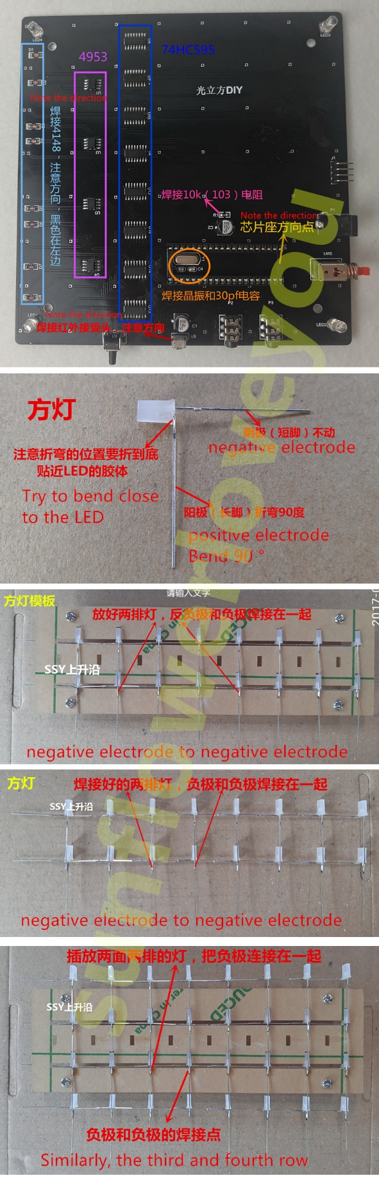

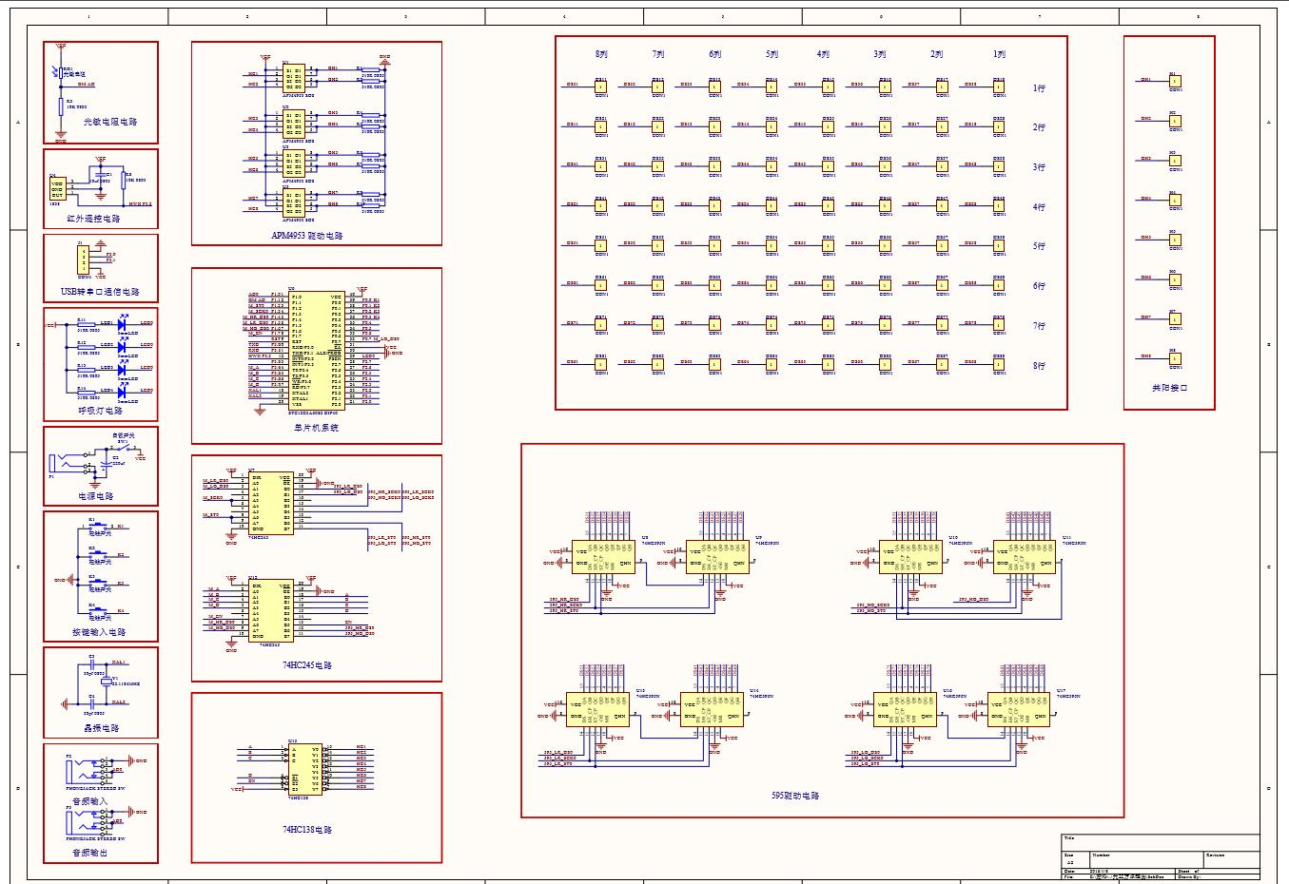

<https://www.instructables.com/id/Led-Cube-8x8x8/>

<http://forum.hobbycomponents.com/viewtopic.php?t=1744>

<https://github.com/enjrolas/L3D-Hardware/blob/master/1x1x1%20cube/L3D_Necklace_Rev1%20BOM.txt>