JEGYZŐKÖNYV

Adatkezelés XML környezetben

Féléves feladat

Készítette: **Paulin Krisztián**

Neptunkód: **WF8H4F**

**A feladat leírása:**

Ebben a feladatban videojátékokat áruló cégek, azok boltjaik ,bennük fellelhető videojátékok és az ott vásárolt felhasználók adatainak tárolását tűztem ki célul. Felépítésének köszönhetően több céget képes tárolni, amelyeknek egy vagy több boltja lehet, és a felhasználók egy vagy több boltból is vásárolhatnak videojátékokat kedvük szerint.

1. **feladat**

**1a) Az adatbázis ER modell:**

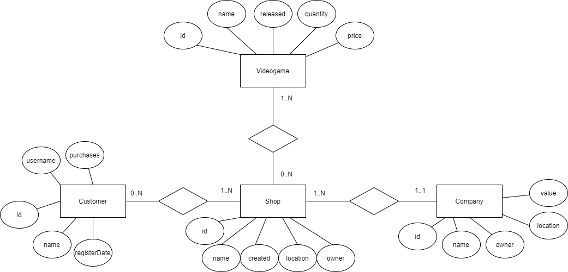

**1b) Az adatbázis konvertálása XDM modellre:**

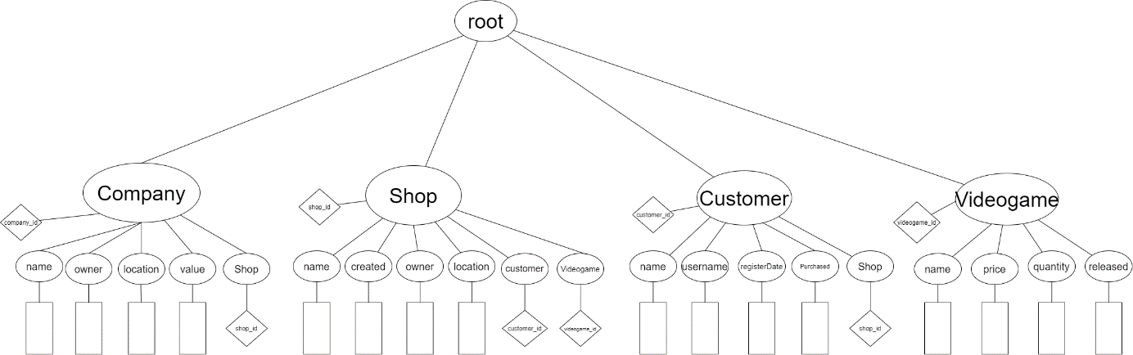

**1c) Az XDM modell alapján XML dokumentum készítése:**

<?**xml** version=*"1.0"* encoding=*"UTF-8"*?>

<?**xml-stylesheet** type=*"text/xsl"* href=*"XMLSchemaWF8H4F.xsd"*?>

<**root**>

<**videogame** videogame_id=*"1"*>

<**name**>DOOM (2016)</**name**>

<**price**>18999</**price**>

<**quantity**>69</**quantity**>

<**released**>2016-06-09</**released**>

</**videogame**>

<**videogame** videogame_id=*"2"*>

<**name**>DOOM Eternal</**name**>

<**price**>18999</**price**>

<**quantity**>20</**quantity**>

<**released**>2020-04-20</**released**>

</**videogame**>

<**videogame** videogame_id=*"3"*>

<**name**>Dark Souls REMASTERED</**name**>

<**price**>10000</**price**>

<**quantity**>14</**quantity**>

<**released**>2019-03-15</**released**>

</**videogame**>

<**customer** customer_id=*"1"*>

<**name**>Minta Béla</**name**>

<**username**>MenoMano2000</**username**>

<**registerDate**>2015-08-26</**registerDate**>

<**purchased**>5</**purchased**>

<**shop** shop_id=*"1"*/>

</**customer**>

<**shop** shop_id=*"1"*>

<**name**>Steam</**name**>

<**created**>2003-11-10</**created**>

<**owner**>Gabe Newell</**owner**>

<**location**>Washington</**location**>

<**customer** customer_id=*"1"*/>

<**videogame** videogame_id=*"1"*/>

</**shop**>

<**company** company_id=*"1"*>

<**name**>Valve</**name**>

<**owner**>Gabe Newell</**owner**>

<**location**>Washington</**location**>

<**value**>10000</**value**>

<**shop** shop_id=*"1"*/>

</**company**>

</**root**>

**1d) Az XML dokumentum alapján XMLSchema készítése:**

<?**xml** version=*"1.0"* encoding=*"UTF-8"*?>

<**xs:schema** xmlns:xs=*"http://www.w3.org/2001/XMLSchema"*>

<**xs:complexType** name=*"videogameType"*>

<**xs:sequence**>

<**xs:element** name=*"name"* type=*"xs:string"*/>

<**xs:element** name=*"price"* type=*"xs:integer"*/>

<**xs:element** name=*"quantity"* type=*"xs:integer"*/>

<**xs:element** name=*"released"* type=*"xs:date"*/>

</**xs:sequence**>

<**xs:attribute** name=*"videogame_id"* type=*"xs:integer"* use=*"required"*/>

</**xs:complexType**>

<**xs:complexType** name=*"customerType"*>

<**xs:sequence**>

<**xs:element** name=*"name"* type=*"xs:string"*/>

<**xs:element** name=*"username"* type=*"xs:string"*/>

<**xs:element** name=*"registerDate"* type=*"xs:date"*/>

<**xs:element** name=*"purchased"* type=*"xs:integer"*/>

<**xs:element** name=*"shop"* maxOccurs=*"unbounded"*>

<**xs:complexType**>

<**xs:attribute** name=*"shop_id"* type=*"xs:integer"* use=*"required"*/>

</**xs:complexType**>

</**xs:element**>

</**xs:sequence**>

<**xs:attribute** name=*"customer_id"* type=*"xs:integer"* use=*"required"*/>

</**xs:complexType**>

<**xs:complexType** name=*"shopType"*>

<**xs:sequence**>

<**xs:element** name=*"name"* type=*"xs:string"*/>

<**xs:element** name=*"created"* type=*"xs:date"*/>

<**xs:element** name=*"owner"* type=*"xs:string"*/>

<**xs:element** name=*"location"* type=*"xs:string"*/>

<**xs:element** name=*"customer"* maxOccurs=*"unbounded"*>

<**xs:complexType**>

<**xs:attribute** name=*"customer_id"* type=*"xs:integer"* use=*"required"*/>

</**xs:complexType**>

</**xs:element**>

<**xs:element** name=*"videogame"* maxOccurs=*"unbounded"*>

<**xs:complexType**>

<**xs:attribute** name=*"videogame_id"* type=*"xs:integer"* use=*"required"*/>

</**xs:complexType**>

</**xs:element**>

</**xs:sequence**>

<**xs:attribute** name=*"shop_id"* type=*"xs:integer"* use=*"required"*/>

</**xs:complexType**>

<**xs:complexType** name=*"companyType"*>

<**xs:sequence**>

<**xs:element** name=*"name"* type=*"xs:string"*/>

<**xs:element** name=*"owner"* type=*"xs:string"*/>

<**xs:element** name=*"location"* type=*"xs:string"*/>

<**xs:element** name=*"value"* type=*"xs:integer"*/>

<**xs:element** name=*"shop"* maxOccurs=*"unbounded"*>

<**xs:complexType**>

<**xs:attribute** name=*"shop_id"* type=*"xs:integer"* use=*"required"*/>

</**xs:complexType**>

</**xs:element**>

</**xs:sequence**>

<**xs:attribute** name=*"company_id"* type=*"xs:integer"* use=*"required"*/>

</**xs:complexType**>

<**xs:element** name=*"root"*>

<**xs:complexType**>

<**xs:sequence**>

<**xs:element** name=*"videogame"* type=*"videogameType"* maxOccurs=*"unbounded"*></**xs:element**>

<**xs:element** name=*"customer"* type=*"customerType"* maxOccurs=*"unbounded"*></**xs:element**>

<**xs:element** name=*"shop"* type=*"shopType"* maxOccurs=*"unbounded"*></**xs:element**>

<**xs:element** name=*"company"* type=*"companyType"* maxOccurs=*"unbounded"*></**xs:element**>

</**xs:sequence**>

</**xs:complexType**>

<**xs:key** name=*"key1"*>

<**xs:selector** xpath=*"videogame"*/>

<**xs:field** xpath=*"@videogame_id"*/>

</**xs:key**>

<**xs:key** name=*"key2"*>

<**xs:selector** xpath=*"customer"*/>

<**xs:field** xpath=*"@customer_id"*/>

</**xs:key**>

<**xs:key** name=*"key3"*>

<**xs:selector** xpath=*"shop"*/>

<**xs:field** xpath=*"@shop_id"*/>

</**xs:key**>

<**xs:key** name=*"key4"*>

<**xs:selector** xpath=*"company"*/>

<**xs:field** xpath=*"@company_id"*/>

</**xs:key**>

<**xs:keyref** name=*"keyref1"* refer=*"key1"*>

<**xs:selector** xpath=*"shop/videogame"*/>

<**xs:field** xpath=*"@videogame_id"*/>

</**xs:keyref**>

<**xs:keyref** name=*"keyref2"* refer=*"key2"*>

<**xs:selector** xpath=*"shop/customer"*/>

<**xs:field** xpath=*"@customer_id"*/>

</**xs:keyref**>

<**xs:keyref** name=*"keyref3"* refer=*"key3"*>

<**xs:selector** xpath=*"company/shop"*/>

<**xs:field** xpath=*"@shop_id"*/>

</**xs:keyref**>

<**xs:keyref** name=*"keyref4"* refer=*"key3"*>

<**xs:selector** xpath=*"customer/shop"*/>

<**xs:field** xpath=*"@shop_id"*/>

</**xs:keyref**>

</**xs:element**>

</**xs:schema**>

1. **feladat**

**2a)**

package hu.domparse.wf8h4f;

import java.io.File;

import javax.xml.parsers.DocumentBuilderFactory;

import javax.xml.parsers.DocumentBuilder;

import org.w3c.dom.Document;

import org.w3c.dom.NodeList;

import org.w3c.dom.Node;

import org.w3c.dom.NamedNodeMap;

public class DOMReadWF8H4F {

public static void main(String[] args) {

try {

DocumentBuilderFactory dbFactory = DocumentBuilderFactory.newInstance();

DocumentBuilder dBuilder = dbFactory.newDocumentBuilder();

Document doc = dBuilder.parse(new File("src/XMLWF8H4F.xml"));

doc.getDocumentElement().normalize();

printNode(doc.getDocumentElement(), "+");

} catch (Exception e) {

e.printStackTrace();

}

}

public static void printNode(Node rootNode, String spacer) {

if (rootNode.getNodeType() == Node.ELEMENT_NODE) {

System.out.print(spacer + rootNode.getNodeName() + " -> " + (rootNode.hasAttributes()? printAttributes(rootNode)+"\n" : rootNode.getFirstChild().getNodeValue().replace("\n", "")+"\n"));

}

NodeList nl = rootNode.getChildNodes();

for (int i = 0; i < nl.getLength(); i++)

printNode(nl.item(i), spacer + " ");

}

public static String printAttributes(Node mainNode)

{

NamedNodeMap attributeList = mainNode.getAttributes();

String attributes = " " + attributeList.item(0).getNodeName() + ":" +attributeList.item(0).getNodeValue();

for(int i = 1; i < attributeList.getLength(); i++)

{

Node attribute = attributeList.item(i);

attributes += (", " + attribute.getNodeName() + ":" +attribute.getNodeValue());

}

return attributes;

}

}

**2b)** adatmódosítás

package hu.domparse.wf8h4f;

import java.io.File;

import javax.xml.parsers.DocumentBuilder;

import javax.xml.parsers.DocumentBuilderFactory;

import javax.xml.transform.TransformerFactory;

import javax.xml.transform.dom.DOMSource;

import javax.xml.transform.stream.StreamResult;

import javax.xml.transform.Transformer;

import javax.xml.transform.TransformerException;

import org.w3c.dom.Document;

import org.w3c.dom.Element;

import org.w3c.dom.Node;

import org.w3c.dom.NodeList;

public class DOMModifyWF8H4F {

public static void main(String[] args) {

try {

DocumentBuilderFactory dbFactory = DocumentBuilderFactory.newInstance();

DocumentBuilder dBuilder = dbFactory.newDocumentBuilder();

Document doc = dBuilder.parse(new File("src/XMLWF8H4F.xml"));

doc.getDocumentElement().normalize();

Node root = doc.getDocumentElement();

search(root, "videogame", "name", "xd", "1");

modifyDocument(doc, new File("src/XMLWF8H4F.xml"));

}catch (Exception e) {

e.printStackTrace();

}

}

public static void search(Node root, String parent, String child, String replace, String id) {

NodeList list = root.getChildNodes();

for (int i = 0; i < list.getLength(); i++) {

Node node = list.item(i);

if (node.getNodeType() == Node.ELEMENT_NODE) {

Element eElement = (Element) node;

if (parent.equals(eElement.getNodeName()) && eElement.getAttributes().getNamedItem(parent+"_id").getNodeValue().equals(id)) {

Element foundElement = (Element) eElement.getElementsByTagName(child).item(0);

foundElement.setTextContent(replace);

}

}

}

}

public static void modifyDocument(Document document, File xmlFile) throws TransformerException

{

TransformerFactory transformerFactory = TransformerFactory.newInstance();

Transformer transformer = transformerFactory.newTransformer();

DOMSource source = new DOMSource(document);

StreamResult result = new StreamResult(xmlFile);

transformer.transform(source, new StreamResult(System.out));

transformer.transform(source, result);

}

}