**Project Overview**

The Dashboard was created in ASP.NET CORE MVC (**M**odel-**V**iew **C**ontroller) using Visual Studio.

This Dashboard offers various services such as Weather as well as Google.

Model-view-controller is a software architecture pattern for graphical user interfaces, launched in 1978 and very popular for web applications. The pattern is composed of three types of modules with three different responsibilities: models, views and controllers.

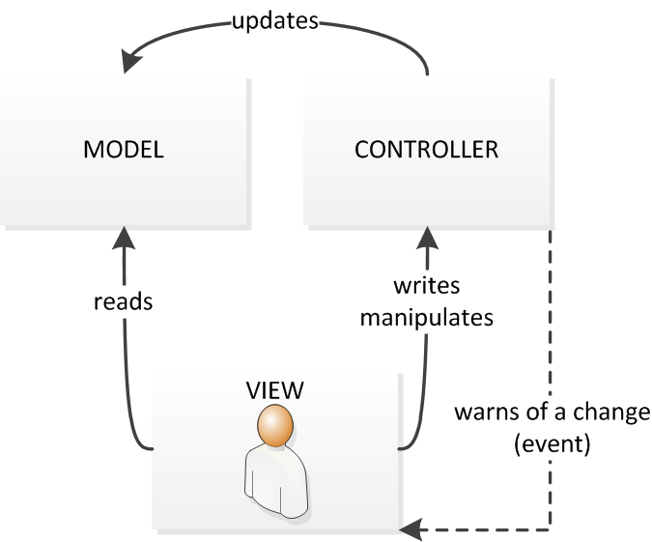

**How to launch the Project**

The Dashboard is a web application that is deployed from a docker, in order to launch it, it is necessary to have Docker installed on your machine (to install it on Mac OS: https://docs.docker.com/docker-for-mac/install and for Windows: https://docs.docker.com/docker-for-windows/) to execute the following commands:

1) docker-compose build

2) docker-compose up

**Modifications**

If server side changes are needed in the Dashboard Sources they will take place in:

-Controllers/DashboardController.cs

And side View in:

-Views/Dashboard/index.cshtml

In the file index.cshtml it is possible to integrate c # code as well as html.