Mean Reversion in Motion: Building an FX Statistical Arbitrage System from Scratch
Industry Project | Financial Mathematics Program • April 2026
Statistical arbitrage sits at the intersection of econometrics, signal processing, and risk management — and building one end-to-end has been one of the most technically demanding and rewarding experiences of the FM program.
The project targets the foreign exchange market. Using 24 years of tick-level data (2001–2025) across 14 major and cross currency pairs resampled to nine timeframes (from 1-minute to daily), the goal is to identify pairs whose price relationship is mean-reverting and systematically trade the deviations.

Pair Selection: Starting with Cointegration
The foundation is the Engle-Granger cointegration test. Two price series P₁ and P₂ are cointegrated if their spread Sₜ = P₂ − β·P₁ is stationary, even though each series individually follows a random walk. The hedge ratio β is estimated via OLS regression on price levels, and stationarity is verified through ADF and KPSS tests. The Hurst exponent serves as an additional filter — values below 0.5 confirm mean-reverting behavior.
A key metric is the half-life of mean reversion, derived from the Ornstein-Uhlenbeck process:
ΔSₜ = λ·Sₜ₋₁ + εₜ → half-life = −ln(2) / λ
Pairs are accepted only if the half-life falls within practical trading bounds (e.g., 2–35 bars at daily frequency). Rolling monthly calibration ensures the hedge ratio and half-life remain valid over time — a critical design choice, since static estimates deteriorate quickly in FX.

Signal Generation and Risk Management
Spread deviations are normalized as z-scores using a rolling mean and standard deviation:
zₜ = (Sₜ − μ) / σ
Entry triggers when |z| > 2.0. Positions are closed when |z| < 0.5 (profit target), |z| > 3.5 (stop-loss), or the hold duration exceeds 2.5× the half-life. A consecutive-loss counter suspends trading after repeated drawdowns, preventing the system from compounding losses during regime breaks. Position sizing uses inverse-volatility weighting, clamped between 5% and 15% of notional per pair.

Extending to Kalman Filtering
The most technically involved extension replaces static rolling regression with a 2-state Kalman filter that tracks the hedge ratio β and intercept α in real time:
log(P₂,ₜ) = βₜ · log(P₁,ₜ) + αₜ + εₜ
The process noise parameter δ is tuned per interval (e.g., δ = 5×10⁻⁵ for 1H, δ = 5×10⁻² for 1D) to balance responsiveness against stability. A multi-lock state machine gates live trading behind paper-trade validation, month-long stability checks, and portfolio heat limits.

Optimization
Z-score thresholds were optimized using Bayesian search (Optuna’s TPE sampler) on a training window (pre-2015), with out-of-sample evaluation on 2015–2023. Trials are pruned early if the Sharpe ratio falls below −1.0 after five years of in-sample data.

Results
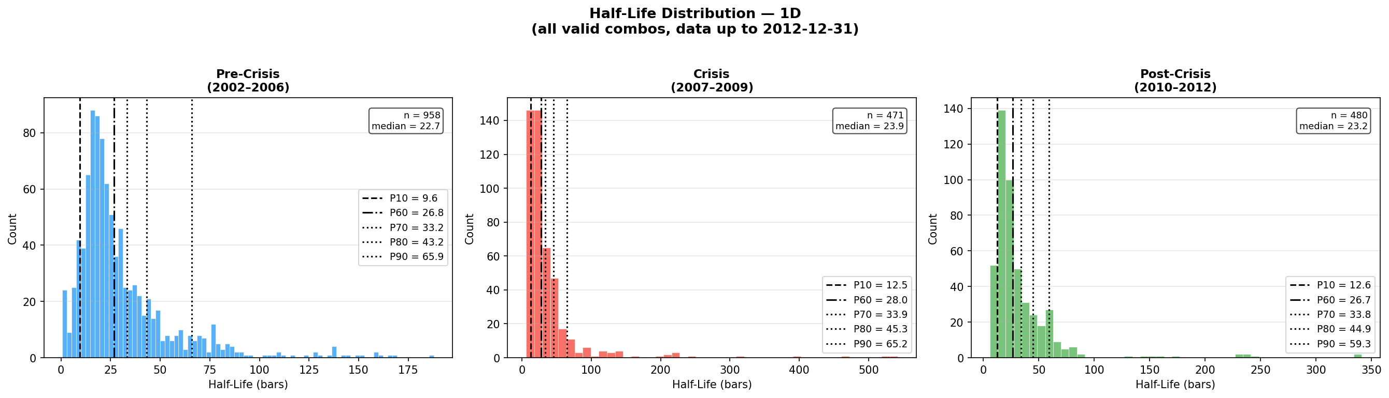
Figure 1. Half-life distributions at the 1D interval across pre-crisis (2002–2006), crisis (2007–2009), and post-crisis (2010–2012) periods. Median half-life remains stable (~21–23 bars), but the distribution widens significantly during stress.
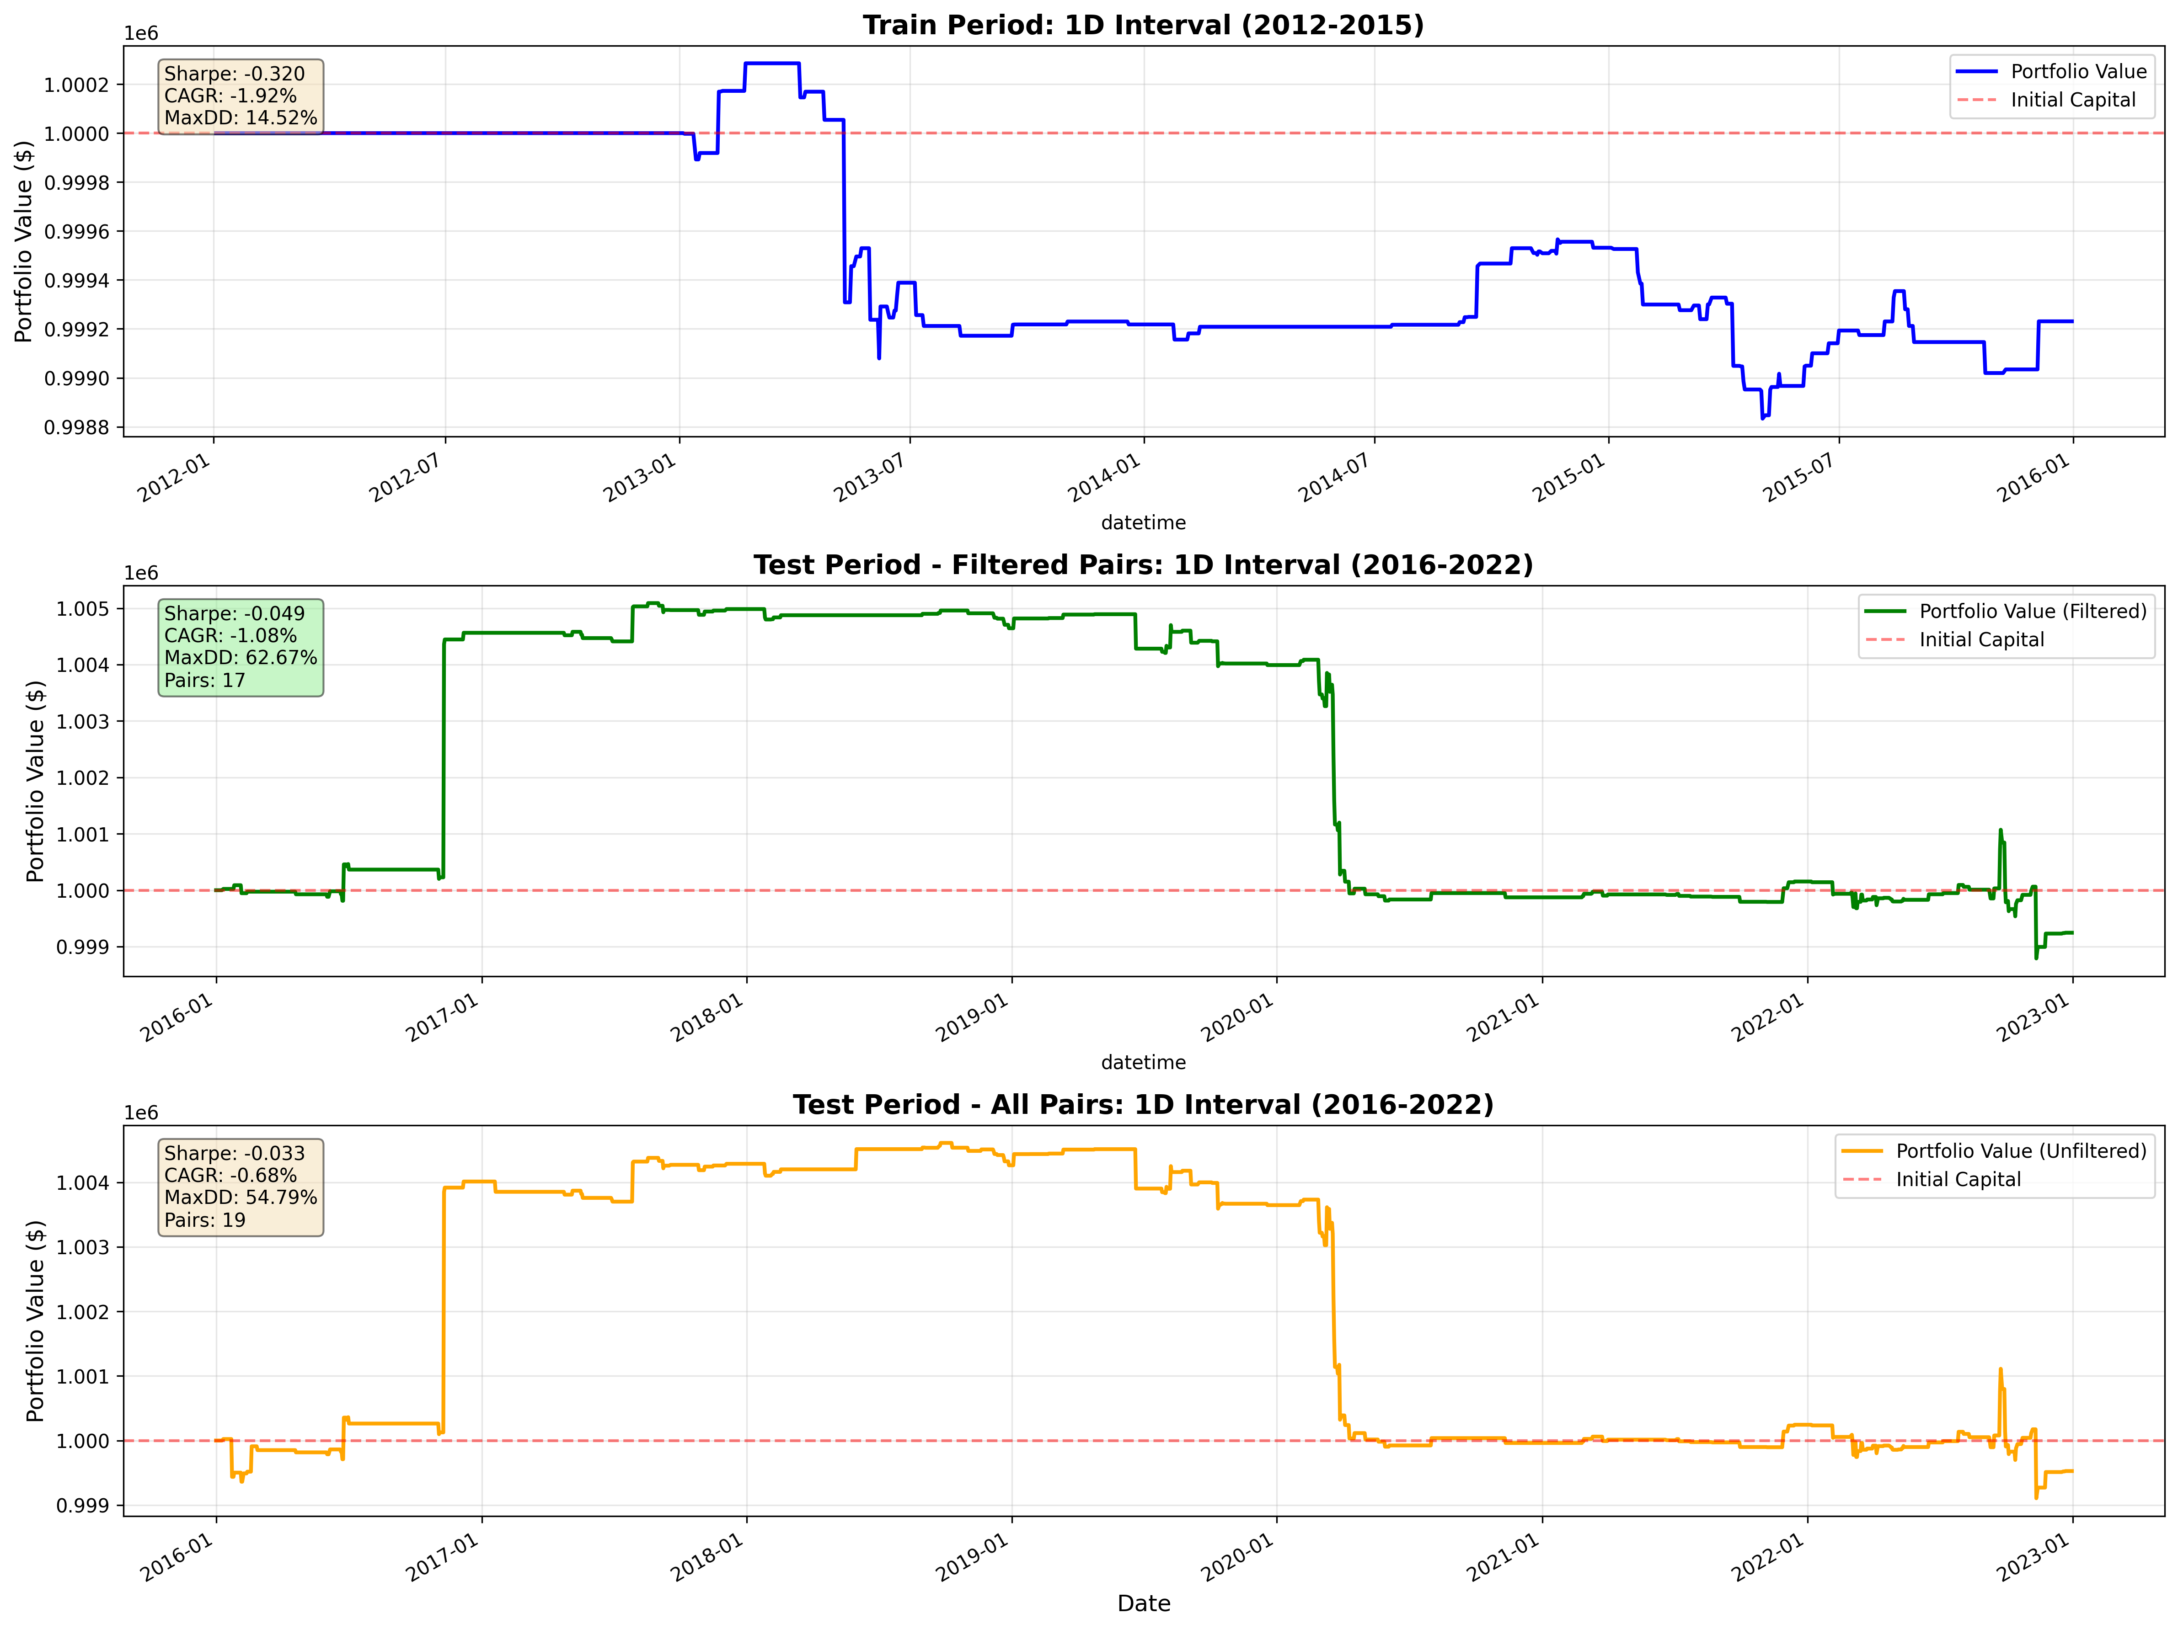
Figure 2. Equity curves for the 1D interval. Train (2012–2015): Sharpe 0.32, CAGR 1.92%. Test — filtered pairs (2016–2022): Sharpe 0.049, CAGR 1.08%, Max DD 62.67%. The COVID-19 dislocation (2020) is visible as a sharp drawdown.
These results highlight a recurring challenge: strategies that perform well in-sample often degrade sharply out-of-sample, particularly during the 2020 COVID-19 dislocation. The half-life distributions reveal that mean reversion speeds cluster tightly in stable regimes but widen dramatically during stress — a structural insight that directly informs parameter calibration.

Key Takeaway
This project forced a reckoning with the gap between academic finance and production reality. Statistical significance in-sample is not alpha. The harder engineering problems — rolling calibration, regime detection, dynamic position sizing, and state machine-based risk overlays — are where the edge (or lack thereof) actually lives. And the most important line in any backtest output is the max drawdown, not the Sharpe ratio.

