Java OOP – Section 5: Calculator App
Write a Calculator App that has the following requirements
  - Use GitHub and add dejohns2 to your repository
    - include @author full names and @see repo in ALL program file
    - commit and push code often with meaningful comments
  - UML diagram as a JPG file (also checked into GitHub)
  - Abstract base class that uses an interface
  - Derived classes that build on top of each other using an additional interface
  - Generic data type to handle both integer and double values
Do NOT try to code the whole project before testing. Incremental development is key! Coding Steps:
- Code the BasicMath interface (see starting code below) NOTE: you can’t test this yet.
- Code the Calculator class implementing the BasicMath interface, but do NOT make the class abstract so you can test it.
Once you have thoroughly tested your Calculator, make it abstract so you can no longer instantiate it, which will also require you to remove your testing logic.
- Code the MemoryCalc class and test.
In case you do not know how memory keys should work: https://calculator-1.com/
- Code the AdvanceMath interface and AdvanceCalc then test
How to turn in the assignment:
NOTE: A total of 8 files will be attached.
- Attach your GBU reflection (college-level writing style)
- Attach ALL program files individually (NOT in a zip file) (6 programs)
- Include your UML Image in your README
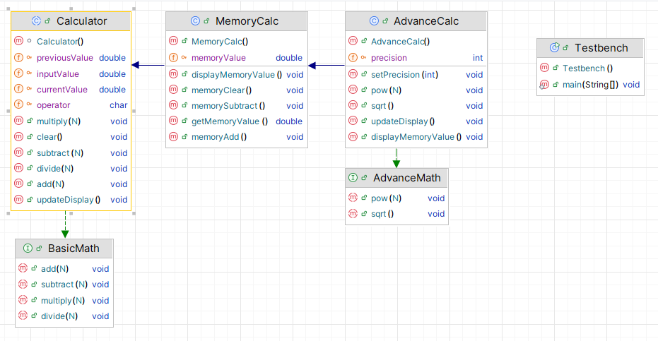

Important Notes:
- Default constructors should be calling super and setters when appropriate
- Calculator.clear sets all numeric fields to zero
- MemoryCalc.clear sets only the memory field to zero
- AdvanceCalc.precision
  - only allows a value between 0 – 10
  - I provide you with the code for sqrt method below
  - For the power method, code it similar to Calculator.add
Math.pow receives to arguments (1) for the current value (2) for the input value you are raising it to
NOTE: you have to convert inputValue to a double similar to how we do it in the add method
Code Help
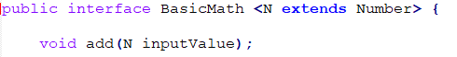
public abstract class Calculator<N extends Number> implements BasicMath<N> {
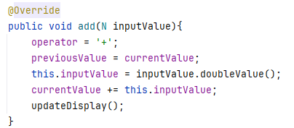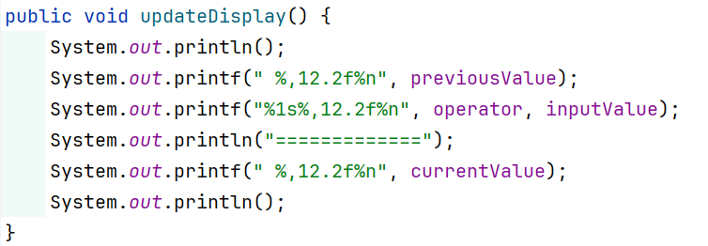
Continue on next page…
public class AdvanceCalc <N extends Number> extends MemoryCalc<N> implements AdvanceMath<N> {
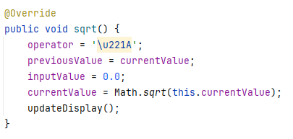
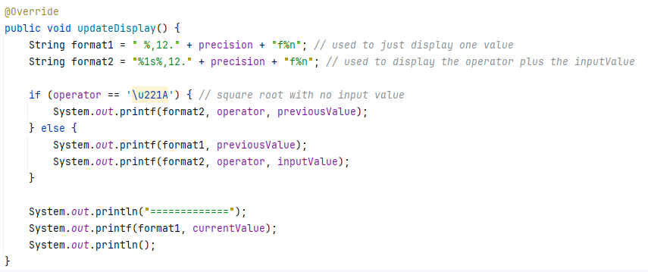
Testbench.main
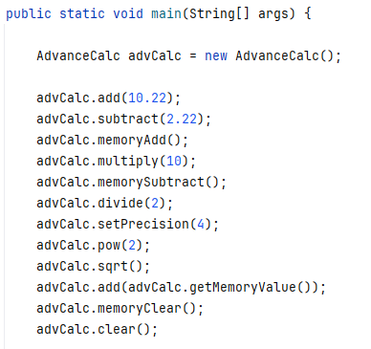
Output on next page…
Calculator On (NOTE: text in blue is coded in the Calculator class)
Calculator Cleared
Calculator Precision is 2 decimal places. (NOTE: text in yellow is coded in the AdvanceCalc class)

0.00 (NOTE: text in black is coded in the Calculator class)
+ 10.22
=============
10.22

10.22
- 2.22
=============
8.00

Memory Add 8.00(NOTE: text in red is coded in the MemoryCalc class)
2.0000
8.00
* 10.00
=============
80.00

Memory Subtract -72.00

80.00
/ 2.00
=============
40.00

Calculator Precision is 4 decimal places. (NOTE: this even impacts memory precision too)

40.0000 (NOTE: text in purple is coded in the AdvanceCalc class)
^ 2.0000
=============
1,600.0000

√ 1,600.0000
=============
40.0000

Using memory value
40.0000
+ -72.0000
=============
-32.0000

Memory Cleared 0.0000

Calculator Cleared

Additional Assignment Requirements:
- Well-documented code, so make sure to update the class-level JavaDoc and add JavaDoc for any new methods.
Helpful resource for learning how to JavaDoc: JavaDoc: A Simple Overview (7:08 minutes)
- Must use GitHub
  - Invite me to your repository (dejohns2)
  - Numerous meaningful commits which will prove who did work
  - When working in groups, you must have balance work across code and README by switching often
  - Professional README.md
    - Fully explain what the program does
    - Embedded screenshots (stored in a subfolder)
    - Bullet point list of what new concepts were used
    - links to author’s profiles
How to embed an image:
![Program Output](assets/name_of_file.png)
How to link to an image or file:
[Program header level documentation](assets/name_of_file.png)
- PDF Peer or Self reviews in a GitHub subfolder. Use the person’s name as the file name. A peer review should focus on the person’s strengths and possibly providing helpful suggestions for future group work. A self review reflects on what you did well and what you could do differently on your next assignment.
- Attach six of your program files, plus your Good, Bad, and Ugly (GBU) reflection written at a college level. IMPORTANT: Include your GitHub URL in this document.

