CSC160 Programming Fundamental II - Spring 2025
Section 1 Assignment - InvoiceApp
Add a new method to the InvoiceApp.java to apply the following discount and modify the receipt to produce the following output.
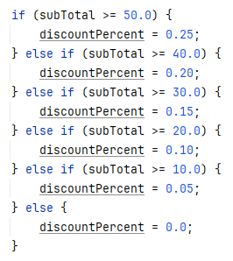
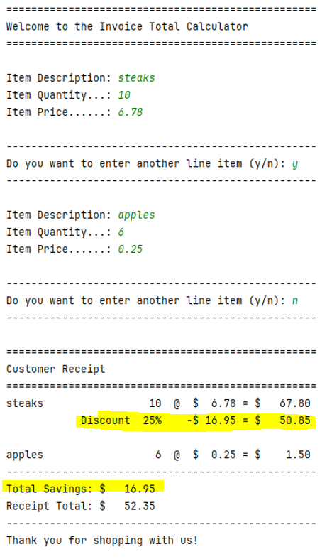
NOTE: This new Discount and Total Savings lines will ONLY print out if there is a discount applied.

Psuedocode
NOTE: if you are working in a group, then you should be switching off between each step.
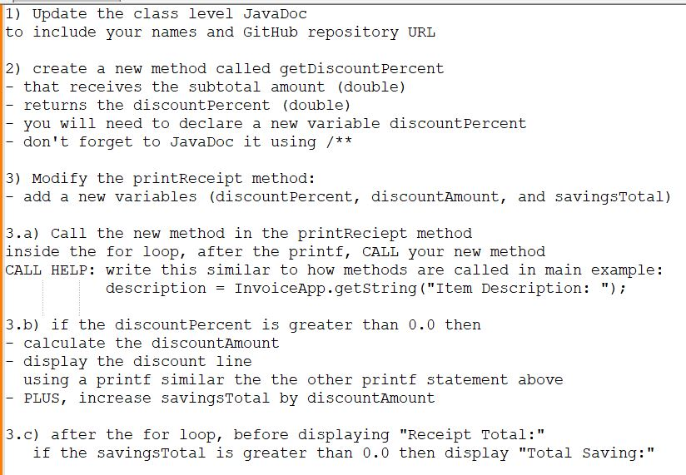
Additional Requirements:
- Your goal is to NOT use AI for this assignment, but if you do, use it sparely. If you use AI, you need to document where you used it in your code and justify your reason. I’m okay with you using it to get help, for very specific items, but not to write your code for you.
- Use meaningful variable and function names (ex: discountPercent vs discountAmount)
- Use printf for controlling the console output format
NOTE: To display the % symbol using a printf, you have to type %%

Helpful resources for learning how to use printf:
- https://youtu.be/g_BsIuRVfvk (5:12 min)
- https://alvinalexander.com/programming/printf-format-cheat-sheet/
- https://www.baeldung.com/java-printstream-printf
- https://www.jquery-az.com/10-examples-learn-java-string-formatting-printf-method/
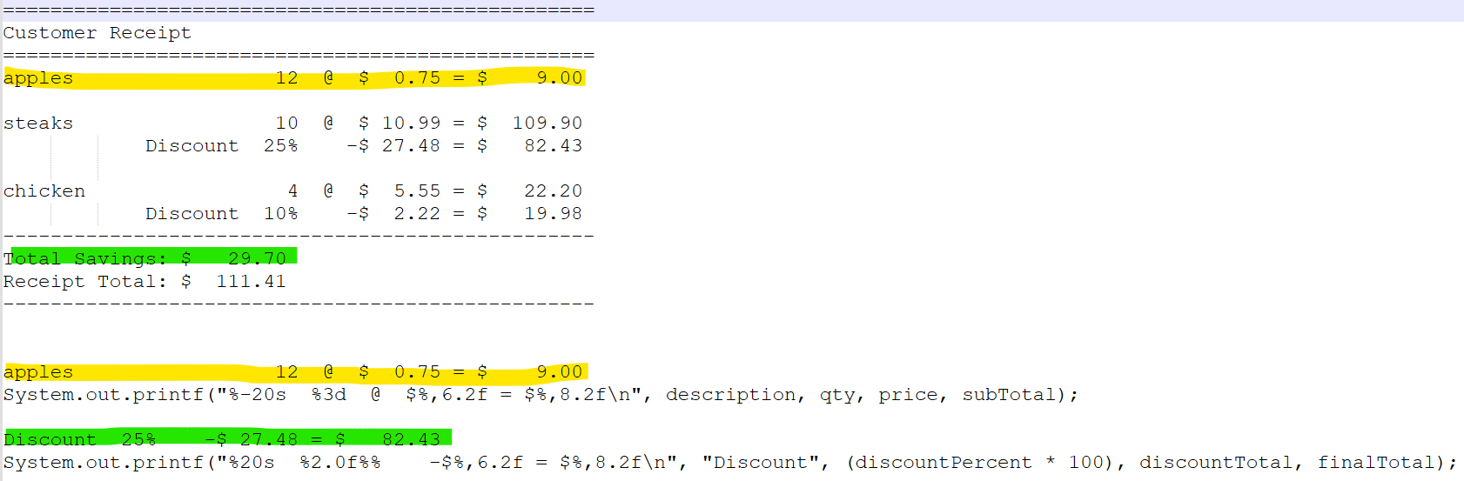
- Well documented code so make sure to update the class level JavaDoc and plus add JavaDoc any new methods.
Helpful resource for learning how to JavaDoc: JavaDoc: A Simple Overview (7:08 minutes)
- Must use GitHub
  - Invite me to your repository (dejohns2)
  - Numerous commits which will prove who did work
  - When working in groups, you must have balance work across code and README by switching often
  - Professional README.md
    - Fully explain what the program does
    - Embedded screenshots (stored in a subfolder)
    - Bullet point list of what new concepts were used
    - links to author’s profiles

README examples:
- https://github.com/banesullivan/README
- https://github.com/matiassingers/awesome-readme?tab=readme-ov-file
- https://github.com/othneildrew/Best-README-Template
- https://gist.github.com/DomPizzie/7a5ff55ffa9081f2de27c315f5018afc
- https://gist.github.com/noperator/4eba8fae61a23dc6cb1fa8fbb9122d45
Helpful resources for learning how to use README Markdown:
    - https://github.com/adam-p/markdown-here/wiki/markdown-cheatsheet
    - https://docs.github.com/en/get-started/writing-on-github/getting-started-with-writing-and-formatting-on-github/basic-writing-and-formatting-syntax
    - README.md emojis https://emojipedia.org/
Make sure to include testing for both line items that do NOT have a discount and line items that do. REMINDER: if no line items have a discount, then the Total Savings line will not print

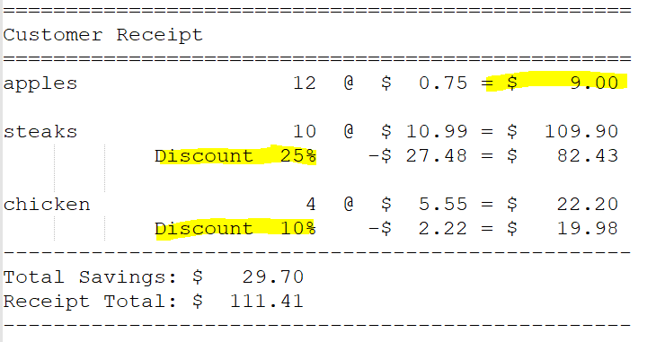

- PDF Peer reviews in a GitHub subfolder. Use the other person’s name as the file name. A peer review should focus on the person’s strengths and possibly providing helpful suggestions for future group work.
To give a good peer review on a programming assignment, be constructive, focus on learning, and use a positive, clear tone, starting with praise and then suggestions for improvement. Frame feedback as questions or requests, provide code examples, and avoid nitpicking minor issues, ensuring the review is a collaborative effort to improve future code and collaboration.
- Attach your program files to the assignment along with your Good, Bad, and Ugly (GBU) reflection written at a college level. IMPORTANT: include your GitHub URL in this document.

