An Era of the Seas
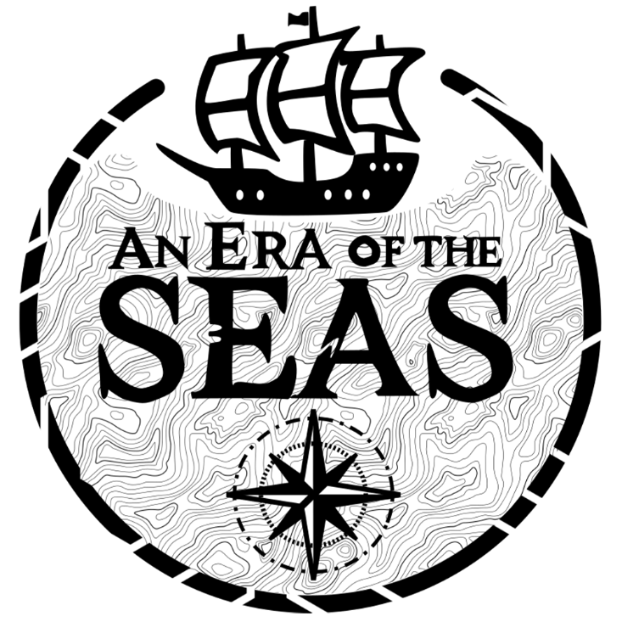
Version 1.0.0

Sommaire

Introduction
Welcome to An Era of the Seas, an open-world adventure and exploration game where every island holds its mysteries, dangers… and opportunities. In this vast and living world, you play as the son of a debt-ridden merchant, determined to restore your family’s honor and fortune.

Your mission: explore the 8 islands of the archipelago, each with its own resources, inhabitants, challenges, and secrets. Whether through trading, treasure hunting, or battling enemies, every means is fair game to repay the family debt… and perhaps, along the way, forge your own legend.

Sail between islands, build your network, upgrade your ship, make tough decisions… The world of An Era of the Seas is open, but unforgiving. The path you choose is yours alone.

Get ready to set sail. The adventure begins now.

About the Developers
Dream Chasers is an independent studio driven by one passion: turning dreams into interactive worlds. For them, a video game is more than entertainment — it's an adventure, a story to live.

With An Era of the Seas, their ambition is clear: to deliver an immersive experience blending exploration, realistic navigation, and strategic progression. This project reflects their commitment to pushing the boundaries of narrative gaming and crafting rich, captivating universes for players seeking escape.

Installation
On Windows (7, 8, 10, 11):
- Download the installer (AnEraOfTheSeasSetup.exe)
Source: [link]
- Run the installer (AnEraOfTheSeasSetup.exe) and follow the instructions
- Follow the instructions of the installer:
  - Choose your preferred language
  - Accept the terms and conditions
  - Select the installation directory (default: C:\Program Files\AnEraOfTheSeas)
  - Choose whether to create a desktop shortcut or not by checking/unchecking the option.
  - Click Install.
- After installation:
  - Optionally check "Launch An Era Of The Seas”.
  - Click Finish to close the installer
You can launch the game in two ways:
- From the desktop (if shortcut was created):
Double-click the An Era Of the Seas icon.
- From the Start Menu:
Go to Start > An Era Of The Seas > Open

On Linux:
Download the tar file (AnEraOfTheSeas.tar)
Source: [link]
```
tar -xvzf AnEraOfTheSeas.tar.gz
cd AnEraOfTheSeas
```
Make the main executable runnable:
```
chmod +x AnEraOfTheSeas.x86_64
./AnEraOfTheSeas.x86_64
```

Uninstallation
On Windows:
Open Control Panel > Programs > Uninstall a program
Select AnEraOfTheSeas and click Uninstall
Or:
Use the Uninstall AnEraOfTheSeas shortcut from the Start Menu

On Linux:
```
rm -rf ~/AnEraOfTheSeas/
rm -rf ~/.config/unity3d/DreamChasers/AnEraOfTheSeas/
```

Command:
Key | Action
W / A / S / D | Move
Mouse movement | Move Camera
Left Click | Attack
Space bar | Jump
E | Interact
B | Inventory
M | Map
H | Place/Remove Boat
R | Eat
X | Exit Boat
Esc | Return / Settings

User Interface:

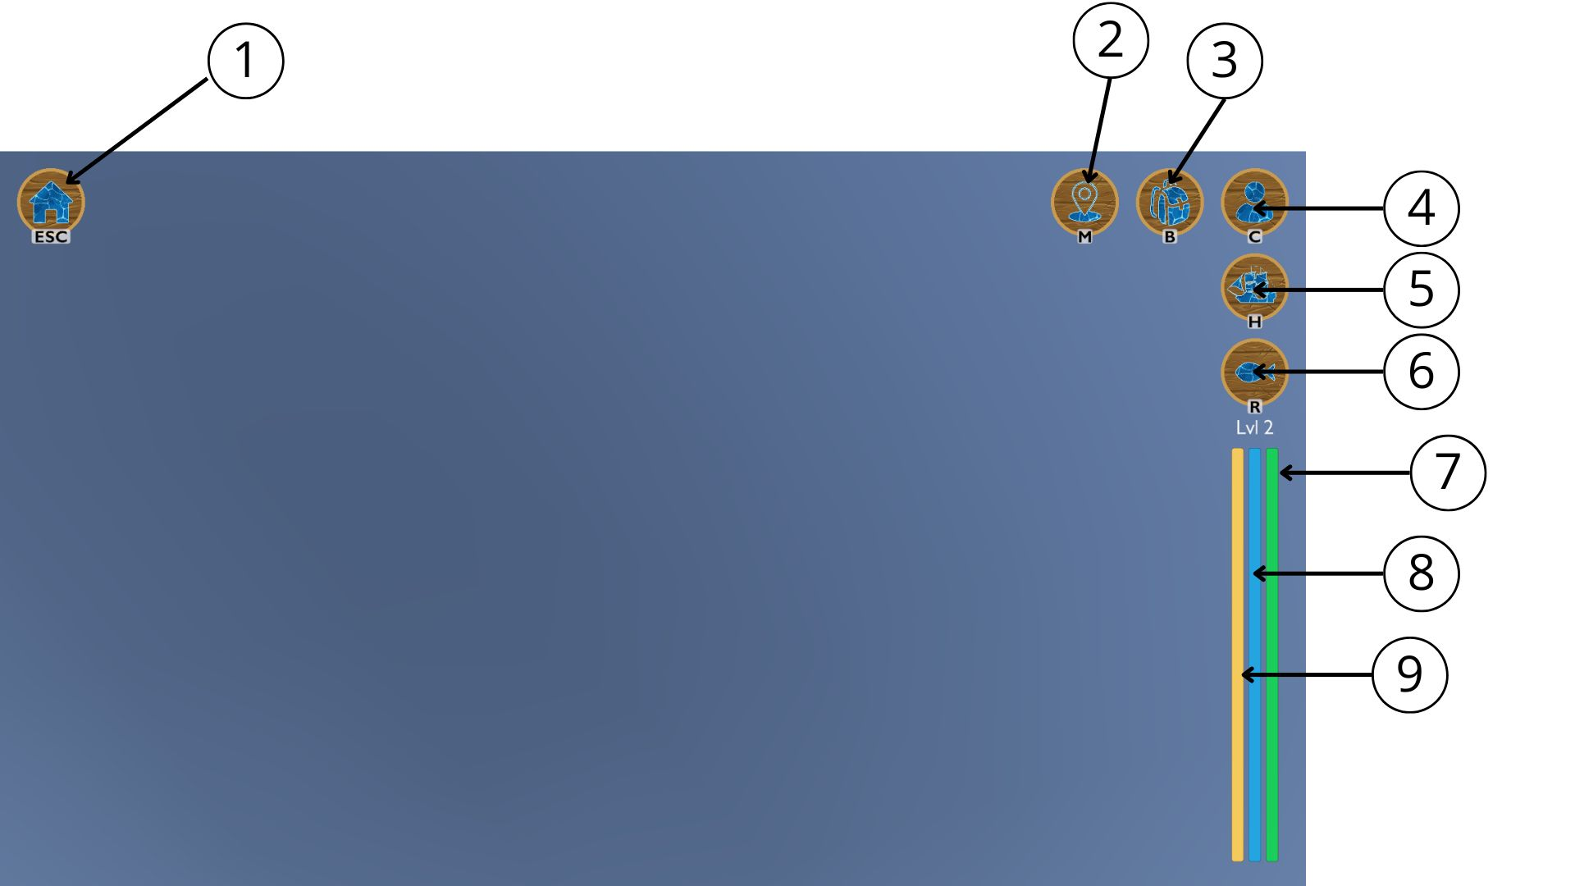

1: Settings
2: Map
3: Inventory
4: Equipment
5: Place/Remove Boat
6: Eat
7: Health Bar
8: Defense Bar
9: Hunger Bar

Game Mechanics
Quests & Story Progression
The player embarks on a journey as the son of a vanished merchant burdened by debt. Set in the mysterious world of the Shattered Seas, the player’s goal is to gain power and wealth. The main storyline unfolds through a Story Quest, where players interact with NPCs and explore diverse islands to uncover the fate of their family and the secrets of the seas.

Combat System
Combat in Shattered Seas is divided into two main types:
- Land Combat: Engage enemies on foot using your sword in real-time battles. Defeating enemies may yield valuable loots and resources.
- Naval Combat: Battle maritime foes aboard your ship. Maneuver your vessel and defeat the enemies to claim rewards.

Exploration
Exploration plays a crucial role in your journey to grow stronger and wealthier. Travel from island to island by boat and face new enemies.

Upgrades
Players can enhance their strength by upgrading:
- Weapons
- Sigils
- Boat
- Crew Members
Upgrades improve stats such as damage, health, and defense.
Upgrade materials include:
- Coins and Pure Water Drop for general upgrades
- Wood and Steel for boat enhancements
Advanced gear and upgrade items can be purchased from shops located in the central towns of each island.

Hunger system
Managing your character’s Hunger bar is essential for survival:
- When full, it regenerates health over time.
- When empty, the player gradually loses health.
Players can fish at designated spots and consume the catch to restore hunger and stay in fighting shape.

Shop
Each island town features a variety of shops where players can buy or sell equipment and manage their resources:
- Armorer – Sells weapons
- Mage – Offers magical sigils
- Boat Salesman – Provides ships and naval upgrades
- Material Seller – Sells crafting materials (Pure Water Drop, Steel, Wood)
- Purchaser – Buys any items and offers money or Pure Water Drop depending on the trade
Managing your economy effectively is key to progression and survival.

Multiplayer
Players can enjoy local multiplayer through two competitive mini-games:
- Treasure Hunt – Compete to find the hidden treasure chest first.
- Boat Race – Navigate through a challenging course; the first to capture the final flag wins.
These modes offer fun, fast-paced gameplay for friends on the same system.

Credits
Name of the Game: An Era of the Seas
Developed by: Dream Chasers

Programming:
- Achref Ben-Abdallah
- Ethan Bruno
- Joseph Devin
- Jérôme Lin

Art & Graphics:
- "9 Free Backgrounds" by Catlands Games (https://assetstore.unity.com/packages/2d/environments/9-free-backgrounds-285183)
- "Gold coins icons, tokens for game ui interface Free Vector" by Yuliya Pauliukevich (https://www.vecteezy.com/vector-art/16962878-gold-coins-icons-tokens-for-game-ui-interface)
- "Hand drawn animation frames element collection" by freepik (https://www.freepik.com/free-vector/hand-drawn-animation-frames-element-collection_32376918.htm)
- "Stump log Cartoon piece of wood Broken oak linden maple cedar" by valadzionak_volha (https://www.freepik.com/free-vector/stump-log-cartoon-piece-wood-broken-oak-linden-maple-cedar_20366568.htm)
- "Steal" by Canvas (https://media-public.canva.com/9TFWM/MAF-OH9TFWM/1/tl.png)
- "Free Low Poly Swords" by Pure Poly (https://assetstore.unity.com/packages/3d/props/weapons/free-low-poly-swords-189978)
- "Fantasy Sword" by 3dKingdom (https://assetstore.unity.com/packages/3d/props/weapons/fantasy-sword-25596)
- "FREE - Low Poly Swords - RPG Weapons" by Blink (https://assetstore.unity.com/packages/3d/props/weapons/free-low-poly-swords-rpg-weapons-198166)
- "sabre excalibur modèle 3D" by rito-kun (https://free3d.com/fr/3d-model/saber-excalibur-81501.html)
- "Poly Angel - Mini Pirates Island" by Poly Angel (https://assetstore.unity.com/packages/3d/vehicles/sea/poly-angel-mini-pirates-island-267015)
- "Stylized Pirate Ship" by Comeback (https://assetstore.unity.com/packages/3d/vehicles/sea/stylized-pirate-ship-200192)
- "Boats - PolyPack" by Alstra Infinite (https://assetstore.unity.com/packages/3d/vehicles/sea/boats-polypack-189866)
- "x mark png" by pngfind (https://www.pngfind.com/mpng/iiTwhiT_x-pirate-pirate-x-marks-the-spot-hd/)
- "clipart-scar" by purepng (https://purepng.com/photo/12877/clipart-scar)
- "Low-Poly Medieval Market" by VanillaArt (https://assetstore.unity.com/packages/3d/environments/low-poly-medieval-market-262473)
- "LowPoly Survival Character Rio" by VertexModeler Team (https://assetstore.unity.com/packages/3d/characters/humanoids/lowpoly-survival-character-rio-273074)
- "FREE Low Poly Human - RPG Character" by Blink (https://assetstore.unity.com/packages/3d/characters/humanoids/fantasy/free-low-poly-human-rpg-character-219979)
- "FREE - Modular Character - Fantasy RPG Human Male" by Blink (https://assetstore.unity.com/packages/3d/characters/humanoids/humans/free-modular-character-fantasy-rpg-human-male-228952)
- "Modular Fantasy Character" by asoliddev (https://assetstore.unity.com/packages/3d/characters/modular-fantasy-character-165896)
- "Brick Textures (LITE) FREE" by SR Studios Kerala (https://assetstore.unity.com/packages/2d/textures-materials/brick-textures-lite-free-289917)
- "Lowpoly Nature & Village Pack" by Hasan3DModels (https://assetstore.unity.com/packages/3d/environments/lowpoly-nature-village-pack-165318)
- "Stylised Fantasy House" by Naasz Arts (https://assetstore.unity.com/packages/3d/environments/fantasy/stylised-fantasy-house-257964)
- "Low Poly Fantasy Medieval Village Vol.2 Lite" by JustCreate (https://assetstore.unity.com/packages/3d/environments/fantasy/low-poly-fantasy-medieval-village-vol-2-lite-242322)
- "Medieval Village - POLY Pack - Demo" by Nicrom (https://assetstore.unity.com/packages/3d/environments/fantasy/medieval-village-poly-pack-demo-274109)
- "Lowpoly Medieval Peasants - Free - MEDIEVAL FANTASY SERIES" by Polytope Studio (https://assetstore.unity.com/packages/3d/characters/humanoids/humans/lowpoly-medieval-peasants-free-medieval-fantasy-series-122225)
- "Minimalist Demon" by Conquerror (https://assetstore.unity.com/packages/3d/characters/minimalist-demon-255613)
- "Goblin LowPoly - Animation" by Sr_bodinho (https://assetstore.unity.com/packages/3d/characters/goblin-lowpoly-animation-311643)
- "Sea anemone" by Poly by Google (https://poly.pizza/m/5mWGVL6VgMd)
- "Squid by Poly" by Google (https://poly.pizza/m/6ar_2XbrzCp)
- "Seahorse" by Poly by Google (https://poly.pizza/m/d_36p3CahYa)
- "Beach Lifeguard Buoy" by PijayArt (https://assetstore.unity.com/packages/3d/props/beach-lifeguard-buoy-282246)
- "Environment Track Lowpoly: Cartoon Props Mobile Free" by BE DRILL ENTER (https://assetstore.unity.com/packages/3d/props/environment-track-lowpoly-cartoon-props-mobile-free-211494)

Music & Sound Effects:
- "UI SFX Free Pack" by Skril Studio (https://assetstore.unity.com/packages/audio/sound-fx/ui-sfx-free-pack-245925)
- "FREE Casual Game SFX Pack" by Dustyroom (https://assetstore.unity.com/packages/audio/sound-fx/free-casual-game-sfx-pack-54116)
- "Adventure Gaming Music Suite" by Alison Turk (https://assetstore.unity.com/packages/audio/music/orchestral/adventure-gaming-music-suite-300438)
- "Music - Sanctuary (Free Piano Solo)" by Neko Legends (https://assetstore.unity.com/packages/audio/music/music-sanctuary-free-piano-solo-296088)
- "Mountain Pass Fantasy Music" by Alison Turk (https://assetstore.unity.com/packages/audio/music/orchestral/mountain-pass-fantasy-music-308919)
- "Medieval Music Pack Vol. 2" by alkakrab (https://assetstore.unity.com/packages/audio/music/medieval-music-pack-vol-2-233785)
- "25 Fantasy RPG Game Tracks Music Pack" by alkakrab (https://assetstore.unity.com/packages/audio/music/25-fantasy-rpg-game-tracks-music-pack-240154)
- "Piano Instrumental Music Loops" by alkakrab (https://assetstore.unity.com/packages/audio/music/piano-instrumental-music-loops-240221)
- "Music - Medieval Marketplace (Free Single)" by Neko Legends (https://assetstore.unity.com/packages/audio/music/music-medieval-marketplace-free-single-311109)

Game Engine:
- Unity (https://unity.com) Version 6000.0.30f1

Development Tools:
- Unity (https://unity.com) – Game engine
- Blender (https://blender.org) – 3D modeling
- Inkarnate (https://inkarnate.com) – 2D map design
- Adobe Photoshop – Image editing
- Canva (https://www.canva.com) – Graphic design
- Git & GitHub – Version control and collaboration
- Inno Setup (https://jrsoftware.org/isinfo.php) – Installer creation

© 2025 Dream Chasers. All rights reserved.

Licence
End-User License Agreement (EULA)

This game is licensed, not sold. By installing or using the software, you agree to the following terms:

1. You may use this software for personal entertainment.
2. You may not redistribute, modify, or decompile this software.
3. All content, including code, art, and audio, is owned by Dream Chasers.
4. This software is provided "as is", without warranty of any kind.

© 2025 Dream Chasers. All rights reserved.

