**User Manual**

**Drilling Machine Digital Twin**

**Introduction**

This user manual provides guidance for interacting with a simplified digital twin of a drilling machine, developed using the Unity game engine as part of an engineering internship project at Saipem SA of 2 months supervised by Rudy Maugé as a first-year preparatory cycle student in EPITA. The digital twin is designed to simulate the functionality of a real-world drilling machine in a virtual environment, enabling users to explore its components and operations in an interactive and intuitive manner.

In addition to interaction, the system allows real-time visualization of sensor data collected from the physical drilling machine. This integration of monitoring and simulation supports a better understanding of machine behavior, facilitates training, and contributes to operational insight in a safe and controlled setting.

**Installation**

* Download the installer (DM-DigitalTwinSetup.exe)
* Run the installer (DM-DigitalTwinSetup.exe) and follow the instructions
* Follow the instructions of the installer:
  + Choose your preferred language
  + Accept the terms and conditions
  + Select the installation directory (default: C:\Program Files\DrillingMachine-DigitalTwin)
  + Choose whether to create a desktop shortcut or not by checking/unchecking the option
  + Click Install
* After installation:
  + Optionally check ”Launch Drilling Machine Digital Twin”
  + Click Finish to close the installer

You can launch the software in two ways:

* From the desktop (if shortcut was created):  
  Double-click the Drilling Machine Digital Twin icon.
* From the Start Menu:  
  Go to Start > Drilling Machine Digital Twin > Open

**Uninstallation**

* Open Control Panel > Programs > Uninstall a program
* Select DrillingMachine-DigitalTwin and click Uninstall  
  Or:
* Use the Uninstall DrillingMachine-DigitalTwin shortcut from the Start Menu

**Commands (AZERTY configuration)**

In Drilling Mode

|  |  |  |
| --- | --- | --- |
| Action | Key (QWERTY) | Key (AZERTY) |
| Return / Settings Menu | ESC | ESC |
| Open Parameter Menu | TAB | TAB |
| Move camera view | Mouse Right Click + Mouse Movement | Mouse Right Click + Mouse Movement |
| Height Navigation | W/S | Z/S |
| Zoom in/out | Mouse scroll | Mouse scroll |
| Select Slip Table | 1 | & |
| Select Rotary Table | 2 | é |
| Reset selection | 3 | “ |
| Lock the table to the Kelly Bar | L | L |
| Move selected upward | Arrow Key Up | Arrow Key Up |
| Move selected downward | Arrow Key Down | Arrow Key Down |
| Change Drilling Leader Tower details visibility | V | V |
| Change Terrain Layer visibility | T | T |

In Replay Mode

|  |  |  |
| --- | --- | --- |
| Action | Key (QWERTY) | Key (AZERTY) |
| Return / Settings Menu | ESC | ESC |
| Move camera view | Mouse Right Click + Mouse Movement | Mouse Right Click + Mouse Movement |
| Height Navigation | Arrow Key Up/Down | Arrow Key Up/Down |
| Zoom in/out | Mouse scroll | Mouse scroll |
| Change Drilling Leader Tower details visibility | V | V |
| Change Terrain Layer visibility | T | T |
| Pause/Resume | Space | Space |

**Mechanics**

**Main Menu**

Upon launching the software, users can choose between two modes: Interactive Mode and Replay Mode, by selecting the corresponding button.

Additionally, users are directed to the Settings Menu, where various configurable options are available. These include:

* Display Settings: Screen mode and refresh rate.
* Navigation Sensitivity: Mouse control, scroll sensitivity, and height navigation sensitivity.
* Graphics Settings: Fog distance and sensor visibility.

Users also have access to the **Credits Menu**, where information regarding the various assets and development tools utilized in the creation of the software is available.

**Drilling Machine Structure**

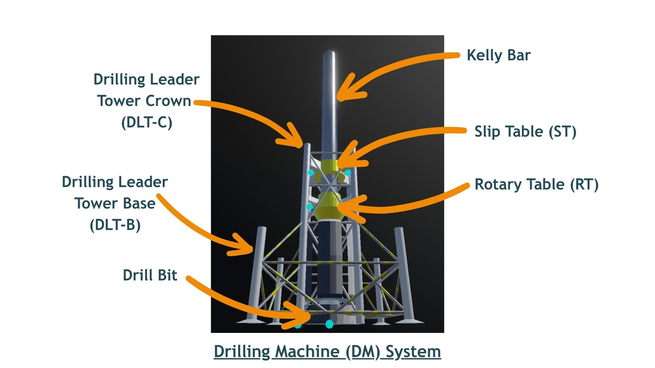

**Interactive Mode**

In InteractiveMode, users directly interact with and control the drilling machine through a set of commands.

To move the drilling machine, the user must select one of the two available tables: the Slip Table or the Rotary Table. When one of the tables is selected it is highlighted in white.

When a table is locked, it is highlighted in orange upon selection. In this state, the Kelly bar and drill bit move together with the selected table, enabling the drilling operation. When a table is unlocked (highlighted in white), it moves independently along the Kelly bar when the user triggers movement using the associated keys. Note that if both tables are locked simultaneously, neither of them will be able to move.

Height navigation is divided into three distinct layers: Surface, Underwater, and Underground. Within the underground layer, users can observe the different subsea soil.

A Parameters Menu is accessible by pressing the TAB key, allowing adjustment of several drilling machine and subsea soil parameters. These include:

* Time speed, enabling acceleration or deceleration of simulated time.
* Drilling velocity.
* Rotation velocity.
* Subsea soil parameters such as the required weight for each layer and their respective depths.

The **Settings Menu** can be accessed at any time by pressing the **ESC** key, which also allows returning to the main menu.

Sensors installed on the drilling machine are interactive and can be selected with the mouse when highlighted in blue. Selecting a sensor displays its data evolution through a line chart.

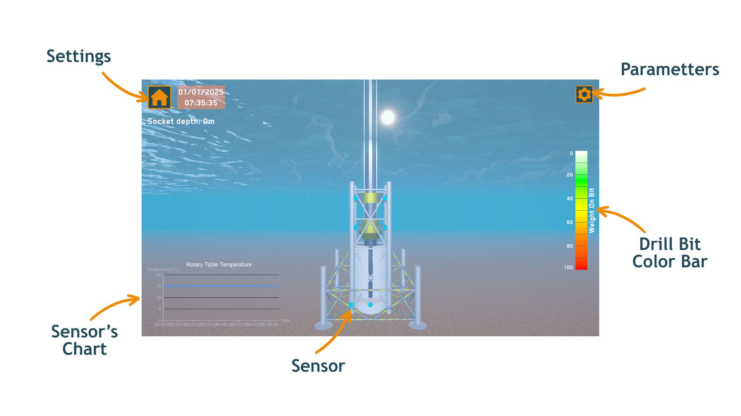

**Replay Mode**

The Replay Mode enables users to review and monitor sensor data and observe the drilling process and installation over time.

To use this mode, a properly formatted CSV file containing the required data must be provided. The file must include a header row with the following columns:  
Date, DLT_B, DLT_C, DM, ST_Height, RT_Height, DrillBit_Height, DrillBit_Rotation, ST_Load, ST_Temp, RT_Load, RT_Temp, WeightOnBit, DrillingVelocity, DM_Torque, Soil_Type.

|  |  |
| --- | --- |
| Variables | Unit/Format |
| Date | dd/MM/yyyy hh:mm |
| DLT_B, DLT_C, DM | Value between 0 (uninstalled) and 1 (installed) |
| ST_Height, RT_Height, DrillBit_Height | meter |
| DrillBit_Rotation | RPM |
| ST_Load, RT_Load, WeightOnBit | tons |
| ST_Temp, RT_Temp | °C |
| DrillingVelocity | mm/s |
| DM_Torque | N.m |
| Soil_Type | Integer between 0 and 5 |

Sensor data visualization is available through line charts similar to those in Interactive Mode. Users can navigate through the timeline using a slider to move forward or backward to specific timestamps.

Replay playback speed can be adjusted, functioning like a video player within a 3D environment.

Subsea soil corresponding to the data provided in the CSV file are also displayed.

The Settings Menu in Replay Mode offers the same configuration options as in Interactive Mode.

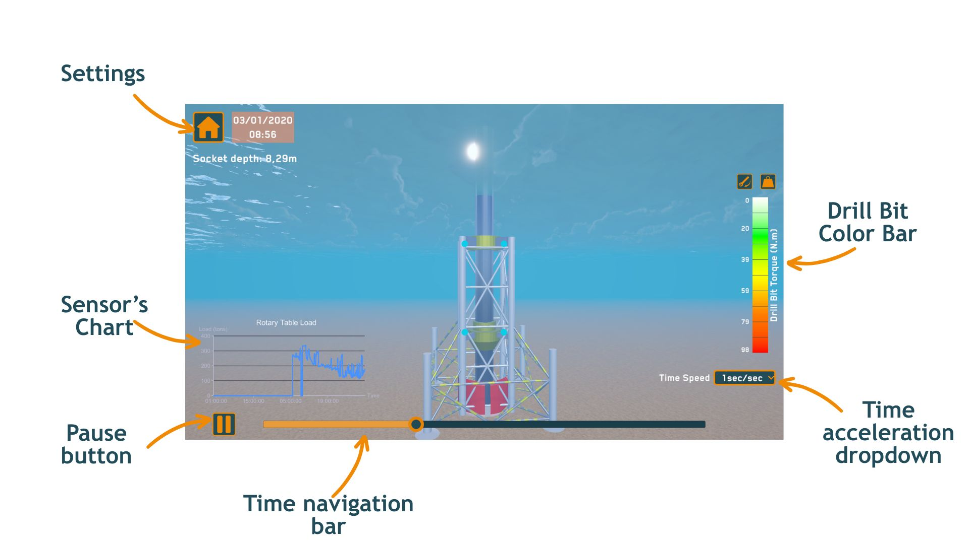

**Step-by-step example**

Start the Interactive Mode

Launch the Digital Twin

Click on Interactive Mode

Change the time acceleration

Go to the parameter menu

Change the Time Speed to “30min/sec”

Drill with the slip table

Select the slip table (press 1)

Move the slip table (press Arrow key Down)

Drill with the rotary table

Unlock the slip table (press L)

Select the rotary table (press 2)

Lock the rotary table (press L)

Move the rotary table (press Arrow key Down)

Move the Drilling Machine Upward

Move the rotary table (press Arrow key Up)

See the sensors values

Click on the Rotary Table sensor (click on the blue on one of the blue dots on the rotary table)

Quit the application

Navigate to the Settings Menu (press ESC)

Click the quit button to return to the main menu

Click the quit button to close the application

**License**

**End-User License Agreement (EULA)**

This software is licensed, not sold. By installing or using the software, you agree to the following terms:

1. You may use this software for personal entertainment.

2. You may not redistribute, modify, or decompile this software.

3. All content, including code, art, and audio, is owned by Lin Jérôme.

4. This software is provided "as is", without warranty of any kind.

© 2025 Saipem SA. All rights reserved.