Employee Sentiment Analysis - Final Report

1. Approach and Methodology
This project involved analyzing an unlabeled dataset of employee messages to assess sentiment and engagement. Natural Language Processing (NLP) was applied using TextBlob to extract the semantic polarity of each message. The messages were classified based on the following thresholds:
- • Positive: Polarity score > 0.05
• Negative: Polarity score < -0.05
• Neutral: Polarity score between -0.05 and 0.05

2. Key Findings from EDA
The Exploratory Data Analysis (EDA) revealed the following:
- • Positive sentiment dominates the dataset consistently across all months.
• Negative messages are present but make up a small fraction of overall volume.
• Message volume varies significantly between employees, indicating different communication habits.

3. Employee Scoring and Ranking Process
Monthly sentiment scores were calculated using a discrete scoring system:
- • Positive message: +1
• Negative message: -1
• Neutral message: 0
These scores were aggregated monthly and reset at the beginning of each new month. Employees were then ranked by sorting these monthly scores in descending order for the top positive employees, and ascending order for the top negative employees.

4. Flight Risk Identification
A 'flight risk' was defined as any employee sending 4 or more negative messages within a rolling 30-day window. Based on this criteria, 6 employees were identified:
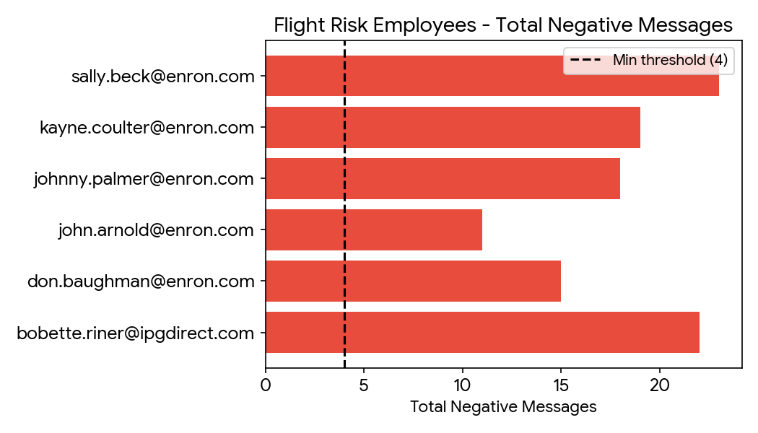

5. Predictive Model Overview and Evaluation
A Linear Regression model was developed to predict monthly sentiment scores based on communication features. The dataset was split 80/20 for training and testing.
- Model Performance Metrics:
• R² Score: 0.8292 (explains 82.9% of variance)
• Mean Absolute Error (MAE): 1.0341
• Root Mean Squared Error (RMSE): 1.4103
Insights:
• The percentage of positive messages (pct_positive) is the strongest positive predictor of a high monthly score.
• The percentage of negative messages (pct_negative) is the strongest negative predictor.
• Message frequency has a positive correlation, indicating that more active employees generally exhibit higher sentiment scores.
