Dense Reward Validation Report
LIBERO-Spatial: comparison with the original terminal-only reward
Project revision | SimpleVLA-RL-DenseReward @ 86111de (validation optimization)
Evidence | 16 validation logs; fixed 300-rollout evaluation per checkpoint; three supplied plots
Starting checkpoint | ≈50.0% validation success before RL (per run-owner note and figures)
Executive summary
The dense reward with terminal coefficient 5 is the strongest tested reward under this validation protocol. It reached 65.3% success at checkpoint 160, exceeding the terminal-only reference’s best observed 61.7% at checkpoint 170 by 3.6 percentage points (pp). From the reported 50.0% pre-RL checkpoint, this is a +15.3 pp gain versus +11.7 pp for terminal-only.
At the three directly aligned checkpoints (40, 80, and 110), dense reward is higher than terminal-only by 0.8, 2.3, and 2.4 pp. The observed advantage therefore appears consistently in the sampled checkpoints and grows over the measured training range.
Decision: Use dense 0.05/0.05 + terminal 5 as the next candidate configuration. Keep terminal success at coefficient 5 for the primary comparison, then confirm the result with multiple training seeds and a held-out evaluation seed set.

Scope and protocol
- Benchmark: LIBERO-Spatial; success rate is the mean of 300 fixed validation rollouts per evaluated checkpoint.
- Model and validation settings in the logs: OpenVLA-OFT, LoRA rank 16 on llm-projector; validation uses libero_spatial_no_noops.
- This report compares reward variants within the supplied runs. It does not claim reproduction of the published SimpleVLA-RL results because the starting checkpoint and training recipe differ.
Results
All values are validation success rates on the same fixed LIBERO-Spatial validation set. Each checkpoint evaluation contains 300 rollouts (10 tasks × 30 trials).
Reward variant | Best success | Checkpoint | Δ from 50.0% | Interpretation
Terminal only (coef=5) | 61.7% | step 170 | +11.7 pp | Reference baseline
Dense 0.05/0.05 + terminal 5 | 65.3% | step 160 | +15.3 pp | +3.6 pp vs terminal
Dense clipped + terminal 5 | 64.7% | step 50 | +14.7 pp | Filtered trajectory set
Dense 0.05/0.05 + terminal 1 | 61.0% | step 110 | +11.0 pp | Different terminal scale
Phase-only + terminal 1 | 63.7% | step 90 | +13.7 pp | Peak; clipped at 0.05
Terminal-only baseline vs. dense reward with terminal coefficient 5
Approx. checkpoint | Terminal only | Dense 0.05/0.05 + terminal 5 | Dense − terminal
40 | 61.0% | 61.8% | +0.8 pp
80 | 60.7% | 63.0% | +2.3 pp
110 | 61.3% | 63.7% | +2.4 pp
160/170 | 61.7% (170) | 65.3% (160) | +3.6 pp
Interpretation by reward
1. Original terminal-only reward (coefficient 5)
This is the reference condition: reward is driven only by episode completion, with terminal coefficient 5. It improves from the reported 50.0% starting point to 60.7–61.7%, but the four observed checkpoints form a near-flat plateau after step 40. Its best gain is +11.7 pp.
2. Dense 0.05/0.05 + terminal 5
This is the main dense-reward condition described by the run owner: 0.05 for within-phase progress and 0.05 for completing a phase, added to terminal reward 5. It rises from 61.8% at step 40 to 65.3% at step 160 without a sampled regression. Its best gain from the starting checkpoint is 15.3 pp, 30.8% larger than the terminal-only gain (15.3 / 11.7 − 1).
3. Dense clipped + terminal 5
This variant reaches 64.7% at step 50, close to the best 65.3% dense run. It trains on a selected trajectory set that excludes fully successful and fully failed trajectories, and the run owner reports approximately four days of training despite only 50 saved steps. Therefore, its 50-step value is evidence of a promising result, but it is not an apples-to-apples claim of faster learning by step count or wall-clock time.
4. Terminal coefficient 1 ablations
Dense 0.05/0.05 + terminal 1 peaks at 61.0%, while the phase-only condition peaks at 63.7% before falling to 62.3% at step 110. These are useful exploratory results but are confounded by the lower terminal coefficient. The run owner notes that phase-only shaping remained clipped at 0.05 because the clip was not increased; this limits conclusions about the intended phase-reward magnitude.
What the data support—and what they do not
- Supported: the dense 0.05/0.05 + terminal 5 series is above terminal-only at every directly aligned measured checkpoint and has the best final observed success rate.
- Supported: dense clipping produces a high success rate under its own filtered-trajectory procedure, but with a different compute/selection profile.
- Not yet supported: a statistically confirmed improvement. With 300 binary rollouts, individual 95% half-widths in the logs are approximately ±5.4–5.6 pp; the 3.6 pp best-checkpoint gap requires repeated training seeds and paired or independent statistical testing.
- Not yet supported: a causal conclusion that lowering terminal reward from 5 to 1 causes instability. The observed pattern is consistent with that hypothesis, but reward scale and dense-reward composition changed simultaneously.
Recommended next experiment
- Run terminal-only (coefficient 5) and dense 0.05/0.05 + terminal 5 with at least three matched training seeds from the same ≈50% starting checkpoint.
- Evaluate every selected checkpoint on the same 300-rollout fixed set and an additional held-out seed set; retain per-episode success IDs to permit paired comparisons.
- Match the dense-clipped and unfiltered conditions by wall-clock budget and record the number of collected, retained, fully successful, and fully failed trajectories.
- Run a controlled terminal-scale ablation: terminal 1 versus 5 while keeping dense weights, clip, batch composition, and all other settings fixed.
- For phase-only shaping, explicitly set and record the intended clip; then repeat its best configuration with matched seeds.

Appendix A — supplied validation plots
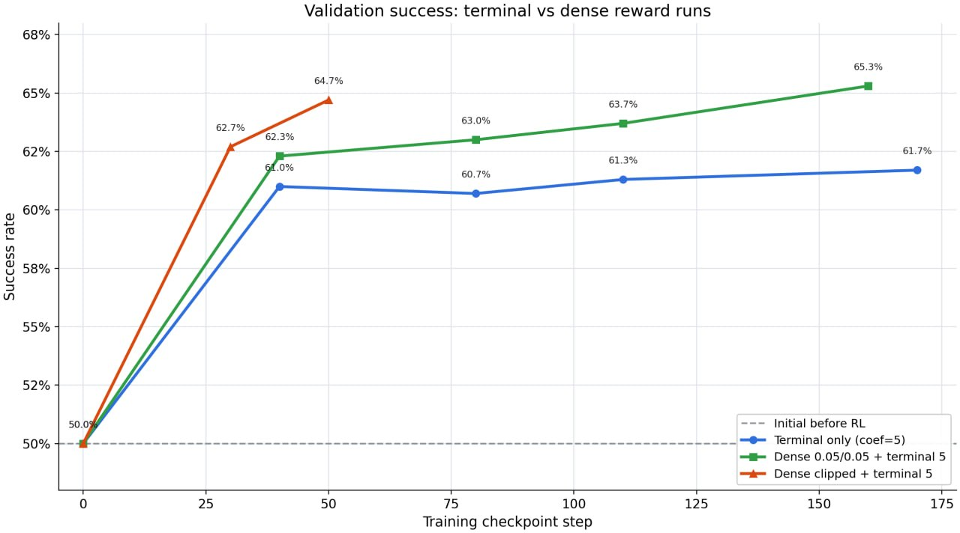
Figure A1. Terminal-only versus the two terminal=5 dense-reward variants.

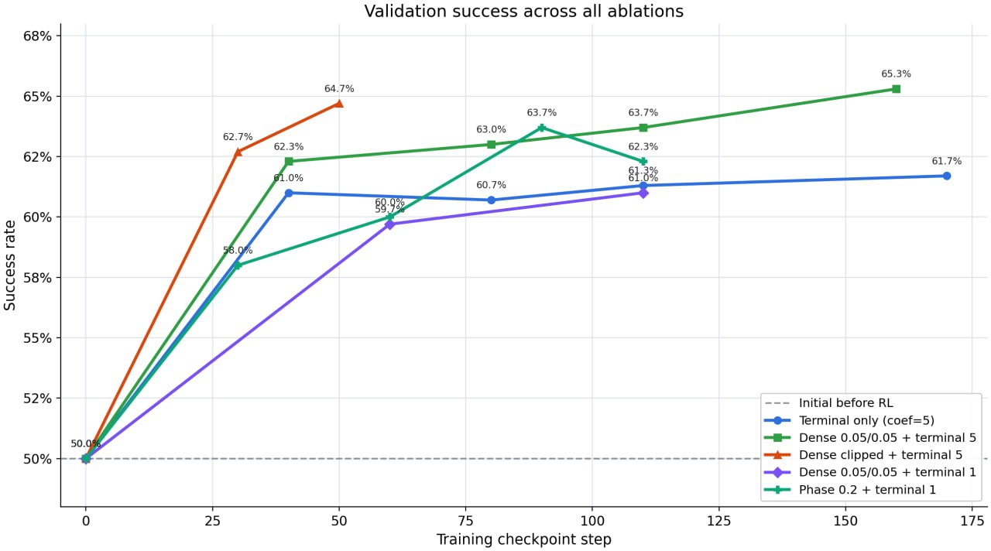
Figure A2. Validation success across all supplied ablations.

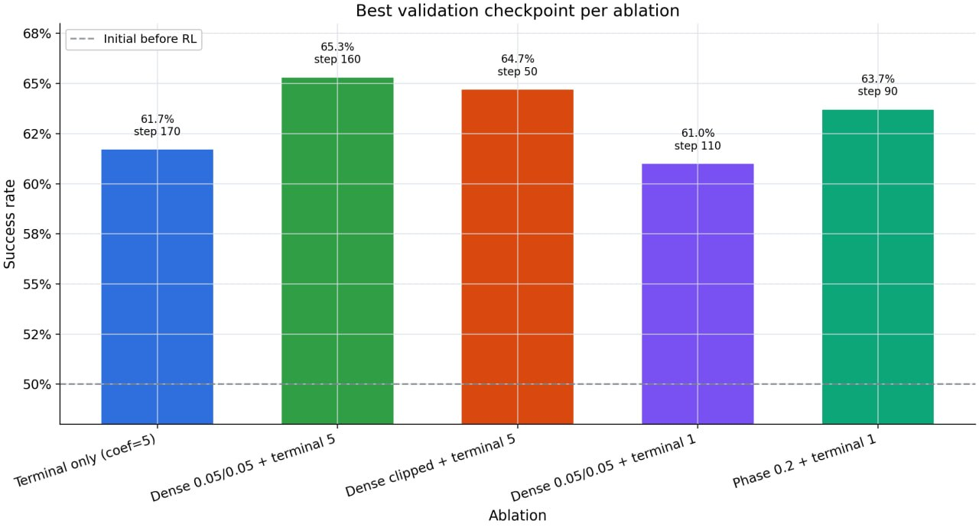
Figure A3. Best evaluated checkpoint for each ablation.

Appendix B — source inventory
Primary quantitative source: /Users/daeron/Downloads/vaidation_runs/plots/validation_metrics_summary.csv and the 16 corresponding validation logs in the same directory. The log evidence reports the final per-checkpoint aggregate validation metric and rollout count.
Qualitative configuration and runtime notes: supplied by the run owner in the task request (starting success ≈0.5, dense/phase definitions, and dense-clipped runtime). These notes are labelled as run-owner descriptions where they are not independently reconstructible from the validation logs.
Codebase inspected: SimpleVLA-RL-DenseReward at git revision 86111de (2026-07-14). Relevant implementation locations include verl/utils/subgoal_reward/dense_reward.py, verl/utils/subgoal_reward/engine.py, and verl/trainer/ppo/ray_trainer.py.

