1、Induction

Our cake ordering system can make the discount function avoid duplication, the cake ordering function can be decoupled and the database connection can improve safety and flexibility, and the cake system can be constructed to achieve simple operation and save system resources and improve efficiency.

2、Overview

* Observer Pattern
* Simple factory Pattern
* Singleton Pattern
* Factory Pattern
* Strategy Pattern
* Facade Pattern

3、Users and Stakeholders

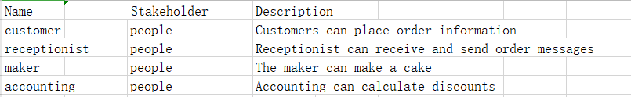4、Usercase diagram

