Delivery Manager System
Requirements

  - Forword
With the rapid growth of our national economy, Chinese Delivery Industry experienced a booster at the rate of 30% every year in China.but it also has a lot of problems.
Since 1979, the first express enterprises established in shenzhen, according to statistics, at present there are more than 6000 express enterprises in China. EMS and other state-owned enterprises,the famous private enterprises such as : ShunFeng, ShenTong, YuanTong, ZhongTong,the foreign companies such as DHL, UPS;
However, there are also many problems in our express industry. For example: there are a lot of small family businesses with old management mode, only forcus on their own interests, can not consider the entire enterprise's long-term development.
We should take some measures to improve the situation. For example, to strengthen the government regulation , apply more technology, improve work efficiency and service quality.

  - Scope
Our delivery manager system that provides tracking express number service,package receiving service and express sending service which are mainly applicable to the whole network express inquiry, and it also supports automatic tracking of online shopping packages such as Taobao, Jingdong, etc., and covers more than 80 express companies at home and abroad.
There are three main functions that constitute the scope of our delivery manager system:
1 .We provide express proxy service which means that you don't have to worry about your packages being lost, because we will receive and organize your packages for you, and then wait for you to collect them.
2 .If you need to send a express, please contact us, we will provide you with the most professional service.Come to us with your package, and leave the rest to us.
3 .The time to wait for the courier is always like "pass a day as if it were a year". If you want to query more about your express, please log in to our system and check with tracking number or shopping information.

2.1 Glossary

Term | Definition
DMS | Delivery Manager System
EPS | Express Proxy Service
ESS | Express Sending Service
QES | Query Express Service

2.2 Overview
DMS is a service that makes express more convenient. Using a website form factor, DMS allows users to create an account to manage their own express. With a special focus on the busy people. In addation, DMS is also an ideal tool for ensuring that everyone can manage express efficiently.

3.1 User Stories
1 .Student:As a college student, I often shopping online, I hope to check my package information at any time.
2 .Businessman：I am very busy, I can't collect my package on time, I need express proxy service.
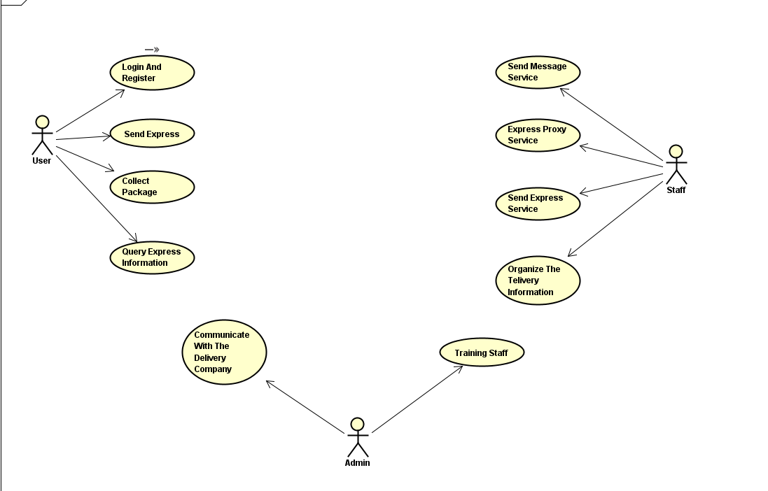

3.2 Prototype
1. Product express boxes and packages -工厂模式
2. Fill in the delivery form -装饰者模式
3. Track the status of the express -状态模式
4. Query the bill -访问者模式
5. VIP system -策略模式
6. Choose express delivery method -桥接模式

