一、Introduction
1.Project brief introduction
With the development of the times, people's life rhythm is faster and faster. Reservation has become an indispensable part of life. For example, when we want to get a cake according to our own ideas, we must book in advance, and then pick up the cake within the prescribed time. This not only enables us to eat fresh cakes, but also allows the cake shop enough time to make a cake, which brings us great convenience.
2.Function
(1) The main functions of the cake ordering system are: displaying the ordering information, ordering the cake, calculating the amount payable, discounting and making the cake.
(2) Display order information function is mainly for pastry chef. The baker can check the order information to make the customer's cake and confirm the time when the customer takes the cake.
(3) The function of ordering cake is mainly for customers. Customers can order cakes online at the cake shop.
(4) The function of calculating the amount payable is mainly for salesmen. When it's time to pick up the cake, the salesman can correctly calculate the amount payable by the customer (including the amount payable after discount when carrying out promotional activities).
(5) The discount function is aimed at customers. When customers encounter promotional activities, the amount payable will be discounted.
(6) The cake making function is directed at the pastry maker. When the customer orders the cake, the baker makes the cake by ordering information.
3.Overview
Cake ordering system adopts the mode of combination of online and offline. When customers order cakes online, pastry chefs can prepare materials and make cakes by ordering information. When customers come to the cakes shop to pick up cakes on the day they pick up cakes, the salesman decides whether it is a promotion day or not, if it is, they can discount and let customers pay less money. If not, they can normally charge the amount.
二、Use Cases
1.Actor and Stakeholder Table
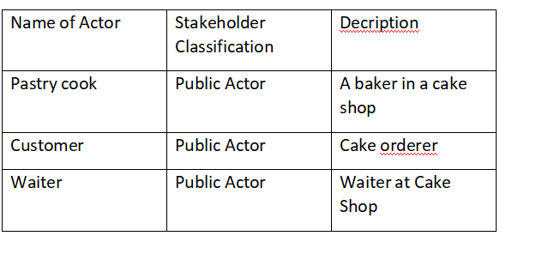
2.UseCase Diagram
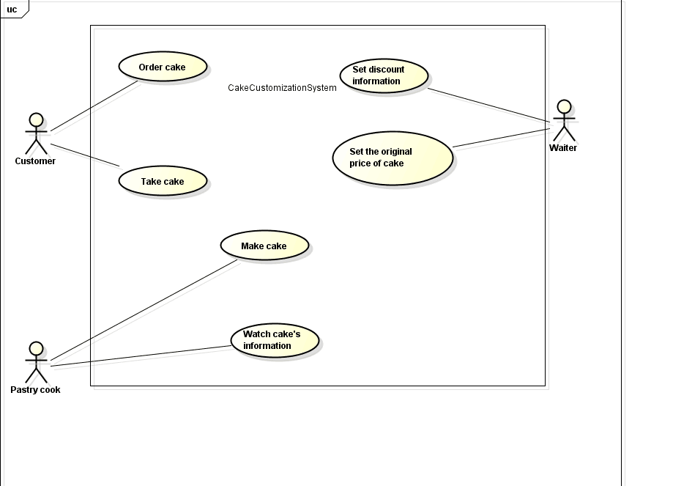
三、Design Pattern
（1）simple factory pattern ------------------ Categories of Cakes

（2）Factory Method pattern ------------------ Make cakes

（3）Facade Pattern ------------------ Business Processing by Servers and Customers

（4）Strategy Pattern ------------------ Describe how cakes are discounted

（5）Proxy Pattern ------------------ Remind customers of the completion of cake making

（6）Observe Pattern ------------------ Receiving customer information

（6）Singleton Pattern ------------------ Create a unique object

