**15CSE312- COMPUTER NETWORK**

**Online Food Ordering System**

**Group Number-17**

|  |  |  |  |
| --- | --- | --- | --- |
| **Registration No** | **Name** | **Email ID** | **Contribution** |
| CB.EN.U4CSE18155 | M.TEJASWINI ANUHYA | cb.en.u4cse18155@cb.students.amrita.edu | * Why networking is required for the application * Software/Operating systems used |
| CB.EN.U4CSE18161 | V.SUREKHA | cb.en.u4cse18161@cb.students.amrita.edu | * Problem Statement * Protocols used in the application * Hardwares/Devices used |
| CB.EN.U4CSE18174 | D.HARSHA VARDHAN | cb.en.u4cse18174@cb.students.amrita.edu | * Benefits of computer networking in the application * Server configuration and web server software |

Why Networking is required for the application:

1. **Smartphone Ownership**

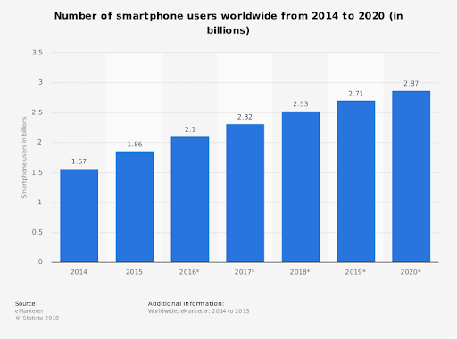

As you can see from this data representation, the number of smartphone users and the number of people using mobile internet is steadily increasing. So clearly, one of the most common tools available to a large portion of the population is a smartphone with connectivity to the internet. This is why we need networking for Online food ordering system, because it helps connect everyone, in this case customers and delivery people, quickly and efficiently.

1. **To create mutual benefit between customer and delivery person**

**(c)The Growing Food Delivery Market**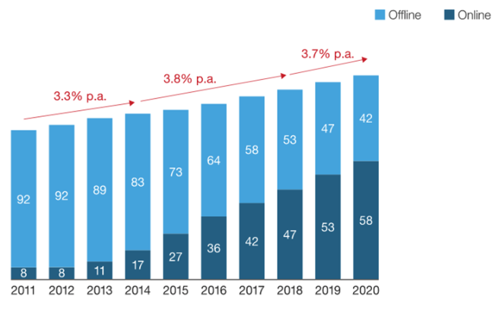

Currently, out of the total traditional food ordering market, 47% is offline while 53% is conducted online. This figure is expected to flip in the next couple of years. Overall, this sector is growing at an annual rate of 3.7%, but interestingly online food ordering, and the delivery sector is expected to grow at 15-20% during the same period. There has been tremendous growth in the online food delivery sector in the past few years and is expected to grow at a rapid pace in the coming few years.

**Case Study:**

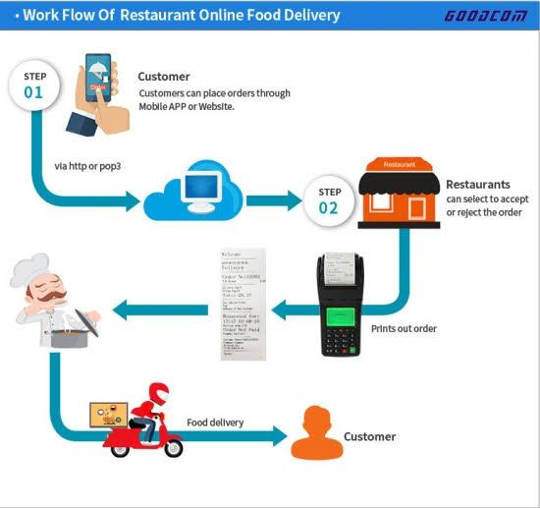

**Problem statement:**

To study the working of online food ordering system (Zomato, Swiggy) and the role of networking in the operation of such services. In this case study, we try to understand how a delivery person is connected to a customer, via the internet.

**Benefits of computer networks in Online Food ordering:**

* Supports Global Payments
* Real-time tracking for orders
* Make up for reduced foot traffic
* Enhanced Productivity
* Keep track of the orders and deliveries
* Better management of Demand and operations

**Protocols in Online Food ordering system:**

* Internet Protocols
* Network Address Translation Protocol(NAT)
* Hypertext Transfer Protocol(HTTP)
* Simple object Access Protocol(SOAP)
* Representative State Transfer Protocol(REST)

**Software/Operating System used:**

**1)** **Operating System:**

* OS: Windows (Vista/7 or above)
* Web Browser: IE 10 or above, Mozilla FF 31 and above or Google Chrome
* Drivers: Java Runtime Environment
* Integrated Development Environment: Eclipse J2EE or Apache Tomcat

**2)** **Programming Languages:**

* Java Script
* HTML
* PHP
* Python
* Ruby

**Hardware/Devices used:**

* Pentium Processor
* 60 B of free hard-drive space
* 128 MB of RAM

**Server configuration:**

* DigitalOcean Cloud Services
* Amazon Web Services
* Linode
* Vultr
* Microsoft Azure

**Web server software:**

* Apache HTTP Server
* Nginx

**Why measure network performance?**

The demands on networks are increasing every day, and the need for proper network performance measurement is more important than ever before. Effective network performance translates into improved user satisfaction, whether that be internal employee efficiencies, or customer-facing network components such as an e-commerce website, making the business rationale for performance testing and monitoring self-evident.

When delivering services and applications to users, bandwidth issues, network down time, and bottlenecks can quickly escalate into IT crisis mode. Proactive network performance management solutions that detect and diagnose performance issues are the best way to guarantee ongoing user satisfaction.

The performance of a network can never be fully modeled, so measuring network performance before, during, and after updates are made and monitoring performance on an ongoing basis are the only valid methods to fully ensure network quality. While measuring and monitoring network performance parameters are essential, the interpretation and actions stemming from these metrics are equally important.

**Performance parameters:**

|  |  |  |
| --- | --- | --- |
| **Parameter** | **Meaning** | **Formula** |
| **Bandwidth** | Bandwidth is the capacity of a wired or wireless network communications link to transmit the maximum amount of data from one point to another over a computer network or internet connection in a given amount of time | Expressed as [bits](https://web.archive.org/web/20190816003233/https:/whatis.techtarget.com/definition/bit-binary-digit) per second ([bps](https://web.archive.org/web/20190816003233/https:/searchnetworking.techtarget.com/definition/bits-per-second)), modern network links have greater capacity, which is typically measured in millions of bits per second ([megabits per second](https://web.archive.org/web/20190816003233/https:/searchnetworking.techtarget.com/definition/Mbps), or Mbps) or billions of bits per second ([gigabits per second](https://web.archive.org/web/20190816003233/https:/whatis.techtarget.com/definition/Gbps-billions-of-bits-per-second), or Gbps). |
| **Throughput** | Throughput measures the percentage of data packets that are successfully being sent; a low throughput means there are a lot of failed or dropped packets that need to be sent again. |  |
| **Packet Loss** | Packet loss occurs when one or more packets of data travelling across a computer network fail to reach their destination.Due to network congestion | Efficiency = 100% * (transferred - retransmitted) / transferred  Network Loss = 100 - Efficiency |
| **Transmission time** | The time required for transmission of a message depends on the size of the message and the bandwidth of the channel. | Transmission time=Message size / Bandwidth |
| **Propagation Time** | Propagation time measures the time required for a bit to travel from the source to the destination. The propagation time is calculated by dividing the distance by the propagation speed. | Propagation time = Distance /Propagation speed |
| **Processing Delay** | Time taken by the processor to process the data packet is called processing delay. |  |
| **Queuing Delay** | Time spent by the data packet waiting in the queue before it is taken for execution is called queuing delay. |  |
| **Jitter** | Jitter is defined as the variation in time delay for the data packets sent over a network. This variable represents an identified disruption in the normal sequencing of data packets. Jitter is related to latency, since the jitter manifests itself in increased or uneven latency between data packets, which can disrupt network performance and lead to packet loss and network congestion. Although some level of jitter is to be expected and can usually be tolerated, quantifying network jitter is an important aspect of comprehensive network | Latency=sum of all delays    To measure Jitter, we take the difference between samples, then divide by the number of samples (minus 1). |

**Architecture diagram:**

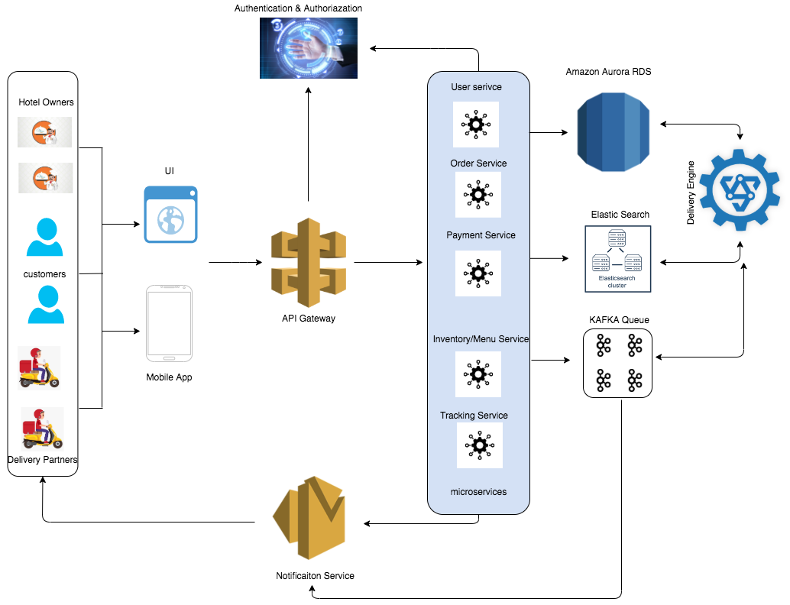

|  |  |
| --- | --- |
| Department Name /SubNetwork Name | Student RollNo and Name |
| Restaurant Management | CB.EN.U4CSE18155-M.TEJASWINI ANUHYA |
| Online Ordering/Tracking | CB.EN.U4CSE18161-V.SUREKHA |
| Payment Management | CB.EN.U4CSE18174-D.HARSHA VARDHAN |

|  |  |  |  |  |
| --- | --- | --- | --- | --- |
| Department | Subnet Mask | Network address | Broadcast Address | Total Number of Usable addresses |
| Department1 | 255.255.255.248 | 172.22.18.8 | 172.22.18.15 | 6 |
| Department2 | 255.255.255.248 | 172.22.18.16 | 172.22.18.23 | 6 |
| Department3 | 255.255.255.240 | 172.22.18.24 | 172.22.18.39 | 14 |