

HRDF: USER GUIDE

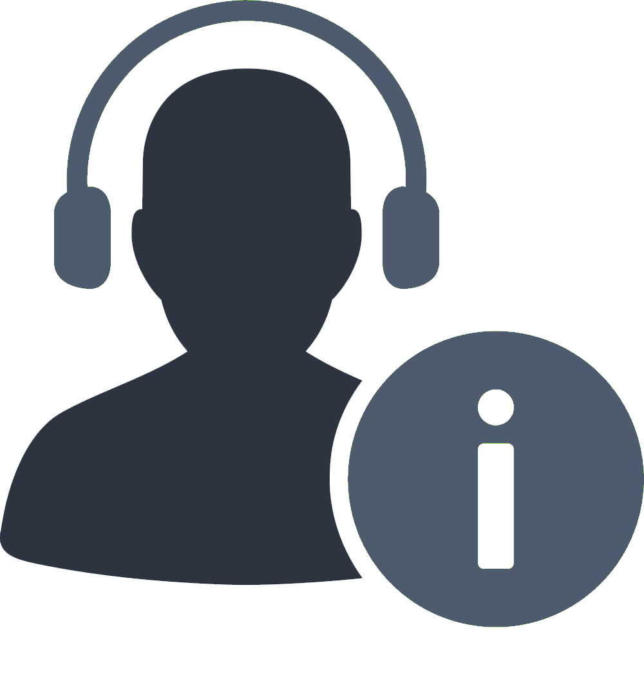

AEXIS e-Helpdesk System:

User Guide



User Manual

**Table of Contents**

SECTION 1 OVERVIEW 1

* 1. PROJECT BACKGROUND 1
  2. ABOUT THIS GUIDE 1
  3. WHO WILL BE USING THIS GUIDE 2

SECTION 2 GENERAL FLOW 3

2.1 GENERAL PROCESSES RELATED TO USERS 4

SECTION 3 LIST OF FUNCTIONS 7

3.1 LIST OF FUNCTIONS RELATED TO USERS 7

SECTION 4 USER REGISTRATION 8

* 1. USER ONLINE REGISTRATION FLOW 8
  2. USER REGISTRATION 9

SECTION 5 CREATE NEW TICKET 10

5.1 CREATE NEW TICKET 10

SECTION 6 MARK TICKET COMPLETE 13

6.1 MARK TICKET COMPLETE 13

SECTION 7 EDIT USER PROFILE 15

7.1 EDIT USER PROFILE 15

SECTION 8 USER ADMIN DASHBOARD 18

8.1 USER ADMIN DASHBOARD 18

## Section 1 Overview

1.1 ***Project Background***

Aexis e-Helpdesk Ticketing System is an online system built with the objective to manage Aexis’s Preventive and Corrective Maintenance in a more systematic way compared to the current ticketing system. This system can be accessed from anywhere at any time. Aexis e-Helpdesk allows user to submit their ticket by filling up a form provided by the system. Upon the submission of ticket, the system will auto-generate an email to alert the assigned technician for the specific ticket. This decision is made fully by the system by weighing a few factors. This e-Helpdesk system supports four (4) types of users:

* Normal User
  + Create Ticket, Mark Complete Ticket, Edit Profile
* User Admin
  + Create Ticket, Mark Complete Ticket, View Dashboard, Edit Profile
* Technician
  + Create Ticket, Edit Ticket, Mark Complete Ticket, Add Claim, Edit Profile
* Administrator
  + Create Ticket, Edit Ticket, Delete Ticket, Mark Complete Ticket, View Report, Manage Claim, Manage Helpdesk Settings

1.2 ***About This Guide:***

This Guide is a reference to users on the followings:

* Registration with e-Helpdesk
* Edit Profile
* Create New Ticket
* Mark Ticket Complete
* View Dashboard (User Admin)

1

1.3 ***Who Will Be Using This Guide? :***

This guide is written specifically for external users and user admin who will be accessing the e-Helpdesk system.

2

# GENERAL APPLICATION FLOW

## Section 2 General Flow

2.1 ***General Processes Related to Users***

Below is the general process flow which user can execute once users have registered with e-Helpdesk.

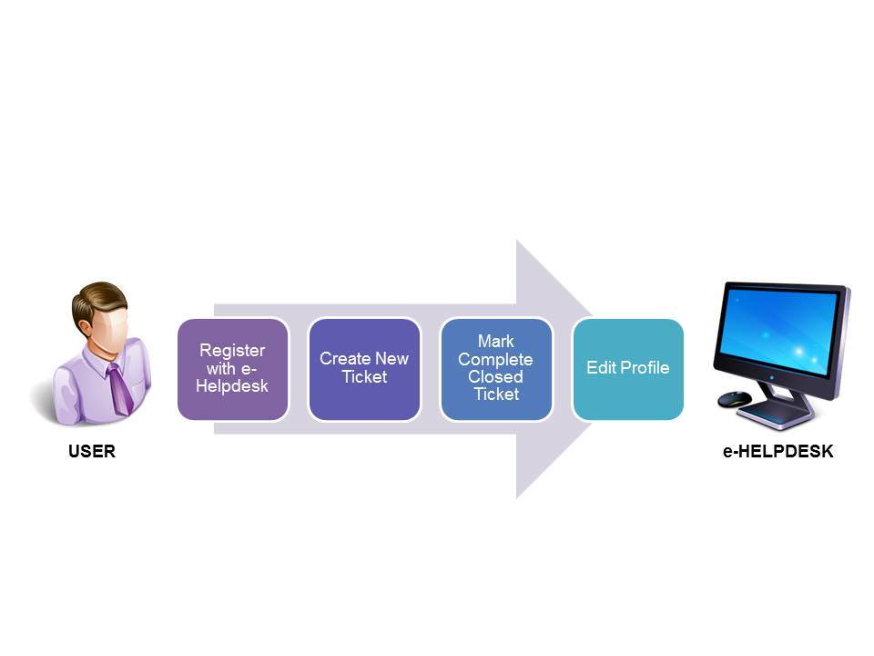

##### General Processes related to Users

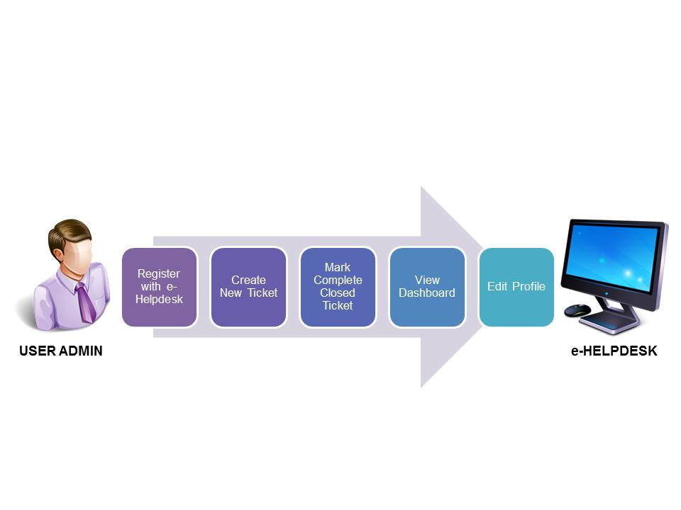

##### General Processes related to User Admin

The above diagram shows the general process for users after registering an account with the e-Helpdesk system. This guide is sectioned into few parts – User Registration, Create New Ticket, Mark Complete Ticket, Edit Profile and View Dashboard (User Admin).

4

Below are the general descriptions of the above diagram:

1. System provides online registration of user from e-Helpdesk Portal Main Page. Online form is based on Form 1.
2. Once registration has succeeded, user will be redirected to e-Helpdesk’s Homepage.
3. User can proceed to create a ticket by clicking on the button ‘CREATE NEW TICKET’ provided on the Homepage, in which User will then have to fill up a form. The form is based on Form 2.
4. Referring to the tickets created by User, once actions has been taken and status has been marked ‘Closed’, User may proceed to ‘Mark Complete’ the mentioned ticket.
5. User is also allowed to edit his/her profile. The form for editing user profile is based on Form 3.

5

# USER REGISTRATION

## Section 3 List of Functions

3.1 ***List of Functions Related to Users***

View

Dashboard (User Admin)

Before

Login

After Login

User

Registration (Form 1)

Update User Profile

Create

New

Ticket

Mark

Complete

Ticket

##### List of Functions related to Users

7

## Section 4 User Registration

4.1 ***User Online Registration Flow***

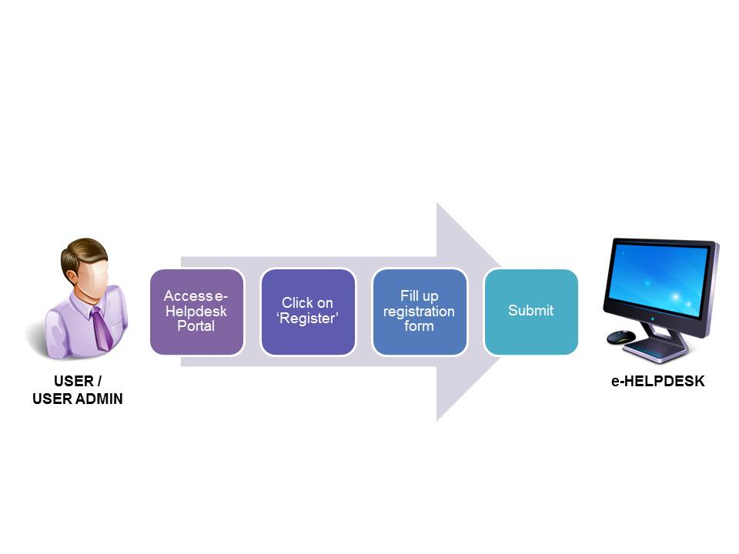

**User Online Registration Flow**

8

4.2 ***User Registration***

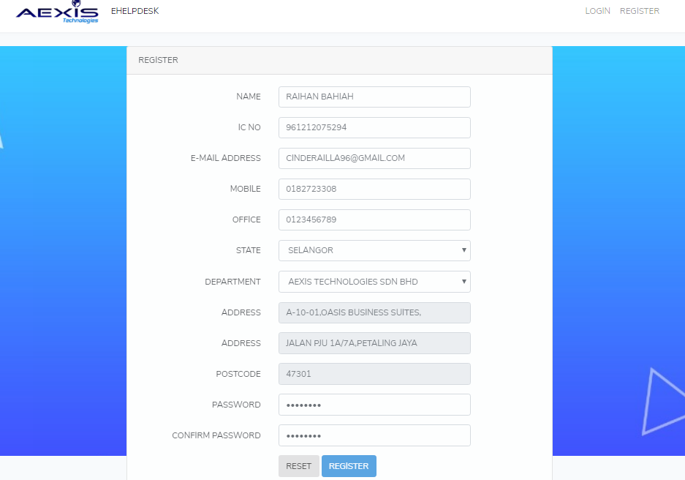

##### Screen ‘Registration Form (Form 1)’.

Follow the steps below to register with Aexis e-Helpdesk System.

**Step 1:** Go to [www.ehelpdesk.aexis.com.my](http://www.ehelpdesk.aexis.com.my) > click on “REGISTER” on the top-right section of the page.

**Result:** The above screen (Form 1) is displayed.

**Step 2:** Fill-up the form.

**Note:** All fields are mandatory.

**Step 3:** Click on “REGISTER”.

**Result:** User redirected to e-Helpdesk Homepage.

9

Section 5 Create New Ticket

5.1 ***Create New Ticket***

This section will guide user on how to create a new ticket.

**Pre-requisite:** User must be a registered user in order to have access to create a new ticket.

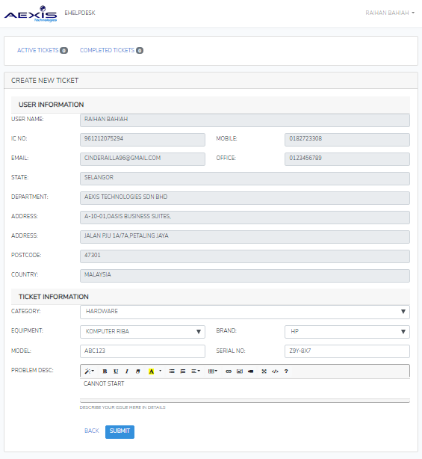

##### Screen ‘Create New Ticket (Form 2)’.

10

Follow the steps below to create new ticket.

**Step 1:** Click “CREATE NEW TICKET”.

**Result:** The above screen (Form 2) is displayed.

**Step 2:** Fill up the displayed form.

**Note:** All fields are mandatory.

**Step 3:**”SUBMIT”.

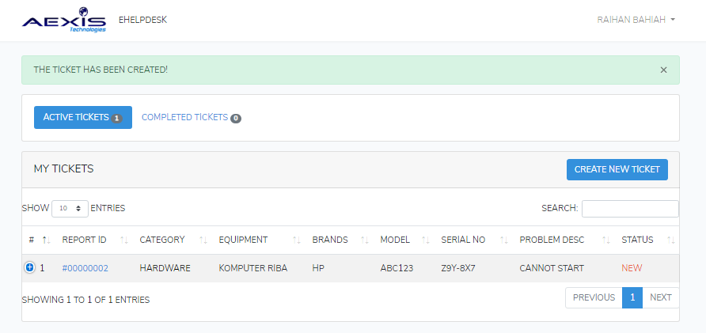**Result:** Success message is displayed as below:

**Screen Success Create Ticket**

11

**Step 4:** View the details of the new created ticket simply by clicking on the “REPORT ID”.

**Result:** The page is as displayed below:

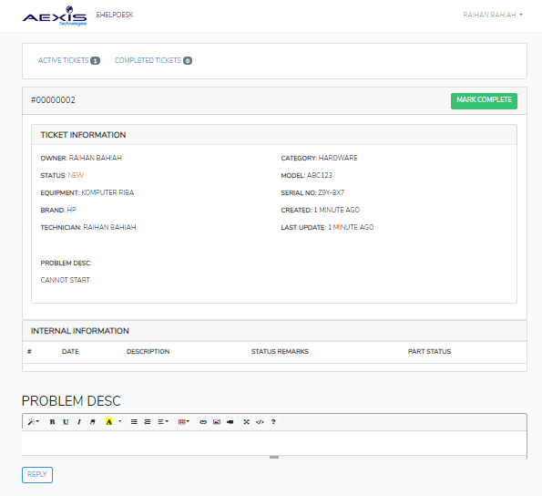

**Screen View Ticket Details**

12

## Section 6 Mark Ticket Complete

6.1 ***Mark Ticket Complete***

**Pre-requisite:** The ticket status must be “CLOSED” before marking it complete.

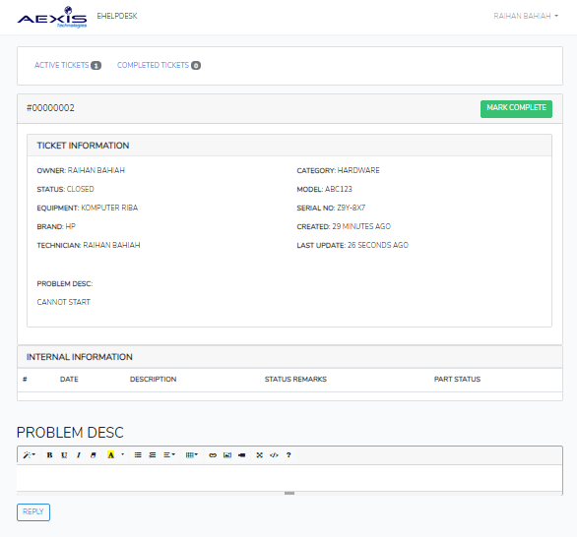

**Screen View Ticket Details - Status: Closed**

13

Follow the steps below to mark a ticket complete.

**Step 1:** ACTIVE TICKETS > REPORT ID (of desired ticket).

**Result:** The above screen is displayed.

**Step 2:** Click “MARK COMPLETE”.

**Result:** A success message is displayed as screen below:

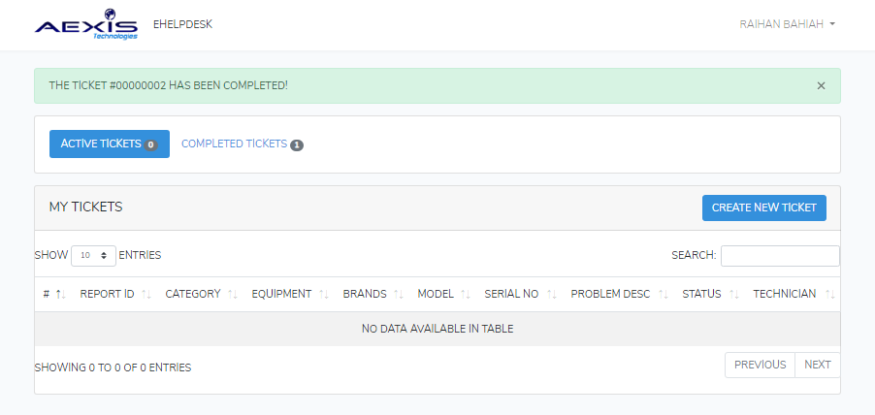

**Screen Mark Complete Ticket Success**

14

## Section 7 Edit User Profile

7.1 ***Edit User Profile***

**Pre-requisite:** The User should have already been registered with e-Helpdesk.

This section will guide user on how to update user profile.

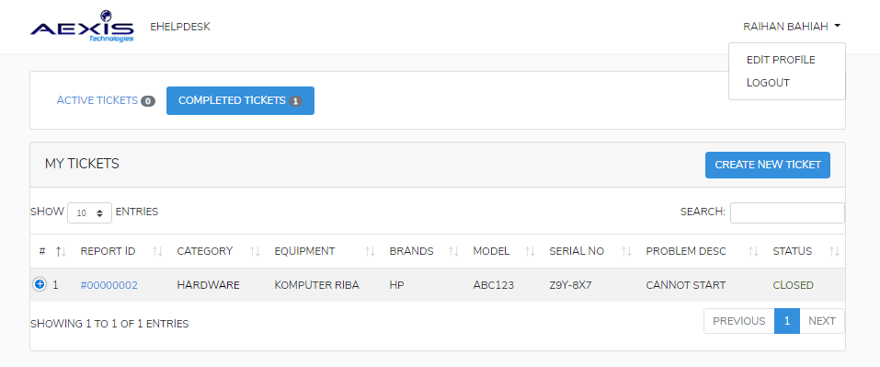

**Screen Guide to Edit Profile**

15

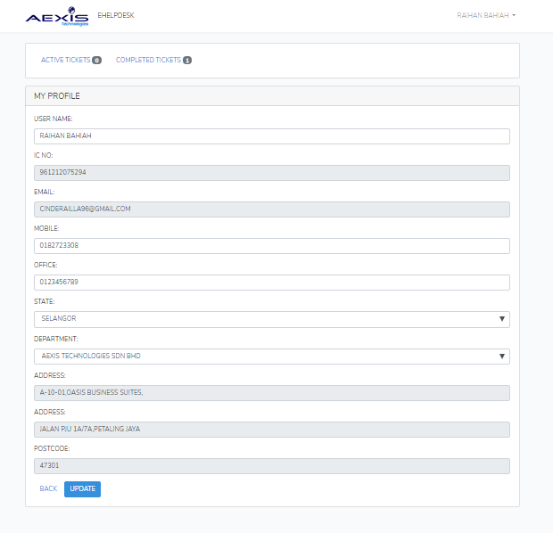

##### Screen Edit Profile (Form 3)

16

Follow the steps below to update user information.

**Step 1:** Select “EDIT PROFILE” from the drop-down menu on the top-right corner of any page.

**Result:** The above screen is displayed.

**Step 2:** Modify any field that user wants to update.

**Step 3:**”UPDATE”.

**Result:** A success message is displayed as below:

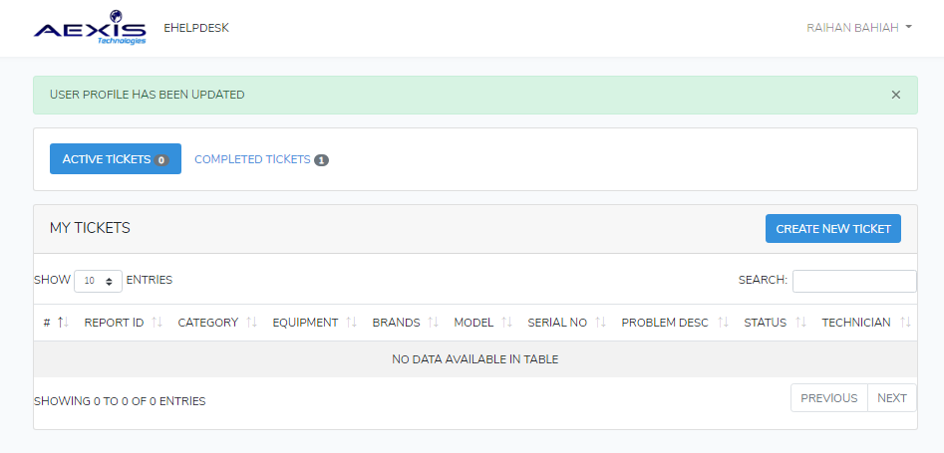

**Screen Edit Profile Success**

17

## Section 8 User Admin Dashboard

8.1 ***User Admin Dashboard***

**Pre-requisite:** User must be assigned as “User Admin” to have access to the Dashboard.

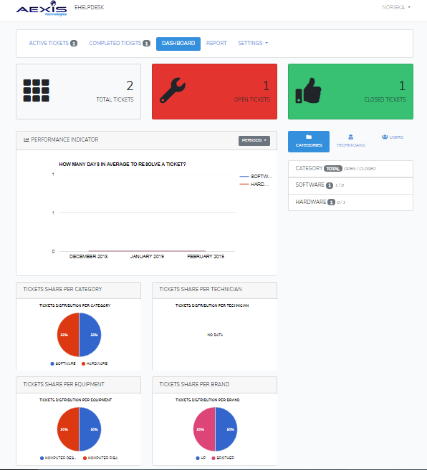

##### Screen Dashboard

18

Follow the steps below to view “Dashboard”.

**Step 1:** Select ”DASHBOARD” from the top menu of any page.

**Result:** The above screen is displayed.

**Step 2:** User Admin can view the line chart labeled “PERFORMANCE INDICATOR” by Period (3 Months, 6 Months, 12 Months) by toggling the drop-down menu on the top-right of the “PERFORMANCE INDICATOR” card

**Result:** The screen is as below.

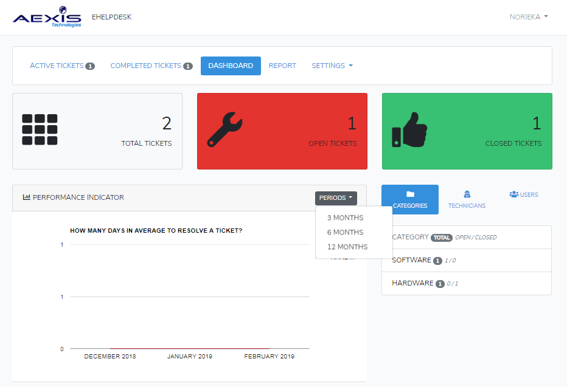

**Screen Guide Performance Indicator**

19