

**Data Analysis of the FrED functioning**

Hi! This was the report of today:

This test was made on 2025-03-30 and corresponds to test number 4 of the day.

Hope you have fun!

boxplot_temperature.png

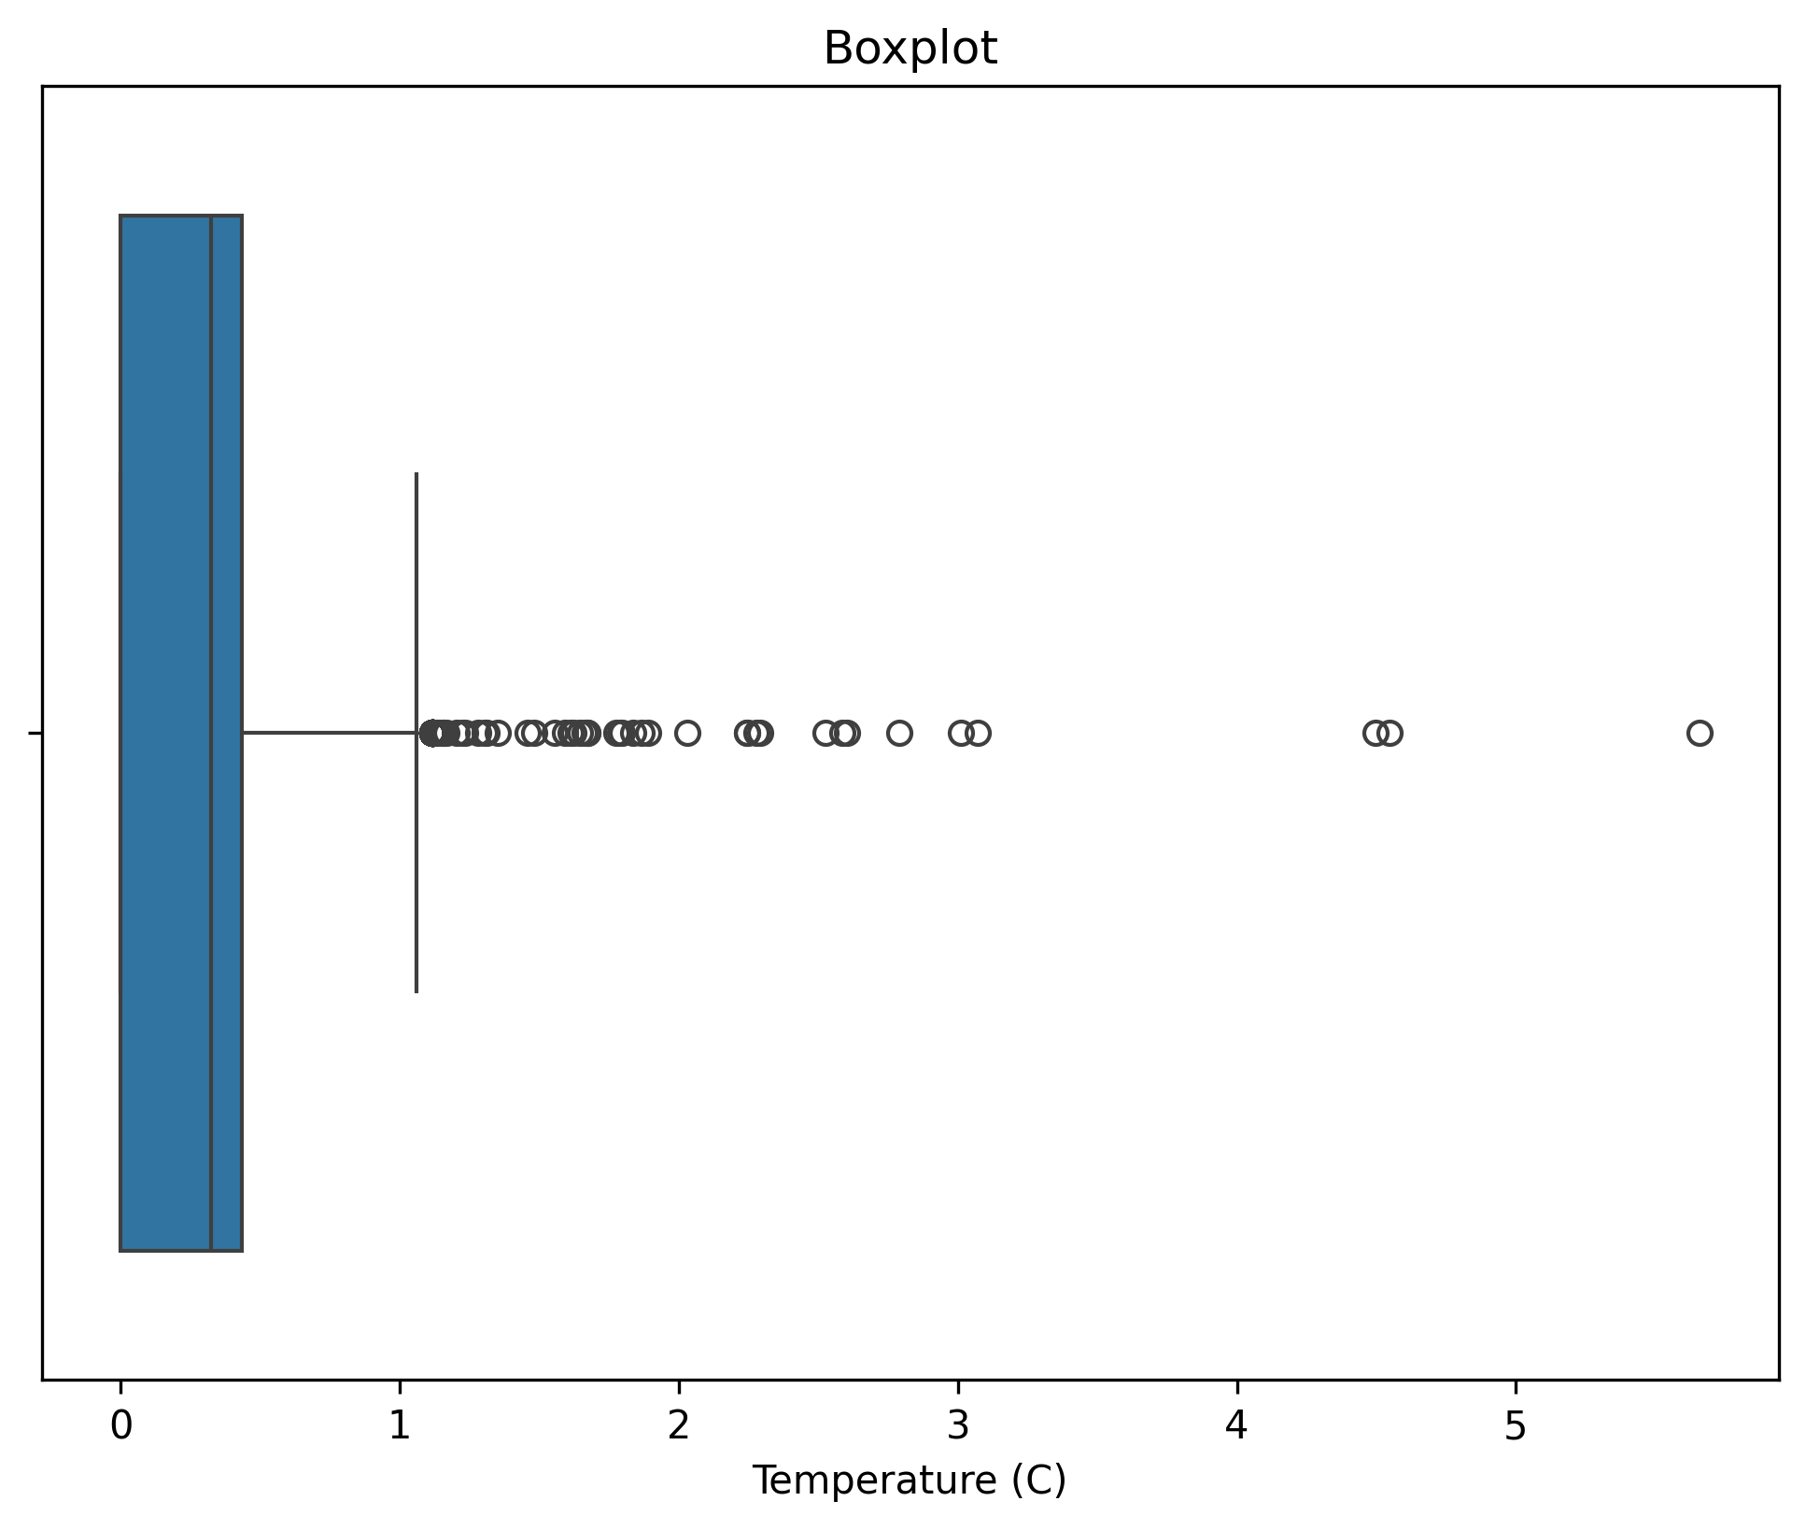

cross_correlation.png

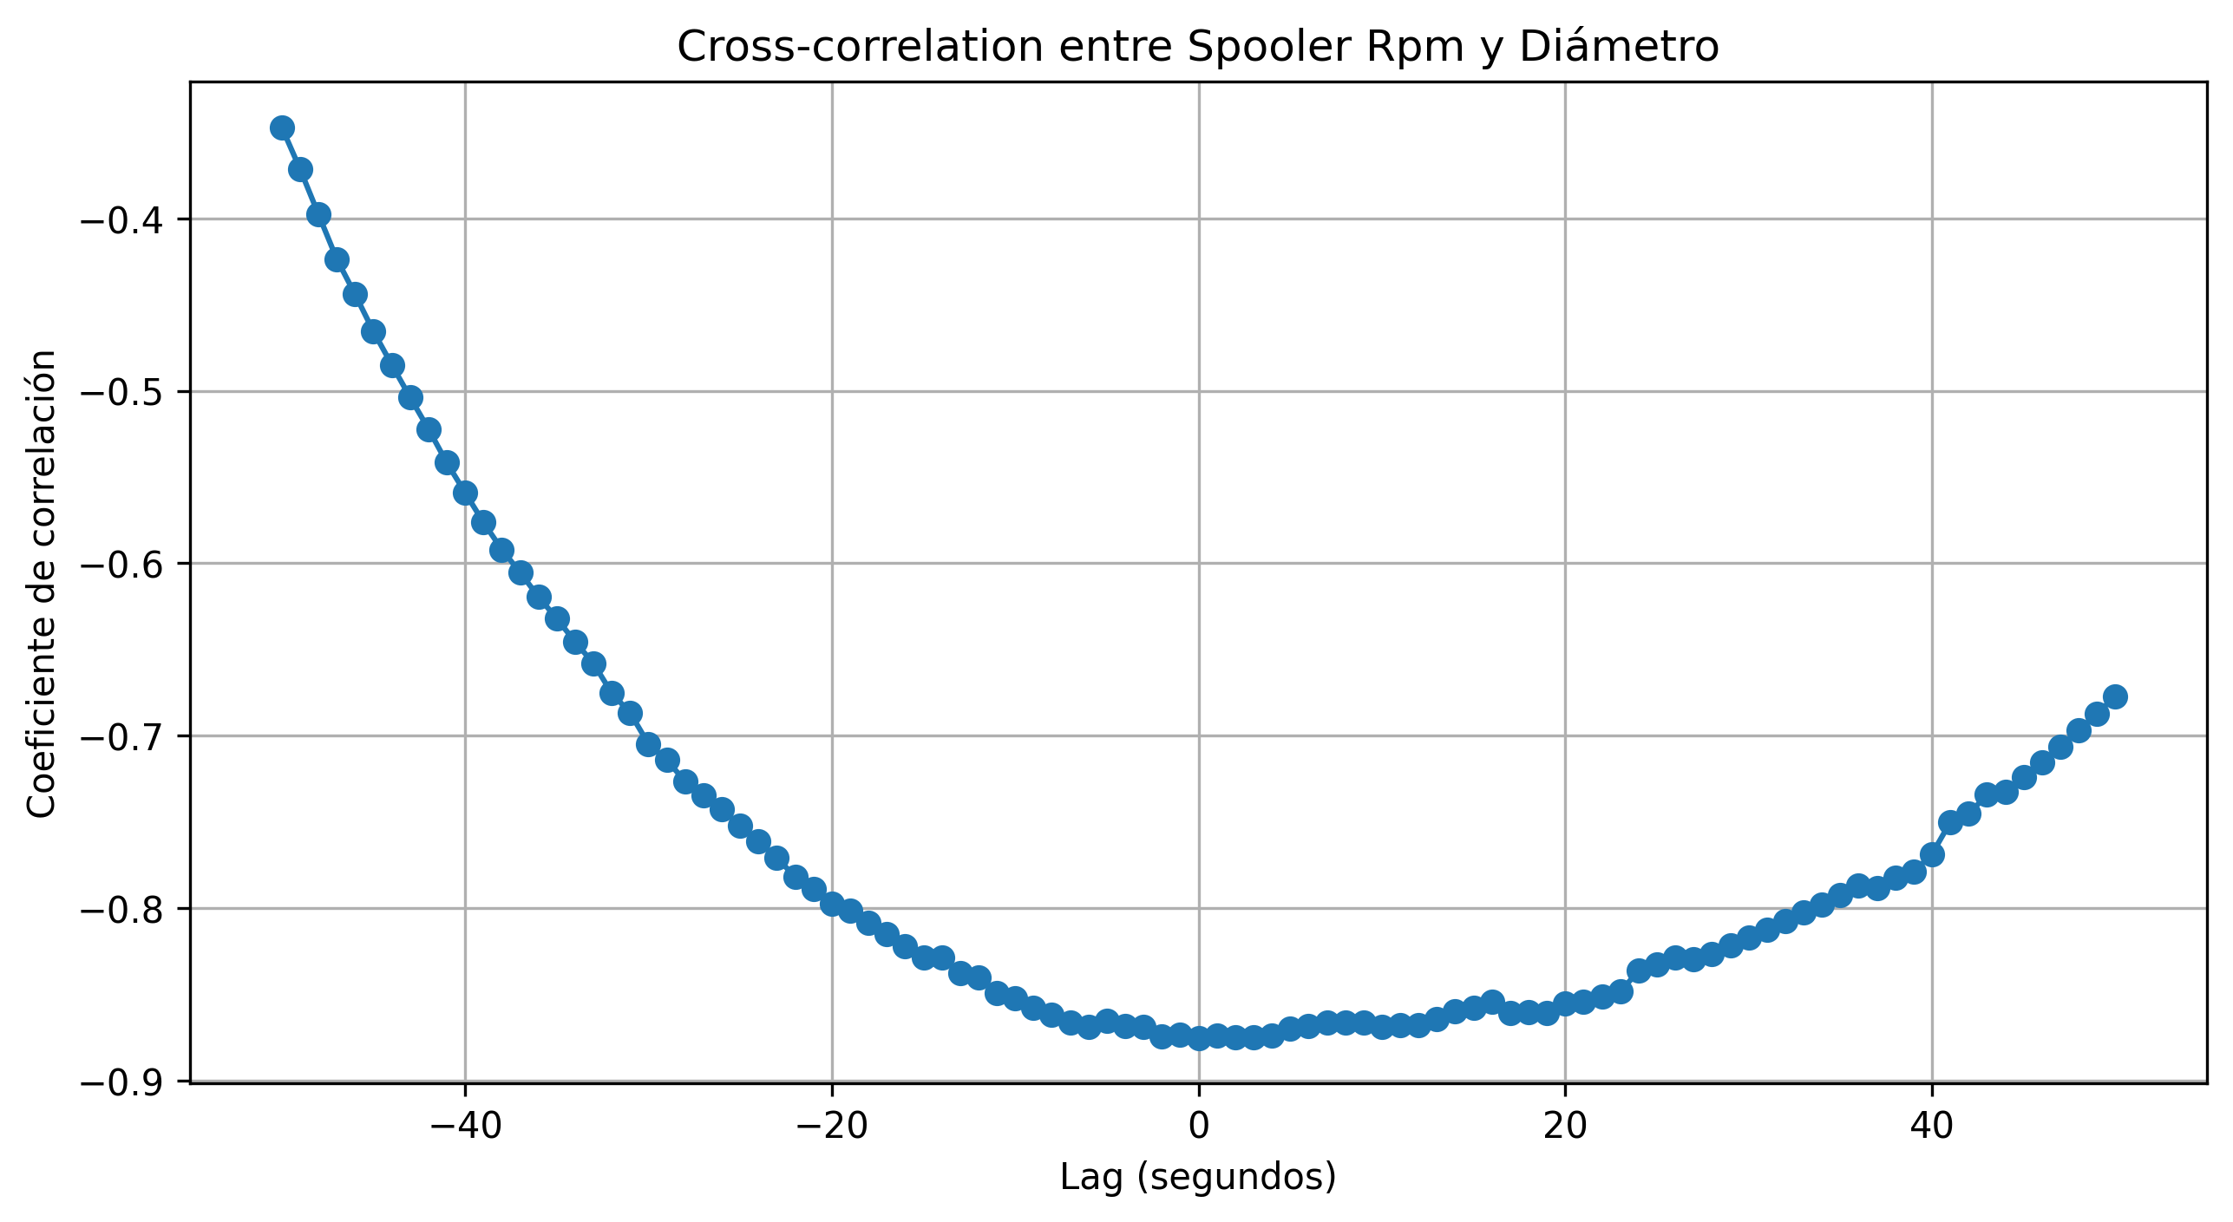

heatmap_correlacion.png

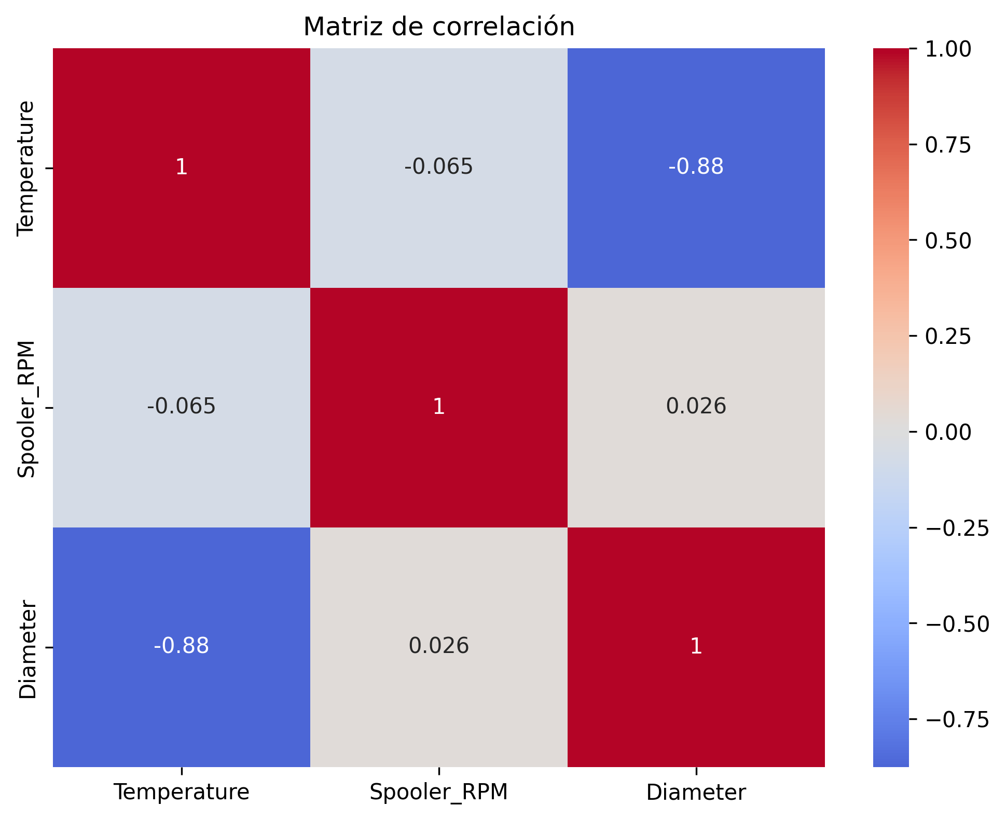

variables_seleccionadas.png

