CYBERSECURITY SIWES TRAINING PROGRAMME
Week 6 Project Report
Ethical Reconnaissance: OSINT and Nmap on Axia Hub
Student name | Ayeni Ayomide Caleb
Student ID | UJ/2024/NS/0739
SIWES organisation | Axiahub
Instructor / supervisor | Sir Excel
Submission date | 23/10/2026

1. Introduction and Objectives
This report records a Week 6 reconnaissance exercise on Axia Hub, a technology and innovation hub in Jos, Nigeria, which is my SIWES organisation. The work was authorised by my supervisor. It combines two foundational activities: Open-Source Intelligence (OSINT), which is passive and uses only public sources, and a basic Nmap check, which is active and sends packets to a target.
The goal is not to break into anything or to prove a weakness. It is to follow a careful, repeatable process: define scope, collect evidence, validate it, interpret it cautiously and report only what the evidence supports.
Objectives:
- Explain the difference between passive and active reconnaissance.
- Collect public information about Axia Hub and record where each item came from.
- Separate direct observations from assumptions and conclusions.
- Use basic Nmap commands safely and explain the results without overclaiming.
- Give three recommendations that match the evidence.

Summary of results
- Ten OSINT findings were recorded, each with a source, date, confidence rating and limitation. Cross-checks across the website, LinkedIn, Facebook, Instagram and X confirmed Axia Hub's identity and hub phone number, and exposed inconsistencies in the office floor, training figures and website footer.
- DNS and whois show axiahub.org is registered with OwnRegistrar and fronted by Cloudflare, so the IP addresses it resolves to are Cloudflare's, not Axia Hub's own server.
- The localhost scan found one open port (22/ssh). The limited scan of the Cloudflare address found ports 22, 80 and 443 all filtered. These results describe what my scanner saw at that moment and do not show any vulnerability.
- Some of my scans went outside the approved scope because of a wrong domain and a mistyped IP address. These are disclosed in Section 2.3.

2. Scope, Authorisation and Safety Boundaries

2.1 Scope note
Item | Detail
OSINT case | Axia Hub (Axia Technology and Innovation Hub), a real organisation, approved as the case by my supervisor. Public sources only: its website, public social media pages, public DNS and registration data.
Nmap targets | 127.0.0.1 (my own Kali VM) and the Cloudflare address 104.21.90.95 that axiahub.org resolves to, using only the brief's limited scan.
Permitted activities | Passive OSINT; Nmap version and help; a default scan of localhost; and, for the assigned target, the limited TCP scan of ports 22, 80 and 443.
Restrictions | No logins, password guessing, exploitation, denial of service, evasion or access to data. No collection of unnecessary personal information.
Date and time of practical work | 2026-10-21. Kali VM clock (EDT): 09:09-09:38 and 17:35-17:56. Browser evidence was captured between 08:39 and 09:02 on the browser machine's clock.
Approved by | My supervisor

2.2 Safety boundaries kept
- No logins, form submissions or password attempts on any site.
- No exploitation, denial-of-service or evasion options were used.
- The public About page lists staff names and photos. I did not record them, because they are unnecessary personal information.
- No passwords, tokens or keys appear in the report. The only contact details recorded are Axia Hub's own published organisation lines and addresses.

2.3 Disclosure: scans outside the approved scope
I made two mistakes while finding the target address, and ran some scans that were wider than the brief allows. I have not hidden them. Table 1 lists every command I ran. Rows marked OUT OF SCOPE are excluded from my findings and are kept only in a separate folder for my supervisor's review.
- Wrong domain. I first looked up axia.org instead of axiahub.org. It resolved to 89.46.108.70, a shared web host run by Aruba S.p.A. in Italy. I found no link between that host and Axia Hub, but I scanned it, including one run with -A.
- Mistyped address. I typed 107.67.155.107 instead of 172.67.155.107 and scanned it twice. It is not a Cloudflare address and I have no evidence it belongs to Axia Hub.
- Wider scans. The 17:53 scan of 104.21.90.95 used default options, which cover about 1,000 ports. The brief allows only ports 22, 80 and 443 without further approval.
- Output files. Several scans used the same output filename, so some raw files were overwritten (see 5.4).
When I noticed, I stopped scanning, re-checked the domain with dig, nslookup and whois.
Table 1: Complete command log
# | Date/time (Kali clock, EDT) | Command | Target | Status
1 | 2026-10-21 09:09 | dig axia.org; nslookup axia.org | axia.org (wrong domain) | Passive DNS. Wrong domain.
2 | 2026-10-21 09:15 | nmap -oN nmap_localhost.txt 127.0.0.1 | 127.0.0.1 | In scope. Output file later overwritten.
3 | 2026-10-21 09:18 | nmap -oN nmap_localhost.txt 89.46.108.70 (twice) | 89.46.108.70 (axia.org, Aruba host) | OUT OF SCOPE. Wrong target. Default scan.
4 | 2026-10-21 09:28 | nmap -sT -p 22,80,443 -oN nmap_target.txt 89.46.108.70 | 89.46.108.70 | OUT OF SCOPE. Wrong target.
5 | 2026-10-21 09:29 | nmap -A 89.46.108.70 | 89.46.108.70 | OUT OF SCOPE. Wrong target and wider options than the brief.
6 | 2026-10-21 17:35-17:43 | dig, nslookup, whois on axiahub.org and its two IPv4 addresses | axiahub.org; Cloudflare IPs | Passive. In scope.
7 | 2026-10-21 17:45 | nmap -sT -p 22,80,443 -oN nmap_target.txt 104.21.90.95 | 104.21.90.95 (Cloudflare address for axiahub.org) | Brief's scan. Exact IP approval: see 2.3.
8 | 2026-10-21 17:47 | nmap -sT -p 22,80,443 -oN nmap_target.txt 107.67.155.107 | 107.67.155.107 (mistyped IP) | OUT OF SCOPE. Typing error. Overwrote the file from #7.
9 | 2026-10-21 17:53 | nmap -oN nmap_localhost.txt 104.21.90.95 | 104.21.90.95 | Wider than the brief's scan (default 1,000 ports).
10 | 2026-10-21 17:55 | nmap -oN nmap_localhost.txt 107.67.155.107 | 107.67.155.107 (mistyped IP) | OUT OF SCOPE. Typing error.
11 | 2026-10-21 17:56 | nmap -oN nmap_localhost.txt 127.0.0.1 | 127.0.0.1 | In scope. Final content of nmap_localhost.txt.

Further note: Cloudflare addresses are shared infrastructure.

3. Methodology

3.1 OSINT sources
I used only public sources, without logging in or interacting with any service. The Facebook page and LinkedIn page were opened in a browser as a normal visitor.
- Official website axiahub.org (home page, footer, About page).
- Public social media pages: LinkedIn, Instagram, Facebook and X.
- Public DNS and registration data: dig, nslookup and whois on axiahub.org and on the two IP addresses it resolves to.
For each finding I recorded the source, date collected, source type, confidence rating (High, Medium or Low) and a limitation. Claims I could not verify are labelled UNVERIFIED. At least one finding was cross-checked against a second independent source (see Section 4).

3.2 Nmap commands
Command | Purpose
nmap --version | Confirm Nmap is installed (version 7.95).
nmap -h | Review the help output.
nmap -oN nmap_localhost.txt 127.0.0.1 | Default scan of my own machine; save normal output.
nmap -sT -p 22,80,443 -oN nmap_target.txt 104.21.90.95 | The brief's limited scan: TCP connect scan of three selected ports.
dig / nslookup / whois | Passive lookups of DNS records and registration data.
Tools: Kali Linux 2025.1c (VirtualBox), Nmap 7.95, dig, whois, Chrome. Times are from each machine's own clock (Kali VM: EDT), so they only order the work.

4. OSINT Findings
Every finding below was collected on 2026-10-21 from the sources shown. The Evidence numbers refer to screenshots in Appendix A and the 02_Source_Evidence folder.
No. | Title | Observation (what the source shows) | Source / evidence | Collected / published | Source type | Confidence and reason | Limitation / alternative explanation
1 | Organisation and services | axiahub.org describes Axia Hub as a technology and innovation hub. Menu items: Learn A Skill, Use Our Workspaces, Projects & Initiatives. The footer says it aids individuals, businesses, organisations and governments through "cutting-edge innovative tools, products, services". | Axia Hub website, https://axiahub.org (E01, E02) | Collected 2026-10-21 / publication date not shown | Official website | HIGH. First-party description, consistent with Finding 9. | It is marketing text. It shows what Axia Hub says it offers, not what it delivers.
2 | Office address differs between channels | Website: "Top Floor, Old NITEL Building, Jos, Plateau State". Facebook: "2nd Floor Old Nitel Building Old Airport Junction, Jos". | Website footer (E02); Facebook page details (E08) | 2026-10-21 / not shown | Official website; social media page | MEDIUM. Both name the same building; the floor wording differs. | "Top Floor" may simply be the 2nd floor. Not confirmed with the organisation.
3 | Contact phone numbers | Hub line 0903 520 8470 appears on the website, on LinkedIn (+2349035208470) and on Facebook. A separate Coworking line 0911 323 6246 appears on the website only. | Website (E01, E02); LinkedIn (E05); Facebook (E07, E08) | 2026-10-21 / not shown | Official website; social media pages | HIGH for the hub line (three channels agree). UNVERIFIED for the coworking line (one source). | All channels are controlled by Axia Hub, so they are not truly independent. I did not call the numbers.
4 | Public email addresses | Website top bar: info@axiahub.org. Website footer: contact@axiahub.org. Facebook: axiahubng@gmail.com. | Website (E01, E02); Facebook (E08) | 2026-10-21 / not shown | Official website; social media page | HIGH that each address is published. MEDIUM that all are actively used. | I did not send mail, so I cannot say which addresses are monitored.
5 | Training reach claims differ | Instagram bio: "Trained 700+ People in Tech Skills". Facebook: "Trained 900+ People in Tech Skills". | Instagram (E06); Facebook (E07) | 2026-10-21 / not shown | Social media pages | LOW. UNVERIFIED: no independent source found. | The figures may be from different dates, because profiles may be updated at different times. Both are self-reported.
6 | Website footer year | The footer reads "Copyright 2025 by Axia Hub" although it was viewed in October 2026 and the Facebook page shows recent posts. | Website footer (E03); Facebook (E08) | 2026-10-21 / not shown | Official website | MEDIUM. The footer text is clear; the reason is unknown. | A copyright year can mark first publication and is not necessarily an oversight.
7 | Domain registration and DNS | whois for axiahub.org: registrar OwnRegistrar, Inc.; created 2022-02-14; updated 2026-08-12; expires 2027-02-14; status clientTransferProhibited; DNSSEC unsigned; name servers emma/memphis.ns.cloudflare.com. | whois axiahub.org and dig NS (E12, E13) | 2026-10-21 17:36-17:37 EDT / registry record | Public DNS and registration data | HIGH. Registry-sourced. | Registration data does not show who operates the site. "DNSSEC unsigned" is an observation, not a confirmed weakness. Cross-check: X says "Joined February 2022" (E09), consistent with the creation date, but LinkedIn says "Founded 2020" (E05), so the organisation may predate the domain.
8 | Hosting addresses belong to Cloudflare | axiahub.org resolves to 172.67.155.107 and 104.21.90.95 (plus two IPv6 addresses). ARIN whois for both IPv4 addresses shows Cloudflare, Inc. (CLOUDFLARENET). | dig, nslookup, whois (E10, E11, E14, E15) | 2026-10-21 17:35-17:43 EDT / ARIN record | Public DNS and registration data | HIGH. | Cloudflare addresses are shared and do not reveal the origin server or who owns Axia Hub's own infrastructure.
9 | Social presence is consistent | LinkedIn: Axia Technology and Innovation Hub (Axia Hub), IT Services, Jos, 11-50 employees, 197 followers. Instagram @axiahub 554 followers. Facebook about 1K followers. X @AxiaHub 110 followers, 379 posts, joined February 2022. Each links to axiahub.org. | LinkedIn (E04, E05); Instagram (E06); Facebook (E07); X (E09) | 2026-10-21 / not shown | Social media pages | HIGH for identity (platforms agree on name, location and domain). LOW for the counts. | Follower counts change daily; the employee band is self-reported.
10 | Second domain axiahub.ng | Facebook lists axiahub.org and axiahub.ng as links. I observed that axiahub.ng shows the same content as axiahub.org and that its whois points to Cloudflare. | Facebook (E08); own checks, no screenshots yet | 2026-10-21 / not shown | Social media page; public DNS data | MEDIUM until my own screenshots are added. | It could be a redirect or a mirror; I have not yet recorded which.

Cross-checks
- Address and phone (Findings 2 and 3): website, LinkedIn and Facebook were compared. The phone number matched in all three; the floor wording differs.
- Domain age (Finding 7): the registry creation date (14 Feb 2022) matches X "Joined February 2022", but LinkedIn gives "Founded 2020". This is flagged, not resolved.
- Identity (Finding 9): four independent platforms agree on the name, location and domain.
Not recorded: individual staff names and photos on the public About page, because the brief asks me not to collect unnecessary personal information.

5. Nmap Results
Nmap version 7.95 was confirmed (Evidence_16) and the help output reviewed (Evidence_17 to Evidence_19). Raw output files are listed in Appendix C.

5.1 Scan 1: localhost
Target | 127.0.0.1 (my own Kali VM)
Exact command | nmap -oN nmap_localhost.txt 127.0.0.1
Date and time | 2026-10-21 17:56 EDT
Result | Host is up (0.000005s latency). 999 closed TCP ports (reset). 22/tcp open ssh. Done in 0.11 seconds.
Evidence | Evidence_22; raw file nmap_localhost.txt (final contents)
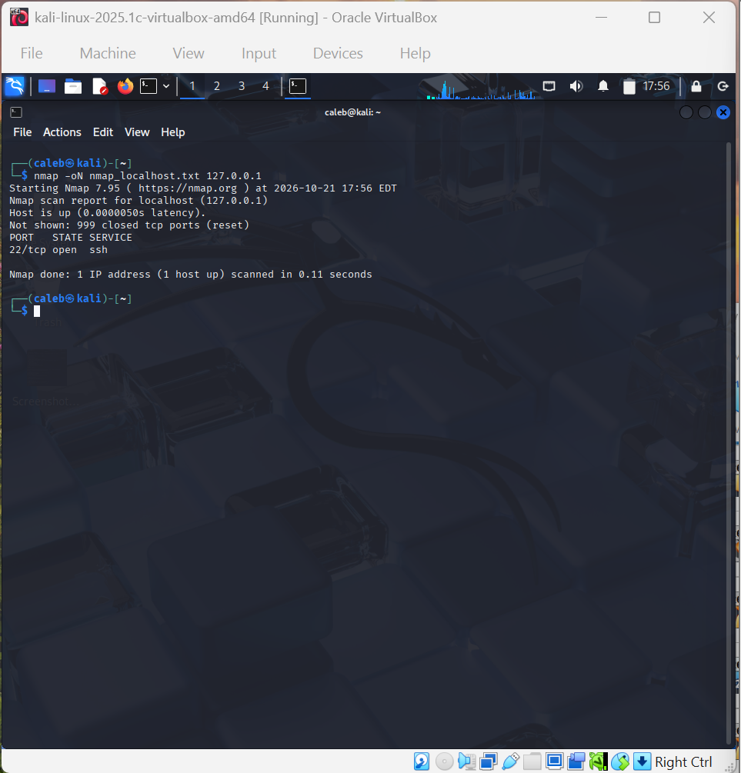
Evidence_22: Localhost scan of 127.0.0.1 (17:56 EDT)

5.2 Scan 2: limited scan of the Cloudflare address for axiahub.org
Target | 104.21.90.95, one of the two IPv4 addresses axiahub.org resolves to. Whois shows it belongs to Cloudflare, Inc.
Exact command | nmap -sT -p 22,80,443 -oN nmap_target.txt 104.21.90.95
Date and time | 2026-10-21 17:45 EDT (date run afterwards: 17:46)
Result | Host is up (0.0017s latency). 22/tcp filtered ssh; 80/tcp filtered http; 443/tcp filtered https. Done in 13.12 seconds.
Evidence | Evidence_20. The raw file nmap_target.txt was later overwritten by a scan of a mistyped address (see 5.4), so this screenshot is the record.
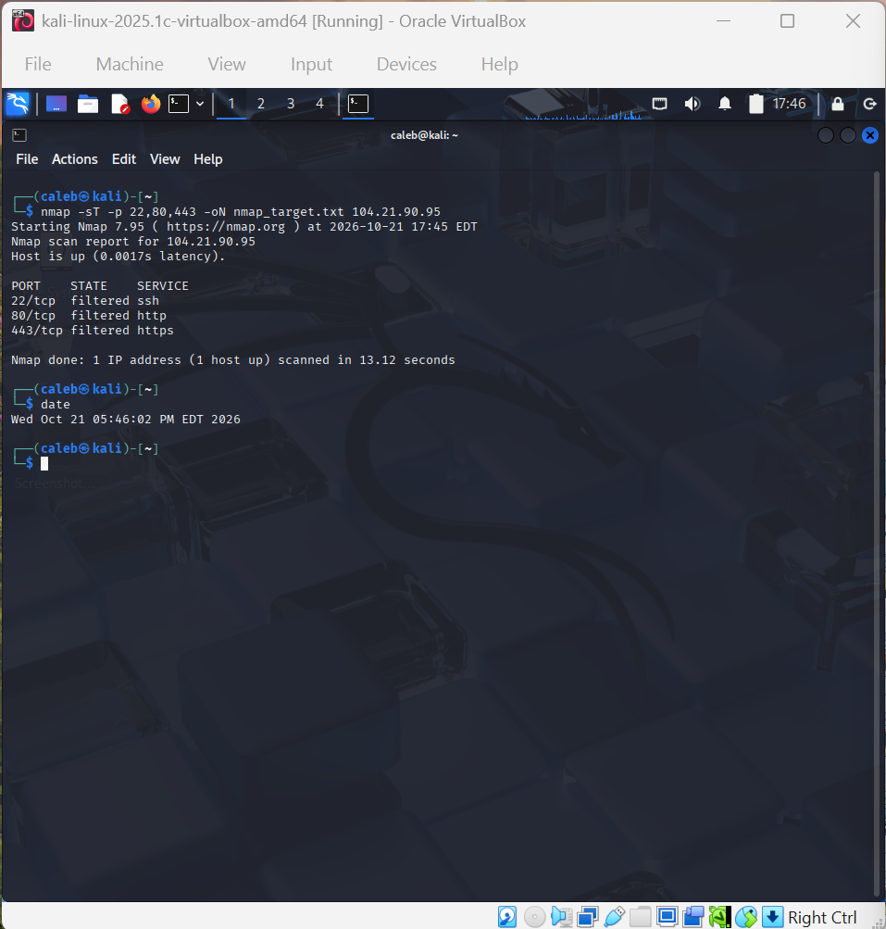
Evidence_20: Limited scan of 104.21.90.95, ports 22,80,443, followed by date (17:45-17:46 EDT)

5.3 Scan 3: default-port scan of the same address (wider than the brief)
Target | 104.21.90.95
Exact command | nmap -oN nmap_localhost.txt 104.21.90.95 (the output file kept the name "localhost" by mistake)
Date and time | 2026-10-21 17:53 EDT
Result | Host is up (0.031s latency). 995 filtered ports. Open: 21/ftp, 80/http, 443/https, 8080/http-proxy, 8443/https-alt. Done in 39.99 seconds.
Evidence | Evidence_21. Used only to illustrate how results vary; I did not use it for conclusions about Axia Hub.
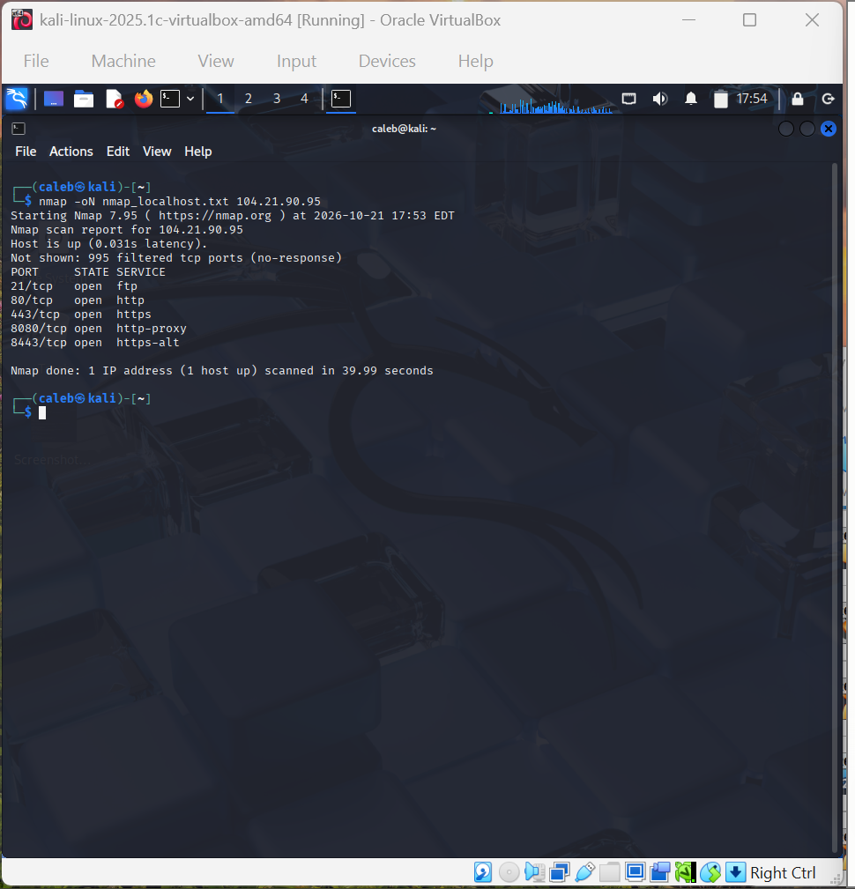
Evidence_21: Default-port scan of 104.21.90.95 (17:53 EDT), wider than the brief; see Section 5.3

5.4 What these results do and do not establish
- They establish that at the time of each scan, my VM received the responses shown from these addresses.
- They do not establish that any service is vulnerable, that any listed service is really what its name suggests (I did not use version detection, so names such as ftp come from a port-number table), or that Axia Hub's own server has these ports open.
- File handling: nmap_localhost.txt and nmap_target.txt were reused for several scans, so the final saved files do not match every screenshot. The raw copies in 04_Scan_Output are unedited; the screenshots are the full record.

6. Interpretation

6.1 Key terms in my own words
- Host responds vs does not respond: "Host is up" means Nmap received a reply to its discovery probes. A host that does not reply may be switched off, or may be filtering or blocking the probes. Silence does not prove a host is absent.
- Open, closed and filtered: open means something accepted my connection on that port. Closed means the host answered that nothing is listening (the localhost scan showed 999 closed ports, "reset"). Filtered means no usable answer came back, so a firewall or other device may be dropping the probes.
- Detected service vs confirmed vulnerability: a service name tells me what usually uses that port number. A vulnerability needs specific evidence, such as a confirmed version with a known flaw, and testing that I was not authorised to do.

6.2 Reading my results
My localhost result shows that only SSH listens on my Kali VM. That describes my own lab machine and says nothing about Axia Hub.
For the Cloudflare address, ports 22, 80 and 443 were all filtered at 17:45, but ports 80 and 443 showed as open at 17:53, and the reported latency also changed (0.0017s then 0.031s). I cannot tell from my evidence why. Timing, rate limiting, filtering along the path and my scanner's vantage point (a VM on a home network) are all possible. This is a good example of why one scan is not a conclusion.
Because axiahub.org is fronted by Cloudflare (Findings 7 and 8), any scan of those addresses describes Cloudflare's shared edge network. It cannot tell me how Axia Hub's own origin server is configured.

6.3 Observations, assumptions and conclusions
Observation (seen) | Assumption (not proven) | Conclusion the evidence supports
axiahub.org resolves to two Cloudflare IPv4 addresses and uses Cloudflare name servers. | Axia Hub's own server is behind Cloudflare. | The site is served through Cloudflare; the scan targets belong to Cloudflare.
Ports 22, 80 and 443 were filtered at 17:45; 80 and 443 were open at 17:53. | A firewall or rate limit explains the change. | Results varied between scans; one scan is not enough to describe the target.
Website says "Top Floor"; Facebook says "2nd Floor". | They mean the same floor. | The channels word the address differently; not confirmed.
Instagram says 700+ trained; Facebook says 900+. | One figure is out of date. | The claim is unverified and the channels are inconsistent.
Localhost: only 22/ssh open. | SSH on my VM is needed. | My VM has an SSH service listening; this is not a vulnerability.

7. Recommendations
These are proportionate to the evidence. None of them claims that a weakness exists.
No. | Recommendation | Linked finding | Evidence
1 | Make Axia Hub's public details consistent: use one wording for the office floor, one set of contact emails, one training figure with a date, and an up-to-date website footer year. | Findings 2, 4, 5, 6 | The website and Facebook word the address differently; the training figures differ (700+ vs 900+); three email addresses across two domains; footer says 2025.
2 | Review domain housekeeping: confirm that auto-renewal is on before the registration expires on 14 February 2027, and consider whether to sign the domain with DNSSEC. | Finding 7 | whois shows expiry 2027-02-14 and DNSSEC unsigned. This is a decision for the domain owner, not a confirmed weakness.
3 | Before any future scan, resolve the domain, check who owns each IP with whois, and get the exact targets approved in writing. For sites behind a CDN, also check the provider's testing policy. | Finding 8 | axiahub.org resolves to Cloudflare addresses; my scans described Cloudflare's edge, and two scans hit wrong addresses.

8. Reflection and Conclusion

Reflection
Before this project I treated scanning and finding vulnerabilities as almost the same thing. I now understand that information gathering only records what is publicly visible or what answers a probe, while confirming a vulnerability needs permission, specific evidence and testing that I was not allowed to do. An open port told me nothing about weakness.
The finding that was hardest to verify was Axia Hub's training figures. Instagram says 700+ and Facebook says 900+, and both are controlled by Axia Hub, so I found no independent source and left it unverified.
The main limitation on my Nmap results was not knowing whose machine I was looking at. axiahub.org sits behind Cloudflare, so my scan described Cloudflare's shared edge, not Axia Hub's own server. The same ports were also filtered at 17:45 and open at 17:53, which shows how timing and vantage point change results.
I also made mistakes. I first scanned an address belonging to the wrong domain and later mistyped an IP address. I stopped, recorded everything honestly and am reporting it to my supervisor. In a future authorised assessment I will confirm the domain, resolve it with dig, check the owner with whois, copy the IP address instead of typing it, and have the exact targets confirmed in writing before I run any scan.

Conclusion
Public sources gave a clear picture of Axia Hub's identity, contact details and domain setup, and also surfaced small inconsistencies worth correcting. The Nmap checks showed what my scanner saw from my VM at specific times, and no more than that. Axia Hub is served through Cloudflare, so a scan of those addresses cannot describe its own server. The scope mistakes I made are disclosed so the evidence can be trusted.

Appendices

Appendix A: Evidence screenshots
Original, unedited screenshots are in 02_Source_Evidence. Screenshots of out-of-scope scans are not included here; they are in 04_Scan_Output/Out_of_scope_for_supervisor_review.

Evidence_01: Axia Hub website home page, axiahub.org (08:39, browser clock)
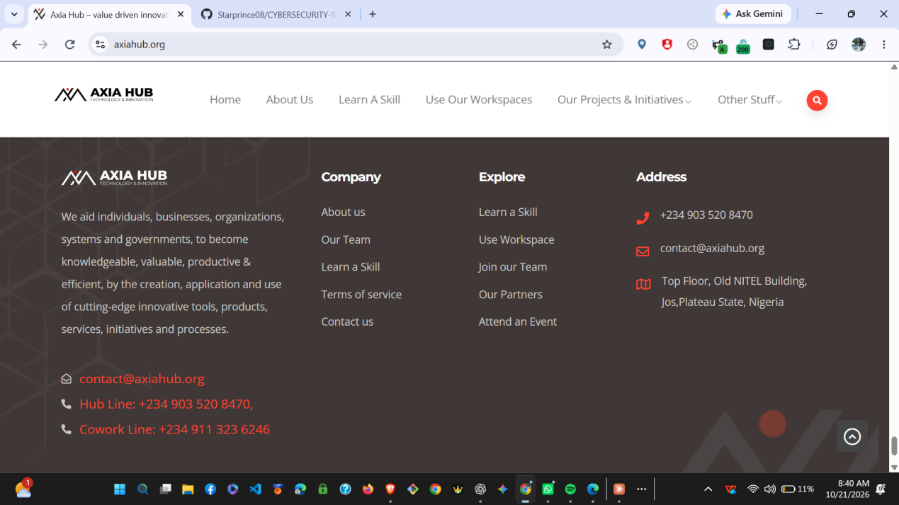
Evidence_02: axiahub.org footer: mission text, contact details, address (08:40)
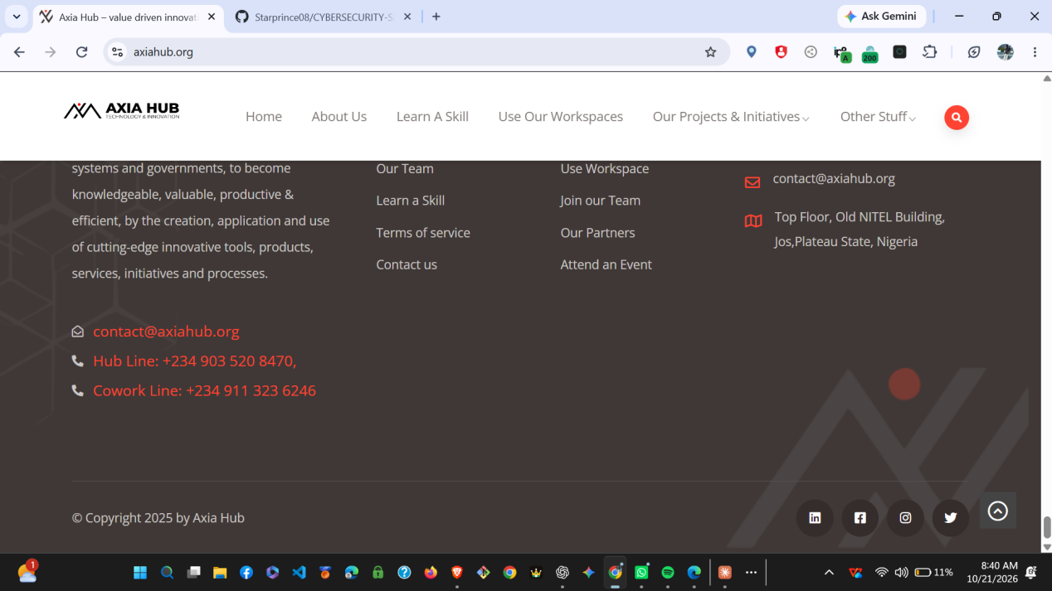
Evidence_03: axiahub.org footer: copyright line and social links (08:40)
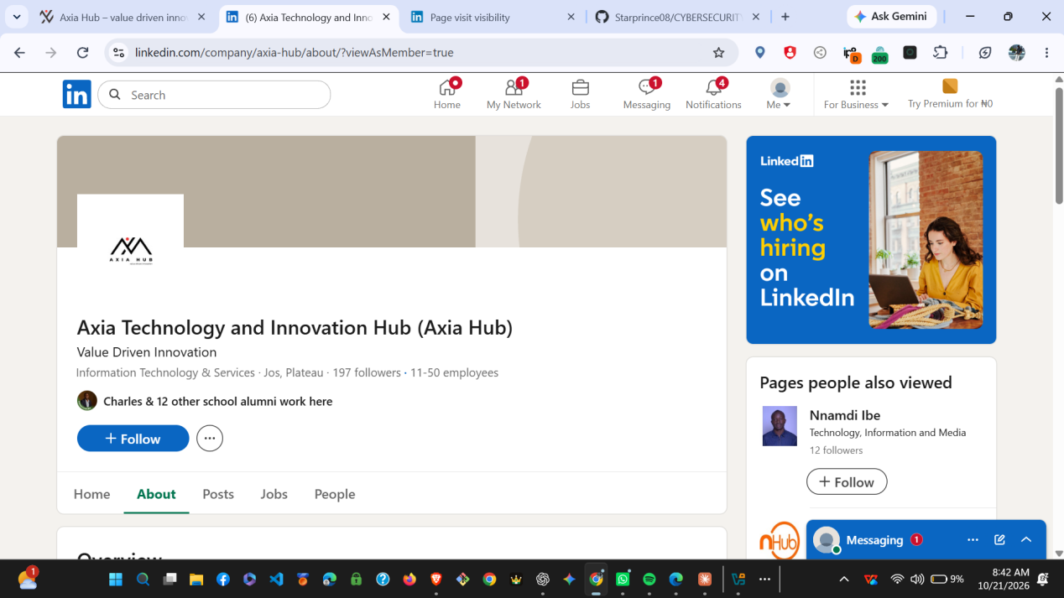
Evidence_04: LinkedIn company page: Axia Technology and Innovation Hub (08:42)
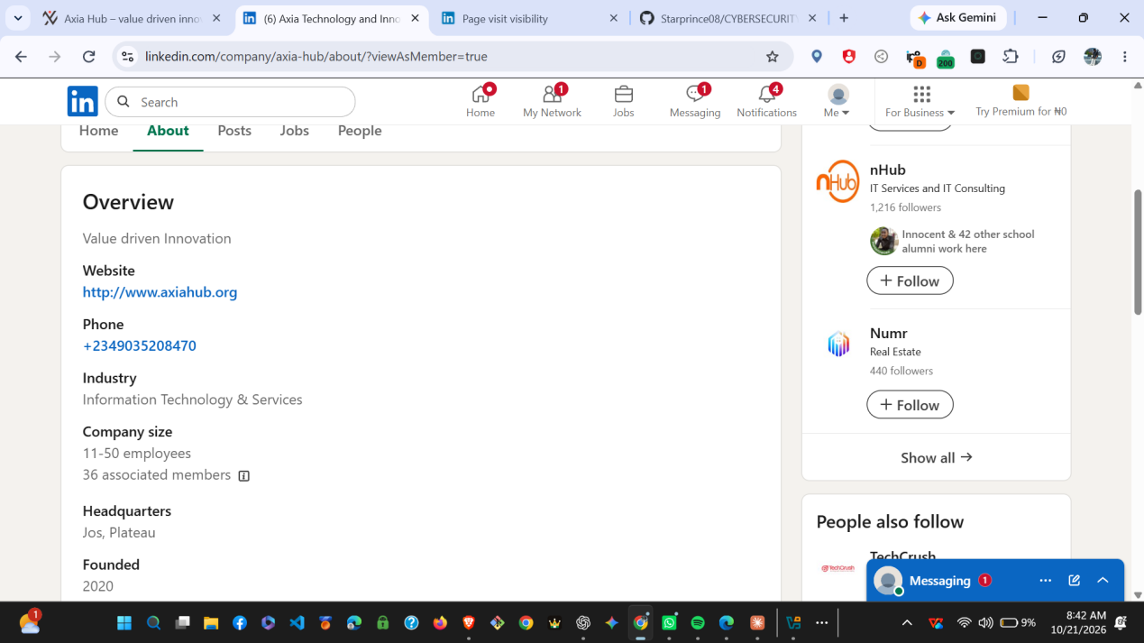
Evidence_05: LinkedIn About: website, phone, size, headquarters, founded (08:42)
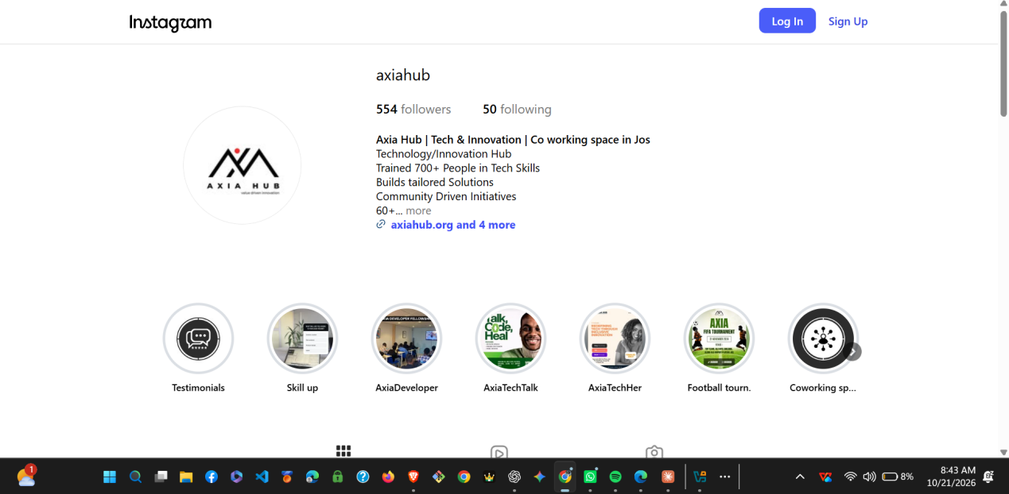
Evidence_06: Instagram profile @axiahub (08:43)
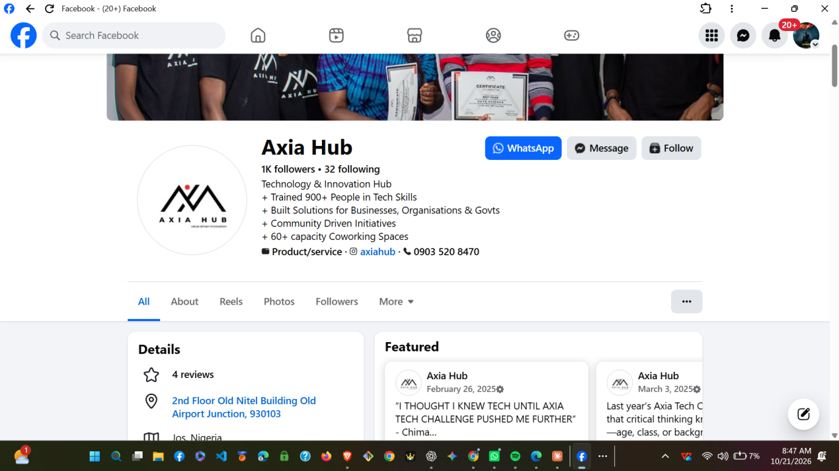
Evidence_07: Facebook page: Axia Hub profile summary (08:47)
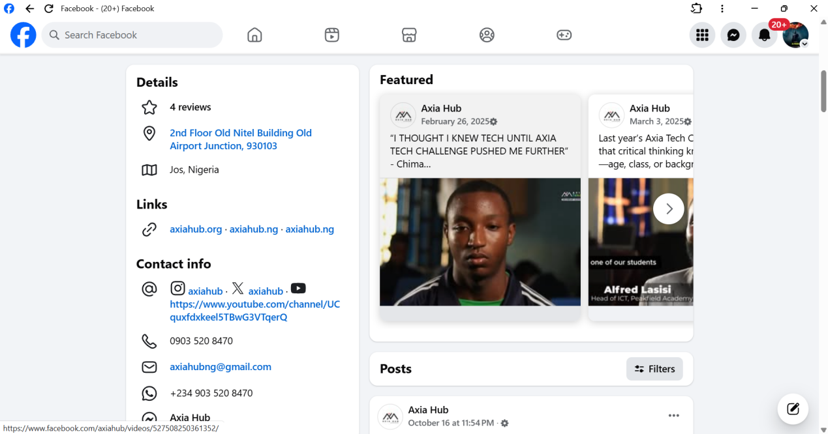
Evidence_08: Facebook page: details, linked domains, contact info (08:47)

Evidence_09: X profile @AxiaHub (browser)
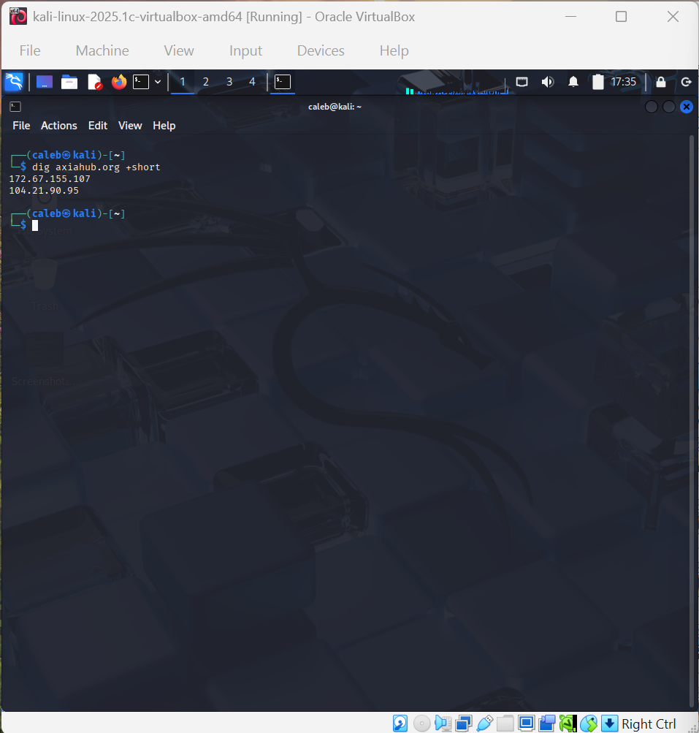
Evidence_10: dig axiahub.org +short (17:35 EDT)
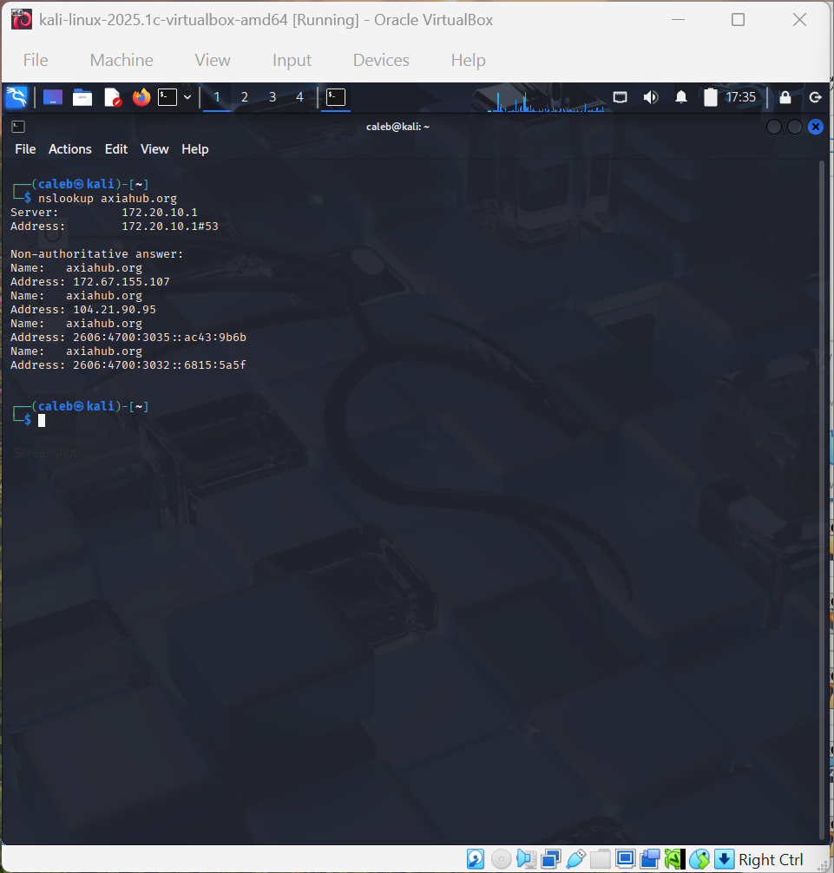
Evidence_11: nslookup axiahub.org (17:35 EDT)
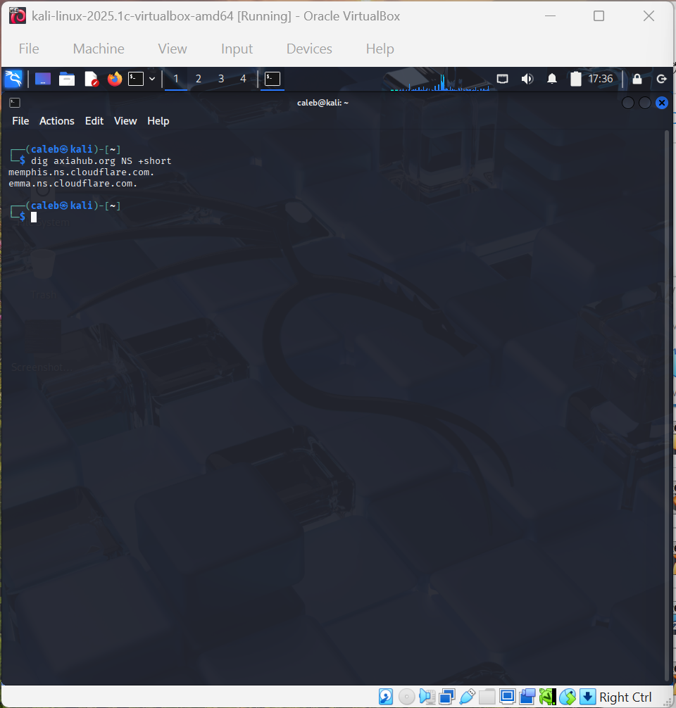
Evidence_12: dig axiahub.org NS +short (17:36 EDT)
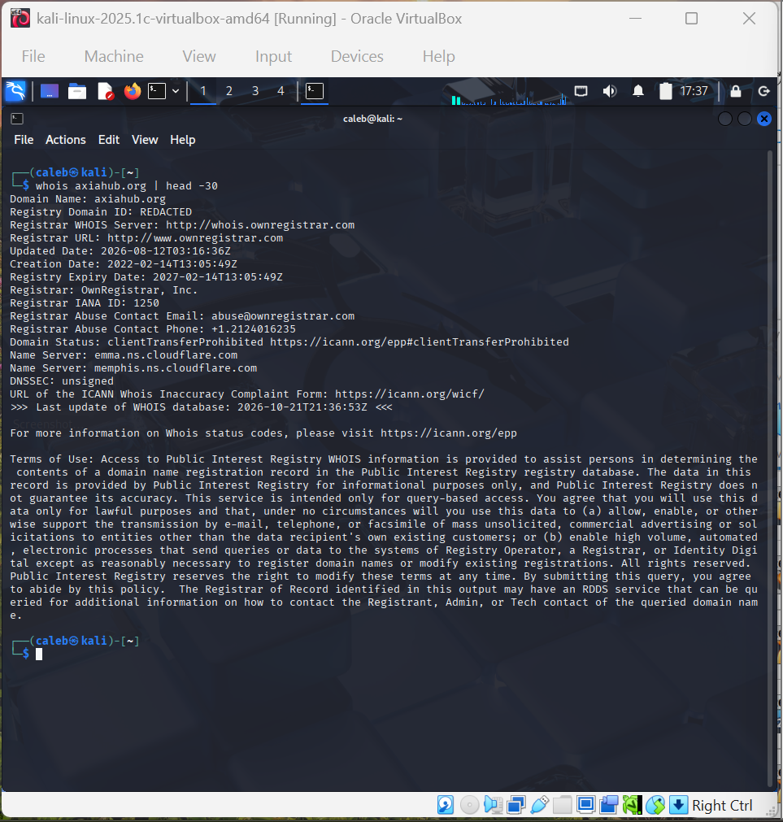
Evidence_13: whois axiahub.org, first 30 lines (17:37 EDT)
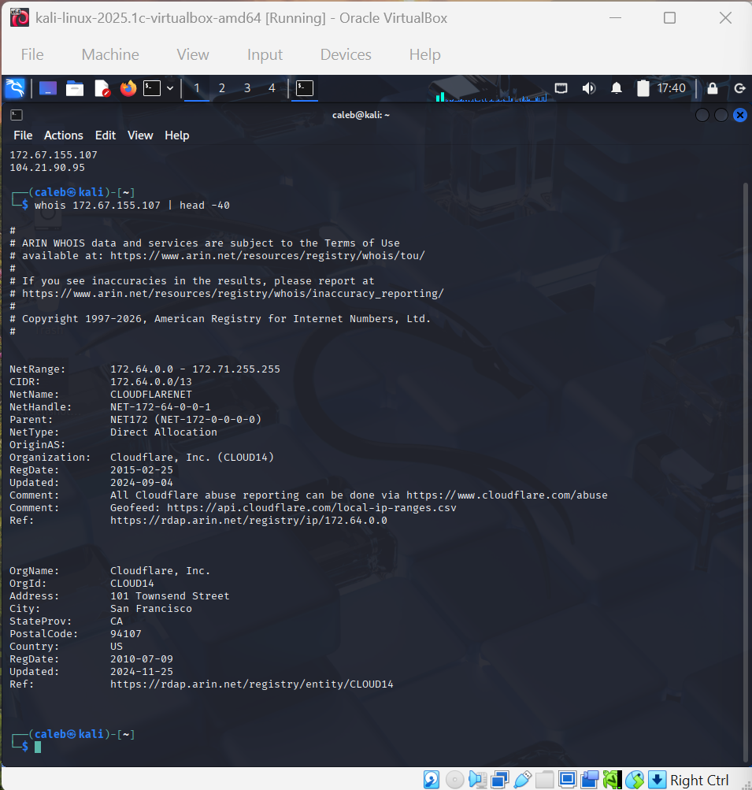
Evidence_14: whois 172.67.155.107, first 40 lines (17:40 EDT)
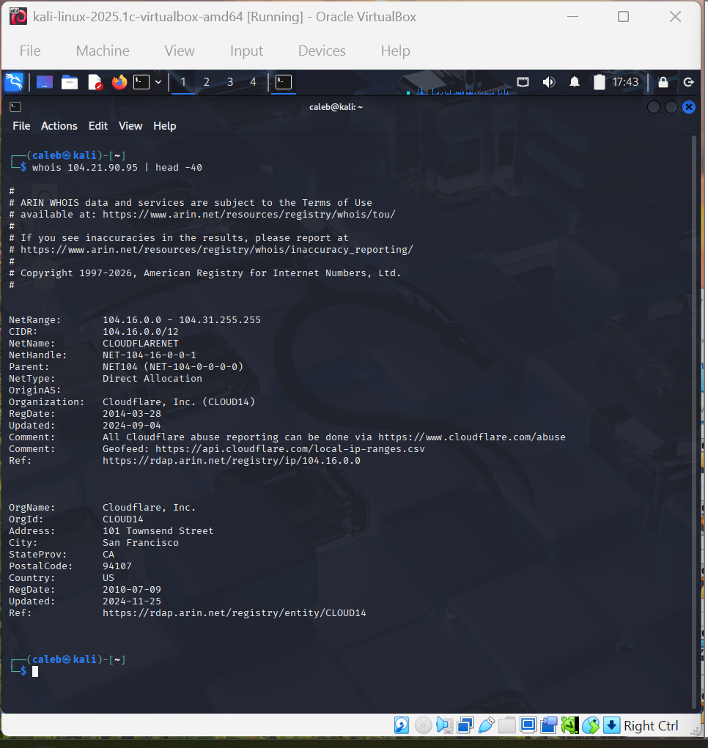
Evidence_15: whois 104.21.90.95, first 40 lines (17:43 EDT)
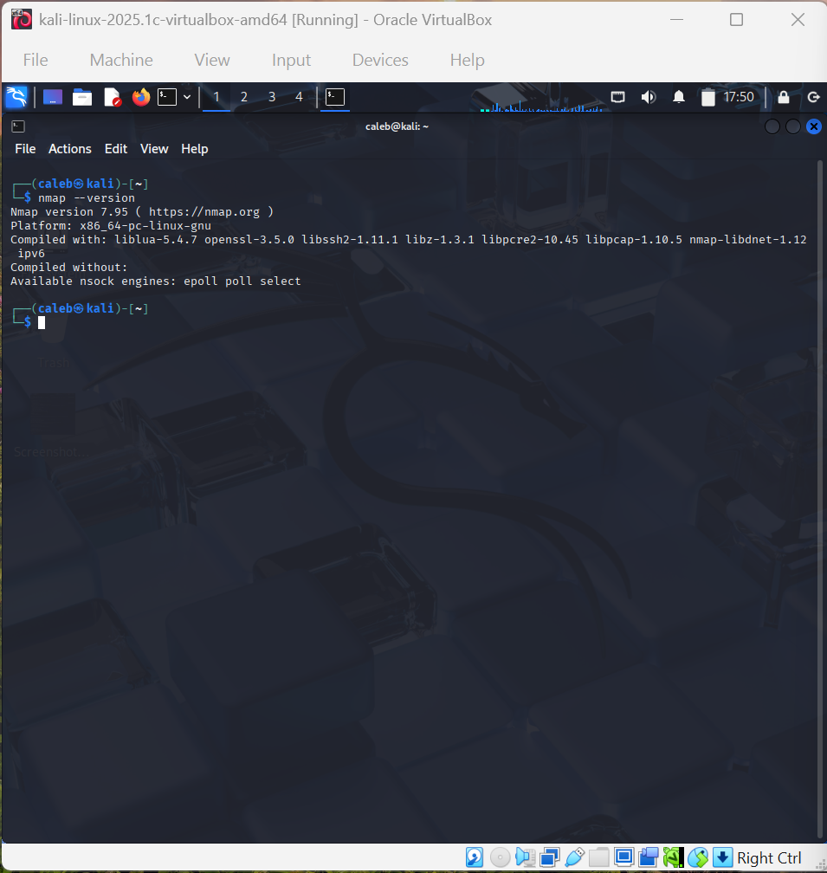
Evidence_16: nmap --version (17:50 EDT)
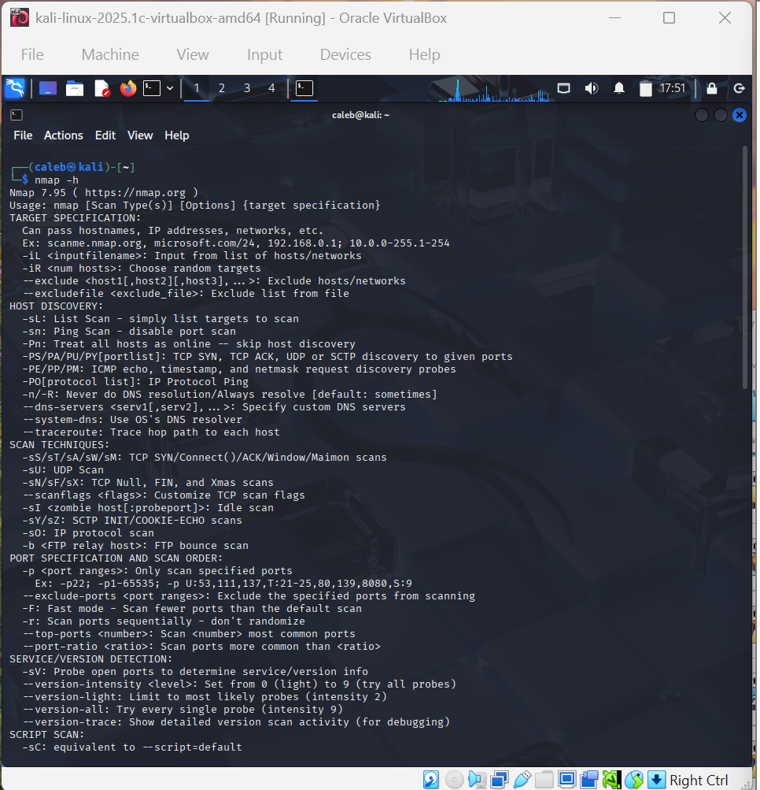
Evidence_17: nmap -h, part 1 (17:51 EDT)
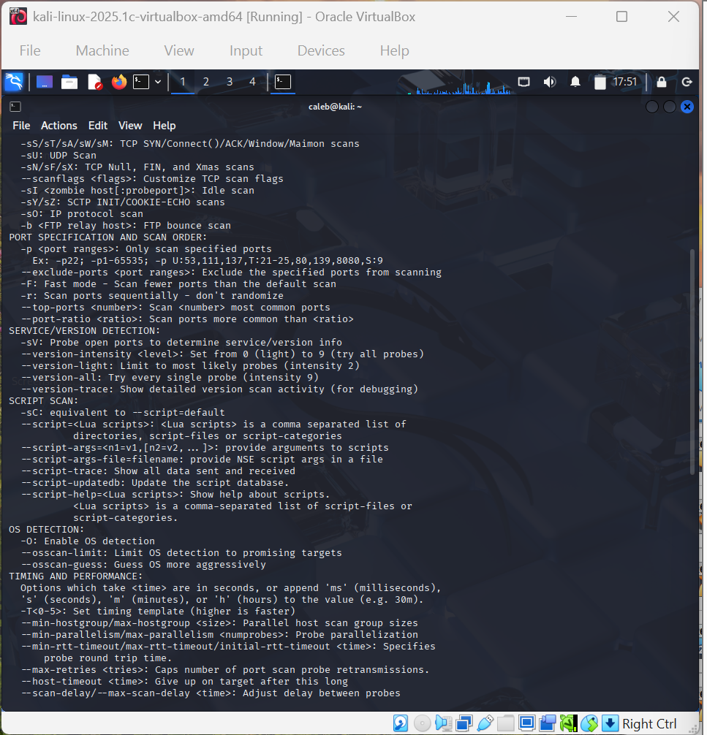
Evidence_18: nmap -h, part 2 (17:51 EDT)
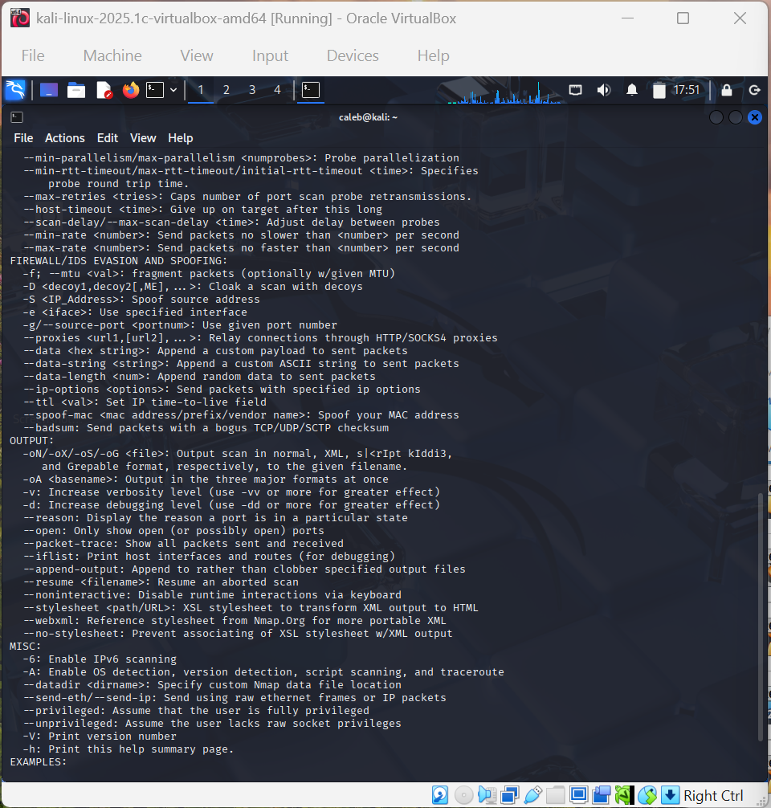
Evidence_19: nmap -h, part 3 (17:51 EDT)

Appendix B: Source references
Source | URL or reference | Accessed
Axia Hub website | https://axiahub.org | 2026-10-21
Axia Hub About page (staff details deliberately not recorded) | https://axiahub.org/about-page/ | 2026-10-21
LinkedIn: Axia Technology and Innovation Hub | https://www.linkedin.com/company/axia-hub/about/ | 2026-10-21
Instagram: axiahub | https://www.instagram.com/axiahub | 2026-10-21
Facebook: Axia Hub | https://www.facebook.com/axiahub | 2026-10-21
X: @AxiaHub | https://x.com/AxiaHub | 2026-10-21
whois (Public Interest Registry record) for axiahub.org | command line, Evidence_13 | 2026-10-21
ARIN whois for 172.67.155.107 and 104.21.90.95 | command line, Evidence_14 and Evidence_15 | 2026-10-21
Nmap 7.95 help output and version | command line, Evidence_16 to Evidence_19 | 2026-10-21

Appendix C: Saved scan output
The unedited raw files are in 04_Scan_Output: nmap_localhost.txt (final contents are the 17:56 scan of 127.0.0.1), plus nmap_version.txt and nmap_help.txt if saved. The text below is retyped from the screenshots so it can be read and searched; the files and screenshots are the originals.
Scan 1: nmap -oN nmap_localhost.txt 127.0.0.1
Starting Nmap 7.95 ( https://nmap.org ) at 2026-10-21 17:56 EDT
Nmap scan report for localhost (127.0.0.1)
Host is up (0.0000050s latency).
Not shown: 999 closed tcp ports (reset)
PORT STATE SERVICE
22/tcp open ssh

Nmap done: 1 IP address (1 host up) scanned in 0.11 seconds

Scan 2: nmap -sT -p 22,80,443 -oN nmap_target.txt 104.21.90.95
Starting Nmap 7.95 ( https://nmap.org ) at 2026-10-21 17:45 EDT
Nmap scan report for 104.21.90.95
Host is up (0.0017s latency).

PORT STATE SERVICE
22/tcp filtered ssh
80/tcp filtered http
443/tcp filtered https

Nmap done: 1 IP address (1 host up) scanned in 13.12 seconds

Scan 3: nmap -oN nmap_localhost.txt 104.21.90.95
Starting Nmap 7.95 ( https://nmap.org ) at 2026-10-21 17:53 EDT
Nmap scan report for 104.21.90.95
Host is up (0.031s latency).
Not shown: 995 filtered tcp ports (no-response)
PORT STATE SERVICE
21/tcp open ftp
80/tcp open http
443/tcp open https
8080/tcp open http-proxy
8443/tcp open https-alt

Nmap done: 1 IP address (1 host up) scanned in 39.99 seconds

Appendix D: Evidence checklist status
Checklist item | Status
Scope note states the OSINT case and Nmap target | Included (Section 2)
OSINT worksheet has at least five observations | Included: 10 (Section 4; OSINT_Worksheet.docx)
Each observation has a source and collection date | Included
Confidence and limitations recorded | Included
At least one observation cross-checked | Included (Section 4)
Nmap version and help evidence | Included (Evidence_16 to 19)
Command and exact target recorded | Included (Section 5, Table 1)
Saved raw Nmap output, unedited | Copy the unedited files into 04_Scan_Output
Screenshots legible with context | Included (Appendix A)
Observations, assumptions and conclusions separated | Included (Section 6.3)
Three recommendations linked to findings | Included (Section 7)
Reflection and conclusion complete | Included (Section 8); edit into your own words
Folder structure and filenames correct | Included in the supplied folder
No passwords, tokens or unnecessary personal data | Staff details omitted; organisation contacts only

