CYBERSECURITY SIWES TRAINING
WEEK 3 PROJECT REPORT

Basic Network Discovery and Traffic Analysis

Student Name: Ayeni Ayomide Caleb
UJ/2024/NS/0739
Department: Mathematics
Institution: University of Jos
SIWES Organisation: Axiahub
Training Period: 19 August 2026 to 19 November 2026

1. Introduction
This report documents the Week 3 practical project of my Cybersecurity SIWES training, titled Basic Network Discovery and Traffic Analysis. The purpose of the project was to understand the basic network information of my own workstation and to observe simple network communication safely. I identified my hostname, network interface, IP address, MAC address, default gateway and DNS information. I tested connectivity with ping, performed DNS lookups, examined the route to an approved destination, and captured and analysed ICMP and DNS traffic in Wireshark.
All tasks were done on my own workstation, which is a Kali Linux virtual machine running in Oracle VirtualBox, and only against example.com and google.com, which are public domains named in the project brief. I did not use any network scanner, port scanner or vulnerability scanner, I did not probe random systems, and I did not change any network settings. The work was observation and documentation only.
The tools used were the Linux commands hostname, ip, ping, nslookup, dig, traceroute and tracepath, together with Wireshark for packet capture and analysis. All screenshots in this report were taken by me on this workstation and are stored in the 06_Evidence folder.

2. Workstation and Network Configuration
The commands hostname, ip link, ip addr and ip route were used to collect the identity of the workstation and its active interface. The results are summarised in Table 1.
Table 1: Workstation network details
Item | Value observed
Hostname | kali
Active network interface | eth0 (state UP, default route metric 100)
IPv4 address | 10.0.2.15/24 (assigned dynamically by DHCP)
MAC address | 08:00:27:b4:a1:05
Default gateway | 10.0.2.2 via eth0
DNS servers | 172.20.10.1, fd17:625c:f037:2::3, fd17:625c:f037:3::3

The output of ip link showed four interfaces: lo (loopback), eth0, eth1 and docker0. The ip addr output showed that eth0 holds 10.0.2.15/24 and that eth1, a second virtual adapter, holds 10.0.3.15/24 with MAC address 08:00:27:82:d3:03. The docker0 interface (172.17.0.1/16) was DOWN because no containers were running. The ip route output showed two default routes, one through eth0 via 10.0.2.2 with metric 100 and one through eth1 via 10.0.3.2 with metric 101. Linux prefers the route with the lower metric, so eth0 is the active interface used for outgoing traffic, and I recorded eth0 as the main interface for this project.
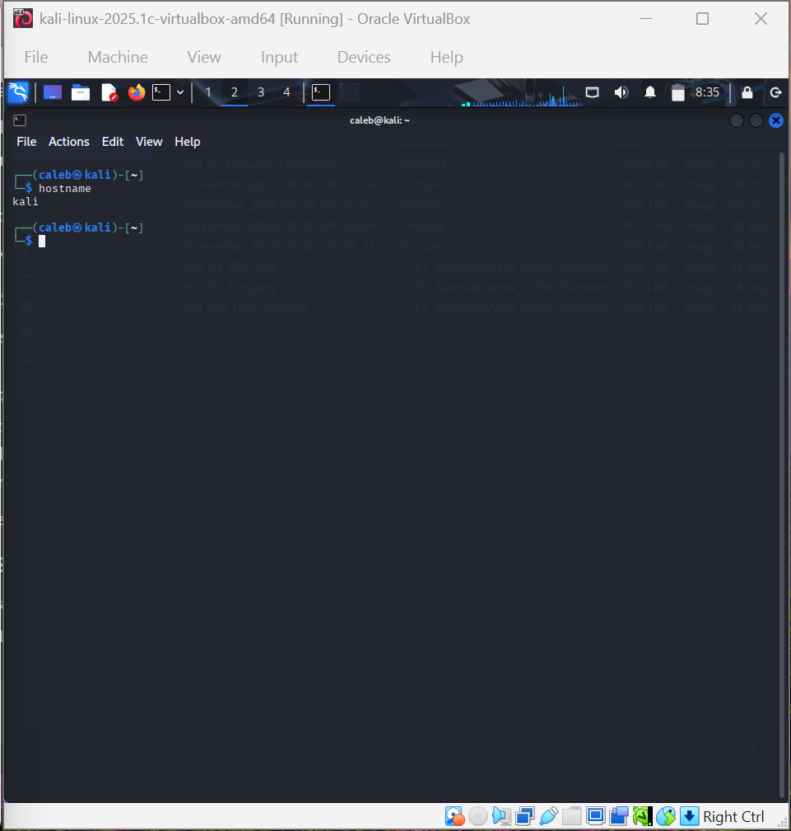
Figure 1: Output of the hostname command
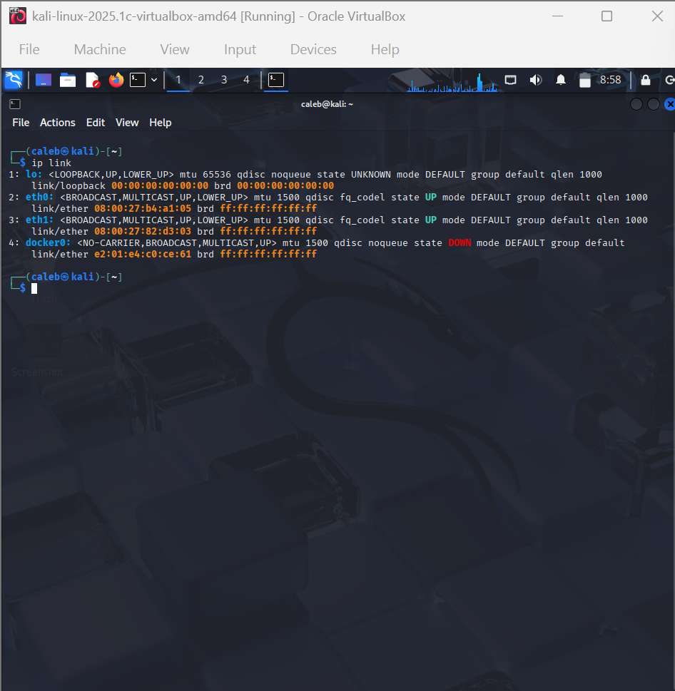
Figure 2: Output of the ip link command
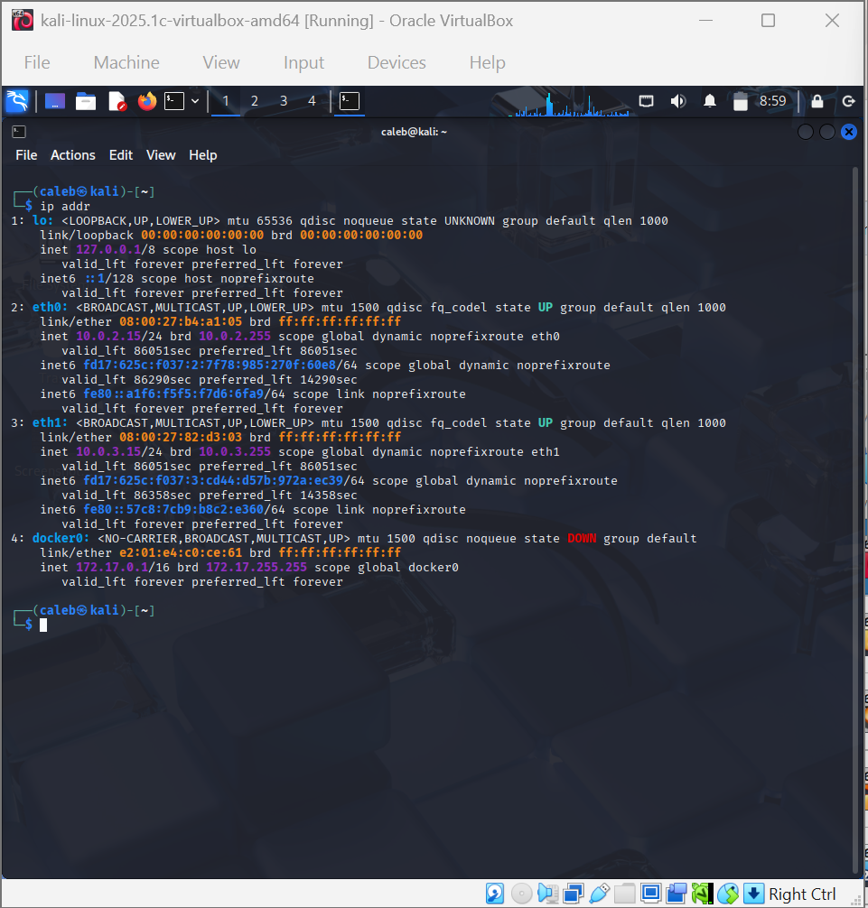
Figure 3: Output of the ip addr command
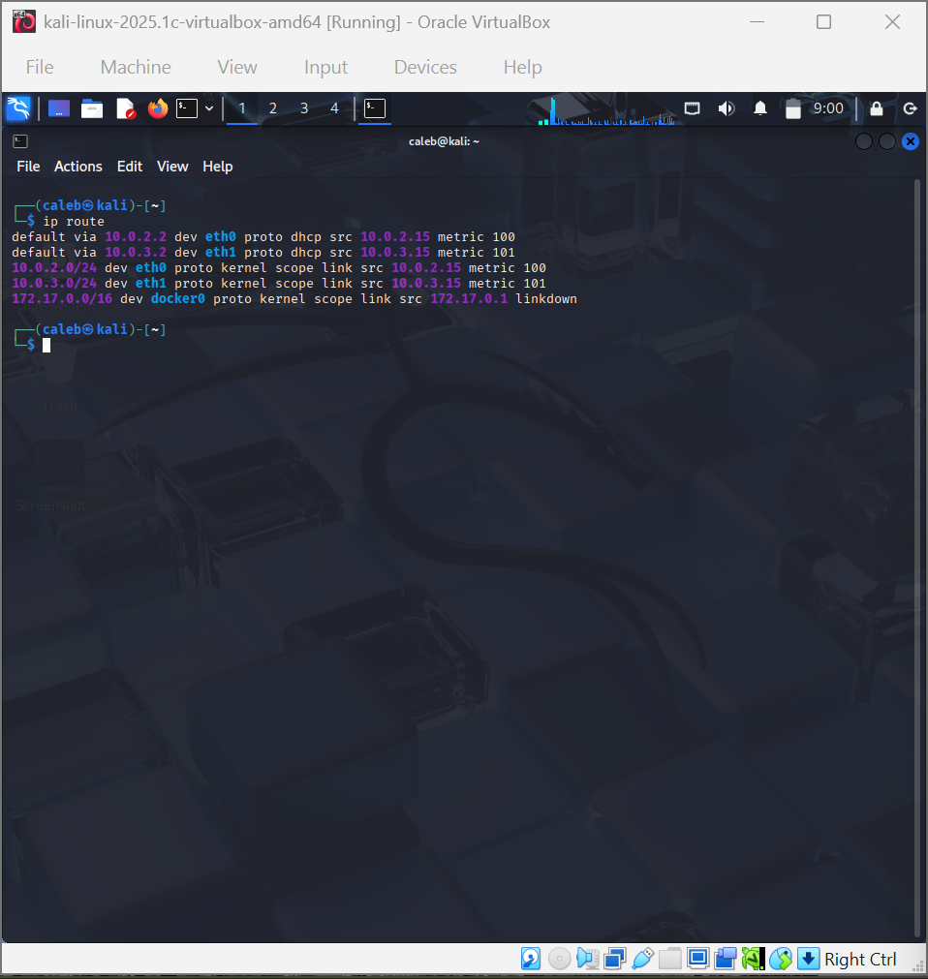
Figure 4: Output of the ip route command

2.1 DNS Information
DNS information was collected with cat /etc/resolv.conf. The file was generated by NetworkManager and listed three nameservers: 172.20.10.1, fd17:625c:f037:2::3 and fd17:625c:f037:3::3. The first is an IPv4 address and the other two are IPv6 addresses. The system did not use a local resolver address such as 127.0.0.53, so the addresses above are what the workstation is configured to query. The address 172.20.10.1 is outside the two subnets that belong to the virtual machine (10.0.2.0/24 and 10.0.3.0/24), so I only record it as the configured DNS server and I make no further claim about what device it belongs to.
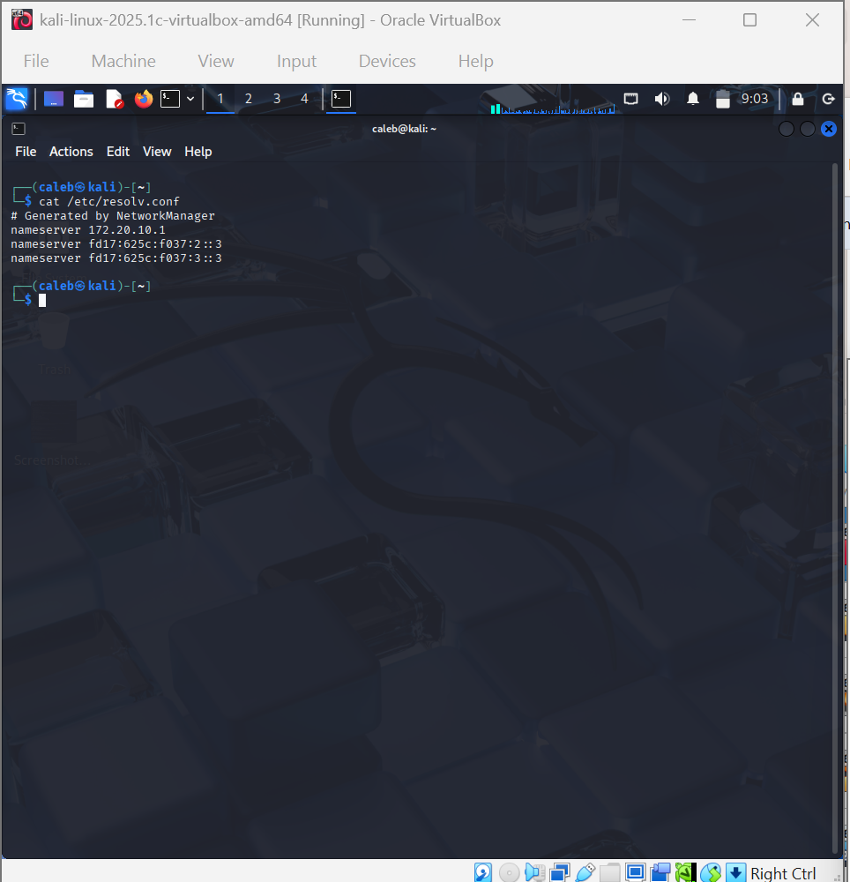
Figure 5: DNS configuration from /etc/resolv.conf

2.2 Key Concepts
An IP address is a logical address that identifies a device on a network so that data can be sent to it and from it. A MAC address is a hardware address built into a network interface and used for delivery within the local network. The default gateway is the router that the workstation sends traffic to when the destination is outside its own network. DNS (Domain Name System) converts human-readable names such as example.com into IP addresses. DHCP (Dynamic Host Configuration Protocol) automatically gives a device its IP address, gateway and DNS settings when it joins a network. In my case the ip addr output shows the word dynamic next to the eth0 address, which means the address was given by DHCP.

3. Connectivity Testing
The ping command was used to test my own machine, my default gateway and an approved destination. Only these targets were tested. The results are in Table 2.
Table 2: Ping test results
Destination | Result | Meaning
127.0.0.1 (loopback) | 20 sent, 20 received, 0% packet loss. Round trip min/avg/max = 0.065/0.169/0.904 ms | The TCP/IP software on my workstation is working.
10.0.2.15 (my own eth0 address) | 8 sent, 8 received, 0% packet loss. Round trip min/avg/max = 0.066/0.118/0.384 ms | My own network interface answers correctly.
10.0.2.2 (default gateway) |  | Would show whether the workstation can reach its router. The traceroute test in Section 5 also received replies from 10.0.2.2 at hop 1.
example.com (104.20.23.154) | 4 echo requests sent and 4 echo replies received (seen in the Wireshark capture, Section 6). [[PENDING: terminal ping screenshot]] | Traffic can travel beyond the gateway to the approved destination and come back.

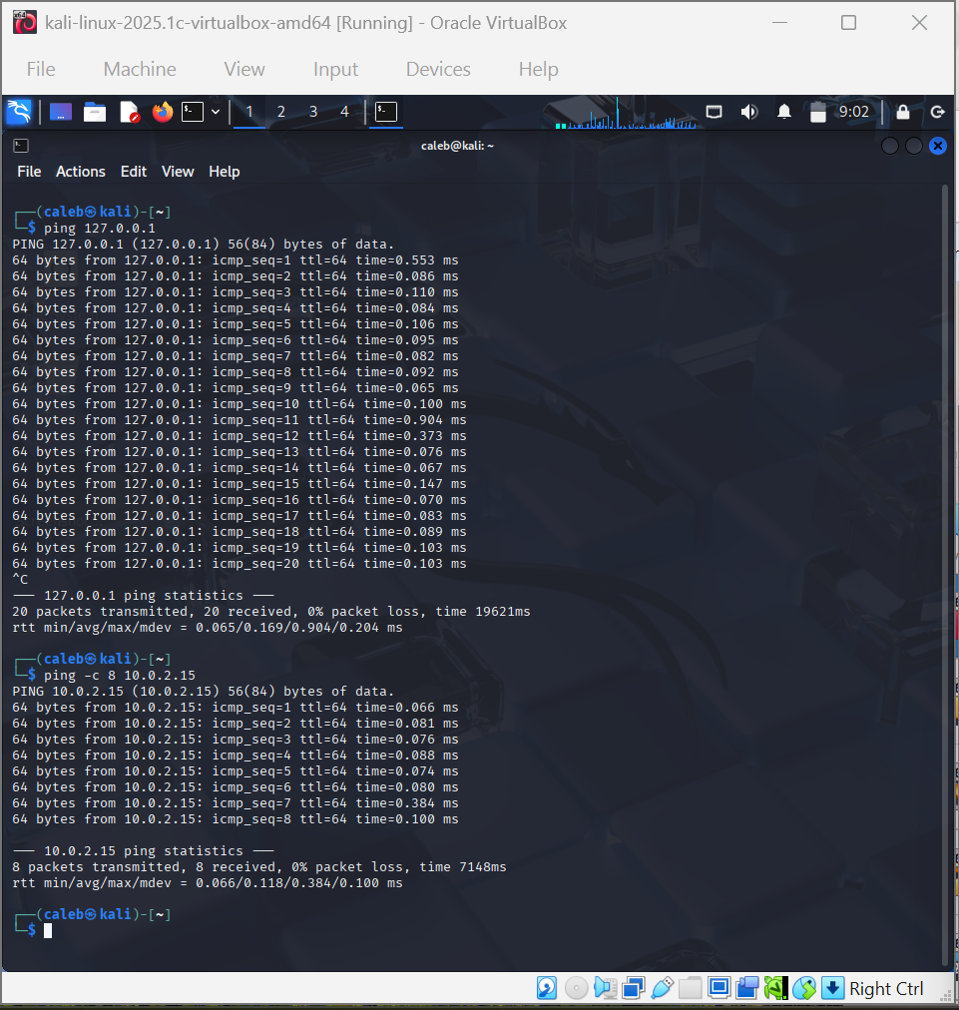
Figure 6: Ping tests to 127.0.0.1 and to my own address 10.0.2.15
Observation: both local tests received a reply for every packet with no loss, and the times were well below one millisecond for almost all replies, which is normal because the packets never leave the machine. The ping to 127.0.0.1 was stopped manually with Ctrl+C after 20 packets. The ping to example.com is evidenced by the Wireshark capture in Section 6, where every echo request had a matching echo reply. If a ping had failed, that would not automatically mean the destination was offline, because some systems and firewalls block ICMP echo requests.

4. DNS Lookup
A DNS lookup was performed for the public domain google.com with both nslookup and dig. The results are in Table 3.
Table 3: DNS lookup results
Item | Value observed
Domain queried | google.com
DNS server used | 172.20.10.1 (port 53)
Returned IPv4 addresses | 142.250.129.101, 142.250.129.102, 142.250.129.113, 142.250.129.100, 142.250.129.139, 142.250.129.138
Returned IPv6 addresses (nslookup) | 2a00:1450:4009:c0f::8b, ::65, ::8a, ::64
dig details | Status NOERROR, 6 answers (type A), TTL 345 seconds, query time 88 ms, answer was non-authoritative

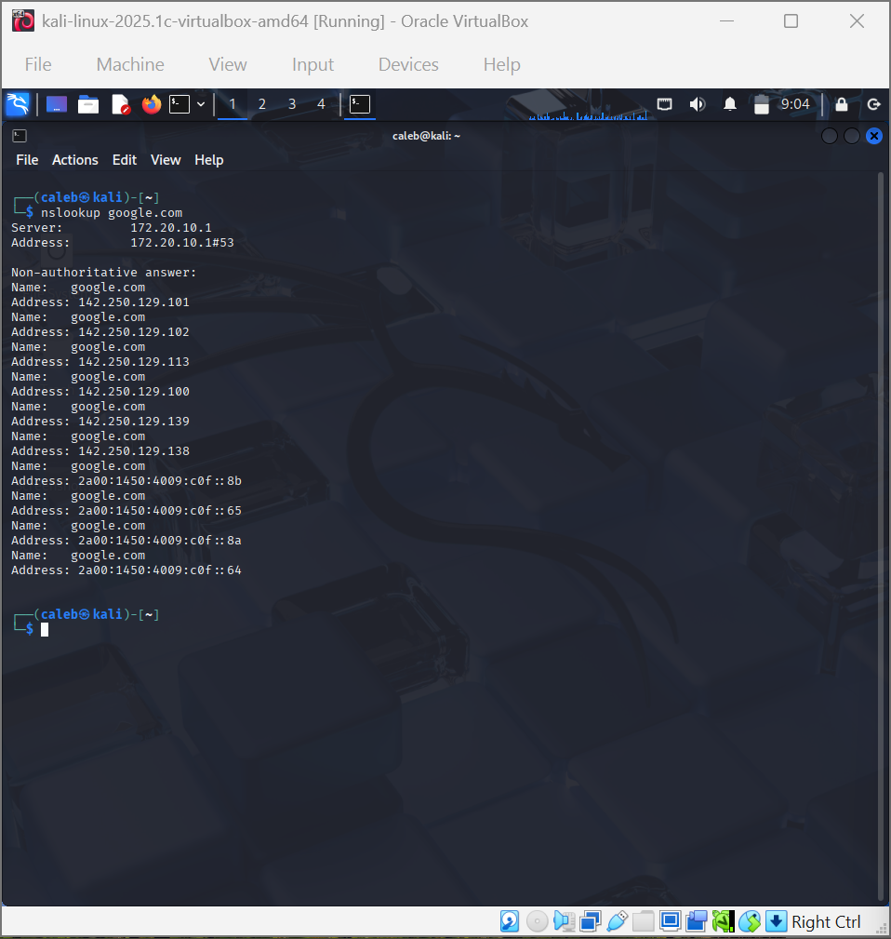
Figure 7: nslookup google.com
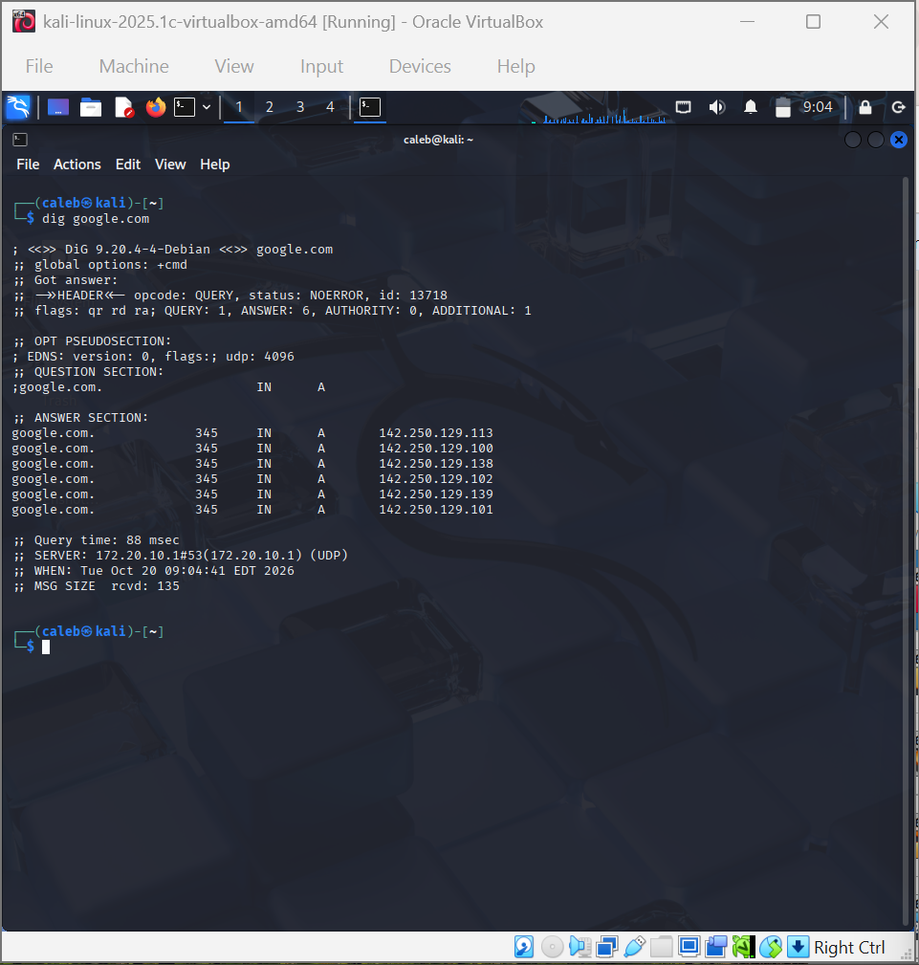
Figure 8: dig google.com
In this test, DNS converted the name google.com into IP addresses. My workstation sent a query to the DNS server 172.20.10.1, and the server replied with several addresses that belong to google.com. The reply was marked non-authoritative in nslookup, meaning the server answered from its own stored copy and not from Google's own name server.

5. Route Investigation
The route to example.com was observed with both traceroute and tracepath. Traceroute resolved example.com to 172.66.147.243 and tried up to 30 hops. Only hop 1 replied, and it was 10.0.2.2, my default gateway, with response times of 12.608 ms, 11.423 ms and 10.313 ms. Hops 2 to 30 showed three asterisks each, which means no reply was received. Tracepath gave the same picture: hop 1 was 10.0.2.2 (0.849 ms and 1.375 ms) and hops 2 to 30 showed no reply, ending with the message Too many hops with pmtu 1500.
Table 4: Route investigation summary
Item | Value observed
Destination | example.com (172.66.147.243 shown by traceroute)
Number of visible (responding) hops | 1 (10.0.2.2)
Hops without reply | 29 (hops 2 to 30)
Tools used | traceroute and tracepath

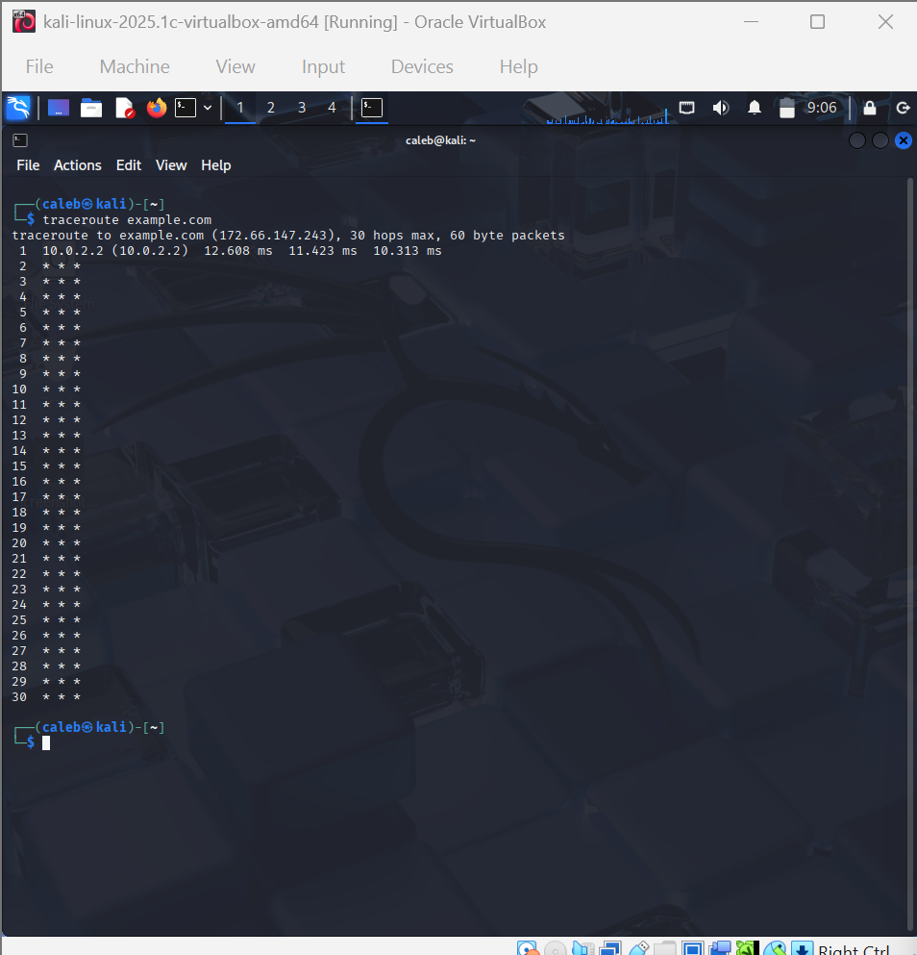
Figure 9: traceroute example.com
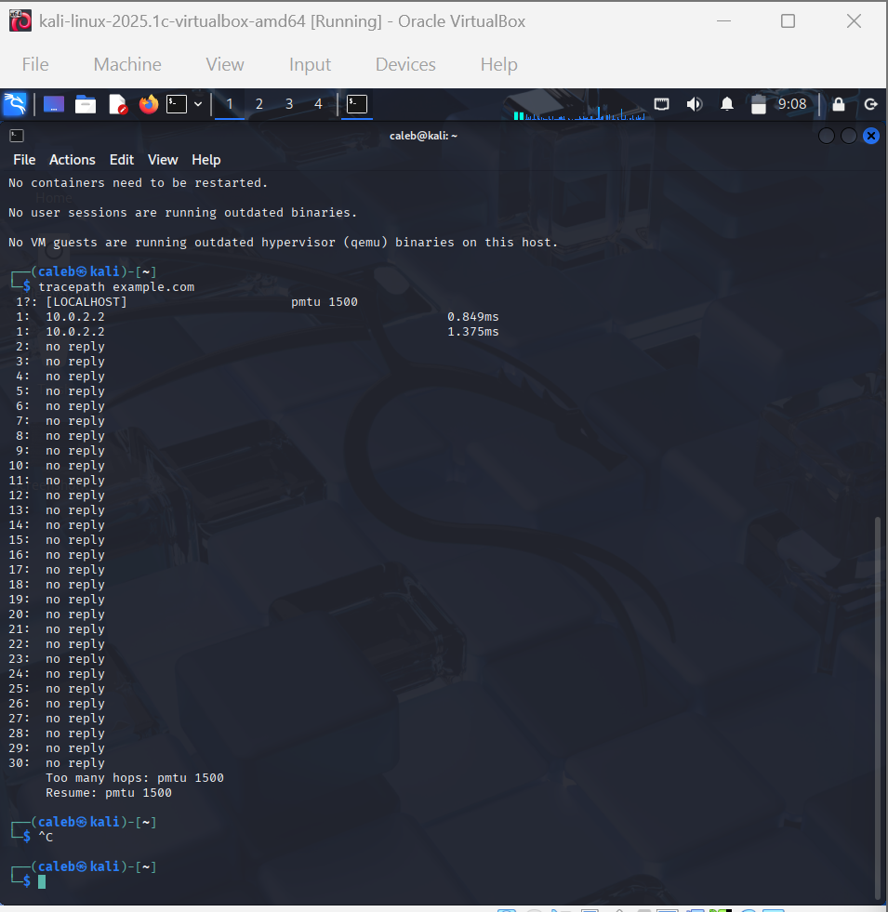
Figure 10: tracepath example.com
A hop is one router or network device that a packet passes through on its way to the destination, and each hop moves the packet one step closer. Timeouts are not automatically an error. Many routers and firewalls do not send back the replies that traceroute depends on. In my case the virtual machine uses the VirtualBox NAT network, which is a likely reason why no device after the gateway answered, but I did not test this and I only record what I observed. The ping replies from example.com in Section 6 prove that the destination was reachable even though the intermediate hops were silent.

6. Wireshark ICMP Analysis
Wireshark was started with sudo wireshark and a capture was started on the interface eth0. A short ping to example.com was generated, the capture was stopped, and the display filter icmp was applied. Eight ICMP packets were displayed out of 23 captured (34.8%), which is four echo requests and four echo replies, and no packets were dropped. One echo request and one echo reply were examined and are recorded in Table 5.
Table 5: ICMP packets identified
Item | Echo Request | Echo Reply
Packet (frame) number | 18 | 19
Source IP | 10.0.2.15 | 104.20.23.154
Destination IP | 104.20.23.154 | 10.0.2.15
Protocol | ICMP | ICMP
Request or reply | Echo (ping) request | Echo (ping) reply
Frame length | 98 bytes | 98 bytes

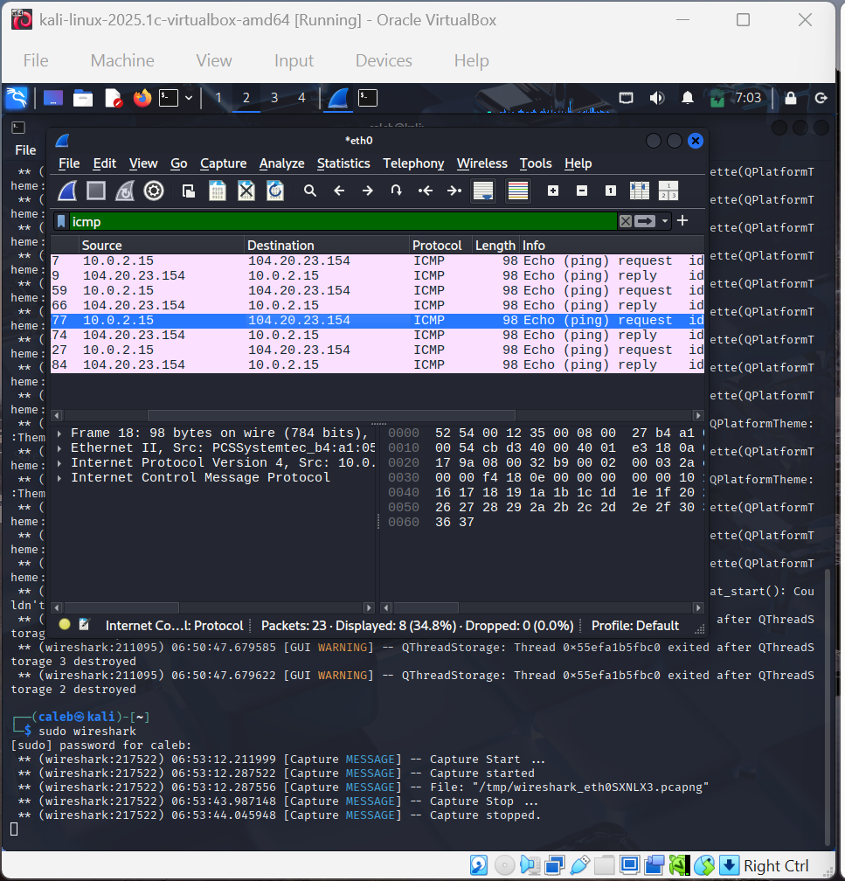
Figure 11: Wireshark with the icmp filter, Echo request (frame 18) selected
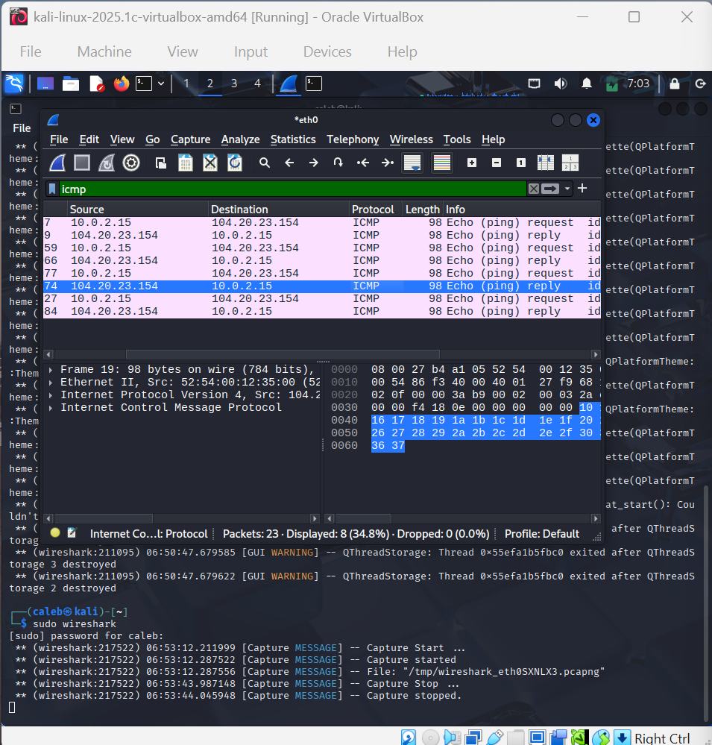
Figure 12: Wireshark with the icmp filter, Echo reply (frame 19) selected
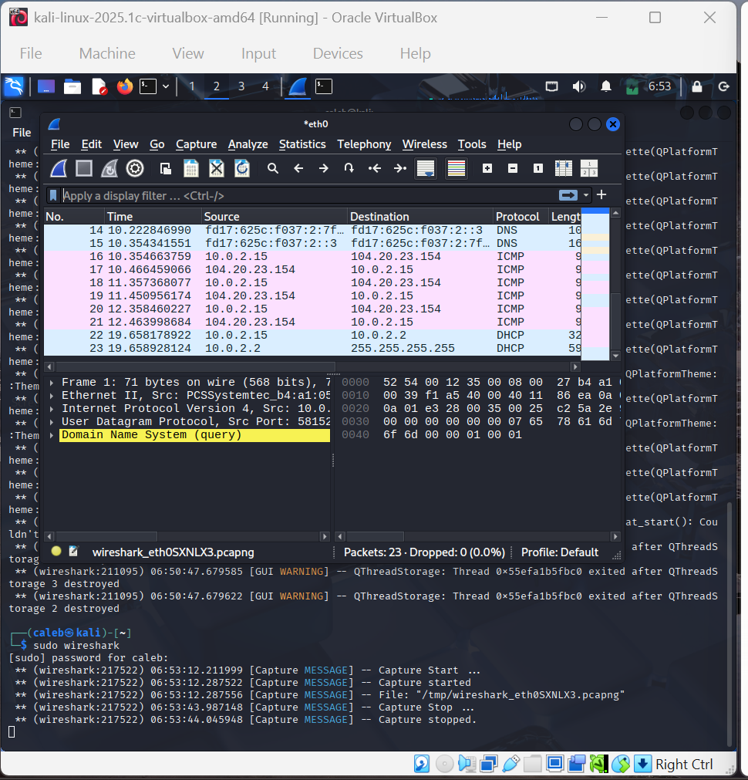
Figure 13: Unfiltered capture showing DNS, ICMP and DHCP packets with timestamps
The Echo Request was sent from my workstation (10.0.2.15) to the destination (104.20.23.154), and the Echo Reply came back from the destination to my workstation, so the source and destination addresses are reversed between the two packets. The unfiltered capture in Figure 13 also shows the time of each packet. Using these times, the three request and reply pairs visible there took about 111.8 ms (frames 16 and 17), 93.6 ms (frames 18 and 19) and 105.5 ms (frames 20 and 21). These times are much longer than the local pings in Section 3 because these packets travelled out to the remote server and back. The address 104.20.23.154 is one of the two addresses returned for example.com in the DNS capture in Section 7.

7. Wireshark DNS Analysis
A fresh capture was started on eth0, a DNS lookup for example.com was generated, the capture was stopped, and the display filter dns was applied. The capture had 34 packets and 8 were displayed as DNS (23.5%), with none dropped. The results are in Table 6.
Table 6: DNS packets identified
Item | DNS Query | DNS Response
Source IP | fd17:625c:f037:2:7f78:985:270f:60e8 (my workstation, IPv6) | fd17:625c:f037:2::3
Destination IP | fd17:625c:f037:2::3 | fd17:625c:f037:2:7f... (my workstation, IPv6)
Protocol | DNS (over UDP) | DNS (over UDP)
Domain requested | example.com (type A) | example.com
IP addresses returned | None (this is a question) | 172.66.147.243 and 104.20.23.154
Packet length | 114 bytes | 134 bytes (frame 20)

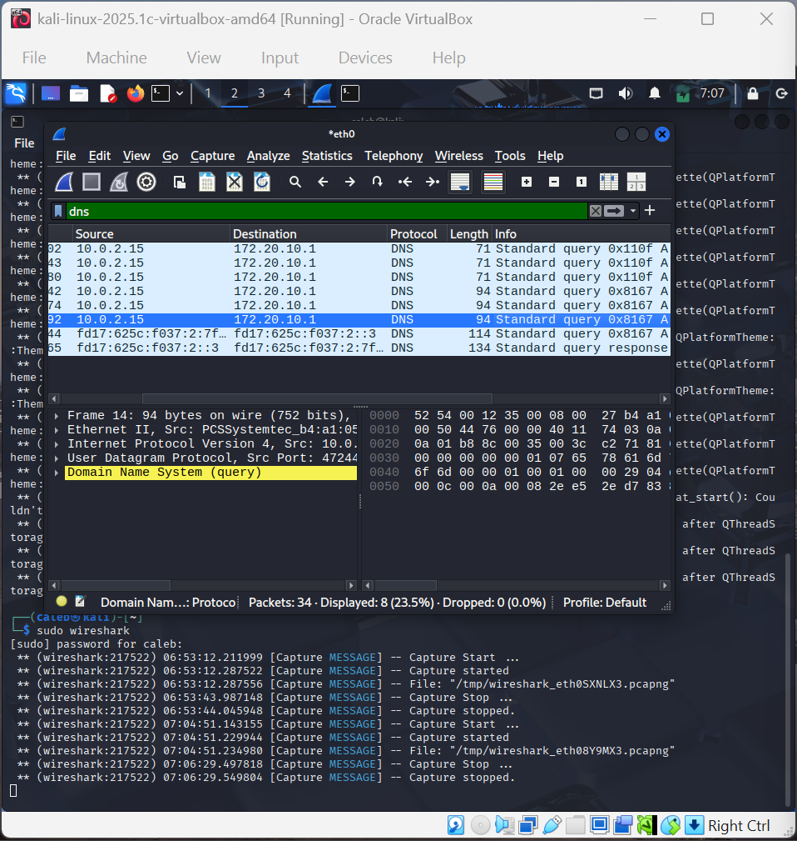
Figure 14: Wireshark with the dns filter, DNS query (frame 14) selected
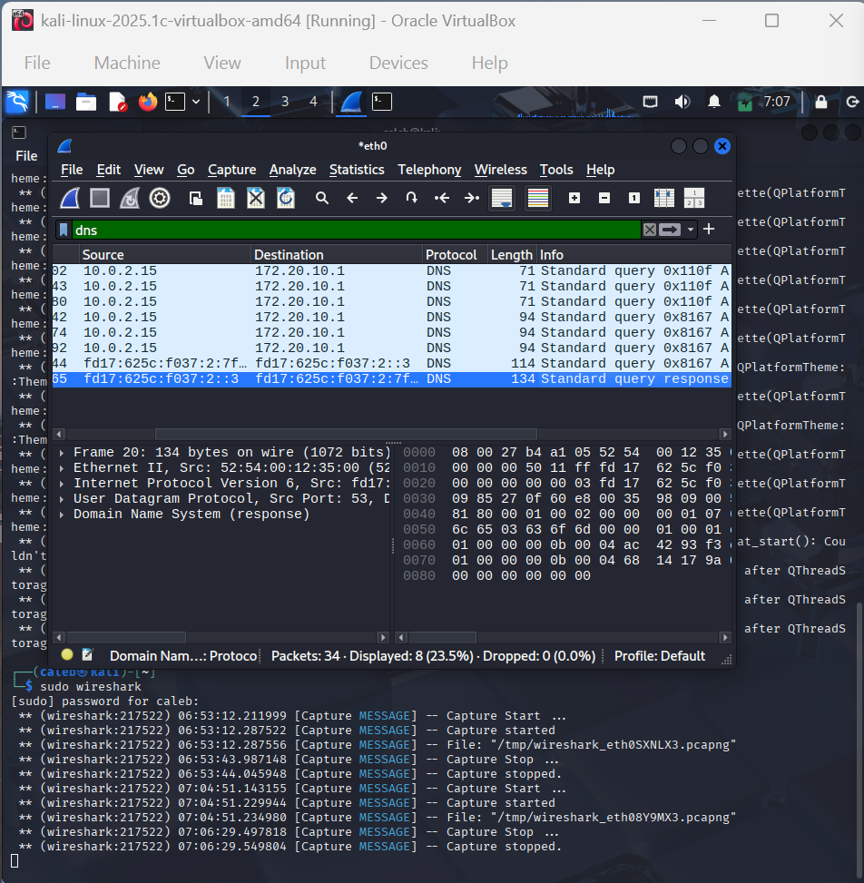
Figure 15: Wireshark with the dns filter, DNS query response (frame 20) selected
The domain name and the returned addresses were read from the packet bytes shown in the lower pane of Figure 15. The bytes spell the name example.com, and the two answer records contain ac 42 93 f3 (172.66.147.243) and 68 14 17 9a (104.20.23.154). The response flags show that the query succeeded with two answers.
The capture also contained six DNS queries sent over IPv4 from 10.0.2.15 to 172.20.10.1, which is the DNS server listed in /etc/resolv.conf. These were three queries with ID 0x110f and three with ID 0x8167, all of type A. Each ID was sent three times, which means the resolver repeated the same question. Under the dns filter, no reply from 172.20.10.1 appears in this capture, and the only response shown came from the IPv6 server fd17:625c:f037:2::3. I report this as observed and I do not claim to know why the IPv4 replies are missing from the capture on eth0. The query in Figure 14 (frame 14) is one of these IPv4 queries, sent from 10.0.2.15 to 172.20.10.1 and 94 bytes long. The query and response in Table 6 are the IPv6 pair, because the response in Figure 15 came from the IPv6 server and answers a query for the same domain. The response ID is not visible in the screenshot, so I matched this pair by domain name, protocol and the order of the packets.
This confirms the request and response behaviour of DNS: the workstation asks a DNS server for the address of a domain name, and the server answers with the IP addresses for that name.

8. Network Diagram
Figure 16 shows the logical path from my workstation to a remote server. Traffic leaves the Kali workstation (10.0.2.15 on eth0), passes through the virtual network adapter of VirtualBox, reaches the default gateway 10.0.2.2, crosses the Internet and arrives at the remote server example.com. The DNS server used by the workstation is 172.20.10.1. No passwords, Wi-Fi keys or other secrets are included.
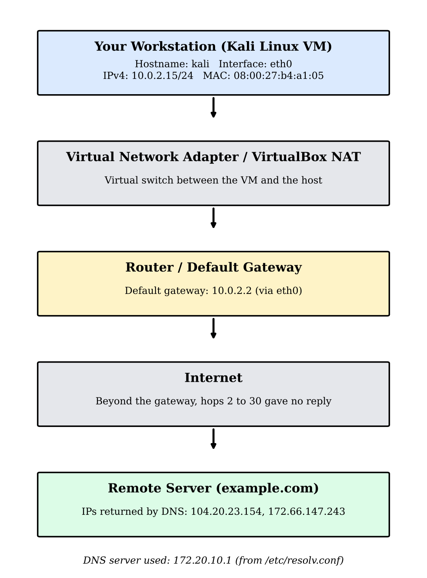
Figure 16: Network diagram from the workstation to the remote server

9. Security Observations and Reflection
1. What is the purpose of an IP address?
An IP address identifies a device on a network so that data can be sent to the correct place. My workstation used 10.0.2.15 as its address, and every packet it sent carried that address as the source.
2. What is the difference between an IP address and a MAC address?
An IP address is a logical address that can change from one network to another and is used to route data between networks. A MAC address is a hardware address of the network interface, and it stays with the interface and is used inside the local network. My eth0 interface had the MAC address 08:00:27:b4:a1:05 and the IP address 10.0.2.15.
3. What is the purpose of a default gateway?
The default gateway is the router that receives traffic meant for networks outside my own. In my test it was 10.0.2.2, and it was the first hop in both traceroute and tracepath.
4. What does DNS do?
DNS translates domain names into IP addresses, so I can use a name like google.com instead of remembering numbers. In my test, DNS returned six IPv4 addresses for google.com.
5. Why can a failed ping be misleading?
A failed ping only tells me that no ICMP reply came back. Many firewalls and devices block ICMP echo requests, so the destination may be working even though ping fails. My own traceroute also showed silent hops, yet the destination still replied to ping.
6. What information did Wireshark show during your ICMP capture?
Wireshark showed the packet number, time, source IP, destination IP, protocol (ICMP), length and the Info column that says Echo (ping) request or Echo (ping) reply. It showed 4 requests from 10.0.2.15 to 104.20.23.154 and 4 replies coming back. The lower panes showed the frame, Ethernet, IP and ICMP details.
7. What did you observe in the DNS query and DNS response?
The query asked for the A record of example.com and was sent over UDP. The response came from fd17:625c:f037:2::3 and contained two addresses, 172.66.147.243 and 104.20.23.154. I also saw that the IPv4 queries to 172.20.10.1 were repeated three times each.
8. Why do cybersecurity analysts inspect network traffic?
Analysts inspect traffic to understand what normal behaviour looks like, to find suspicious or malicious activity, to investigate incidents and to troubleshoot problems. Packet captures show what really happened on the network.
9. Why should packet capture be performed only on authorised systems and networks?
Packet capture can reveal private information that belongs to other people, such as websites visited or data they send. Capturing without permission is unethical and may be illegal, so it must be done only on systems and networks where I have authority. In this project I captured only the traffic of my own workstation.
10. What was the most useful networking concept you learned this week, and why?
The most useful concept was how DNS and ICMP work together in real packets. Seeing the query and response in Wireshark made DNS clear to me, and I noticed that the resolver repeats queries when it does not get an answer. It also showed me that I should record exactly what I see, and not guess, which is important in security work.

10. Conclusion
In this project I identified the network configuration of my Kali Linux workstation, which uses eth0 with the address 10.0.2.15, the MAC address 08:00:27:b4:a1:05 and the default gateway 10.0.2.2. I tested connectivity, performed DNS lookups with nslookup and dig, observed the route to example.com, and analysed my own ICMP and DNS traffic in Wireshark. The work showed me how a request leaves my machine, passes through the gateway and receives a reply. It also showed that tools like traceroute can be silent at later hops without meaning a fault. These skills are the base for the monitoring and analysis work that comes later in my cybersecurity training.

