**Stars**

**for Stalin**

**Documentation**

COSC 304 - Final Project

Brian Zhou, Joshua Cooper, Michael Turner

**Table of Contents**

Mission Statement 3

Executive Summary 3

System Features 4

**Walkthrough** 6

Homepage 6

Navigation Bar 6

Login 6

Register 7

Shop for Stars 8

**Individual Stars** 8

Shopping Cart 9

Order Summary 9

My Info 10

Order History 10

Admin Panel 10

## Mission Statement

Our mission is to revive and expand the Union of Soviet Socialist Republics to the stars and beyond.

## Executive Summary

It is our goal to provide stars for the resurrection and expansion of the Union of Soviet Socialist Republics. Our mission is to master the technology of animating and rehabilitating undead and reinstate our glorious leader Joseph Stalin - who even in death is a guiding star in our lives. Purchases with ‘Stars for Stalin’ are direct donations to the organization and its mission. Donators will be given the naming rights to the systems, planets, moons, and most importantly, a seat in the higher level of the Communist Party of the Soviet Union.

## System Features

|  |  |  |  |  |
| --- | --- | --- | --- | --- |
| **Final Overall System Features** | **Category** | **Possible Points** | **Points** | **Comments / Code Files** |
| **Documentation (10 total points)** | | | | |
| Executive Summary (up to 1 page) | Core | 2 |  | (see above) |
| System Features (2 pages) | Core | 2 |  | (included here) |
| Walkthrough with screenshots (up to 10 pages) | Core | 6 |  | (see below) |
|  | | | | |
| **Hosting (10 total points)** | | | | |
| Running on cloud server | Advanced | 10 |  | http://52.250.107.134 |
|  | | | | |
| **Main/Home Page (up to 14 total points)** | | | | |
| Search for a product by name | Core | 1 |  | prodlist.php |
| Browse products by category | Core | 1 |  | prodlist.php |
| List products (by search/browse) | Core | 1 |  | prodlist.php |
| List products with image | Core | 1 |  | prodlist.php (on hover) |
| Page header with menu | Basic | 1 |  | include/header.php |
| Page header shows current logged in user | Basic | 1 |  | include/header.php |
| Dynamic products on page based on sales | Basic | 2 |  |  |
| Improved UI (user-friendly, images, etc.) | Basic | 2 |  | prodlist.php/product.php/ showcart.php/order.php/etc. |
| Product recommendation based on user | Advanced | 4 |  |  |
|  | | | | |
| **Shopping Cart (up to 8 total points)** | | | | |
| Add to shopping cart | Core | 1 |  | addcart.php |
| View shopping cart | Core | 1 |  | showcart.php |
| Update quantity (with data validation) | Basic | 1 |  | showcart.php |
| Remove item from shopping cart | Basic | 1 |  | showcart.php |
| Improved formatting/UI (e.g. in header bar) | Basic | 1 |  | include/header.php |
| Cart stored in database between sessions | Basic | 3 |  |  |
|  | | | | |
| **Checkout (up to 9 total points)** | | | | |
| Checkout with customer id | Core | 1 |  | checkout.php |
| Checkout with payment/shipment info | Basic | 2 |  |  |
| Checkout with data validation | Basic | 2 |  | checkout.php |
| Multiple shipments per order supported | Advanced | 2 |  |  |
| Calculate taxes/shipping (by items/state) | Advanced | 2 |  |  |
|  | | | | |
| **Product Detail Page (up to 2 total points)** | | | | |
| Product detail page and item description | Core | 1 |  | product.php |
| Product detail has an image from database | Core | 1 |  | product.php/displayImage.php |

|  |  |  |  |  |
| --- | --- | --- | --- | --- |
| **User Accounts/Login (up to 12 total points)** | | | | |
| Create user account page | Basic | 2 |  | account/register.php |
| Create account with data validation | Basic | 2 |  | account/register.php |
| Edit user account info (address, password) | Basic | 2 |  | account/info.php |
| Login/logout | Core | 1 |  | account/login.php  account/logout.php |
| Register user/Forgot password email | Advanced | 4 |  | account/login.php  account/forgot-password.php |
| Page listing all orders for user | Core | 1 |  | listorder.php |
| **Product Reviews (up to 5 total points)** | | | | |
| Ability to enter a review on a product | Basic | 2 |  |  |
| Display product review on product detail page | Basic | 1 |  |  |
| Restrict to one review per user on item purchased | Advanced | 2 |  |  |
| **Warehouses/Inventory (up to 5 total points)** | | | | |
| Display item inventory by store/warehouse | Basic | 2 |  |  |
| Edit item inventory by store/warehouse | Advanced | 3 |  |  |
| **Administrator Portal (up to 19 total points)** |  |  |  |  |
| Secured by login | Core | 1 |  | account/admin.php  include/auth.php |
| List all customers | Core | 1 |  | account/admin.php |
| List report showing total sales/orders | Core | 1 |  | account/admin.php |
| Report with a graph | Advanced | 3 |  |  |
| Add new product | Basic | 2 |  | account/admin.php |
| Update/delete product | Basic | 2 |  | account/admin.php |
| Change order status/ship order | Basic | 1 |  |  |
| Upload a photo to file system for product | Advanced | 2 |  |  |
| OR: Upload a photo to database for product | Advanced | 4 |  |  |
| Database restore with SQL script | Basic | 2 |  | loaddata.php |
| Add/update warehouse, customer | Basic | 2 |  |  |
| **Database System/General** |  |  |  |  |
| Implement some validation using triggers | Advanced | 2 |  |  |
| Use AJAX for some pages | Advanced | 4 |  | prodlist.php (add to cart, could use a feedback popup eg. “Added to cart” but definitely does use ajax) |
| User interface and navigation/usability |  | Up to 5 |  | include/header.php include/footer.php Bootstrapping on all pages, room for improvement but fairly slick interface |
| *Others (your suggestions)* |  | Up to 5 |  |  |
| **Total: (out of 50 with maximum of 10 bonus marks. i.e. 60 points out of 50 is max.)** |  |  |  |  |

# **Walkthrough**

## **Homepage**

Connecting to Stars4Stalin.com will lead you to the “Homepage” of the website. The “Homepage” consists of the following links:

* Login
* Log out
* Register
* My Info
* Order History
* Shop for Stars

The home page also consists of a navigation bar located at the top of the site and an admin bar at the bottom of the site.

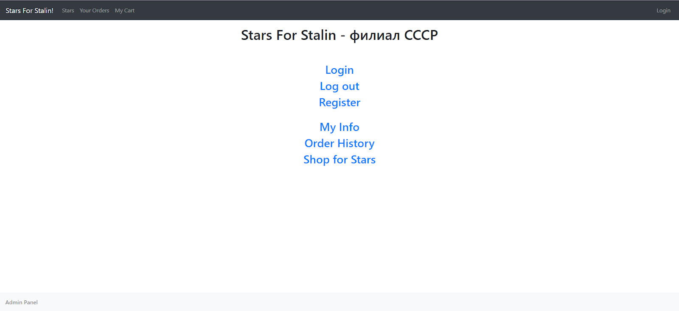

## **Navigation Bar**

The “Navigation Bar” consists of links:

* Stars for Stalin (Homepage)
* Stars (Shop for Stars)
* Your Orders (Order History)
* My Cart
* Login



## **Login**

The “Login” page allows customers to log into their account so they can access other pages on the site. Admins are also able to login through the login page to access pages that only admins are able to view.

In order to login, users must enter their username and password into the form. Users can click “Reset” to reset the form.

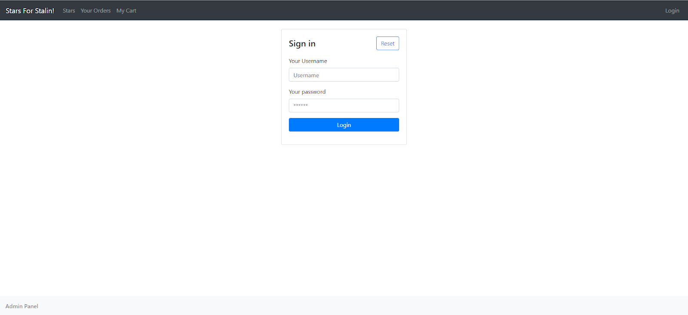

## **Register**

The “Register” page allows users to create an account. Users must enter their first name, last name, username, and password in order to sign up. The username must not be taken in order to create an account. In the event of successful completion of the form, the user will be notified that their account has been completely set up.

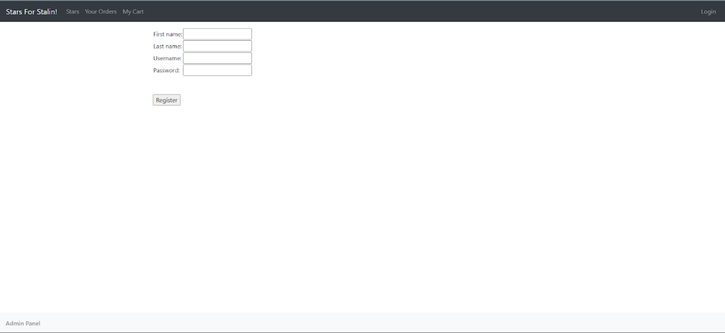

## **Shop for Stars**

The “Shop for Stars” page provides a list of stars which users can purchase. Stars are listed with their name and price. Users can click on the name of the star in order to be redirected to a page containing an image and description of the star. Users can also click on the “Add To Cart” button to add the star to the cart for purchase. At the top of the page, there is a filter tab and a search bar. Users can filter the stars based on the constellation which that star is located in. As well, users can use the search bar to search for stars individually based on the star’s name.

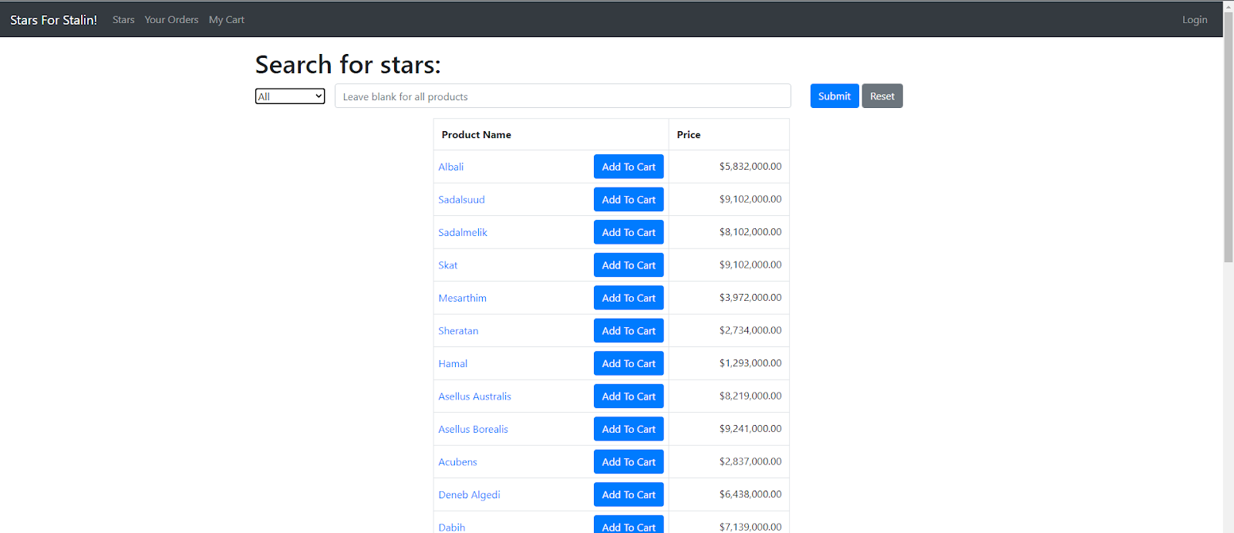

### **Individual Stars**

By clicking on the name of the star in the “Shop for Stars” page, you will be directed to the individual star. This page includes the star’s name, photo, id, price and description. Clicking “Add to Cart” adds the star to the cart and clicking “Continue Shopping” will redirect you back to the “Shop for Stars” page. Example of the individual star “Albali” can be found below.

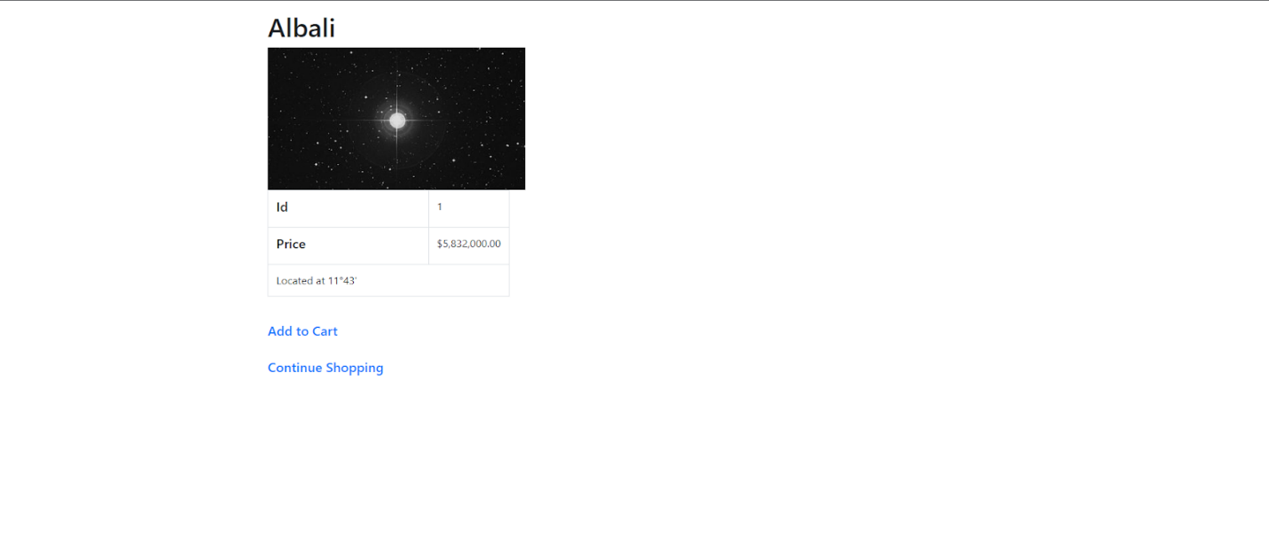

## **Shopping Cart**

The “Shopping Cart” page contains the products that the user has added to their cart. The products in the cart include a table of their id, name, quantity, price, and subtotal. Users can change the quantity of the product in their cart by changing the number entered in the table. At the bottom of the table, there are three buttons which include “Continue Shopping”, “Update Cart”, and “Check Out”. The “Continue Shopping” button redirects the user back to the “Shop for Stars” page. The “Update Cart” button refreshes the table to update the products attributes. And the “Check Out” button will place their order and lead the user to their order summary.

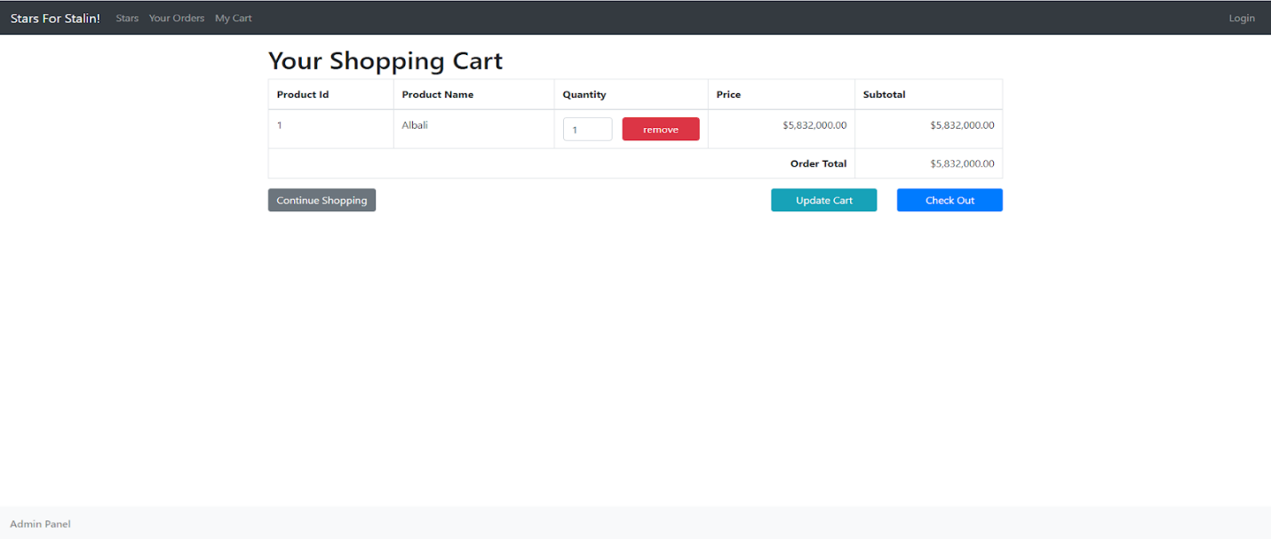

## **Order Summary**

The “Order Summary” page provides the list of items ordered from your shopping cart. Here, the user is given their order id, order date, customer id, and total amount of the order as well as the address, city, state, postal code, and country of which the order will be sent to.

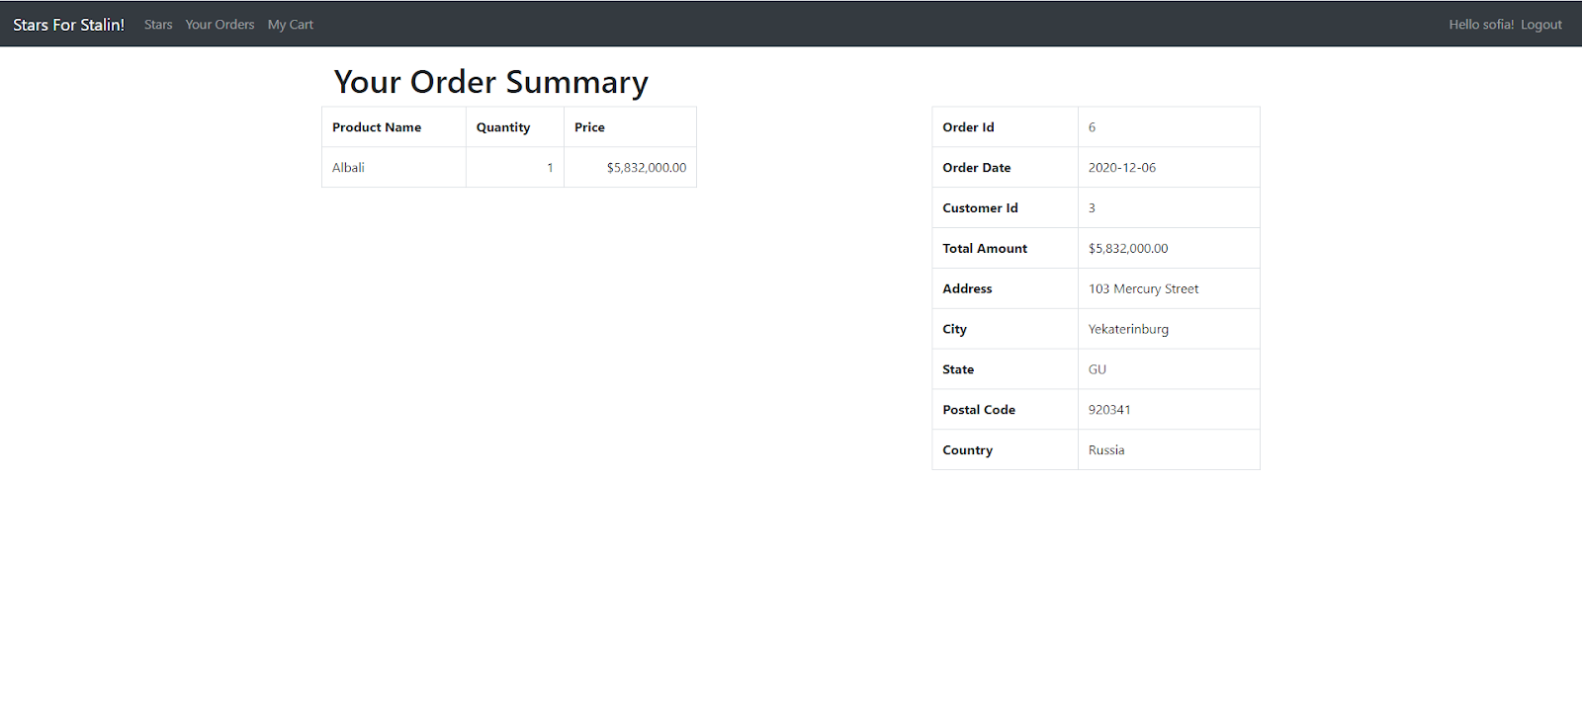

## **My Info**

The “My Info” page provides the user with their information including their id, first name, last name, email, phone number, address, city, state, postal code, country, and user id. Users can also change their password and address on this page.

## **Order History**

The “Order History” page gives the user’s history of their orders. Their order id, order date, customer id, customer name, and total amount is provided along side the product id, quantity, and individual price of the product in the order. If the user accessing the page is an admin, the user has access to view all orders by all users.

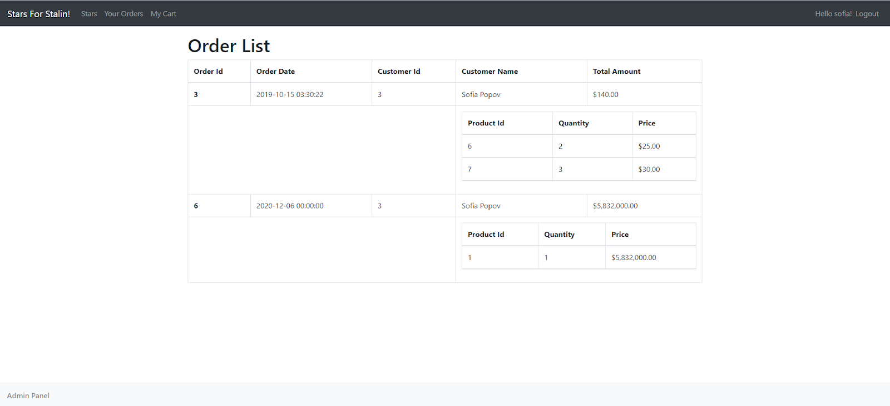

## **Admin Panel**

The “Admin Panel” page contains the sales report of orders from users. The order date and total order amount is provided as a table to admins.

