12) Two column Image and text

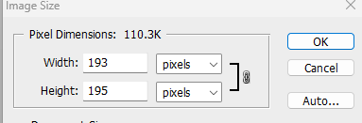

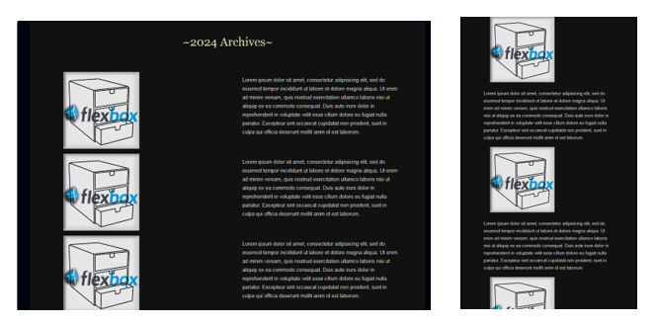

# HTML

#### This entire thing needs to be copied for each list item that you have.

<div class="container">

<div class="content">

<div class="col left">

<img src="Images/Flexbox-Logo-RawSmall.png" title="" alt=""/>

</div>

<div class="col right">

<p class="LeftPSilver">Lorem ipsum dolor sit amet, consectetur adipisicing elit, sed do eiusmod

tempor incididunt ut labore et dolore magna aliqua. Ut enim ad minim veniam,

quis nostrud exercitation ullamco laboris nisi ut aliquip ex ea commodo

consequat. Duis aute irure dolor in reprehenderit in voluptate velit esse

cillum dolore eu fugiat nulla pariatur. Excepteur sint occaecat cupidatat non

proident, sunt in culpa qui officia deserunt mollit anim id est laborum. </p>

</div>

</div>

</div>

# CSS

*, ::after, ::before {

box-sizing: border-box;

}

body {

margin: 0;

font-family:sans-serif;

font-size: 1rem;

font-weight: 400;

line-height: 1.5;

color: #212529;

}

img {

max-width: 100%;

padding-top: 3px;

padding-right: 3px;

padding-bottom: 3px;

padding-left: 40px;

}

.container {

width: 100%;

max-width: 1140px;

margin: 0 auto;

padding-left: 15px;

padding-right: 15px;

}

.content {

display: -ms-flexbox;

display: flex;

-ms-flex-wrap: wrap;

flex-wrap: wrap;

margin-left: -15px;

margin-right: -15px;

}

.content .col {

-ms-flex: 0 0 50%;

flex: 0 0 50%;

max-width: 50%;

padding-left: 15px;

padding-right: 15px;

}

.footer {

height: 100px;

background-color: black;

}

@media(max-width: 767px){

.content .col {

-ms-flex: 0 0 100%;

flex: 0 0 100%;

max-width: 100%;

}

}