17 Connecting Mismatched Vertex Counts
12/21/2026

What to do when you come into a Mismatch in Vertex Count?
Here we have a mismatch in the count of vertices between the head mesh and the ear mesh.
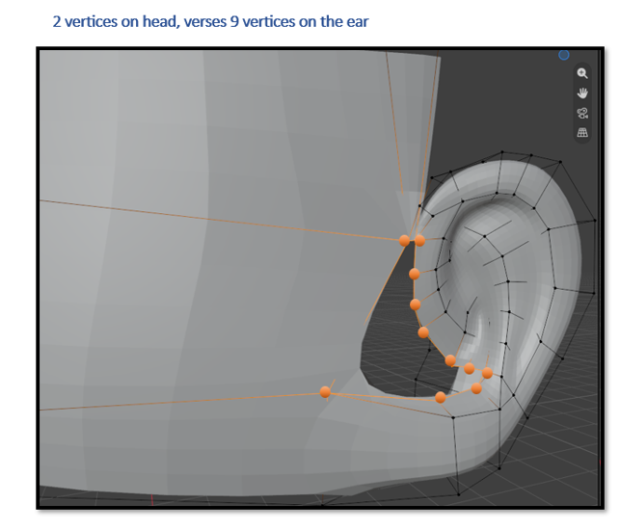
We will need to custom build this vertex count to match each other.
I can start with that original edge loop from the head. Then I can add a top and bottom face to that. This gives me 3 faces to meet the other side. If I need more faces, I just add them to either the top or the bottom until the head faces match the number of vertices on the ear.
Now start with these two vertices on the head.
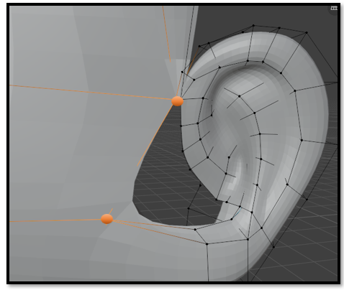
Now you have this edge, but it is way too big. Take the scale tool and scale this edge down to the size of the faces on the ear.

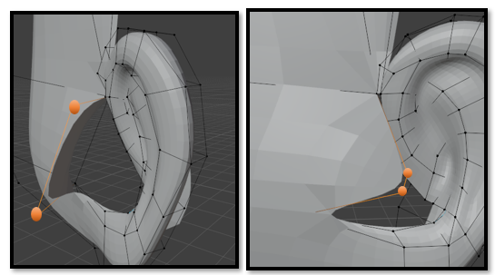
Now select the top edge here
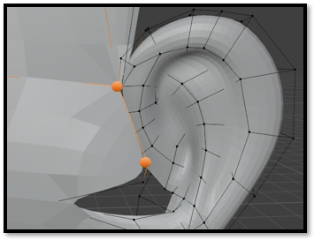
I turned down my Levels Viewport, so I can see my face edges straighter.
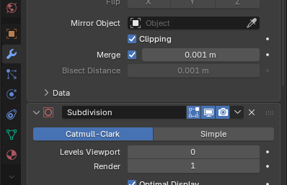
Extrude out these edges
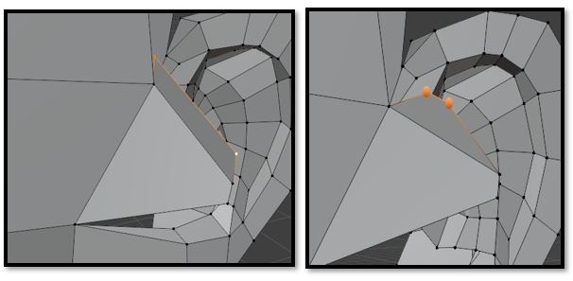
Move and scale these flaps into place, and then fill these two faces. Fill this image with the orange dots in with a face.
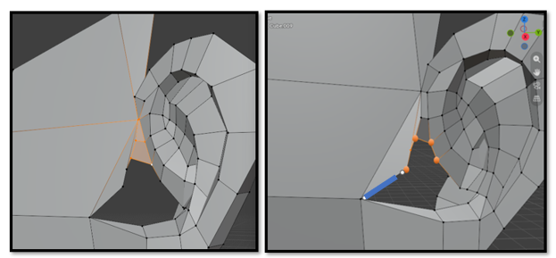

Extrude out that blue edge. I still have vertices to grow to match other side.

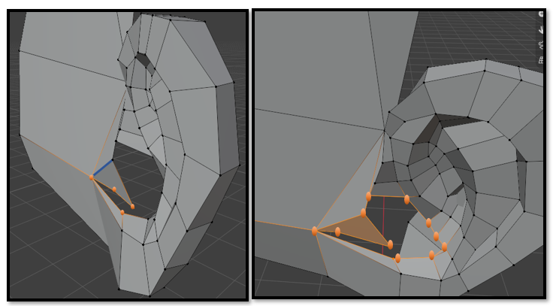
Extrude this vertex down and then then fill that face
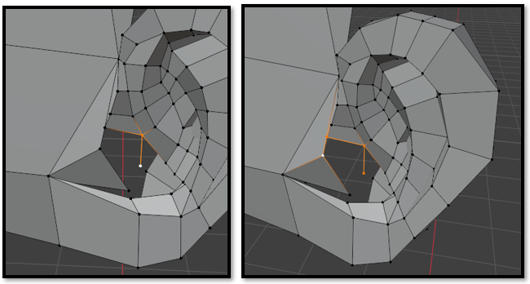

What we have here after filling is a 3 sided triangle, the 3 sided triangle is acceptable for an ear. So, instead of extruding another vertex. Just fill that the way it is. That triangle face is filled but we still need to attach all of this.
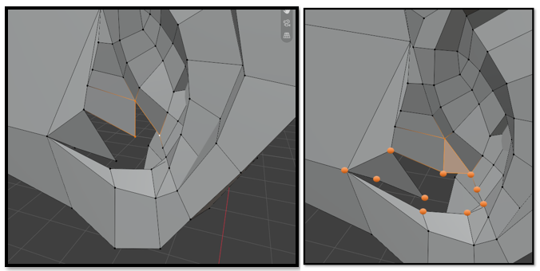

Now line up your vertices. That second vertex and the bottom edge needs to be moved from the middle of that face, right a bit to line up with the vertex on the bottom edge. Count the vertices on the face and the vertices on the ear.
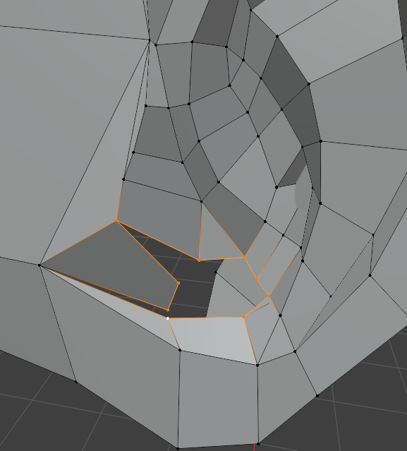
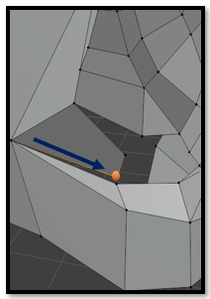

Fill the triangle, then split that edge. This does two things, it turns the triangle in a quad and gives us another vertex to work with

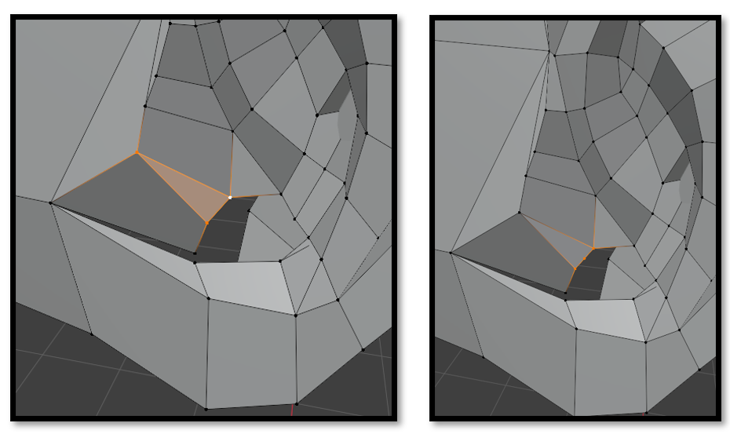
Merge these two vertices. Extrude this vertex
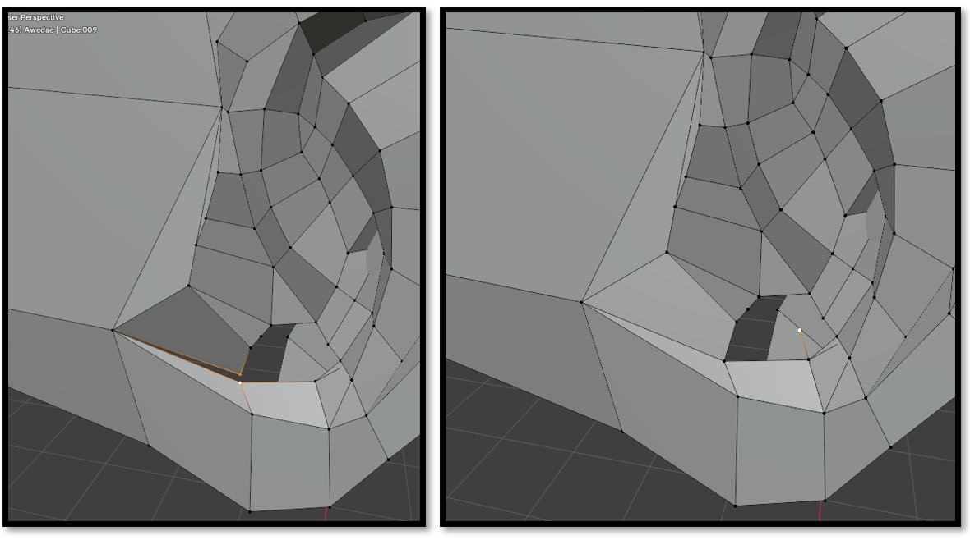

Fill that. Select 4 more and fill
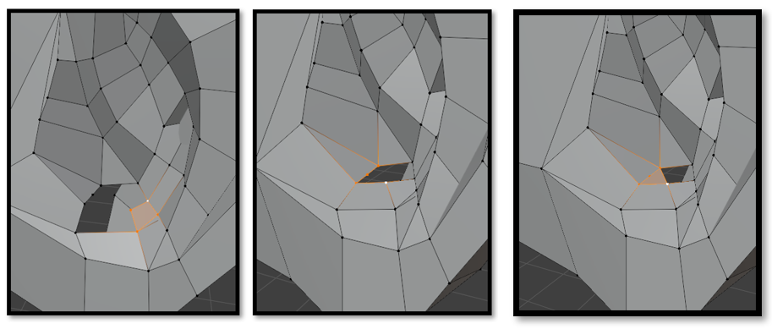
Just fill the last 4 vertices.
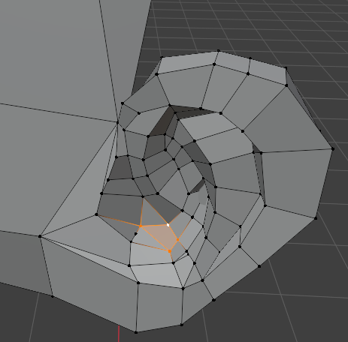
Turn back on the Subdivision Levels Viewport and then view in Object mode. Might need a bit of smoothing but not too bad.

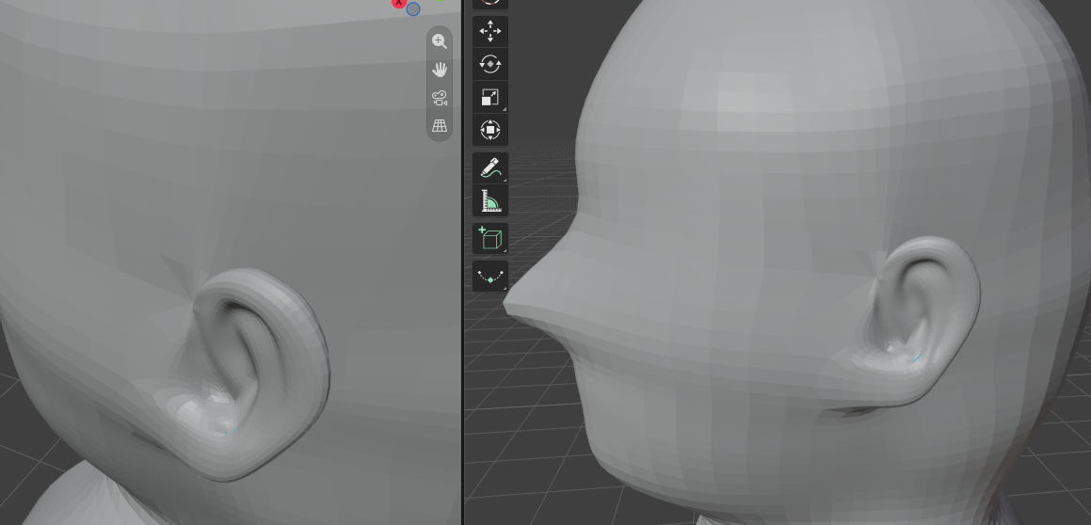

Watch it- If you find a crinkle in the mesh, make sure you did not add an extra vertex while sewing things together, if you use merge, and merge it with the only vertex that should be there the crinkle should smooth out.

