DASHBOARD PROJECT REPORT
Individual Report Sylvia Njane
Project: Fedhatrac Client Performance Dashboard
Tool Used: Microsoft Power BI Desktop
Date: November 2025

Business Intelligence Dashboard Project Report
Introduction
This Business Intelligence (BI) project involved the design and development of three interactive dashboards for Fedhatrac using Power BI.
The dashboards were created to support data-driven decision-making by providing insights into client engagement, employee performance, sales pipeline progression, and segmentation trends.
The dataset used, Fedhatrac_Client_Flux_Data_Realistic.csv, contains fields such as Client Status, Industry, Estimated Deal Value, County, Contact Method, Employee Name, Interaction Count, and Date Stamps.
Together, these dashboards empower the organization to monitor activity, evaluate performance, and optimize engagement strategies.
1. Objective of the Work
The main goal of this project was to design, develop, and refine a set of interactive dashboards in Power BI aimed at analyzing client performance, employee closing efficiency, and segmentation insights.
The dashboards are intended to help Fedhatrac’s management understand client distribution, evaluate employee productivity, and identify high-performing regions, contact methods, and industries.

2. Dataset Used
The dashboards were developed using Fedhatrac_Client_Flux_Data_Realistic.csv, which contains client-level and employee-level engagement information.
The dataset includes:
- Client ID & Client Name
- Industry & Company Size
- County
- Contact Method
- Client Status & Decline Reason
- Employee Name
- Approach Date & Status Update Date
- Interactions Count
- Estimated Deal Value (KES)
This dataset enabled deeper insights into sales performance, regional/client segmentation, and client lifecycle progression.

3. Data Preparation
- Imported the dataset into Microsoft Power BI Desktop
- Cleaned and validated column data types (numeric, dates, categorical)
- Standardized the CLIENT STATUS values
- Created a dedicated Measure Table for all DAX measures
- Developed dynamic measures for deal values, client counts, conversion rates, and time-to-close metrics

4. DAX Measures Developed
Key measures built include:
- Total Clients
- Closed Clients
- Declined Clients
- Closing Rate (%)
- Total Deal Value (KES)
- Average Deal Value (KES)
- Average Days to Close (Closed Only)
These measures are dynamically updated across slicers, charts, and tables.

Dashboard Summaries
Page 1: Employee Closing Rate Dashboard
This dashboard focuses on employee performance in client acquisition and conversion.
It highlights closing efficiency, identifies bottlenecks in the sales cycle, and evaluates overall staff productivity.
Page 2: Segmentation Insights Dashboard
This dashboard analyzes client distribution by Industry, County, and Contact Method.
It helps the organization understand market trends, identify high-engagement segments, and prioritize communication strategies.
Page 3: Client Pipeline & Status Dashboard
This dashboard visualizes the full client journey, showing where clients sit in the pipeline, who requires follow-up, and how workload is distributed across employees.

Dashboard 1: Employee Closing Rate Dashboard
1.1 Key Purpose
The Employee Closing Rate Dashboard provides an executive-level overview of staff performance in converting clients.
It helps management understand workload distribution, closing efficiency, and areas requiring improvement.
1.2 Key Performance Indicators (KPIs)
The top KPI section includes:
- Total Clients — Total number of clients approached.
- Closed Clients — Successfully converted clients.
- Declined Clients — Clients who opted out.
- Closing Rate (%) Percentage of successful conversions.
These KPIs offer a quick snapshot of overall performance.

1.3 Employee Closing Comparison
A bar chart compares Closing Rate (%) for each employee.
This visual helps identify top performers and staff needing support.

1.4 Decline Reasons
A pie chart displays client decline reasons, allowing leadership to monitor why clients fall out of the pipeline.

1.5 Employee Performance Table
A matrix summarizes:
- Total Clients
- Closed Clients
- Declined Clients
- Average Days to Close
- Closing Rate (%)
This enables a detailed comparison of employee performance metrics.
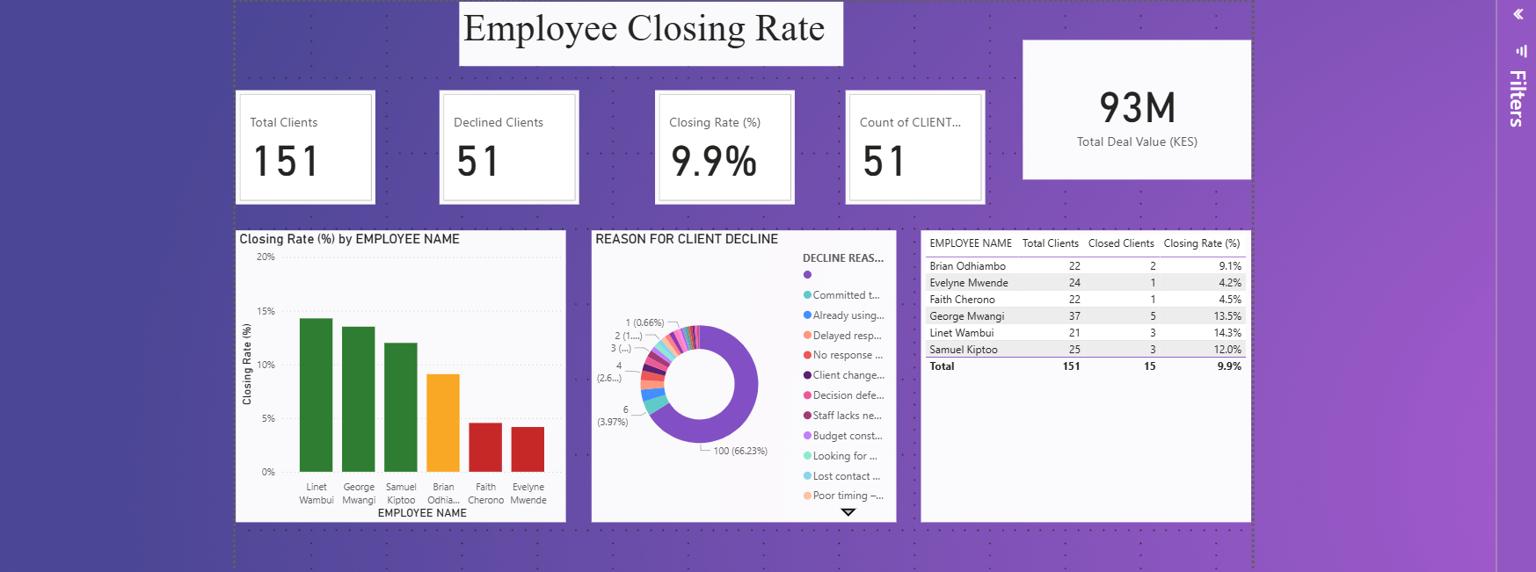

Insights & Recommendations
- The largest proportion of clients fall under 'Potential' and 'Active', indicating opportunity for nurturing.
- Closing rate appears low relative to the engagement volume.
- Recommendation: Initiate follow-ups for dormant clients and build structured engagement workflows.

Dashboard 2: Segmentation Insights Dashboard
2.1 Key Purpose
This dashboard explores how clients are distributed across demographic and behavioral segments.
It supports strategic decision-making by identifying strong markets, underperforming regions, and effective communication methods.

2.2 KPI Cards
Includes KPIs for:
- Total Clients
- Closed Clients
- Decline Rate
- Average Days to Close
These KPIs change dynamically with filters.

2.3 County, Industry & Contact Method Analysis
This section includes:
- Column charts analyzing client distribution across counties.
- Bar charts showing client distribution by industry.
- Visuals analyzing contact methods such as calls, email, and physical outreach.
These insights support targeted outreach and resource optimization.

2.4 Interactive Slicers
Slicers included:
- Industry
- County
- Contact Method
- Employee Name
These filters enable dynamic analysis across different customer segments.
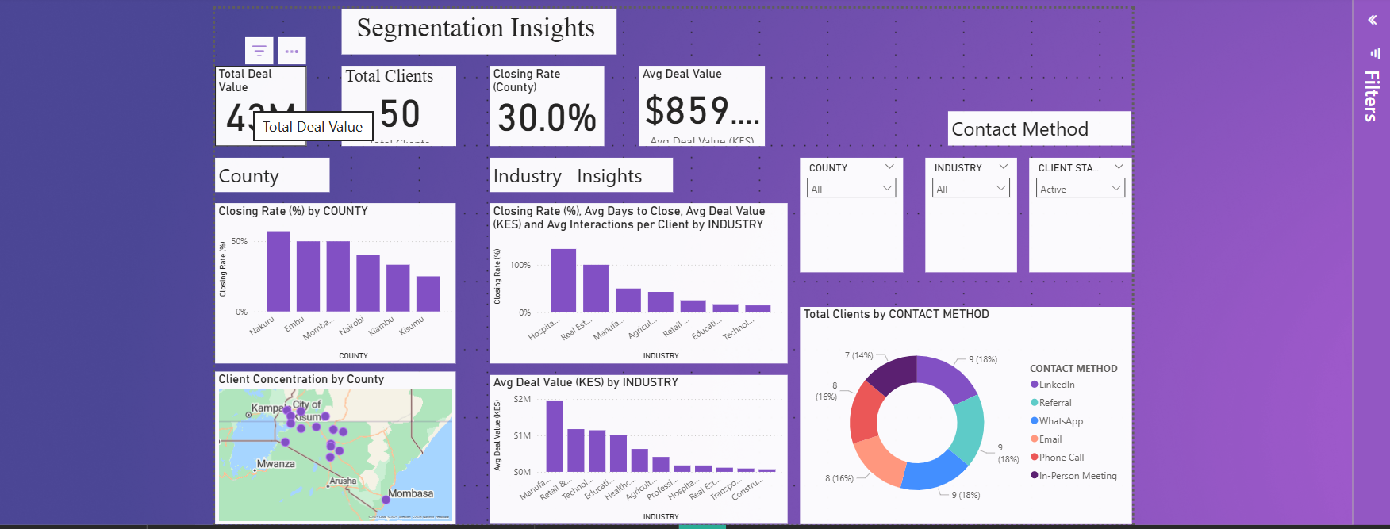

Insights & Recommendations
- Counties such as Nakuru and Mombasa exhibit stronger performance; other counties may benefit from targeted campaigns.
- Industries like Hospitality and Real Estate show higher deal values.
- Recommendation: Allocate sales resources toward high-performing industries and regions while improving outreach for low-performing ones.

Dashboard 3: Client Pipeline & Status Dashboard
3.1 Introduction
This dashboard provides visibility into client movement through the sales pipeline.
It shows where clients are progressing, where they are stalled, and which employees handle various stages of the workflow.

3.2 Key Performance Indicators (KPIs)
This section includes:
- Total Clients
- Active Clients
- Potential Clients
- Yet Closed Clients (clients nearing conversion)
These KPIs summarize the current pipeline health.

3.3 Client Pipeline Funnel
The funnel chart visualizes client movement through the stages:
- Potential
- Active
- Yet Closed
- Declined
This helps identify drop-offs and conversion challenges.

3.4 Status Distribution
A donut chart shows the distribution of client statuses such as:
- Active
- Dormant
- Declined
- Potential
- Yet Closed
This provides a snapshot of high-risk areas and opportunities for follow-up.

3.5 Employee Status Load
The stacked bar chart displays how clients across different statuses are distributed among employees.
This helps management recognize overloaded staff, reassign clients, or support employees managing high-risk leads.

3.6 Filters & Interactivity
Slicers allow filtering by:
- Industry
- County
- Contact Method
- Employee Name
This enhances interactivity and supports deep exploration of the pipeline.

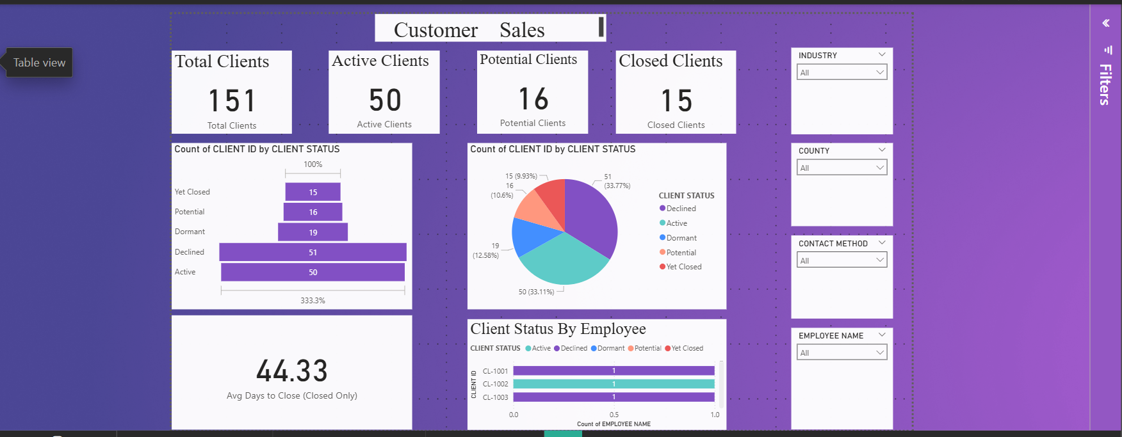

Insights & Recommendations
- Some employees demonstrate significantly higher closing efficiency.
- Declined reasons highlight budget constraints and competition as main obstacles.
- Recommendation: Offer training for lower-performing employees and address decline trends with targeted value propositions

4. Design Principles
We ensured the dashboards maintained:
- Visual Consistency – aligned layout, consistent card styling, color palette, and typography
- Minimalist Design – simple visuals and clear labels
- Color Logic – purple theme with contrasting white KPIs for clarity
- Responsiveness – visuals update dynamically with slicers
- Clarity & Accessibility – descriptive chart titles and intuitive placement

5. Key Insights from the Dashboards
Across the three dashboards, the following data-driven insights are obtained:
- Overall client closing rate stands at approximately 9.9%.
- Certain industries (e.g., Hospitality, Real Estate) show stronger conversion rates.
- In-person meetings and referrals appear to generate better engagement outcomes.
- Counties such as Nakuru, Embu, and Mombasa show relatively stronger performance.
- Declined clients are concentrated around specific reasons such as “Client already using competitor” and “Budget constraints.”

6. Reflection
This project enhanced proficiency in:
- Data cleaning
- DAX measure creation
- Dashboard layout design
- Interactive filtering
- Visual storytelling using Power BI

Conclusion
The three dashboards Employee Closing Rate, Segmentation Insights, and Client Pipeline—collectively provide a comprehensive BI solution tailored to Fedhatrac’s operational needs.
They allow leadership to:
- Monitor employee performance
- Evaluate client conversion behavior
- Identify high-performing segments
- Track pipeline efficiency
- Improve follow-up strategy
- Support data-driven management decisions
These dashboards serve as a unified system for evaluating performance, optimizing workflows, and strengthening client engagement across the entire organization.

