**Single-shared file (SSF)**

Lustre中SSF的性能取决于数据在文件中的分布，以及文件在OST的条带布局。

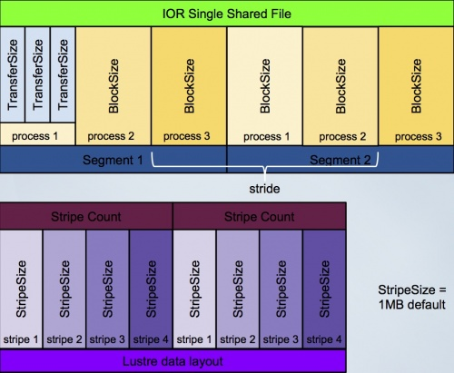

**file per process (FPP)**

**测试方法集锦**

|  |  |  |
| --- | --- | --- |
| **工具** | **测试对象及模式** | **备注** |
| IOR | SSF and FPP runs of sequential I/O tests. |  |
| mdtest | file and directory operations metadata performance | 元数据测试 |
| IOzone | in clustered mode. |  |
| 脚本 | Multi-client test script using groups of dd processes |  |
| Postmark | Random I/O |  |
|  |  |  |
|  |  |  |