**Lustre monitoring tool配置文档**

(邓仕军 2016年10月9日)

1. **系统环境**

|  |  |
| --- | --- |
| 项目 | 说明 |
| 操作系统 | centos7 |
| lustre文件系统 | 2.8.0 |
| cerebro | cerebro-1.12-1.x86_64 |
| lmt | 3.1.2 |
|  |  |

相关文件

|  |
| --- |
| cerebro-1.12-1.x86_64.rpm  cerebro-clusterlist-hostsfile-1.12-1.x86_64.rpm  cerebro-debuginfo-1.12-1.x86_64.rpm  cerebro-event-updown-1.12-1.x86_64.rpm  cerebro-metric-boottime-1.12-1.x86_64.rpm  cerebro-metric-loadavg-1.12-1.x86_64.rpm  cerebro-metric-memory-1.12-1.x86_64.rpm  cerebro-metric-network-1.12-1.x86_64.rpm  lmt-server-3.1.2-1.x86_64.rpm  lmt-server-agent-3.1.2-1.x86_64.rpm  MySQL-shared-compat-5.5.51-1.rhel5.x86_64.rpm |

相关节点说明

|  |  |  |  |
| --- | --- | --- | --- |
| ip | domain | hostname | 说明 |
| 192.168.3.161 | ca01 | ca01 | oss |
| 192.168.3.164 | ca04 | ca04 |
| 192.168.3.181 | ca21 | ca21 |
| 192.168.3.186 | ca26 | ca26 | mds |
| 192.168.3.208 | bd08 | bd08 | client |
| 192.168.3.123 | de03 | de03 |
| 192.168.3.104 | gd04 | gd04 | 独立于lustre之外的管理节点，也是lmt的管理节点，即ltop命令节点 |

注：centos7修改域名的方式为：hostnamectl --static set-hostname newhostname

lmt架构图

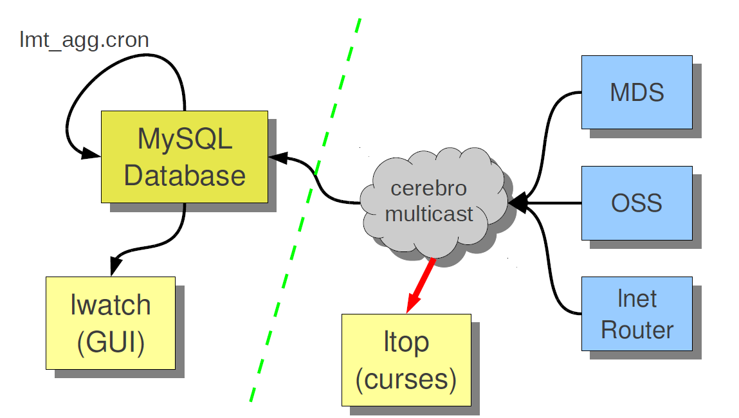

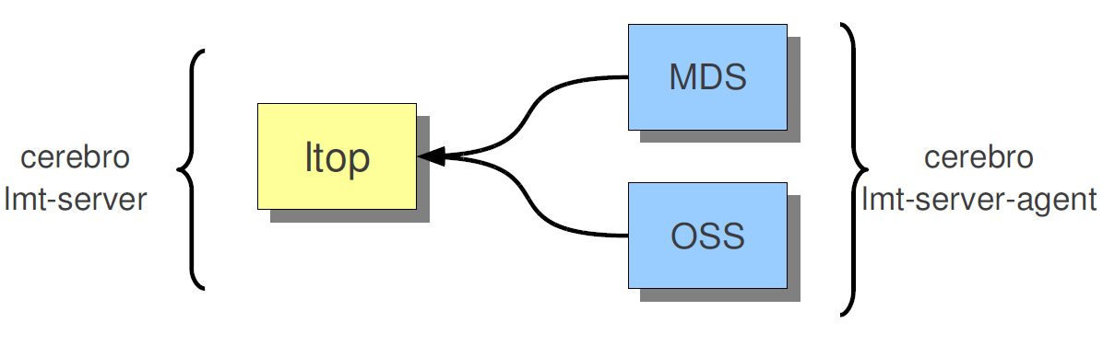

1. **安装**
2. 在所有的oss和mds上安装cerebro and lmt-server-agent （ca01,ca04,ca21,ca26） ，client最好也安装

|  |
| --- |
| 安装依赖（根据实际情况还可能需要其他的依赖）  yum -y install libtool-ltdl-devel glibc-common libtool autoconf automake mysql-devel expat-devel  yum -y install openssl098e  yum -y install perl-Date-Manip  安装cerebro  rpm -ivh cerebro-1.12-1.x86_64.rpm  rpm -ivh cerebro-clusterlist-hostsfile-1.12-1.x86_64.rpm  rpm -ivh cerebro-metric-boottime-1.12-1.x86_64.rpm  rpm -ivh cerebro-metric-loadavg-1.12-1.x86_64.rpm  rpm -ivh cerebro-metric-memory-1.12-1.x86_64.rpm  rpm -ivh cerebro-metric-network-1.12-1.x86_64.rpm  rpm -ivh cerebro-event-updown-1.12-1.x86_64.rpm  安装lmt-server-agent  rpm –ivh lmt-server-agent-3.1.2-1.x86_64.rpm |

1. 在管理节点上（gd04）安装cerebro and lmt-server

|  |
| --- |
| 安装依赖（根据实际情况还可能需要其他的依赖）  yum -y install libtool-ltdl-devel glibc-common libtool autoconf automake mysql-devel expat-devel  yum -y install openssl098e  yum -y install perl-Date-Manip  安装cerebro  rpm -ivh cerebro-1.12-1.x86_64.rpm  rpm -ivh cerebro-clusterlist-hostsfile-1.12-1.x86_64.rpm  rpm -ivh cerebro-metric-boottime-1.12-1.x86_64.rpm  rpm -ivh cerebro-metric-loadavg-1.12-1.x86_64.rpm  rpm -ivh cerebro-metric-memory-1.12-1.x86_64.rpm  rpm -ivh cerebro-metric-network-1.12-1.x86_64.rpm  rpm -ivh cerebro-event-updown-1.12-1.x86_64.rpm  安装lmt-server-agent  rpm –ivh lmt-server-3.1.2-1.x86_64.rpm |

1. **配置**
2. 在所有的client、oss和mds上配置/etc/hosts 、/etc/hostsfile（没有要创建） （ca01,ca04,ca21,ca26,bd8,de83）

|  |  |
| --- | --- |
| **/etc/hosts** | **/etc/hostsfile** |
|  |  |

1. 在启动cerebrod前需要配置cerebro的metric-server和event-server，即在管理节点上（gd04）配置/etc/cerebro.conf、/etc/hosts、/etc/hostsfile(同上)

* 配置metric-server

将/etc/cerebro.conf文件中的如下行：

# cerebro_metric_server localhost

替换为(假设hostA为mds）

cerebro_metric_server ca26或者cerebro_metric_server 192.168.3.186

* 配置event-server

将/etc/cerebro.conf文件中的如下行：

#cerebro_event_server localhost 替换为

cerebro_event_server oss域名或者ip

如图

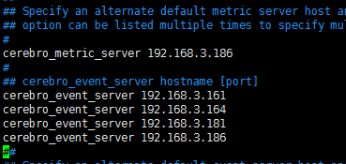

1. **测试**

* 在oss上（ca01,ca04,ca21）

|  |
| --- |
| /usr/sbin/lmtmetric -m ost |

* 在mds上(ca26)

|  |
| --- |
| /usr/sbin/lmtmetric -m mdt |

* 在管理节点上（gd04）

|  |
| --- |
| ltop |

1. **配置MySQL（可选）**

参见<https://github.com/LLNL/lmt/wiki/Installation>

其它参考资料

LMT Code

<https://github.com/chaos/lmt>

<https://github.com/chaos/lmt-gui>

LMT Wiki

<https://github.com/chaos/lmt/wiki>

Cerebro Code

<https://github.com/chaos/cerebro>