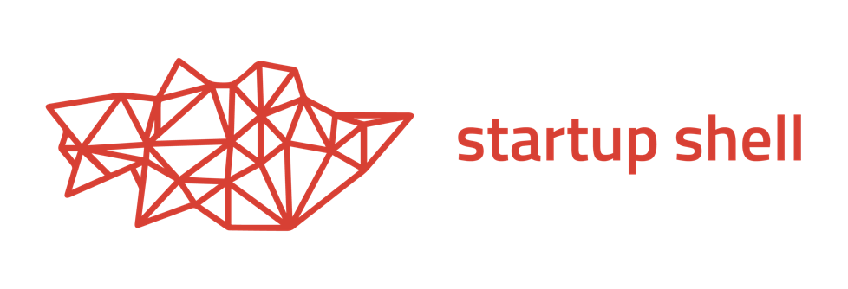

Partners

startupshell.org | partners@startupshell.org | @startup_shell

Partner packages are renewed annually. **Resource partners are considered Alpha partners.**

|  |  |  |  |
| --- | --- | --- | --- |
| **Tier** | **Alpha** | **Beta** | **Launch** |
| **Contribution** | $10K | $25K | $50K |
| Distribution of recruiting and marketing materials at EXPO | ✓ | ✓ | ✓ |
| Distribution of company swag at EXPO | ✓ | ✓ | ✓ |
| Add employees to mentor network | ✓ | ✓ | ✓ |
| Access to resume book, online portfolios | ✓ | ✓ | ✓ |
| Shell sends promotional emails to public community^ | 1 | 2 | 3 |
| Logo presented on website | ✓ | ✓ | ✓ |
| Logo on partner wall in coworking space | small | medium | large |
| Invite to EXPO showcase, acknowledged in opening | ✓ | ✓ | ✓ |
| Exclusive invite to semester-ly reception* |  | ✓ | ✓ |
| Host event / workshop at coworking space^ |  | 1 | 2 |
| Host branded innovation competition |  |  | ✓ |
| Acknowledged as “Launch Partner” in media |  |  | ✓ |
| Naming rights to IDEA Factory innovation rooms |  |  | ✓ |

^ per semester  
* with select Shell ventures and fellows