AIQAS

Consolidated Probationary Period Report
Development of a Unified Digital Platform for Organizing and Managing Student Events
Probationary period 1
Submission date 24 October 2026
Version 0.3 prepared 23 October 2026
Dzhanin Miras — SE-2429 — representative
Turemuratov Galymzhan — SE-2418
Supervisor Sadirmekova Zhanna Bakirbayevna
Repository snapshot https://github.com/StarwinM/aiqas-platform/tree/prob-period-1
This report presents the project proposal, student questionnaire evidence, research and comparisons, initial requirements, architecture, static prototype materials, evaluation plan, and project-management evidence. The project is at the analysis and design stage; no working application, completed interviews, benchmark results, or supervisor approval is claimed.

Table of contents
1 Project proposal 3
2 Evidence of relevance 4
3 Literature review 6
4 Existing system comparison 8
5 Technology comparison 9
6 Requirements specification 10
7 Architecture and diagrams 12
8 UX and prototype 16
9 Verification and evaluation plan 25
10 Project management and risks 29
11 Supervisor feedback 32
References 33
Appendix Materials and source links 35

1 Project proposal

1.1 Topic, Team, and Advisor
Project title: Development of a Unified Digital Platform for Organizing and Managing Student Events.
Authors: Dzhanin Miras (SE-2429) and Turemuratov Galymzhan (SE-2418). Intended pilot: Astana IT University. Supervisor: Sadirmekova Zhanna Bakirbayevna.

1.2 Problem and Target Users
AIQAS addresses fragmented event discovery, registration status, and participant information. An initial student questionnaire collected five responses on October 22–23, 2026: all five selected missing information about available seats; two each reported late discovery, unclear registration success, unclear cancellation, and conflicting information across sources. These are preliminary self-reports from a small student sample. Organizer workload, reporting effort, and the current club process still require organizer discussions and observation; no time saving has been measured.
- Student: find a suitable event, register, see status and ticket, save a confirmed participation history.
- Club Organizer: publish an event, manage seats and participants, confirm attendance, and receive a report.
- University Activity Administrator: manage permissions and view aggregated indicators within the permitted scope.

1.3 Goal, Tasks, and Expected Result
Goal — develop and evaluate a platform that integrates event publication, registration, attendance confirmation, and reporting, maintains data correctness during concurrent actions, and reduces the execution time of selected organizer tasks relative to an agreed manual process.
- Identify the needs of three user roles and describe the current process.
- Analyze scientific approaches, existing systems, and technical alternatives.
- Formulate verifiable requirements, design architecture, and user scenarios.
- Implement the main event cycle with access control, capacity limits, and repeated actions.
- Verify functionality, load, and usability; compare task completion time with the baseline process.
- Document results, limitations, and individual contributions of team members.
Expected results of the final thesis: a working prototype of the main cycle, source code and reproducible launch, requirements specification, architectural materials, test results, and pilot evaluation. Expected result of the first pre-defense: an agreed scope and a documented plan for obtaining them.

1.4 Boundaries and Complexity of the Project
Proposed P0: login and roles, catalog and event card, organizer publication, registration with capacity limit, ticket, attendance confirmation, cancellation, basic notifications, and reports. The pilot is limited to one university; the number of clubs and events will be clarified with the client.
Proposed P1: waitlist, confirmed achievements, student initiatives, and AI assistant for event drafting. P2: personalized recommendations, team matching, second university, payments, and extended gamification. P1/P2 should not block the core cycle.
Engineering complexity lies in access control, atomic registration for limited seats, handling retries, correct attendance tracking, and report consistency. Reducing organizer time and the usefulness of achievements require a separate user evaluation.

2 Evidence of relevance

2.1 Student questionnaire and sample
The initial evidence comes from the Google Forms questionnaire “AITU University Events: Student Experience”. The snapshot contains five response records submitted on October 22–23, 2026, in Asia/Almaty time. All five selected year 3. Reported attendance over the last three months was 1–2 events in two records, 3–5 in two records, and “I do not remember” in one. The analysis uses rows 2–6 of the linked response sheet; later responses require a new snapshot.
Source [E1]: https://docs.google.com/spreadsheets/d/1LD7KbiKtBIbSNliDt4b_7Qe5Hn6dOt_9a6_-1sK_MFU/edit#gid=1057682838
This is an online questionnaire, not a record of completed interviews. It supports preliminary student needs; organizer and university-administration needs remain unvalidated. Multiple-choice questions allow several selections, so counts can exceed five. Optional blanks are missing data, not disagreement.

2.2 Findings and requirement decisions
The table records observed selections and resulting design decisions. Counts describe this five-response snapshot; they are not university-wide estimates.

Observed response selection | Count (n=5) | Design decision / requirement
Missing information about free seats | 5 / 5 | Show current seat availability and explain full capacity. FR-04, FR-05.
Topic/date filters useful | 3 / 5 | Keep combined filters in P0. FR-03.
Found out about an event too late | 2 / 5 | Use a shared catalog with visible dates; validate reminder needs. FR-03, FR-11.
Unclear registration success | 2 / 5 | Show explicit confirmation and owner ticket/status. FR-05, FR-08.
Unclear cancellation process | 2 / 5 | Provide self-service cancellation and invalid-ticket status. FR-07, FR-08.
Information differed across sources | 2 / 5 | Use one current event record and notify important changes. FR-04, FR-11.
Missing time or location | 1 / 5 | Require time, zone and location before publication. FR-04; NFR-08.
Late postponement/cancellation notice | 1 / 5 | Create and retry notification jobs for important changes. FR-11.

Discovery channels included Telegram in three records and friends/classmates in three; one each selected Instagram, university channels/website, and club representatives. Three reported Google Forms registration; two attend without registration. These answers support testing a consolidated discovery/registration flow but do not establish an organizer’s full process.
Two optional free-text answers described participation history as useful for tracking activities and demonstrating involvement in internship applications; three left that question blank. History remains P1. The survey does not establish demand for XP, public rankings, AI, or automatic skill assessment.

2.3 Evidence limits and follow-up discussions
The small, self-selected sample contains only third-year responses. It supplies no verified organizer workload, baseline timings, client agreement, or measured platform outcomes. Two records selected “No desire to participate”, one alongside specific barriers. Such answers should not be treated as problems that software alone can solve.
Next step: document 3–5 discussions across students, club organizers, and university activity administration, or obtain a substantive agreement with the actual client. Record date, role, current workflow, a recent concrete incident, consequence, requirement decision, and disagreement. Use anonymous participant codes in the report. Miras coordinates organizer/administration validation; Galymzhan coordinates student follow-up. Organizer time reduction remains a target until the baseline is measured.

3 Literature review

3.1 Selection Principle
The review includes eight scientific publications and related official sources on systems and technologies. The scientific core pertains to 2023–2026; the work of Sailer and Homner (2020) is retained as a baseline meta-analysis. Selection is thematic: this is not a claimed exhaustive systematic review. Searches covered gamification in higher education, digital badges, micro-credentials, and extracurricular activities. Publisher pages and available texts were used. For each source, the approach, findings, transfer limitations to AIQAS, and corresponding design decision are highlighted.
Reviews, meta-analyses, and studies allowing justification of AIQAS functions or constraints were included. Promotional forecasts and materials without a clear source were excluded. Technical documentation is considered separately and does not replace scientific publications. Findings from academic learning research are transferred to extracurricular activities only as hypotheses for testing.

Source and Method | Main Finding | Limitation for AIQAS | Project Decision
[L1] Khaldi et al., 2023. Review of 90 studies | Examines game elements and design approaches for gamification. | E-learning context; presence of points does not prove increased event participation. | Justify each mechanics by purpose and evaluate repeat usage.
[L2] Almeida et al., 2023. Mapping 87 papers and focus group | Describes unwanted effects of points, badges, leaderboards, and competitions. | Mapping does not provide a unified risk size for our campus. | Do not introduce a mandatory public ranking; check for duplicates and cheating.
[L3] Ahsan et al., 2023. Review of 56 publications | Systematizes implementation of micro-credentials and digital badges in universities. | Micro-credential is tied to an assessed learning outcome; a ticket itself is not such an outcome. | Separate participation, role, and verified skill.
[L4] Varadarajan et al., 2023. Review of stakeholder interests | Describes expectations of students, universities, employers, and government, trust issues. | Conclusions on micro-credentials do not confirm the value of any attendance badge. | For achievements, record author, criteria, and issuance rationale.
[L5] Zeng et al., 2024. Meta-analysis of 22 experiments | Identifies a positive cumulative effect of gamification on academic performance. | Academic performance differs from attendance; effect size cannot be transferred to AIQAS. | Evaluate own participation metrics, do not promise academic performance growth.
[L6] Rohozneanu et al., 2025. Review of 21 articles | Summarizes positive associations of extracurricular participation with student development metrics. | Correlations and varied contexts do not prove a causal effect of our platform. | Record verified participation; do not evaluate competencies by attendance count.
[L7] Gyedu et al., 2026. Meta-analysis of 22 studies | Reveals positive cumulative effect on motivation and deep learning. | High study heterogeneity and limited longitudinal observations; results are not universal. | Do not promise effect without a pilot; separately measure repeat usage and satisfaction.
[L8] Sailer & Homner, 2020. Baseline meta-analysis | Separates cognitive, motivational, and behavioral outcomes of gamification. | Earlier work; effects depend on design and context. | Separately measure behavior and satisfaction; do not count XP as proof of learning.

3.2 Synthesis and Research Question
Literature allows considering gamification and digital achievements as potential means to support participation, but not as a guaranteed effect [L1, L2, L5, L7, L8]. For AIQAS, a transparent core scenario and verifiable data are primary; reward mechanics should be evaluated separately from eliminating manual operations.
Publications on micro-credentials emphasize the importance of criteria and trust [L3, L4]. Therefore, the record "attended event" must differ from "confirmed skill according to criteria". Open Badges [T10] is considered as possible future development, without claiming already implemented compatibility.
Thesis research question: to what extent does a single digital event cycle reduce organizer workload and accounting errors compared to the current process, while maintaining access control and registration correctness? Additional question for P1: is verified participation history useful for students and does it lead to repeat usage?

4 Existing system comparison
Four systems were selected: CampusGroups, Anthology Engage, Modern Campus Involve (formerly Presence), and Eventbrite. The first three are oriented toward university activity; Eventbrite was chosen as an event platform to compare registration and attendance. The matrix is based on official pages [A1–A8] as of October 11, 2026, without access to paid demo environments.
The designation "not established" means the capability was not confirmed by the chosen sources; it does not mean the absence of the feature. No separate technical testing of the systems was conducted. AIQAS is described here as a project, not as a ready competitor.

Criterion | CampusGroups | Anthology Engage | Involve | Eventbrite
1 Event Catalog | Unified calendar [A1] | Events in platform [A3] | Event management [A6] | Event platform [A7]
2 Registration | Registration and tickets [A1] | RSVP and invites [A4] | Exact RSVP scenario not established | Tickets and attendees [A7]
3 Attendance Tracking | Automated check-in [A1] | Manual, QR and card swipe [A4] | Check-in and swipe [A6] | Organizer app [A7]
4 Clubs and Membership | Organization modules [A2] | Organizations and membership [A3] | Organization management [A6] | University model not established
5 Analytics | Attendance reports [A1] | Participation data and integration [A3] | Engagement analytics [A6] | Attendance reports [A8]
6 History and Achievements | Gamification badges [A2] | Co-curricular transcript [A5] | Pathways and SmartTranscript [A6] | University portfolio not established
7 Login via AITU SSO | AITU compatibility not established | AITU compatibility not established | AITU compatibility not established | AITU compatibility not established
8 RU/KZ and Data Hosting | Verification required with vendor | Verification required with vendor | Verification required with vendor | Verification required with vendor

Conclusion: registration, attendance tracking, and university activity history are already presented in analogs. Therefore, the rationale for AIQAS should rely on a confirmed local process, agreed languages, access to integrations, data rules, and pilot capability. In-house development will allow exploring the chosen cycle and engineering solutions, but its superiority over commercial products is not yet proven. Cost, localization, and hosting require separate clarification; they are not declared as shortcomings of analogs without confirmation.

5 Technology comparison
Three key decisions are compared against the data model, concurrent operations, frontend integration, and maintenance effort. The selected baseline is Go for the API, PostgreSQL for storage, and HTTP with SSE for server-to-browser updates; polling remains a fallback. The team chose Go for a stable server foundation and concurrent API/worker processing, accepting a separate OpenAPI contract with the TypeScript frontend. Elysia/Bun remains a capable alternative, particularly for shared TypeScript types; it is not rejected as inherently unreliable. No comparative performance measurements have been made.

Solution and Option | Strong Side | Considerations | Decision
API — Go | Concurrent processing and unified API/worker code [T1] | Separate language from frontend; maintain contract and client via OpenAPI. | Selected main API; validate the implementation against FR/NFR.
API — Elysia/Bun | TypeScript and typed Eden client [T2] | Check team libraries, operations, and test scenarios. | Reasonable alternative when shared TS is prioritized.
API — FastAPI | Python and proximity to ML; async I/O [T3] | CPU tasks require separate execution structure. | Separate ML service if need arises.
DB — PostgreSQL | Relations, constraints, and locks [T4, T5] | Requires indexes, migrations, and concurrency tests. | Main DB for events, registrations, and reports.
DB — MySQL/InnoDB | Transactional relational alternative [T6] | Drivers, SQL, and operations need alignment. | Possible if team has experience; measure benefits.
DB — MongoDB | Document model and multi-document transactions [T7] | Explicitly design relations, uniqueness, and transaction boundaries. | Not selected for current relational model.
Updates — Polling | Periodic HTTP request; clear fallback path | Request frequency sets latency and extra load. | Fallback if persistent connection is unavailable.
Updates — SSE | Server-to-browser stream and reconnection [T8] | Stream authorization, reconnect, and state alignment. | For slots and attendance panel; write via HTTP API.
Updates — WebSocket | Two-way communication [T9] | Requires connection state and protocol maintenance. | No mandatory two-way scenario yet.

6 Requirements specification
Priorities: P0 — mandatory core cycle; P1 — next phase; P2 — further development. Student-side refinements from Section 2 are visible seat availability, explicit registration status, self-service cancellation, and topic/date filters. Organizer/client validation remains required. Acceptance criteria describe intended behavior, not already implemented features.

6.1 Functional Requirements

ID / Priority | Requirement | Acceptance Criteria | Verification
FR-01 / P0 | Login and Logout | Valid identification opens profile; invalid is rejected; protected actions unavailable after logout. | Integration test with test SSO.
FR-02 / P0 | Roles and Access Scopes | Student cannot edit another user's event; organizer manages only permitted clubs; restriction enforced by server. | Matrix of permitted and forbidden requests.
FR-03 / P0 | Catalog and Filters | Published events displayed; combination of tags, date, and status matches test set. | Functional scenarios.
FR-04 / P0 | Creation and Publishing | Event contains title, club, time, location, capacity, and deadline; invalid fields block publishing. | Positive and negative form tests.
FR-05 / P0 | Registration and Capacity | For 100 seats under 1,000 concurrent attempts, max 100 confirmations; with enough unique valid attempts — exactly 100. | Load test and DB check.
FR-06 / P0 | Protection Against Duplicate Registration | Resubmission by same student does not create a second active registration or occupy additional seat. | Repeated and parallel requests.
FR-07 / P0 | Participation Cancellation | Cancellation changes status once and releases seat once; history preserved. | Repeat and concurrent cancellation.
FR-08 / P0 | Ticket and Status | After successful registration ticket accessible to owner; other ticket restricted; cancelled ticket does not confirm attendance. | Owner and status check.
FR-09 / P0 | Attendance Confirmation | Authorized verifier confirms ticket for target event; retry does not create second attendance record. | QR, duplicates, and wrong event.
FR-10 / P0 | List and Report | For permitted event, list and CSV/PDF reflect confirmed registrations and attendances without duplicates. | Reconciliation with control set.
FR-11 / P0 | Notifications on Important Changes | Confirmation, event cancellation, and time change create tasks; sending error does not lose registration. | External service failure and worker retry.
FR-12 / P1 | Waitlist | Freed seat is offered according to agreed order; acceptance does not exceed capacity. | Priority order, deadline, and concurrent acceptance.
FR-13 / P1 | Achievements and Initiatives | Achievement contains rationale and issuer; initiative retains decision and status; re-issuance does not create duplicate. | Permissions, statuses, and uniqueness.
FR-14 / P1 | AI Event Draft | AI generates editable draft; publication only after organizer confirmation; mandatory fields validated. | Control set of inputs; errors and manual check.

6.2 Non-Functional Requirements

ID | Requirement | Target Condition | How to Verify
NFR-01 / P0 | Integrity | No overbooking or duplicate registration/attendance records in test scenarios. | Reconciliation of SQL invariants after tests.
NFR-02 / P0 | Access Control | All protected operations undergo server-side role and scope checks; all access rejection tests pass. | Automated permissions matrix.
NFR-03 / P0 | API Response | Proposed targets: p95 read ≤300 ms, registration ≤700 ms; technical errors <1% at 100 RPS for 5 minutes. | On specified staging; expected capacity rejections not counted as 5xx.
NFR-04 / P0 | Recovery | Proposed RPO ≤24 h and RTO ≤4 h; restored copy passes integrity check. | Practice recovery with time logging.
NFR-05 / P0 | Mobile Usability | Core scenarios accessible at 360 px width and 200% zoom without action loss; keyboard navigation verified. | Manual check on devices and browsers.
NFR-06 / P0 | Privacy | Private data and secrets do not enter public responses, logs, or repository; data composition agreed. | Check responses, export, logs, and config.
NFR-07 / P0 | Reproducibility | New team member launches system and tests per README with sample configuration; versions locked. | Clean environment and CI.
NFR-08 / P0 | Time and Language | Time displayed with event zone; dates and texts do not contradict. RU/KZ/EN — proposed scope for alignment. | Boundary dates, selected languages, and agreed mockups.
NFR-09 / P1 | PWA Behavior | Installation and saved ticket verified; logout clears private cache; registration requires server confirmation. | Weak network, offline, logout, and re-login.

All numerical NFR values are testing targets, not measured performance. Prior to approving NFR-03, lock machine configuration, application version, dataset size, request distribution, and active connection count. Measure frontend and AI separately; do not mix their latencies with the API.

7 Architecture and diagrams

7.1 Selected stack and component boundaries
Frontend: Next.js, React, and TypeScript; PWA per Next.js guide [T11]. Main backend: Go; database: PostgreSQL; background tasks: Go worker and River PostgreSQL queue [T12]. Files: S3-compatible storage. HTTP API contract: OpenAPI. Pilot deployment: containers and reproducible configuration; hosting location and budget to be agreed separately.
Modular monolith includes Identity, Clubs, Events, Registrations, Attendance, Notifications, and Reports. Achievements and Proposals are added in P1. Python/FastAPI is not created without a task requiring its own models or data processing. University and membership are part of the access model; checking a second university refers to future expansion.

7.2 Data and integration rules
Seat availability is checked and updated within a single transaction; repeat registration is constrained by uniqueness of participant–event pair. Attendance is unique per registration. A notification is queued together with saving registration and sent after commit; task retries must be safe [T4, T5, T12]. These are designed properties that must be confirmed by tests.
University SSO is an external dependency. Until integration parameters are obtained, a working AITU login cannot be claimed. For demonstration, a test identity provider is acceptable with explicit labeling; the fallback method for real login will be agreed with the university. An email domain does not automatically grant an administrative role.
Core entities: User, University, Membership, Club, Event, Registration, Attendance, NotificationJob, and AuditLog. In P1: Achievement and Proposal. Data of a closed participant list is available only to permitted roles; public event card does not disclose personal history.

7.3 Architecture diagrams
The diagrams describe the planned P0 system. Their editable originals were recovered from the existing AIQAS drawings in Winter. Matching .excalidraw, SVG and PNG files are included in the versioned diagram materials. The use-case export includes the full drawing bounds and all three roles.
Source index [E3]: https://github.com/StarwinM/aiqas-platform/tree/prob-period-1/diagrams

7.3.1 System context
Students, club organizers, and administrators interact with AIQAS within their roles. University SSO and notification delivery are external dependencies. The one-university pilot boundary is explicit; integration parameters have not yet been confirmed.
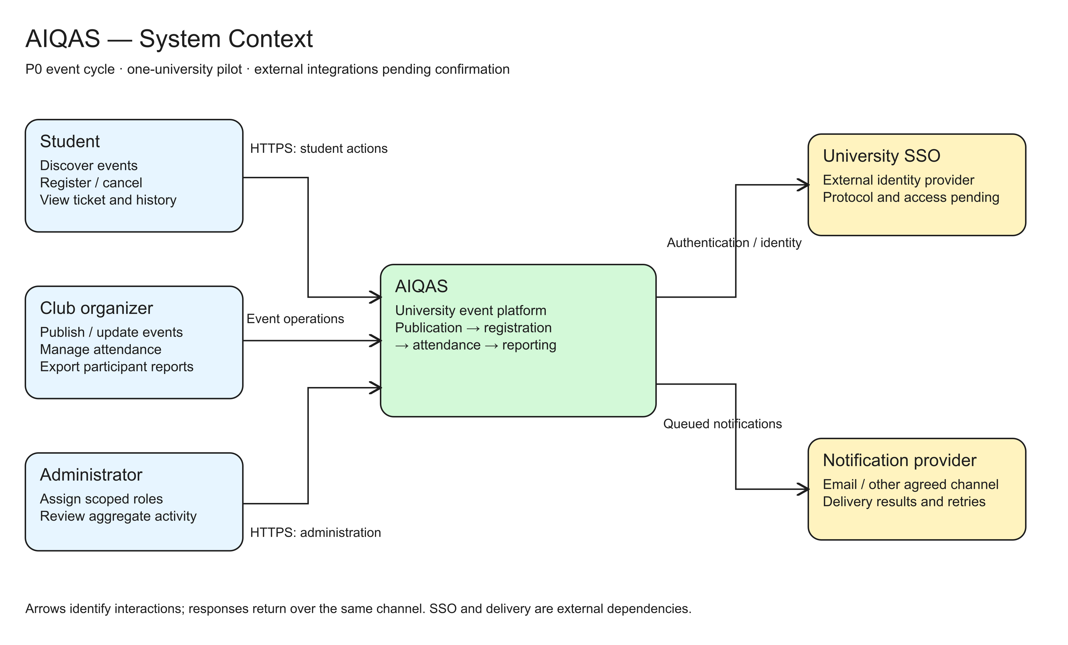
Figure 1. AIQAS System Context. Winter source aiqas-system-context.excalidraw. Task DEMO-27.

7.3.2 Use case diagram
The diagram maps P0 actions to FR identifiers: discovery, registration, cancellation, ticket access, event management, attendance confirmation, reporting, and scoped role management. FR-01 authentication and FR-02 permissions apply to protected actions. P1/P2 extensions are outside this diagram.
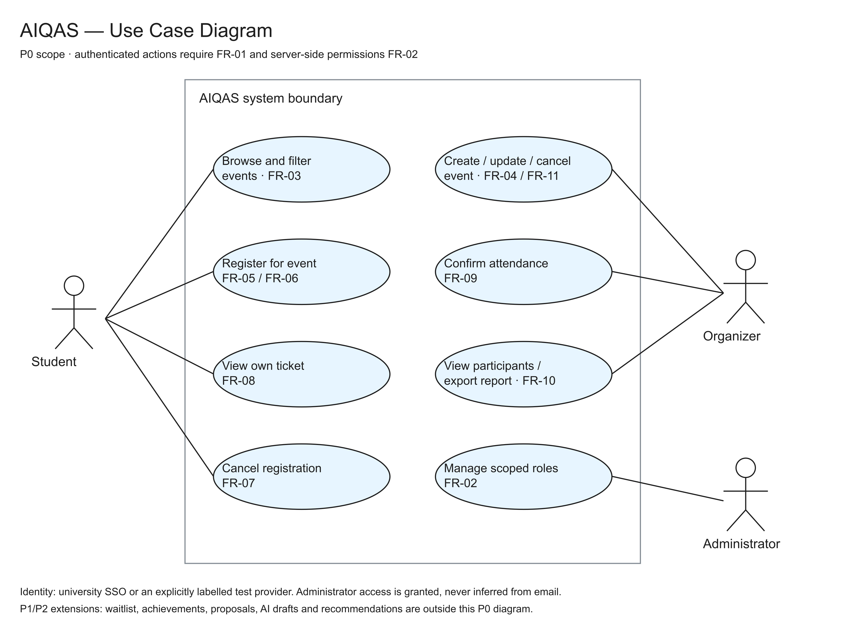
Figure 2. P0 Use Case Diagram. Winter source aiqas-use-case.excalidraw. Task DEMO-28.

7.3.3 Component diagram draft
The frontend calls a Go modular monolith through an OpenAPI-described HTTP interface and receives SSE updates. Identity/Clubs, Events, Registration/Attendance, and Notifications/Reports share the backend and PostgreSQL. Registration changes and durable River jobs are committed in the same transaction. A separate Go worker handles reminders and safe delivery retries. SSO, delivery, and S3-compatible storage are external integrations. Python/FastAPI is optional and requires a concrete ML need.
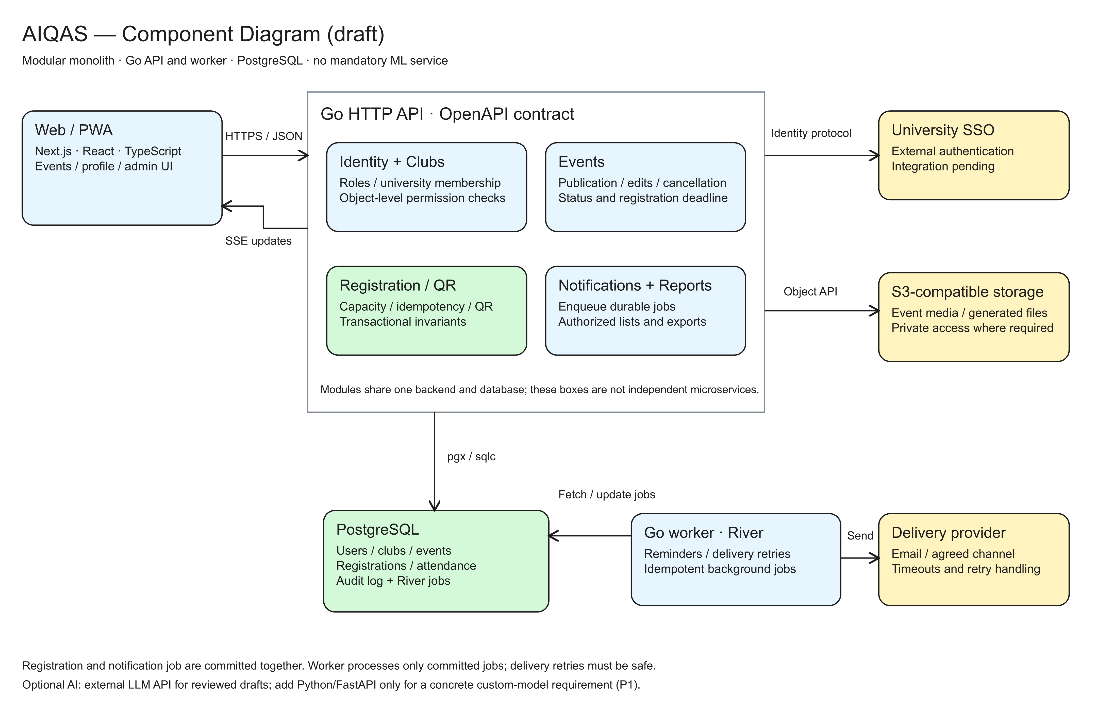
Figure 3. Draft Component Diagram. Winter source aiqas-components.excalidraw. Task DEMO-29.

8 UX and prototype
Design source: AIQAS 0.1 in Paper — https://app.paper.design/file/01M4N0NETW9ZS7E1S9XRYVX5NA/p-1-0
Three original desktop mockups appear below, followed by five low-fidelity scenario drawings in Section 8.4. Together they show the interface direction and main P0 interactions. They are static designs, not an implemented or user-tested app. Names, dates, counts, XP, and rewards are illustrative. Related task: DEMO-30.

8.1 Events discovery and registration
The student searches/filters the catalog, reviews event summaries and remaining places, and chooses Join Now / RSVP. This supports FR-03 and entry to FR-05. Section 8.4 supplies event details, registration confirmation, full-capacity and unknown-result states.
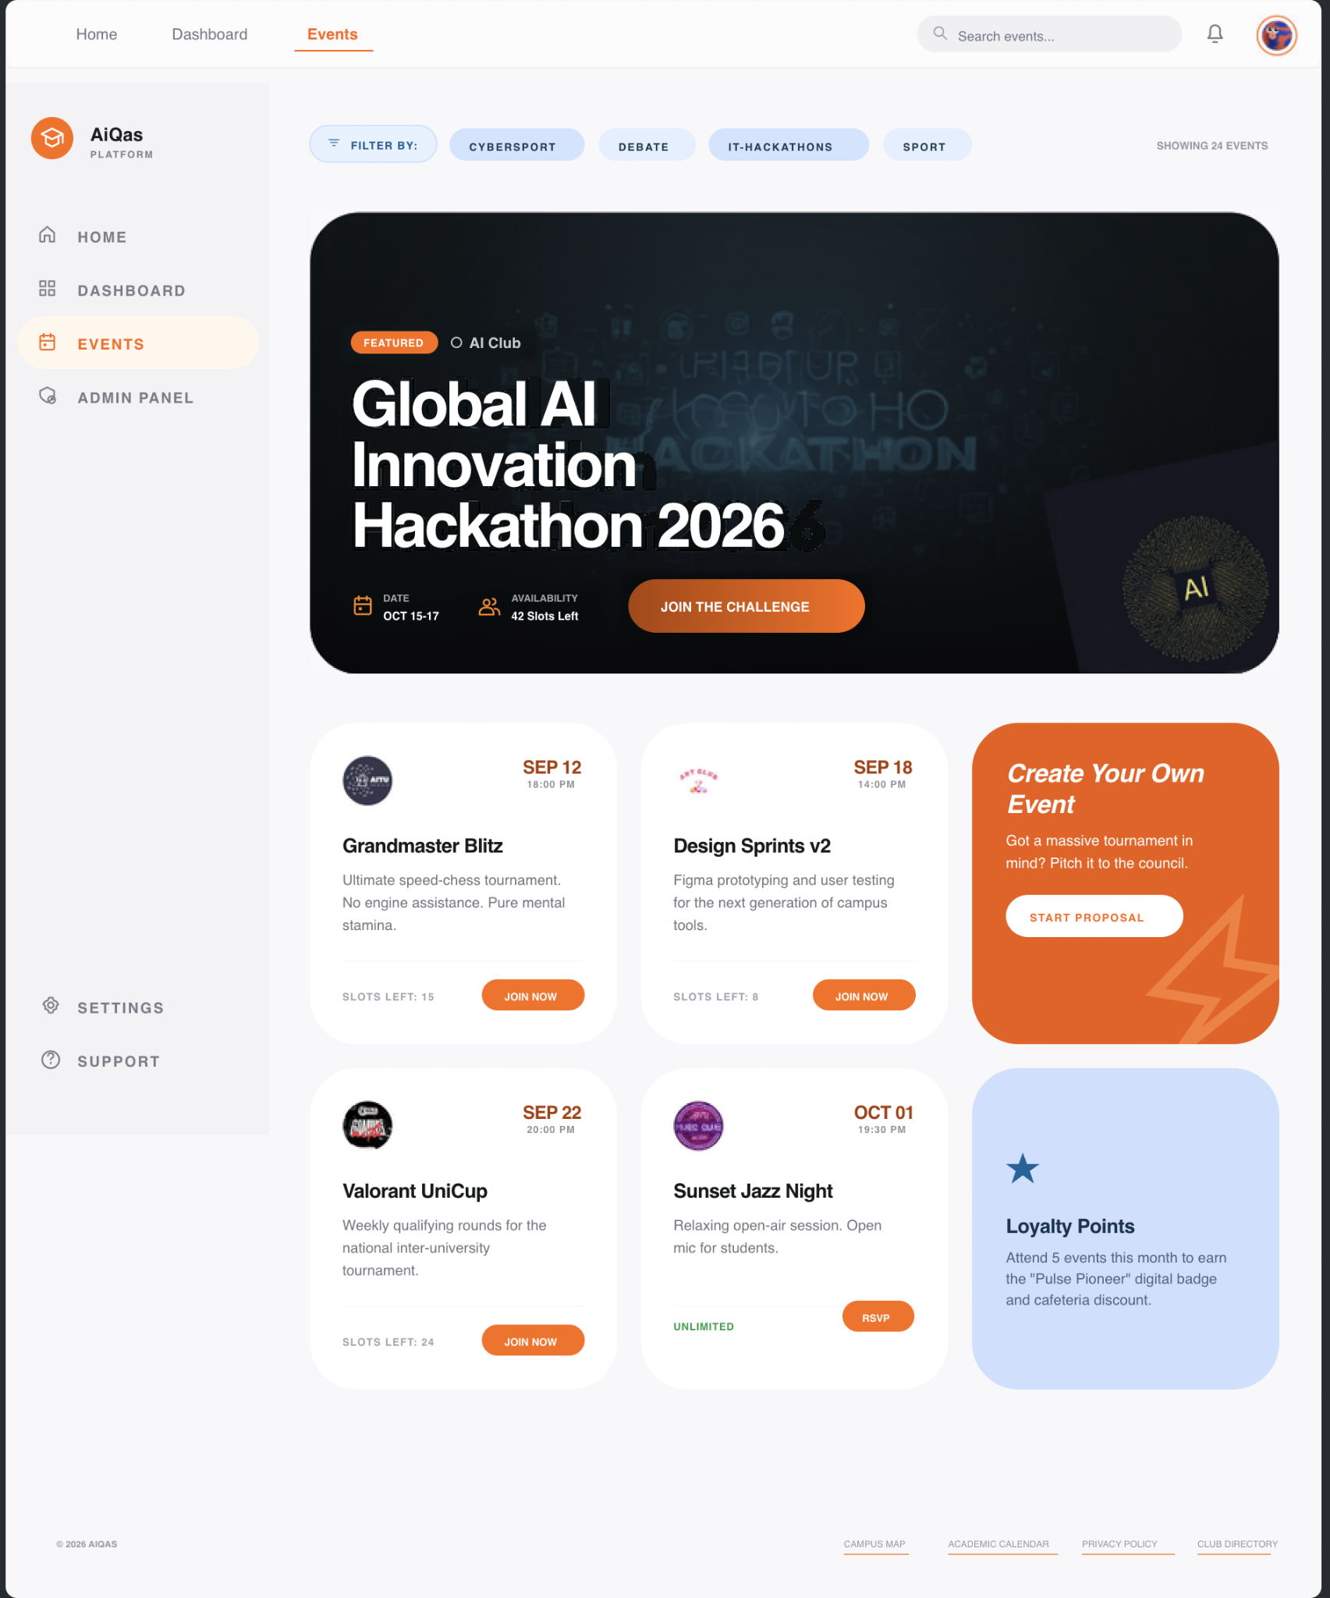
Figure 4. Events catalog exported from the existing Paper artboard.

8.2 Profile and personal ticket
The student sees their profile and upcoming-event entry pass, illustrating FR-08. XP/rewards are a future direction outside P0. Section 8.4 adds ticket status, cancellation, and invalid-ticket behavior. Verified attendance does not automatically constitute a verified skill.
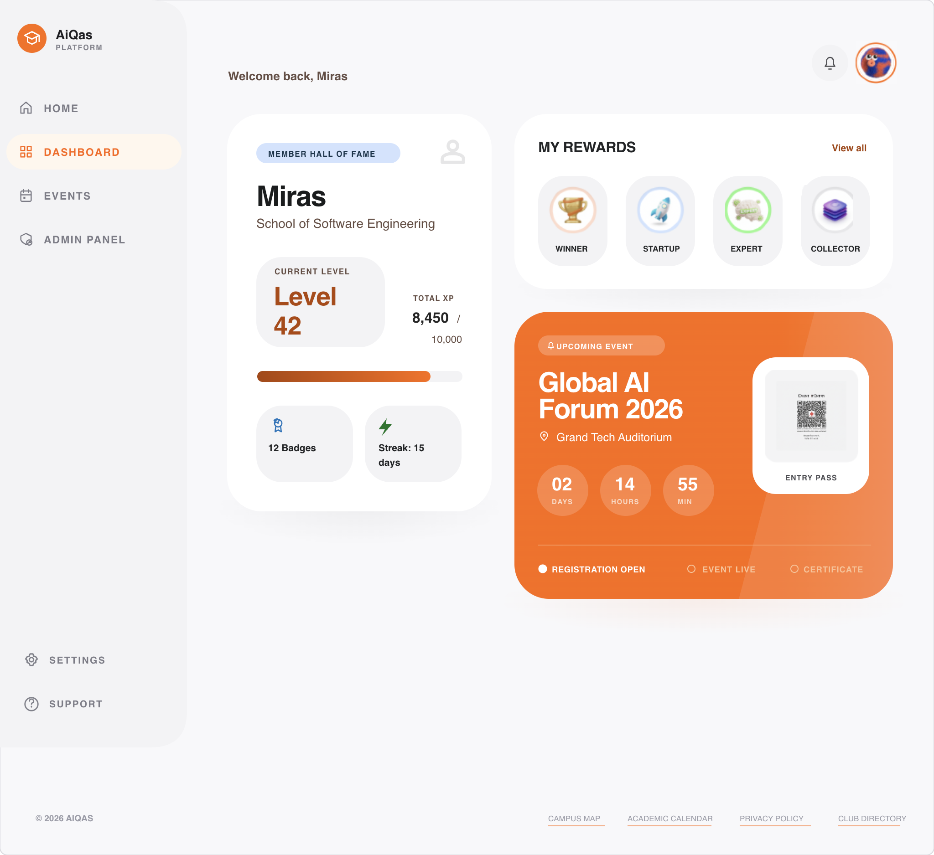
Figure 5. Profile and entry pass exported from the existing Paper artboard.

8.3 Participant management
The panel shows registration/check-in summaries, participants, attendance statuses, event creation, and export, illustrating FR-04/09/10. Organizers manage only their authorized clubs/events; administrators receive separately granted permissions. Section 8.4 adds publication, validation, QR verification, access rejection, and report output.
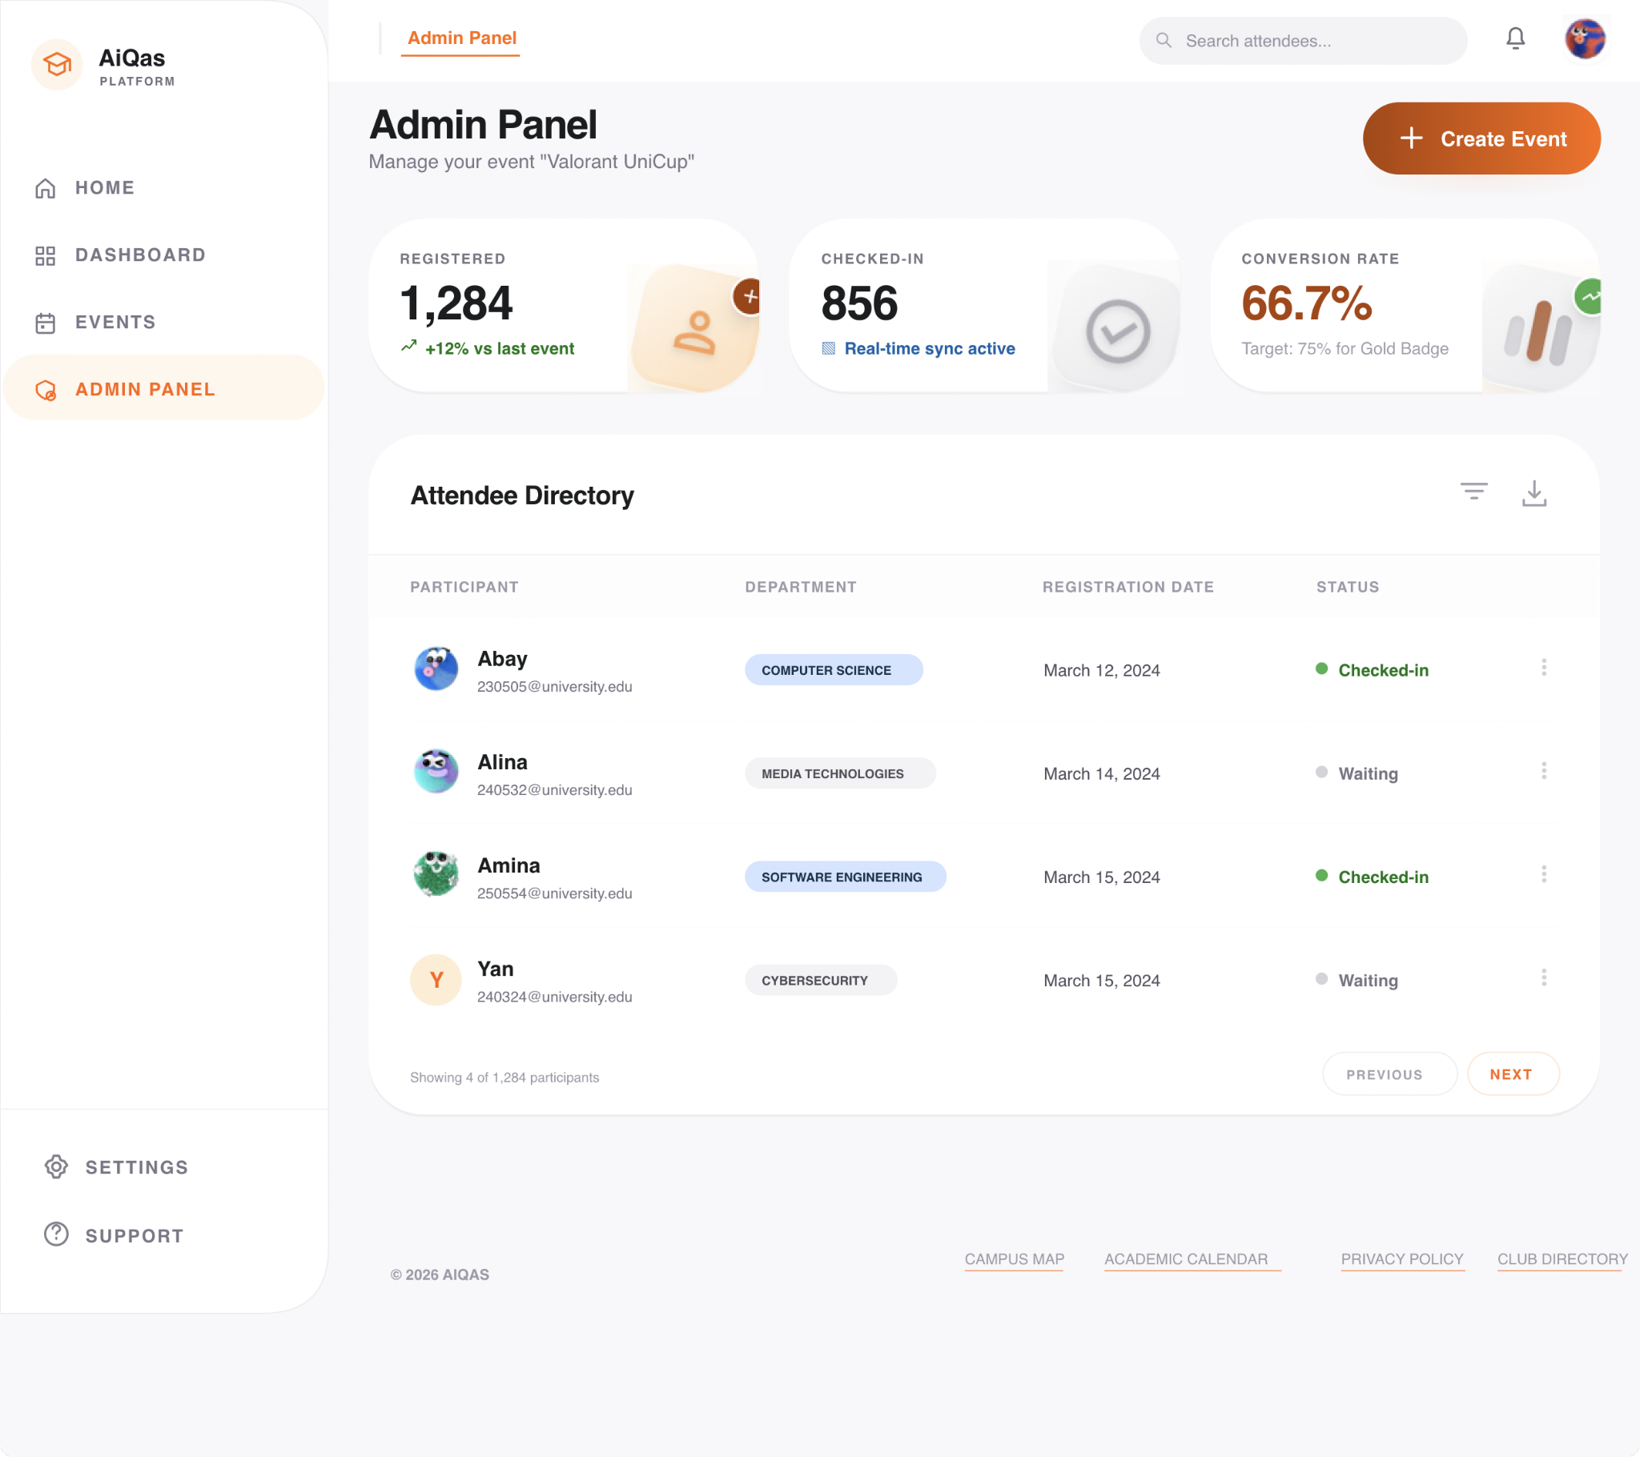
Figure 6. Admin Panel exported from the existing Paper artboard. Displayed figures are sample design data.
The added drawings cover student/organizer P0 flows, key success/failure states, and a mobile sequence. Next, review them with the three roles and record revisions, followed by implementation/device testing. Static mockups do not establish usability or complete the implementation/testing parts of DEMO-30.

8.4 P0 scenario mockups and states

Student registration
Open an event with program, location, time zone, deadline, and current seat availability. Successful registration displays explicit confirmation and the owner’s ticket link. A repeated action returns the same booking. This addresses missing availability and unclear registration status in the questionnaire.
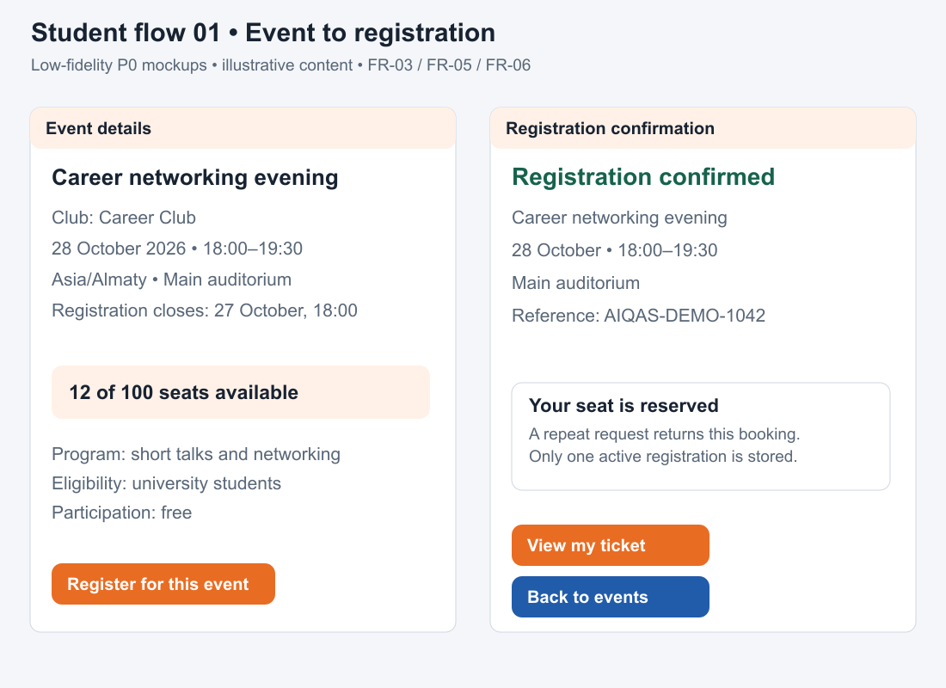
Figure 7. Event details and registration confirmation. FR-03, FR-05, FR-06.

Ticket cancellation and exceptions
The owner views a confirmed ticket and confirms cancellation. A cancelled ticket stays visible as “Cancelled — not valid for entry”. A full event reserves no seat. After a connection failure following submission, check server-side booking status before retrying. An empty catalog explains that no events match and offers Clear filters; loading shows progress without implying registration success.
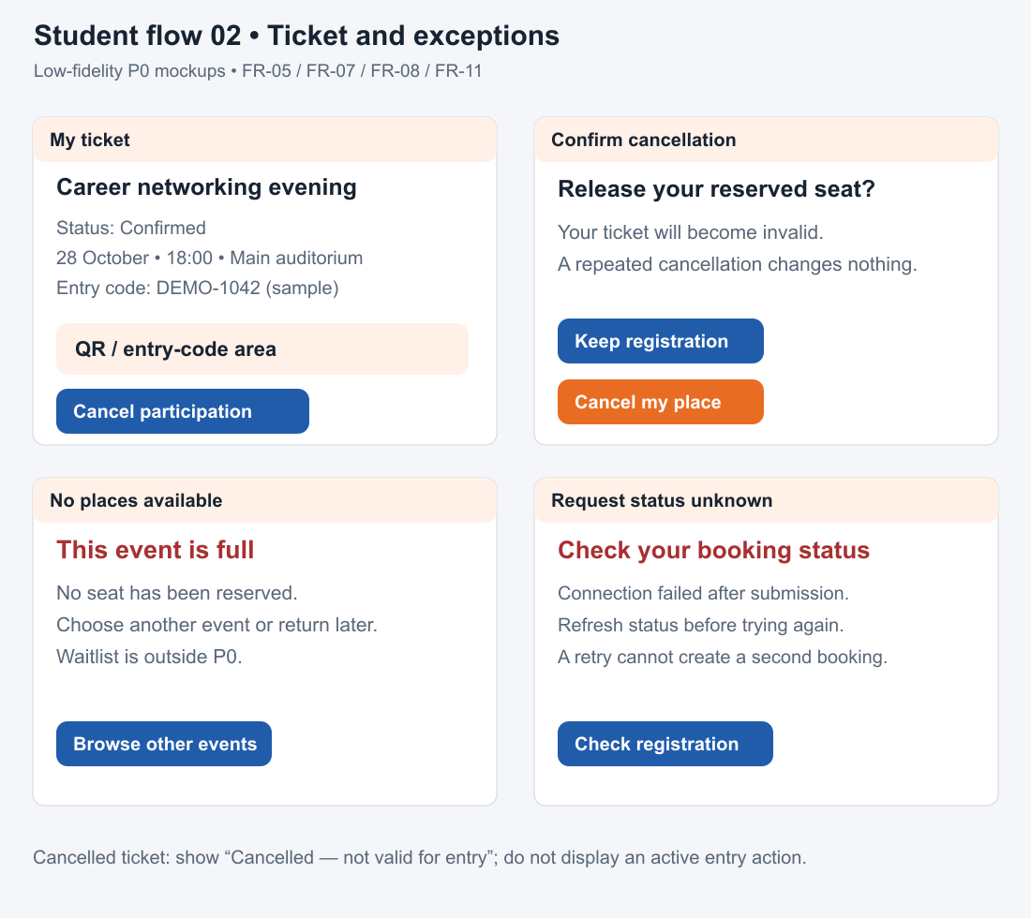
Figure 8. Ticket, cancellation, full event, and unknown request status. FR-05–FR-08.

Organizer publication
Select an authorized club; enter title, start/end time, location, capacity, and deadline. Invalid or missing fields block publication while retaining entered values. The deadline precedes the start. Successful publication opens the event; later cancellation/time changes create notification jobs.
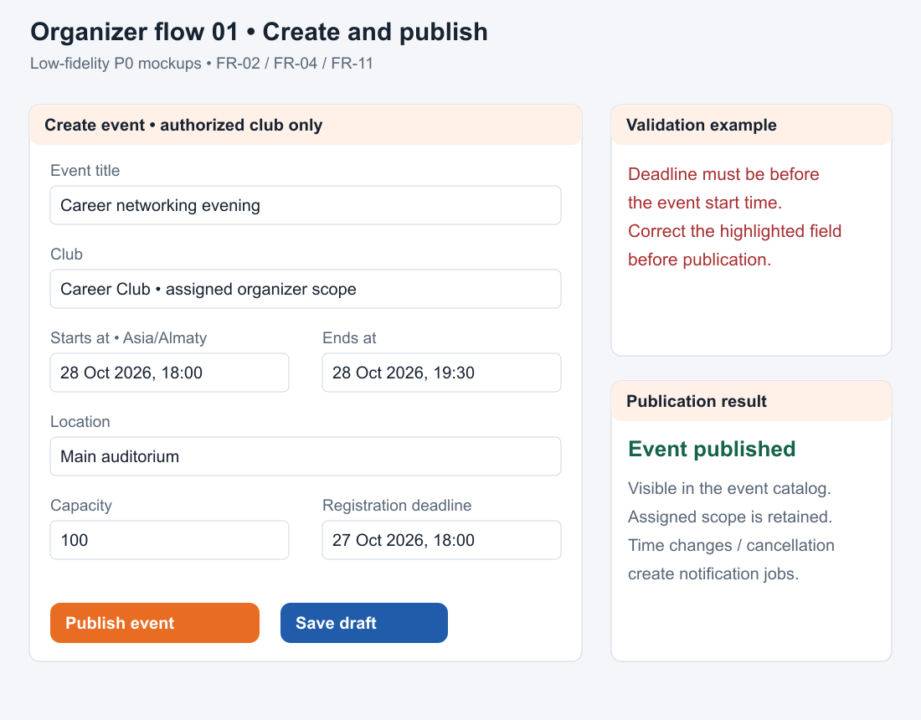
Figure 9. Creation, validation, and publication. FR-02, FR-04, FR-11.

Attendance and reporting
Select the target event, scan a ticket or enter its code. Distinguish saved attendance, already checked in, wrong event, cancelled ticket, and access denied. CSV/PDF separates active registrations, unique attendances, and cancellations. An empty participant list explains that no registrations exist; export failure retains the list and offers retry.
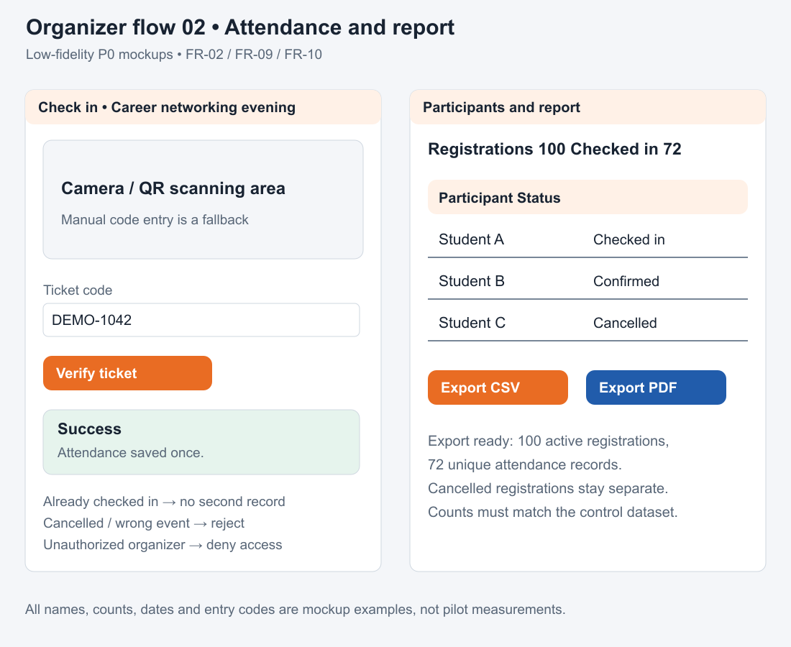
Figure 10. Verification, participant statuses, and reporting. FR-02, FR-09, FR-10.

Mobile scope and administration
Mobile P0 covers discovery, details, registration status, owner ticket, and cancellation. Organizer check-in must also work on a phone; dense reports may use a scrollable table/export. An administrator grants a named user an explicit club/university scope, reviews the change, and receives confirmation. Unauthorized users see access denied without participant data. Role changes are audited.
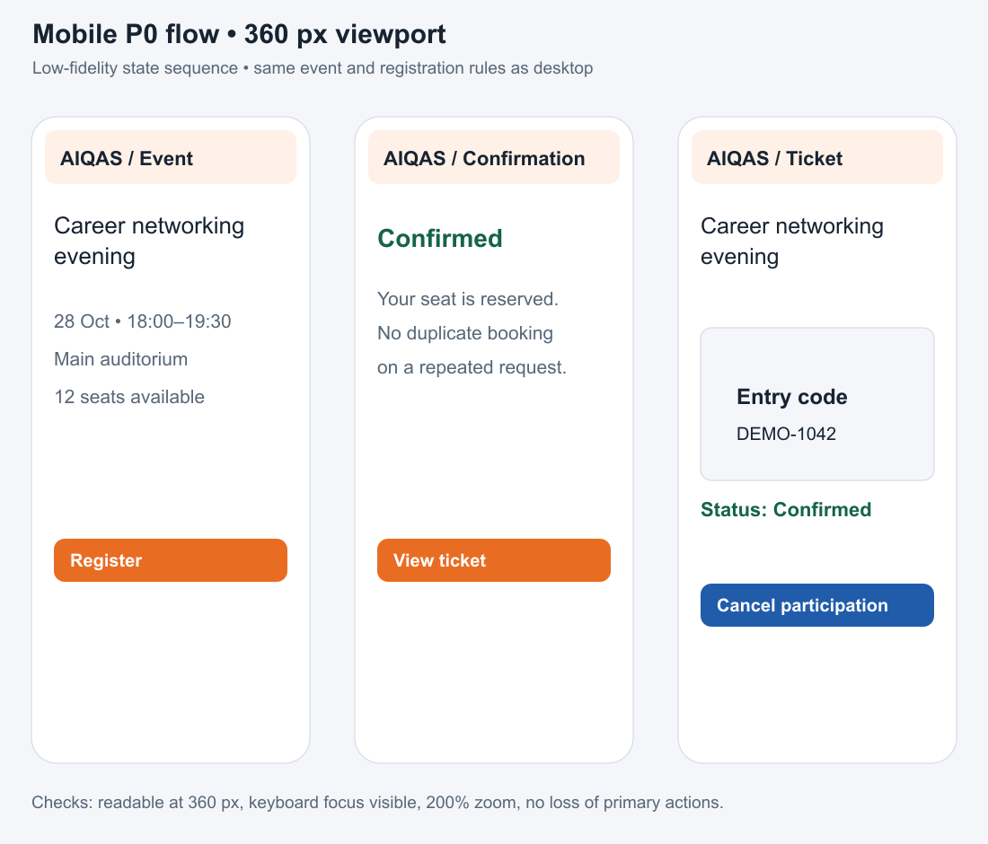
Figure 11. Mobile event-to-ticket sequence; planned reference viewport 360 px.
Editable SVGs and matching PNGs for Figures 7–11 are in [E3]. Prototype review follows Section 9.4.

9 Verification and evaluation plan

9.1 Methodology and test data
Verification covers unit tests of business rules, integration tests of DB and access, end-to-end main cycle, concurrency and load scenarios, manual UX/PWA check, and recovery. Staging data is synthetic: 1,000 students, several clubs, events of various statuses, full and available events. Real pilot data will be used only after university approval.

Test | Related Requirements | Scenario | Expected Evidence
V-01 | FR-01, FR-02; NFR-02 | Login, logout, foreign roles and objects | Permissions/rejections log; unauthorized request rejected.
V-02 | FR-03, FR-04 | Catalog, filters, creation, and validation | Data and results match control set.
V-03 | FR-05, FR-06; NFR-01 | 1,000 unique valid attempts for 100 seats; duplicates | Exactly 100 confirmations; no duplicates or overbooking.
V-04 | FR-07, FR-12 | Repeated cancellation; under P1 — waitlist competition | Seat released once; order maintained.
V-05 | FR-08, FR-09 | Foreign and cancelled QR; 10 scan retries | Invalid ticket rejected; single attendance.
V-06 | FR-10 | Report for set with known numbers | CSV/PDF and UI match DB.
V-07 | FR-11 | Worker failure after write and before send | Registration saved; task retries safely.
V-08 | NFR-03 | 100 RPS for 5 minutes; separate peak 300 RPS for 10 seconds | p95/p99, 5xx, CPU/RAM, queue, locks; peak characterized separately.
V-09 | NFR-04, NFR-07 | Clean start and backup recovery | Launch log, RPO/RTO, and integrity of restored data.
V-10 | NFR-05, NFR-09 | Mobile cycle, keyboard, weak network, and logout | Defect list and confirmed fixes.

9.2 Baseline process and experiment
The proposed reference baseline is Google Forms registration, a participant spreadsheet, manual attendance marking, and a manually assembled report. Three survey records mention Google Forms, but that does not confirm a club’s full workflow. Before comparison, a participating organizer must confirm the actual tools, steps, participant count, report fields, and access conditions. If the real process differs, document and use it. Both conditions use equivalent tasks, event data, and report definitions.
A later field pilot targets three clubs and five events after implementation and agreement on access/data. It is separate from the five questionnaire records and formative UX study. For the paired time study, plan three organizers completing equivalent tasks in both baseline and AIQAS, with alternating order and equivalent practice. Record experience, help, interruptions, and failed tasks. Report paired values and medians; a small pilot does not demonstrate a university-wide causal effect.

Indicator | Definition and Collection | Proposed Target | Limitation
Organizer Time | Publishing time + list processing + reporting; identical tasks; compare medians. | Reduction ≥30%; 50% from technical doc is an ambitious additional target. | Baseline measurements needed; training impacts time.
Accounting Errors | Duplicates and report discrepancies against control DB. | 0 duplicates and 0 discrepancies in required tests. | Does not characterize all possible production failures.
UX Success Rate | Core scenarios completed without assistance / initiated scenarios. | Tentatively ≥80%; align after test format. | Small sample; report numbers of participants and tasks.
Attendance and Repeat Participation | Attendees / active registrations; repeat participation over specific window. | First measure baseline; growth target after pilot. | Diverse events and self-selection hamper causal conclusion.
AI when enabling P1 | Drafting time, share of corrected required fields, cost of accepted output. | No auto-publishing; align utility and budget before launch. | Model failure should not block manual creation.

The final evaluation must contain application version, environment, participants, methods, actual values, identified defects, and limitations. Prior to testing, the results section remains unpopulated. For each mandatory FR/NFR, the report references a test and proof link.

9.3 Planned technical measurement conditions
Planned reference staging: API/Go worker on a 2-vCPU/4-GiB Linux host; PostgreSQL on a separate 2-vCPU/4-GiB SSD-backed host; load generator on another machine. Before testing, record actual CPU/RAM/disk, OS, network path, image digests, dependency versions, database settings, migrations, and Git commit. These are planned conditions, not an already provisioned environment. Record any change and rerun the compared conditions.
Synthetic data: 1,000 students, 10 clubs, and 50 events spanning controlled published, full, draft, and cancelled cases. Fix the generator seed and initial registrations/attendances; reset between runs. The capacity test starts with 100 free places and 1,000 distinct eligible students; duplicate-request tests are separate.
Load protocol: 60-second warm-up, then 100 RPS for five minutes, repeated three times after reset. Planned mix: 60% catalog, 25% event details, 10% registration, 5% owner ticket/status. Keep sufficient seats outside the separate saturation test. Record offered/completed throughput, actual mix, active connections, timeouts, p50/p95/p99, 5xx, CPU/RAM, locks, and queue depth. Test 300 RPS for 10 seconds separately. Record SSE connections separately from HTTP request rate.
Apply NFR-03 by endpoint class: p95 reads ≤300 ms, registration ≤700 ms, technical errors <1% at 100 RPS. Separate expected business/capacity rejections from technical failures. Report every run and the worst observed p95; do not hide failures in averages. Measure API latency independently of frontend rendering, notification delivery, and optional AI.
Add V-11 for NFR-06: inspect public/protected responses, exports, logs, sample configuration, and repository secrets. Add V-12 for NFR-08: check time-zone/date boundaries and each agreed language. V-01 includes scoped role changes; V-07 includes notification retries; V-09 includes clean launch and timed backup restoration. Preserve requirement IDs, data version, commands, and evidence logs.

9.4 Planned UX and outcome measurement conditions
Formative study target: six representatives—three students, two club organizers, one activity administrator. Recruitment and dates remain to be confirmed. The five questionnaire records are not completed usability sessions. Give common orientation and predefined tasks; provide help only after recording an unassisted failure.
Student tasks: find by topic/date and check seats; register and locate confirmation/ticket; cancel and recognize an invalid ticket. Organizer tasks: publish and recover from validation; check valid, repeated, and cancelled/wrong-event tickets; export a correct report. Administrator task: grant a scoped organizer role and verify cross-club rejection. Walk through full, empty, loading, access-denied, and connection-error states.
Per attempt record participant code/role, task, device/browser, unassisted success, errors, help, elapsed time, and comments. Proposed formative target: ≥80% unassisted completion, reported as numerator/denominator overall and by task/role. Record desktop viewport and 360-px mobile viewport, keyboard navigation, focus, 200% zoom, and phone check-in once implemented. A static walkthrough cannot validate device behavior.
Paired organizer-time study: the same publication task, 100-participant list, attendance decisions, and report template in both conditions. Start when instructions/data are available; stop on a correct deliverable. Include correction time and record failures. Compute reduction as (baseline time − AIQAS time) / baseline time × 100%; report every pair and median paired reduction. The ≥30% target is a planned criterion, not an observed result.
The result register records version, environment, participants/tasks, baseline, raw observations, calculations, defects, and limitations. Until tests/sessions run, label results Not measured. Participation history, repeat attendance, and AI benefit remain separate P1 evaluations.

10 Project management and risks

10.1 Distribution of responsibility
Responsibility is assigned in YouTrack: 20 tasks, with 10 owned by Dzhanin Miras and 10 by Turemuratov Galymzhan. The implementation directions below are retained, while research, technical design, and preparation tasks are shared. Each member works under their own account, understands the core event cycle, and reviews the other member's significant changes.
- Frontend and UX direction: interface, prototype, student interviews, and user scenario testing. Responsible: Turemuratov Galymzhan.
- Backend and data direction: API, data model, integrations, concurrency tests, and deployment. Responsible: Dzhanin Miras.
- Jointly: organizer and administration interviews, literature and analog review, requirements and architecture approval, final evaluation, and defense preparation. Each reviews significant changes by the other.

10.2 Milestones and task ownership
The deadlines below match the current YouTrack plan for the October 24 pre-defense. They are planned checkpoints, not evidence that interviews, approvals, or tests have happened.
October 13: proposal and interview preparation; responsibilities, risks, repository basics, and access (DEMO-20, DEMO-21, DEMO-33, DEMO-34).
October 16–17: actual relevance evidence, literature review, analog comparison, and technology decisions (DEMO-22–DEMO-25). Prepared reviews still need peer review and Git traceability.
October 19–20: refine requirements after interviews; review the three diagrams; complete UX scenarios and the evaluation/test plan (DEMO-26–DEMO-32).
October 21–22: obtain substantive feedback from Zhanna Sadirmekova and record resulting decisions and revisions (DEMO-36, DEMO-37).
October 23: verify progressive contributions and reviews, package the exact submission under pre-defense-1, and rehearse the presentation (DEMO-35, DEMO-38, DEMO-39).
Miras owns DEMO-20, 21, 22, 24, 26, 28, 30, 33, 37, and 39: proposal, relevance, analogs, requirements, use cases, UX, coordination, revisions, and presentation.
Galymzhan owns DEMO-23, 25, 27, 29, 31, 32, 34, 35, 36, and 38: literature, technology decisions, context/components, evaluation/testing, repository work, supervisor review, and submission.
Dependency follow-up: Miras coordinates the client/club contacts and confirms baseline and data requirements by October 16 (contact names pending). Galymzhan follows up with the supervisor by October 21 and identifies the university SSO contact by October 13 (name and protocol pending). A delayed external dependency must be recorded in YouTrack and reflected in the scope.

10.3 Risks and dependencies

Risk | Probability / Impact | Mitigation | Trigger and Action
No access to SSO | Medium / High | Identify integration owner early; agree on fallback. | No params by dev start — test SSO for demo, revise plan.
Demand not confirmed | Medium / High | 3–5 interviews; align pilot and baseline. | No recurring problem — clarify goal and P0.
Scope creep | High / High | Core cycle first; separate P1/P2. | P0 falls behind — defer achievements, AI, and 2nd university.
Seat and QR errors | Medium / High | Transactions, uniqueness, and concurrency tests. | Duplicate or overbooking exists — pause registration pilot until fixed.
Data not aligned | Medium / High | Align composition, roles, storage, and retention; demo on synthetic data. | No resolution — do not use real profiles.
Environment unavailability | Medium / Medium | Backups, recovery, monitoring, and assigned lead. | Outage before event — agreed fallback process and incident log.

Probabilities are preliminary qualitative team estimates. External dependencies: advisor, client representative, SSO parameters, data alignment, pilot clubs, and infrastructure. Assign a contact person and response date for each dependency.

10.4 Git and YouTrack traceability
The AIQAS board contains DEMO-20–DEMO-39, covering proposal, interviews, literature, analogs, technologies, requirements, three diagrams, UX, evaluation, repository work, supervisor review, and submission. Tasks have assignees, priorities, acceptance criteria, dependencies, and deadlines in their descriptions. Prepared deliverables are recorded separately from remaining approval, review, and Git publication steps.
YouTrack: https://aiqas.youtrack.cloud/agiles/204-0/current
Repository [E2]: https://github.com/StarwinM/aiqas-platform
Initial Git evidence: README commit 18e9190ba0622230cfba0bb7f3b57dc45aa5d8d5 by Miras / StarwinM. This publication remains part of the history. The current packaging work adds the consolidated report and supporting sources under DEMO-38; the commit/PR and tag are traceable through the repository history.
Commit evidence: https://github.com/StarwinM/aiqas-platform/commit/18e9190ba0622230cfba0bb7f3b57dc45aa5d8d5
Task ownership and Git authorship are distinct. DEMO-34 is assigned to Galymzhan, while the initial README commit was published by Miras. Materials attributed in YouTrack retain their task ownership; packaging commits made through StarwinM belong to Miras. Actual peer review and contributions from Galymzhan’s account remain to be evidenced.
Use personal identifiable accounts, task branches, descriptive commits with DEMO IDs, and pull requests explaining changes and checks. The other member performs real review before merge; record revisions and link the PR/commit back to YouTrack. Mark Done only when acceptance criteria are met.

10.5 Submission version and materials manifest
Submission identifier: prob-period-1. The consolidated PDF and accompanying source materials form one versioned package. The first README-only preparation commit remains available in Git history; the release candidate adds the research, requirements, original Winter diagrams, UX materials, and evaluation plan. The final submitted tag must resolve to this complete package.
Submission snapshot https://github.com/StarwinM/aiqas-platform/tree/prob-period-1
Package content: docs/SE-2429_Dzhanin_ProbPeriod1.pdf; docs/SE-2429_Dzhanin_ProbPeriod1.docx; diagrams/src/*.excalidraw; diagrams/exports/*; prototype/src/*.svg and prototype/exports/*.png; research/survey-summary.csv; verification/verification-and-evaluation-plan.md; project-management/submission-checklist.md; and the supporting materials index.
Known limitations: no executable application or measured outcomes; organizer/client validation and baseline confirmation remain open; peer review and progressive contributions by both personal accounts must be evidenced separately. Publishing this package under Miras’s account is not a claim that Galymzhan authored its Git commits. Supervisor feedback status is stated in Section 11.

11 Supervisor feedback
Supervisor: Sadirmekova Zhanna Bakirbayevna. Substantive feedback and the resulting revisions have not yet been recorded for this submission. No supervisor approval or completed review is claimed. This section remains pending.

References
Scientific publications are labeled L, official analog materials A, technical sources T. References serve to verify specific claims and decisions, not to confirm a conducted pilot.
[L1] Khaldi, A., Bouzidi, R., Nader, F. (2023). Gamification of e-learning in higher education: a systematic literature review. Smart Learning Environments, 10, 10.
https://link.springer.com/article/10.1186/s40561-023-00227-z
[L2] Almeida, C., Kalinowski, M., Uchoa, A., Feijó, B. (2023). Negative effects of gamification in education software: Systematic mapping and practitioner perceptions. Information and Software Technology, 156, 107142.
https://www.sciencedirect.com/science/article/pii/S0950584922002518
[L3] Ahsan, K., Akbar, S., Kam, B., Abdulrahman, M. D.-A. (2023). Implementation of micro-credentials in higher education: A systematic literature review. Education and Information Technologies, 28, 13505–13540.
https://link.springer.com/article/10.1007/s10639-023-11739-z
[L4] Varadarajan, S., Koh, J. H. L., Daniel, B. K. (2023). A systematic review of the opportunities and challenges of micro-credentials for multiple stakeholders: learners, employers, higher education institutions and government. International Journal of Educational Technology in Higher Education, 20, 13.
https://link.springer.com/article/10.1186/s41239-023-00381-x
[L5] Zeng, J., Sun, D., Looi, C.-K., Fan, A. C. W. (2024). Exploring the impact of gamification on students’ academic performance: A comprehensive meta-analysis of studies from the year 2008 to 2023. British Journal of Educational Technology, 55, 2478–2502.
https://bera-journals.onlinelibrary.wiley.com/doi/full/10.1111/bjet.13471
[L6] Rohozneanu, D.-M., Leuciuc, F.-V., Georgescu, A. D. (2025). The impact of extracurricular activities at the university level. A systematic review. Studia Universitatis Babeş-Bolyai Educatio Artis Gymnasticae, 70 (Special Issue 1), 371–384.
https://studia.reviste.ubbcluj.ro/index.php/subbeducatio/article/view/10045
[L7] Gyedu, F. O., Partey, P. A., Boafo, F. A., Agbo, D. D. (2026). Gamification Effect: Enhancing Student Learning Outcomes in Higher Education: A Meta-Analysis and Policy Implications. DOI 10.1177/21582440261421375.
https://journals.sagepub.com/doi/10.1177/21582440261421375
[L8] Sailer, M., Homner, L. (2020). The Gamification of Learning: a Meta-analysis. Educational Psychology Review, 32, 77–112. Baseline work outside the main five-year window.
https://link.springer.com/article/10.1007/s10648-019-09498-w
[A1] CampusGroups. Centralize and Manage Events & Calendars.
https://www.campusgroups.com/product/events-calendars/
[A2] CampusGroups. Discover CampusGroups 30+ Modules.
https://community.campusgroups.com/product/product/
[A3] Anthology. Integration With Anthology Engage.
https://help.anthology.com/eng/Content/Help/Integration/Engage/tocEngage.htm
[A4] Anthology Engage. Tracking Event Participation.
https://help.anthology.com/engage/en/tracking-event-participation.html
[A5] Anthology Engage. Accessing and Customizing Your Co-Curricular Transcript.
https://help.anthology.com/engage/en/accessing-and-customizing-your-co-curricular-transcript--video-.html
[A6] Modern Campus. Involve platform and engagement overview.
https://go.moderncampus.com/involve-student-engagement
[A7] Eventbrite. Event Check In App for Organizers.
https://www.eventbrite.com/organizer/features/organizer-check-in-app/
[A8] Eventbrite. Permissions Glossary — Basic reports, включая Attendance.
https://www.eventbrite.com/help/en-us/articles/362073/
[T1] Go. Frequently Asked Questions — concurrency and parallelism.
https://go.dev/doc/faq
[T2] Elysia. End-to-End Type Safety and Eden.
https://elysiajs.com/eden/overview
[T3] FastAPI. Concurrency and async / await.
https://fastapi.tiangolo.com/async/
[T4] PostgreSQL. Constraints.
https://www.postgresql.org/docs/16/ddl-constraints.html
[T5] PostgreSQL. Explicit Locking.
https://www.postgresql.org/docs/current/explicit-locking.html
[T6] MySQL 8.4. InnoDB Transaction Model.
https://dev.mysql.com/doc/refman/8.4/en/innodb-transaction-model.html
[T7] MongoDB. Transactions.
https://www.mongodb.com/docs/manual/core/transactions/
[T8] MDN. Using server-sent events.
https://developer.mozilla.org/en-US/docs/Web/API/Server-sent_events/Using_server-sent_events
[T9] MDN. WebSocket API.
https://developer.mozilla.org/en-US/docs/Web/API/WebSockets_API
[T10] 1EdTech. Open Badges.
https://www.1edtech.org/standards/open-badges
[T11] Next.js. Progressive Web Applications.
https://nextjs.org/docs/app/guides/progressive-web-apps
[T12] River. Transactional enqueueing.
https://riverqueue.com/docs/transactional-enqueueing

Project evidence sources
[E1] AITU University Events: Student Experience. Google Forms response sheet; five-record snapshot from October 22–23, 2026, rows 2–6. https://docs.google.com/spreadsheets/d/1LD7KbiKtBIbSNliDt4b_7Qe5Hn6dOt_9a6_-1sK_MFU/edit#gid=1057682838
[E2] StarwinM/aiqas-platform. Public main tree, commits, tags, pull requests, and contributors inspected October 23, 2026. https://github.com/StarwinM/aiqas-platform
[E3] AIQAS probationary-period materials. Original Winter sources, readable exports, prototype sources, aggregate survey findings and evaluation plans. https://github.com/StarwinM/aiqas-platform/tree/prob-period-1

Appendix Materials and source links
Tagged package https://github.com/StarwinM/aiqas-platform/tree/prob-period-1
Original Paper prototype https://app.paper.design/file/01M4N0NETW9ZS7E1S9XRYVX5NA/p-1-0
Winter diagram sources https://github.com/StarwinM/aiqas-platform/tree/prob-period-1/diagrams/src
Winter readable exports https://github.com/StarwinM/aiqas-platform/tree/prob-period-1/diagrams/exports
P0 scenario prototype sources https://github.com/StarwinM/aiqas-platform/tree/prob-period-1/prototype/src
P0 scenario prototype exports https://github.com/StarwinM/aiqas-platform/tree/prob-period-1/prototype/exports
YouTrack project https://aiqas.youtrack.cloud/agiles/204-0/current
Student questionnaire source https://docs.google.com/spreadsheets/d/1LD7KbiKtBIbSNliDt4b_7Qe5Hn6dOt_9a6_-1sK_MFU/edit#gid=1057682838
The three original Winter drawings were copied as editable Excalidraw element data on 23 October 2026. Element IDs, positions, labels, and shapes were retained in .excalidraw scenes; the accompanying SVG/PNG exports are regenerated from those scenes with full drawing bounds. They can be opened in Excalidraw and compatible drawing applications. Static UX SVGs are editable design sources; they are not an implemented interface.

