**CAB302 Software Development**

**Assignment 2: Test-Driven Development and Graphical**

**User Interface Programming**

**Documentation**

**Student Name and ID:**

Michael Cartwright, n8869871

Matthew Pike, n9746609

**Evidence of testing:**

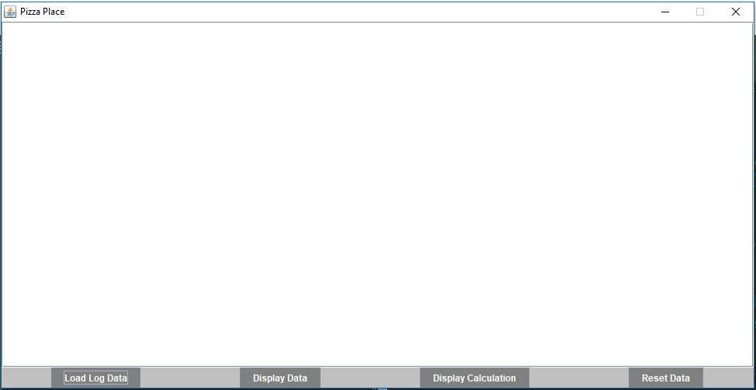

**#1: Successfully loaded PizzaGUI.java**

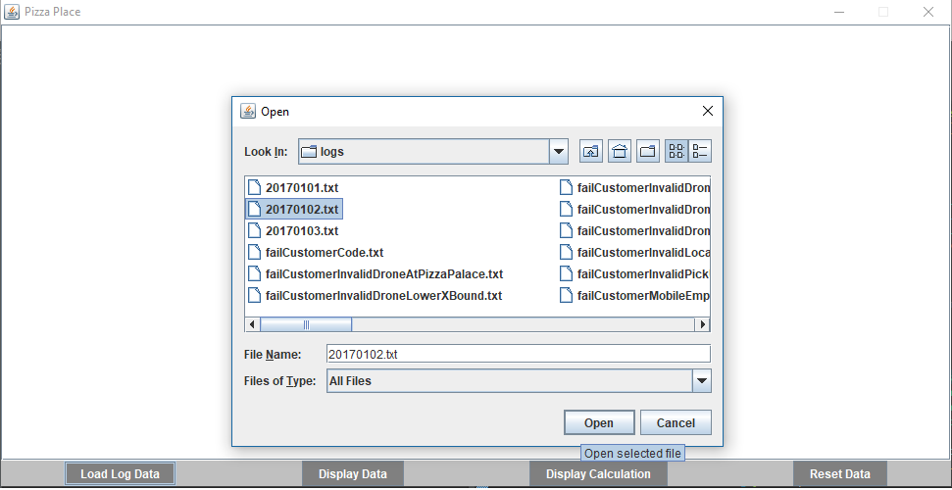

**#2: Load Log Data allows you to select a log file**

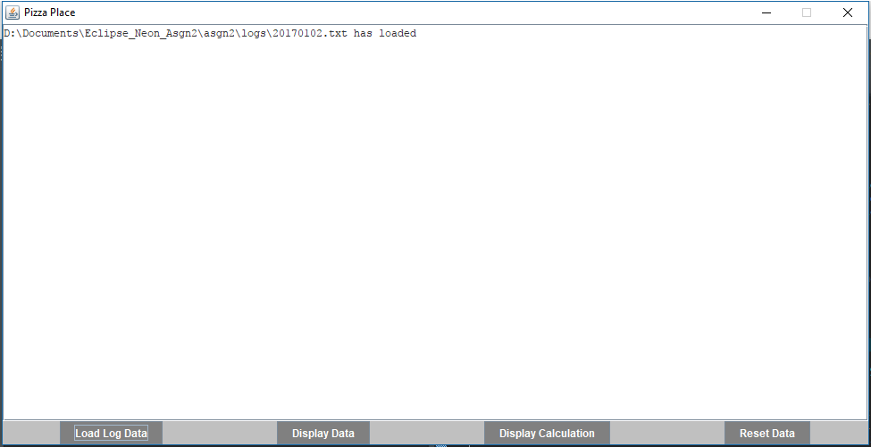

**#3: Opening a valid log file reveals a has loaded message**

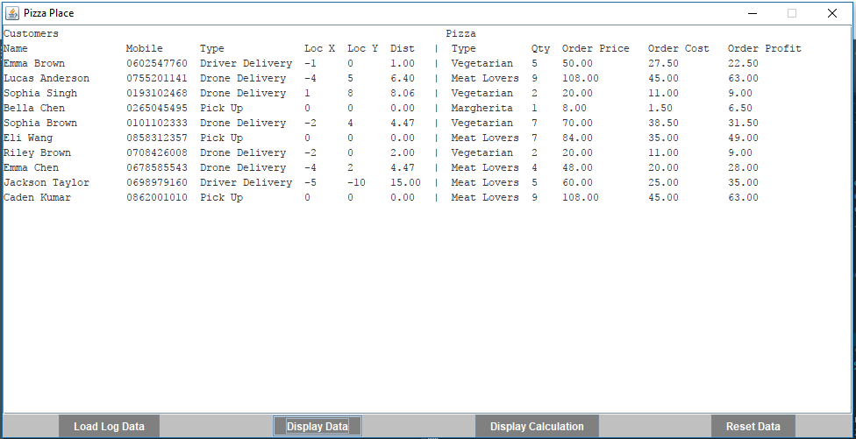

**#4: Display Data displays the orders and details of those orders**

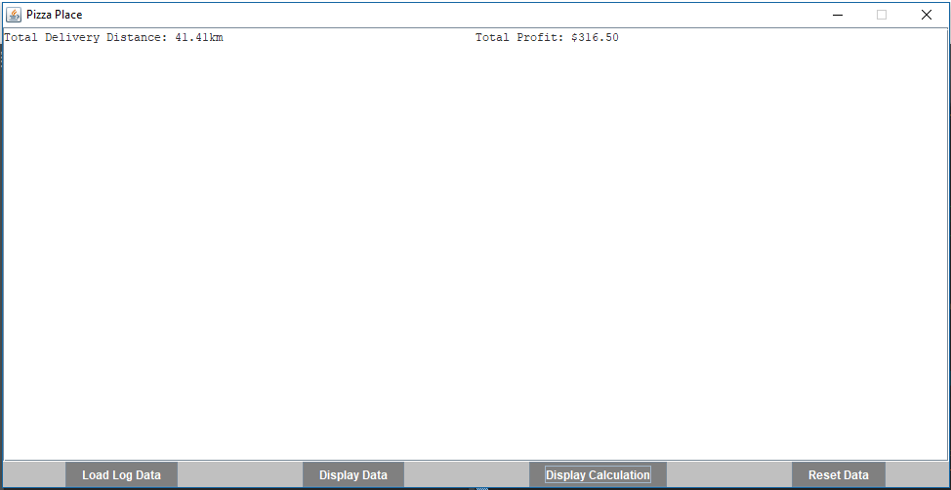

**#5: Display Calculation shows Total Delivery Distance and Total Profit**

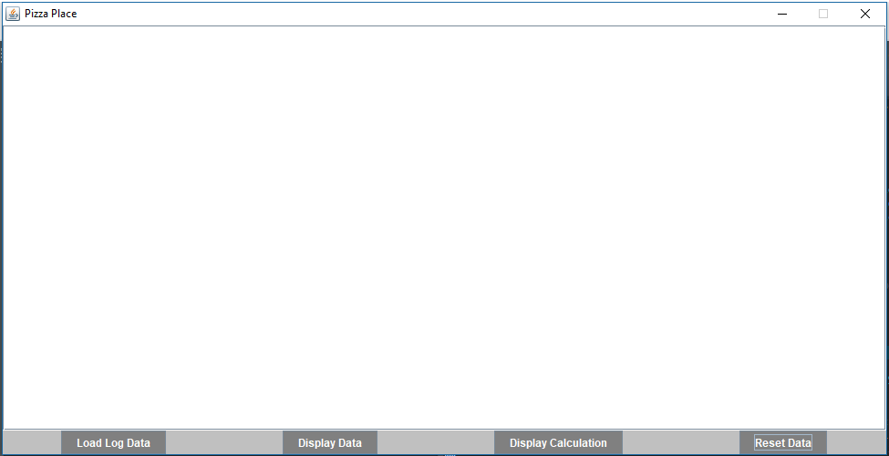

**#6: Reset Data resets and clears the data**

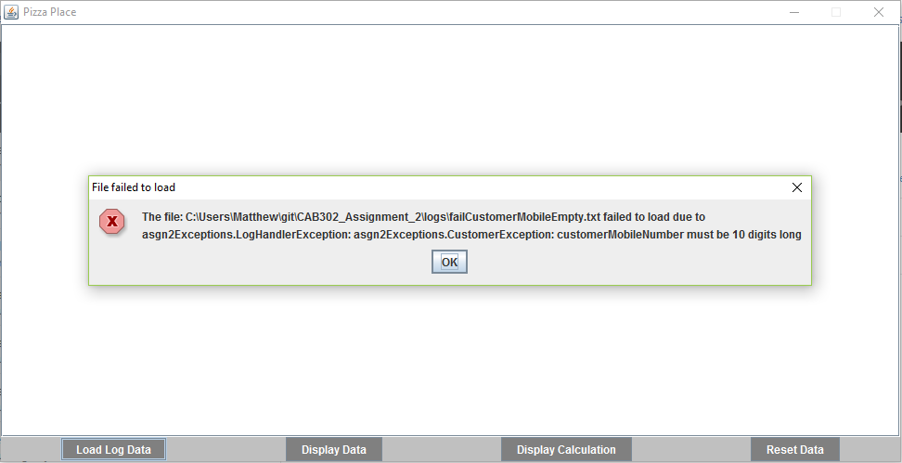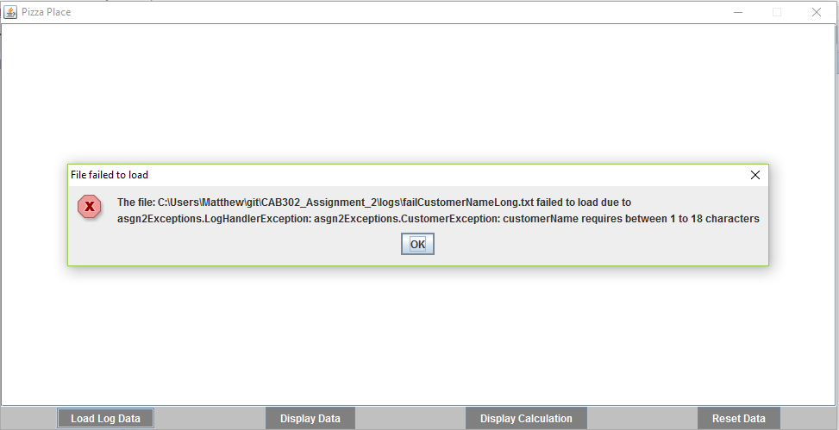

**#7: Fails to load an invalid log file due to a CustomerException**

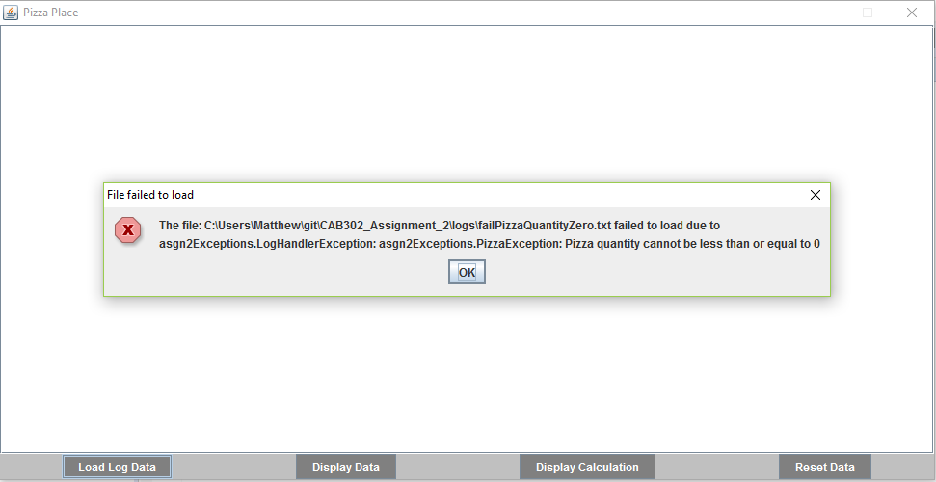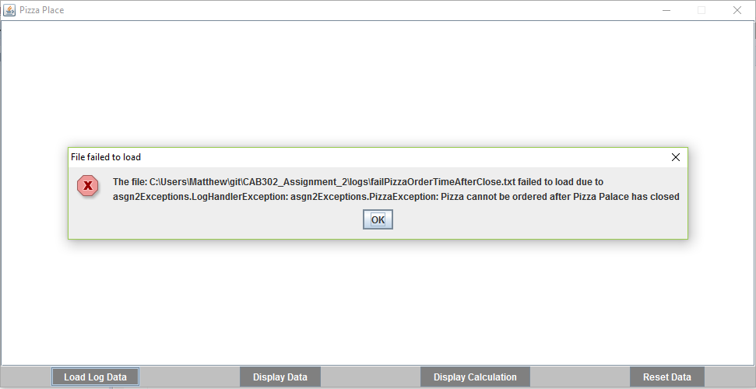

**#8: Fails to load an invalid log file due to a PizzaException**