Select：<https://blog.csdn.net/huntinux/article/details/39289317>

Epoll：<https://blog.csdn.net/davidsguo008/article/details/73556811>

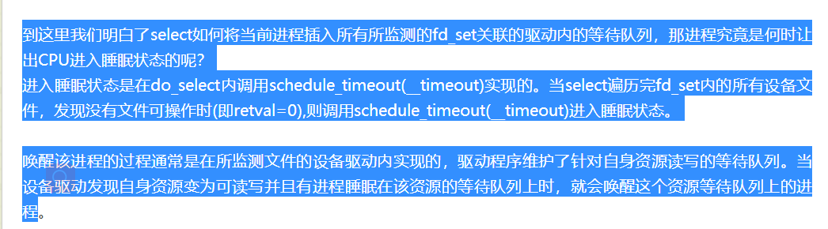

* Select 和 epoll_wait