**Creation of new DAF Templates**

1. Copy profile spreadsheet
2. Update name to include core
   1. allergyintolerance-daf-profile-spreadsheet.xml
   2. allergyintolerance-daf-core-profile-spreadsheet.xml
3. Edit new spreadsheet metadata tab (almost every field!)

|  |  |
| --- | --- |
| **Name** | **Value** |
| **id** | **allergyintolerance-daf-core** |
| **name** | **U.S. Data Access Framework (DAF) Core AllergyIntolerance Profile** |
| **display** | DAF-Core-AllergyIntolerance |
| **author.name** | **Health Level Seven International (FHIR - Infrastructure)** |
| **author.reference** | <http://www.healthit.gov> |
| **code** |  |
| **description** | **Defines constraints and extensions on the AllergyIntolerance resource for the minimal set of data to query and retrieve allergy information.** |
| **status** | **Draft** |
| **date** | **2016-08-01** |
| **published.structure** | DAF-Core-AllergyIntolerance |
| **version** | 0.01 |
| **extension.uri** | <http://hl7.org/fhir/daf/StructureDefinition/allergyintolerance-daf-core> |
| **introduction** |  |
| **publication.status** | STU3 |
| **notes** |  |

1. Update tab name
   1. profile name,
   2. and update elements to match Argonaut IG. Remove unused elements and bindings!

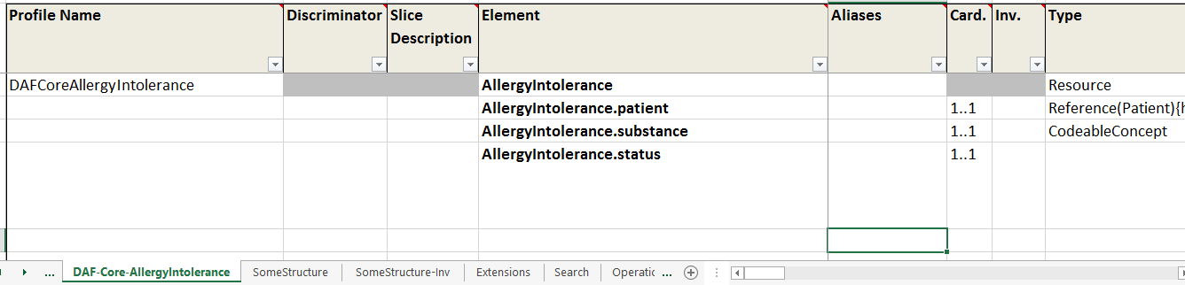

1. Locate and open daf2/daf.json
   1. Add new profile to spreadsheets
      1. 
   2. Add new structure
      1. 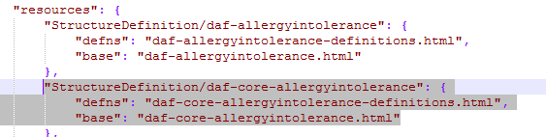
2. Locate and open daf2/resources/daf.xml
   1. Add new profile



1. Add new page

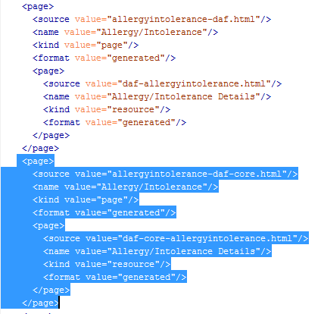

1. Locate and open /daf2/pages
   1. Copy pages

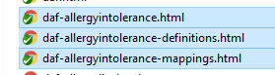

* 1. Add core to title

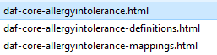

1. Locate and open /daf2/pages/daf-core-allergyintolerance.html
   1. Change

“{% include profile-template.html %}” to {% include core-profile-template.html %}

1. Create Intro /simple summary file ((Use argo content here using Pandoc(http://pandoc.org/try/) to convert from Wikimedia to Git markdown )
   1. Save as _include/daf-core-[profile]-intro.md (eg daf-core-allergyintolerance-intro.md)
   2. Markdown template (need to work on this some more)

##### Mandatory Data Elements

The following data-elements are mandatory (i.e data MUST be present). These are presented below in simple human-readable explanation as well as profile specific implementation guidance. The **Formal Profile Definition** below provides a formal summary and machine processable structuredefinition of the requirements, constraints and extensions of the [Name] resource. An example is provided below to demonstrate the requirement.

**Each [Name] must have:**

1. a patient

2.

3.

**Profile specific implementation guidance:**

*

*

**DAF Core [Name] Example:**

* [Example]()

##### Terminology

* 1. Use argo content here
     1. using Pandoc(http://pandoc.org/try/) to convert from Wikimedia to Git markdown
  2. Note for Jekyll need spaces after text for lists etc.
  3. *Example : _include/*daf-core-allergyintolerance-intro.md
  4. Decisions
     1. Search?
     2. Go on separate page or inline with definitions

1. Create formal summary file
   1. Save as _include/daf-core-[profile]-summary.md (eg daf-core-allergyintolerance-summary.md)
   2. This replaces the build generated one.
   3. Markdown example
      1. Use argo content here
      2. using Pandoc(http://pandoc.org/try/) to convert from Wikimedia to Git markdown

#### Complete Summary of the Mandatory Requirements

1. One Identification of a substance, or a class of substances, that is considered to be responsible for the adverse reaction risk in **AllergyIntolerance.substance**

- AllergyIntolerance.substance with an [ extensible] binding to a Value set (Code set) consisting of:

- NDF-RT codes for drug class allergies

- RxNorm codes limited to term types (TTY) , 'BN' Brand Name, 'IN' ingredient, 'MIN' multiple ingredient, and 'PIN' precise ingredient for drug ingredient allergies

- SNOMED CT if no other code from above code systems are available.

2. One patient reference in **AllergyIntolerance.patient**

3. One status in **AllergyIntolerance.status**

- AllergyIntolerance.status is bound to **[AllergyIntoleranceStatus]** Value set (Code set)

[ extensible]: Implementation_Guide#Extensible_binding_for_CodeableConcept_Datatype "wikilink"

[AllergyIntoleranceStatus]: http://hl7.org/fhir/DSTU2/valueset-allergy-intolerance-status.html

1. Value Sets
   1. Use the build generated artifacts
      1. File names
   2. Link from DAF core home page
2. Examples
   1. Todo- build not generating the artifacts
   2. Backup plan to have static example pages with own narratives