I apologize for machine translation.

Advisor CHANNEL-MAN v. X.X
Advisor Channel-ManXX a semi-automatic trading system ( PATS ) , implementation of the classic channel strategy in technical analysis. Developed by means of language MQ4 platform MetaTrader. Has a wide range of settings , allowing very flexible to adjust to all kinds of custom tactics work with any graphs on forex and the stock market.

Advisor TREND-MAN v. X.X
Advisor Trend-ManXX a semi-automatic trading system ( PATS ) , implementation of the classic channel strategy in technical analysis ( breakdown support / resistance levels ) . Developed by means of language MQ4 platform MetaTrader. Has a wide range of settings , allowing very flexible to adjust to all kinds of custom tactics work with any graphs on forex and the stock market.

The general principle of the program (Channel-man-xx).
At the entrance to the admission price , near the border of the figures advisor ready to make a deal and waiting for confirmation a) price reversal b) compliance with the direction of the trend input (if relevant factors ) . Under these conditions the transaction can be accomplished within the channel .
If the price breaks the figure on the tolerance , then the figure is considered breached and no longer involved in the trade. Punched figure changes color and its name from «C1» on «D1» and " C2 " on «D2», reset the text information .
If the open transaction gives a positive result , the adviser can set StopLoss to breakeven (with appropriate settings).
Introduction to breakeven transaction is a signal for 2 functions. a) The Adviser may implement additional purchase of a lot at the above conditions b) Included algorithm TraillingStop - dynamic pulling StopLoss level in the wake behind the growing profit.
Trailling Stop - implemented using three different algorithms . a) paragraph by paragraph b ) interest in ) fixed
StopLoss level can be adjusted adviser on fractals .

Teamwork and channel breakdown advisers

1. You must open the charts 1 , 2 or 3 currency pairs , such that the user to work or habitually clearly traced channels.
A) A method for constructing channels consists in determining the extrema on the graph and building in 2 unidirectional top of the line , the second line is drawn parallel to the first through the opposite vertex.
B) Even more significant levels can be considered as horizontal lines across the top of the graph constructed higher timeframes ( timeslots candles ) .

2 . Dates set for each channel advisor with customized coefficients.
3 . Choose one of the terminal higher timeframes . And with or without tip , gradually lowering the maximum timeframe select clear channels , and draw up to 2 pieces on each graph . I advise you to use periods 4H, 1H, 30M.
4 . Now you need to open the same number of graphs of the same currency pairs for the breakdown advisor and advisor to install these graphics.
5 . To try to choose the breakdown advisor timeframes step lower than for the channel . Start with H1 and if necessary can reach 5M choosing figure.
6. Draw up to 2 pieces on each break-out schedule. Recommend the use of horizontal levels for the breakdown advisor.
7. As required , usually in the morning and evening , correct shape.
Installation Guide.
Practically the setup process easier to learn Adviser on the example video on the site www.robo-forex.org
1. Start trading platform Metatrader ( running on any terminal Metatrader4 DC , but there are special cases that require special settings or even corrections code ) , open the schedule currency pair , select the desired timeframe , select the Navigator section advisers gained Advisor , attach it to the chart ( via the context menu of the right mouse button ) . In the main menu "allow live trading" be sure to tick .
2 . If no errors occurred , within a few seconds Advisor 3 reference points sloping channel version builds on the current timeframe . These 3 points are 3 levels to draw horizontal support and resistance levels (all 5 levels are for informational purposes only ) . Sometimes it is useful to switch timeframe . Errors when they occur , give your code to the tab terminal "Experts" . In this case it is necessary to describe the problem to the author of the program by Email: stastrader@yandex.ru
3 . If all goes well , the program is an adjustment coefficients respectively your tactics and the coefficient table (see below) .
4 . Every time you need to manually draw shapes - Channels fixed length with the tool " equidistant channel ." on the chart with a pronounced channel ( the three extrema or horizontal levels at two extremes ) to construct a shape so that its right edge further than the current time (as if looking into the future ) and the current price should not go beyond the top and bottom border (Fig. 1) . In other words, the current price and time must not be outside the shape (otherwise the figure is considered to be pierced ( at a price) or spent (time ) ) .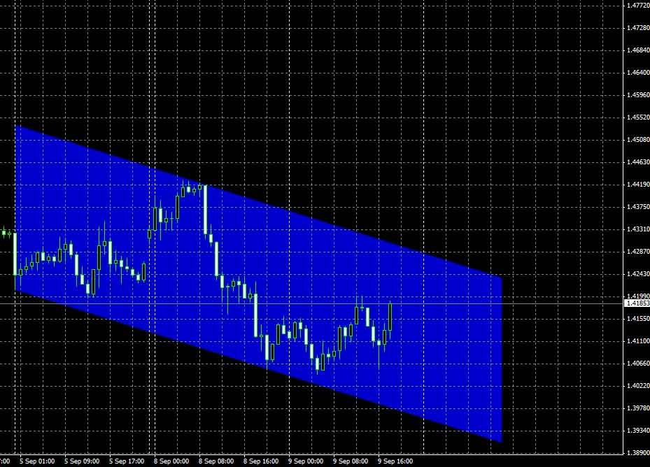
Fig.1
The most important figures are drawn on the senior timeframe . Set on the H4 timeframe and gradually decreasing period choose the most appropriate options channels. Channels offered advisor - it's just a hint , the user can rely on channels offered advisor or construct figures to your liking. Horizontal channels override inclined .
1. Call the context menu you painted figures for this , double-click the left mouse button in the figure, will mark the corners dimensional figures and right-click on one of the labels. Select " Properties Channel». On the "General" tab check the box " Draw object as background ." Figures for workers reserved 2 named " C1 " and " C2 " ( in Latin ) . On the " Options" uncheck "Ray" Figure 2 , Figure 3) (.
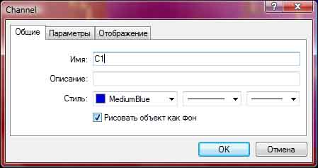
Fig.2
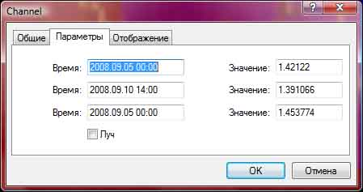
Fig.3
1. If all is well done, automatically will draw horizontal lines tolerance level of current prices for the figures . Automatically calculate the channel parameters and the results are displayed on the screen as text.
Advisor can work simultaneously with two figures ( C1 and C2 ) on the same graph . Graphs can be an unlimited number .
-------------------------------------------------- ------------
Warning: Be careful during channel equalization when the EA. To avoid accidental operation , recommend disabling adviser when correcting a figure.

Automatic functions adviser.
Attention, functional advisor can upgrade depending on the version .
On the chart you can see that the boundaries of each of the figures drawn horizontal lines intersect the blue - they show the current values ​​of alarm levels ( when entering prices in the area ) of the upper and lower boundaries of the figures ( dynamically change ) . The graph shows the text information (Fig. 5) .
A. The first line shows the width of the channel "C1" , the selection TakeProfit, StopLoss, Dopusk in points for this figure.
B. The second line shows the width of the channel , " C2 " , the selection TakeProfit, StopLoss, Dopusk in points for this figure.
B. The third line shows the trend value (to be described later) .
G. The fourth line indicates how lot will be open the next deal . Further, the maximum number of transactions that can be opened simultaneously. Next Modifier compensation Martingale system - activated when the previous deals were unprofitable . Further specifies the maximum lot to which the adviser will increase exhibition Martingale subsequent drawdown .
D. fifth line informs about the amount of collateral for the currency pair for the selected lot. And then the value of the deposit, which is reaching lot Martingale decreases.
E. The sixth and seventh lines show technical information that can be useful when debugging a program .
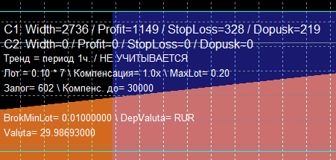
Fig.5
If the price goes beyond the boundary figure on the price axis or time ceases to be a working figure - repainted pink and changes name to «D1» and «D2», respectively, "C1" and "C2". Regardless of active pieces, open transaction advisor before closing fully automatically controlled.

Manage settings Adviser
Double-clicking on the icon in the upper right corner with a picture of a smiling faces enter the settings menu Adviser (Fig. 6).
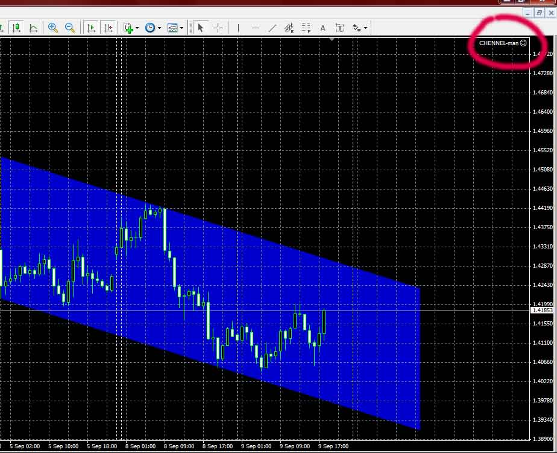
Fig.6
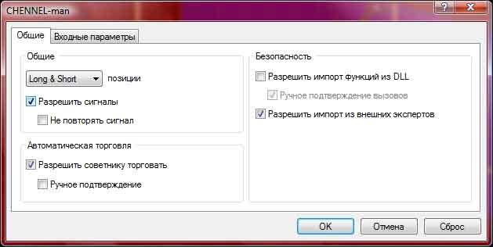
Fig.7
Ticking on the "General" tab as shown in Figure 7. go to the tab "Input parameters".
The table of coefficients
Parameter | Description | Recommended values
BalanceOnLot | Initial minimum lot.  (The free version is fixed  lot = 0.1). | MiniForex = 0,1  MicroForex = 0,01
MaxOrders | The maximum possible number of open orders. Depends on the number of currency pairs, and cash.  (With the increasing size of the lot is automatically reduced the number of simultaneously open lots). | 6
TakeProfit | Parameter defining the purpose of a profitable position (inside the channel). Measured as a percentage of the width of the channel. For example, the value of TakeProfit = -0,5 is 50% of the width.  Alternatively, if set to a positive value, measured in points. For example, TakeProfit = 500, then 500 points. | -0,5
StopLoss | Parameter that determines the fixed maximum drawdown (outside the channel). Measured as a percentage of the width of the channel. For example, the value of StopLoss = -0,15 is 15% of the width.  Alternatively, if set to a positive value, measured in points. For example, StopLoss = 100, then 100 points. | -0.15
Dopusk | Parameter that determines the trigger zone near the channel in which the adviser can make a deal (in the channel). Measured as a percentage of the width of the channel. For example, the value Dopusk = -0,1 is 10% of the width. If the price will go down to 10% of the area near the border, in the absence of conditions preventing the open transactions. Accordingly, near the bottom BUY, SELL near the upper boundary of the figure.  Alternatively, if set to a positive value, measured in points. For example, Dopusk = 100, then 100 points. | -0.1
NoLoss | Parameter that allows to pull level StopLoss to breakeven . Measured in points or percentages, but not the width of the channel and of the maximum profit (ie OrderTakeProfit - OrderOpenPrice).  If the current transaction has reached a predetermined positive value NoLoss, StopLoss level for the transaction is rearranged for the price level of trade opening . Triggering this option activates the pull prices TraillingStop. Unattainable value of this parameter disables the trigger trailing (pin 1).  Alternatively, if set to a positive value, measured in points . For example , NoLoss = 100 , then 100 points . | -0,5
NoLoss2 (hide, fixed) | Parameter allows to pull level StopLoss to breakeven. Triggered similar NoLoss, but only if it is possible to purchase an additional item (a function of re-buys). Actuating provides breakeven already open transaction.  If NoLoss2 = 0, the minimum level NoLoss = stop. | 0
StartTrailing | (pin 1) - parameter defines the beginning of tightening rates. Measured as a percentage of the maximum profit (ie OrderTakeProfit - OrderOpenPrice). For example, the StartTrailing = -0,7 width is 70%. If price overcomes 70% of the width of maximum profit, the value of StopLoss tighten the amount BrokMinStop (hidden).  Alternatively, if set to a positive value, measured in points. For example, StartTrailing = 100, then 100 points. | -0.7
Voshod | If this parameter is zero, the counselor will make transactions in the uplink only BUY, downstream only SELL. If the value is not 0, then the transactions are made on the channel boundaries on both sides. | 1
PeriodsK | Determines the timeframe for working condition ligament number 3. Period in which using two oscillators determines if a price reversal. | 5
MA1 | The first moving average.  Condition for Buy (MA1> = MA2)  Condition for Sell (MA1 <= MA2) | 1
MA2 | The second moving average.  Condition for Buy (MA1> = MA2)  Condition for Sell (MA1 <= MA2) | 3
PeriodsT | (pin 2) - Taymfreym trend. This option attempts to determine the dynamics of the currency pair .  (PeriodsT = 60 ) is the hour ,  (PeriodsT = 240 ) is a four-hour , (PeriodsT = 1440 ) - Day candles .  Related to the parameters and Envelopes Deviates and Envelopes2 and Deviates2.  For a bunch of number 2 in relation condition - if the tape is fast in slow the trend is not defined. If higher, ascending, if lower, then downward. Respectively upstream - only buy. In the downstream , only sale . In an uncertain and buying and selling .  These recommended settings in Example svyazki2 disable this feature to increase the number of opened deals. | 60
Envelopes | (pin 2) - One of the parameters of the standard indicator Envelopes (equidistant Moving Averages) - period moving equidistant. Related to the parameter and PeriodsT Deviates. Plays the role of a fast moving tape.  Condition uptrend: (EnvelopesDown> = Envelopes2Down)  Condition downtrend: (EnvelopesDown> = Envelopes2Down) | 100
Deviates | Deviates (bundle 2) - this parameter determines the degree of remoteness of two moving relative to the original moving average. Associated with PeriodsT and Envelopes. | 0.2
Envelopes2 | (pin 2) - One of the parameters of the standard indicator Envelopes (equidistant Moving Averages) - period moving equidistant. Related to the parameter and PeriodsT Deviates2. Plays the role of the slow moving belt.  Condition uptrend: (EnvelopesDown> = Envelopes2Down)  Condition downtrend: (EnvelopesDown> = Envelopes2Down) | 100
Deviates2 | (pin 2) - this parameter determines the degree of remoteness of two moving relative to the original moving average. Associated with PeriodsT and Envelopes2. | 0.2
Compens_On | (pin 4) - Item Modifier function Martingale  (Can be fractional)  As the size of the lot Advisor automatically reduces the multiplier | 2
CompensPoints | (pin 4) - Threshold drawdown in points, which allows the function to increase the Martingale lot (in points) | 200
MaxLotPeremen | (pin 4) - user-defined value of the deposit sufficient to open a trade 1 lot. (In U.S. dollars). Necessary to determine the threshold (maximum lot) building lot Martingale.  In other words - the aggressiveness of the algorithm Martingale | 6000
UseChannel | Use auto channel.  If UseChannel = 0 then do not use  If UseChannel = 1, then use | 1
BarsForFractal | Minimum number of bars between adjacent fractals. The more, the wider channel. | 20
BarsBeforeChangeChannel | The number of bars required to confirm the formation of a fractal. The smaller the faster rearranged channels and the less accurate.  Classically considered to be fractal formed after the third bar. | 3
Stop_Loss_Chain | The percentage value of drawdown of one transaction of the deposit, which breaks the chain of building lots (open cycle Martingale), returning the item to its original value. | 15
MedExtremFig | Function is not used
MedShift | Function is not used
SecsBetweenOpenOrders (hide) | Minimum number of seconds between the open orders. | 60
SecsBetweenCorrectOrders (hide) | Minimum number of seconds between correction orders. | 10
ColorSet | Setting the color scheme  1-black color scheme  0-and-white color scheme | 1
TechInfo | Displays technical information necessary only during debugging program  1 of those. information is included  0 - excl. information disabled | 1

Описание работы некоторых функциональных связок

СВЯЗКА2 -Подтверждение разворота цены

PeriodsK (связка 2) – Определяет таймфрэйм на котором работает условие связки №2.
PeriodsK=1, 5, 15, 30, 60
MA1 (связка 2) – Быстрая скользящая средняя. Цена открытия текущего бара.
MA1=1
MA2 (связка 2) – Средняя скользящая средняя
MA2=2…10
Задача связки обнаружить подтверждение разворота цены около границы канала «С1» или «С2». Если в области допуска на выбранном таймфрэйме (PeriodsK) быстрая скользящая пробивает среднюю, формируя «крючок», это служит сигналом к совершению сделки.

Если MA1=MA2, то условие связки №2 игнорируется и подтверждение отбоя от стенки не учитывается.

СВЯЗКА3 - Определение тренда
PeriodsT (связка 3) – Таймфрэйм тренда. Эта связка пытается определить тренд на высоких таймфрэймах. (PeriodsT=60) –это часовые, (PeriodsT=240) - четырехчасовые свечи.
PeriodsT= 30, 60, 240, 1440
Envelopes (связка 3) – «быстрая лента» Один из параметров стандартного индикатора Envelopes (равноудаленные скользящие средние) - период равноудаленных скользящих. Связан с параметром PeriodsT и Deviates.
Envelopes=1…50
Deviates (связка 3) – «быстрая лента» Параметр определяющий степень удаленности двух скользящих относительно исходной. Связан с PeriodsT и Envelopes.
Deviates=0,1 …3
Envelopes2 (связка 3) – «медленная лента») Один из параметров стандартного индикатора Envelopes (равноудаленные скользящие средние - период равноудаленных скользящих. Связан с параметром PeriodsT и Deviates.
Envelopes2=20…200
Deviates2 (связка 3) – «медленная лента» Параметр определяющий степень удаленности двух скользящих относительно исходной. Связан с PeriodsT и Envelopes.
Deviates2=0,1 …3

Для связки №3 применительно условие – если Envelopes= Envelopes2 и Deviates= Deviates2, то разрешены сделки и на покупку и на продажу. (по умолчанию)

Наглядно работа связки №3 представлена на рисунке 9. Используются 2 индикатора Envelopes. Если «быстрая» Envelopes1 находится над «медленной» Envelopes2 (зеленая заливка), то тренд считается восходящим. И разрешены только ордера на покупку (Buy). И наоборот, если находится ниже (красная заливка), то разрешены только ордера на продажу (sell).
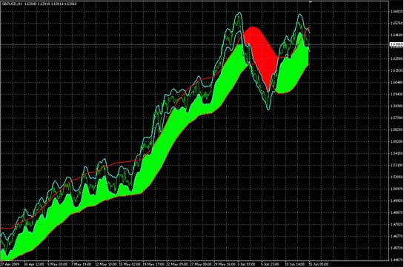
Рис.9

